Impacted Module

1. Auto Debit – Billing

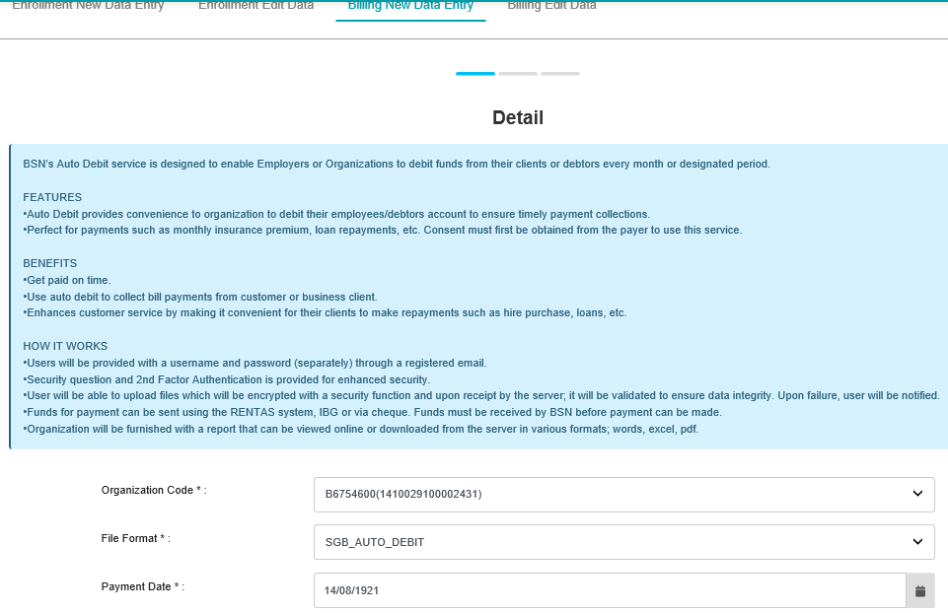

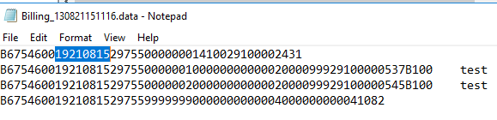

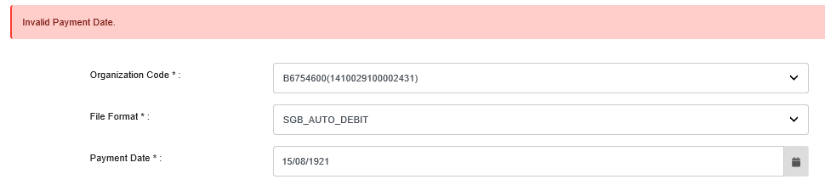

1. Bulk Payment – Data Entry

* Once click ‘Check Duplicate’ > field reset

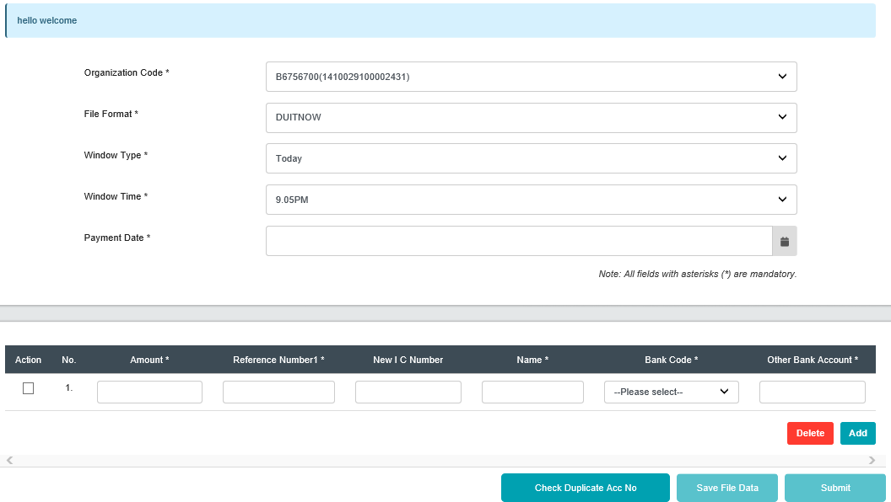

1. Bulk Payment – Edit Data
2. EPF – Other Payment
3. EPF – Data Entry
4. EPF – Edit Data
5. LHDN – Data Entry
6. LHDN – Edit Data