**TESTING ON 03/10/2011**

CREATE BANKBRANCH

Create Content Msg:

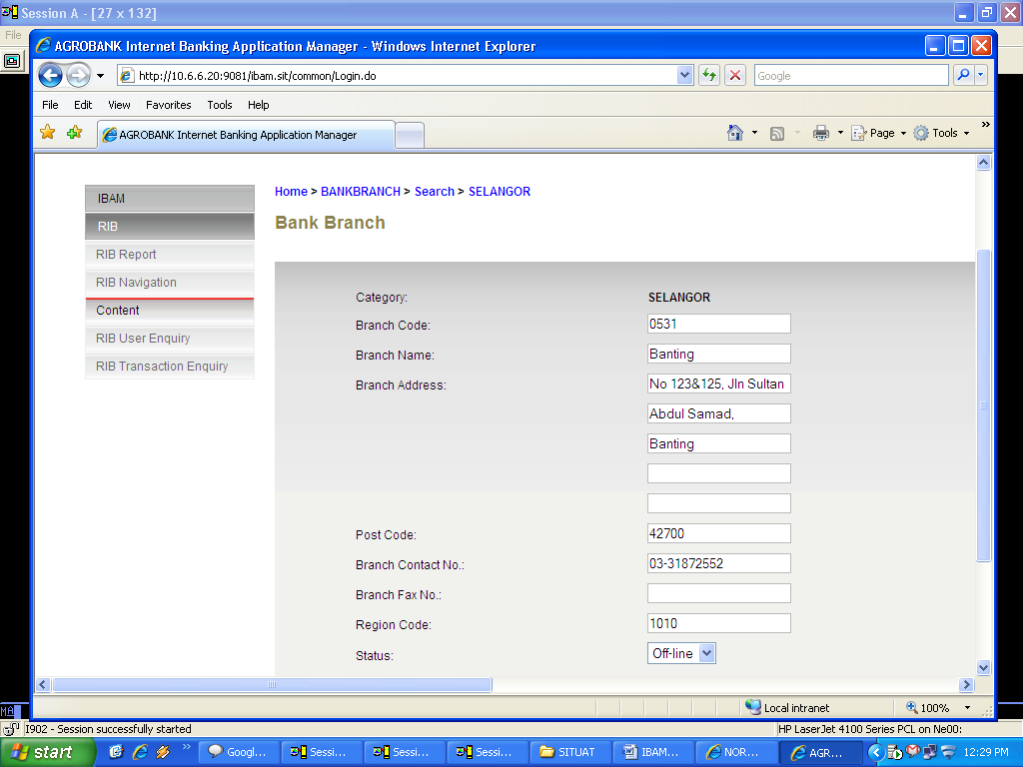

* Click DONE

Msg: (First Time Test)

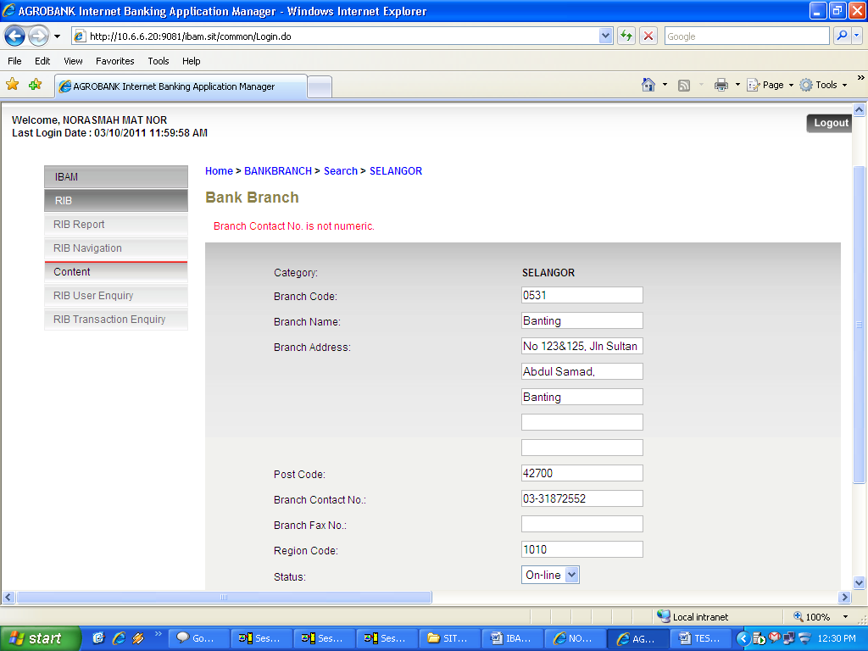

Msg: (Second Time Test)

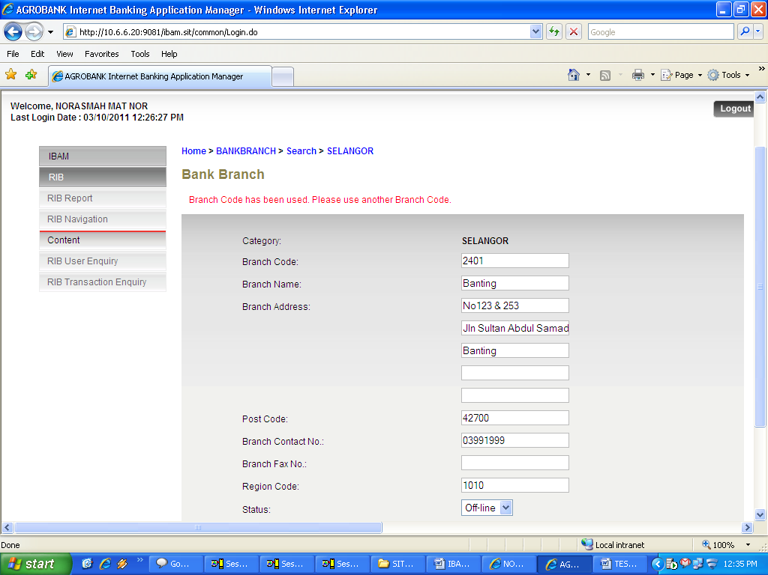

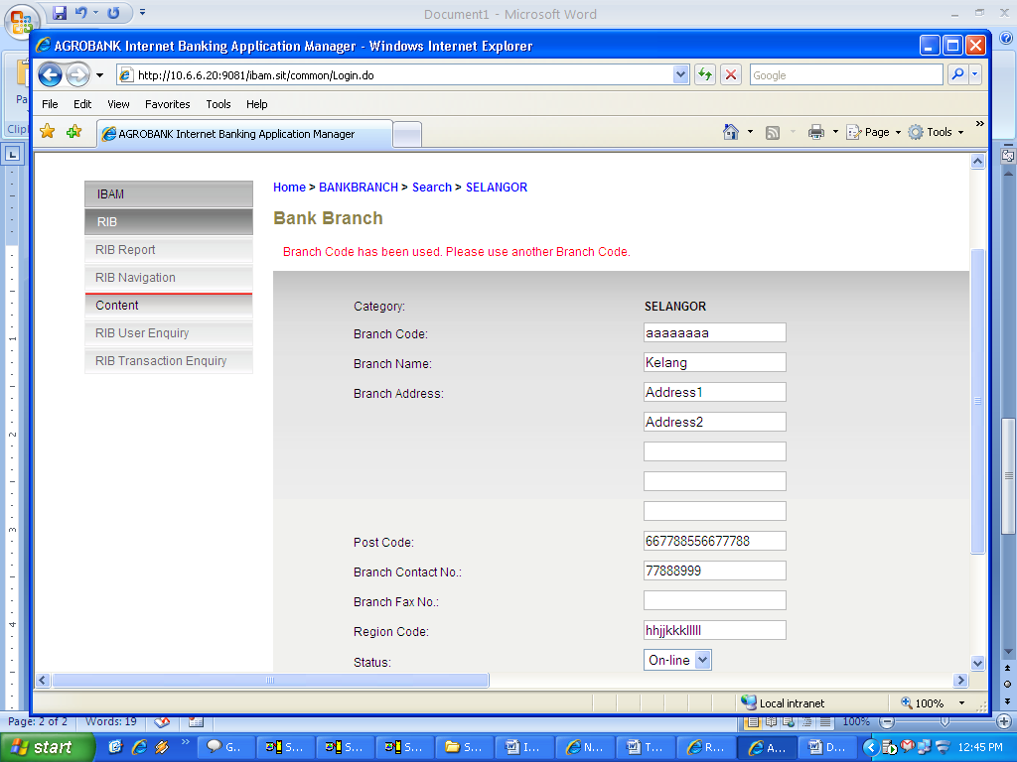

**\*\* Branch Code & Region code: Should be NUMERIC**