BIF-21223-FAILED

Step 1: System displays Audit Trail Enquiry screen

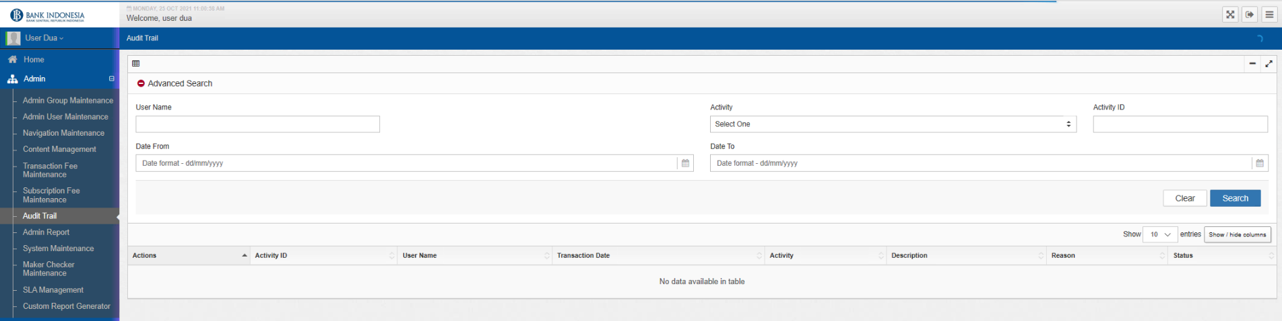

Step 2: System displays the Advance Search screen

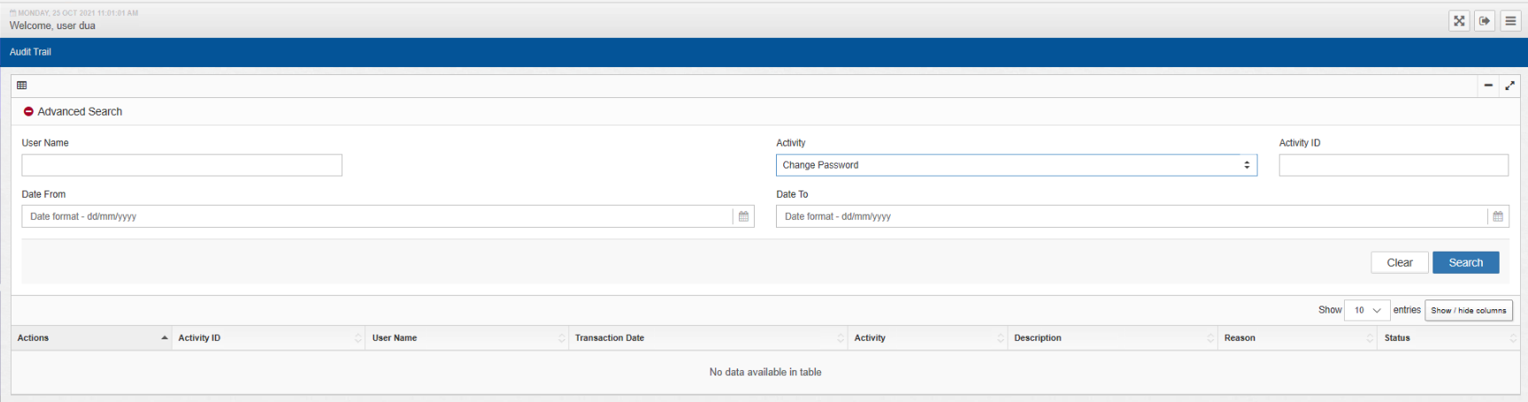

Step 4: System displays Audit Trail search result screen based on search criteria. Host can check all participant data

Result : System can not displays audit trail search result screen on search criteria (No data available in table)

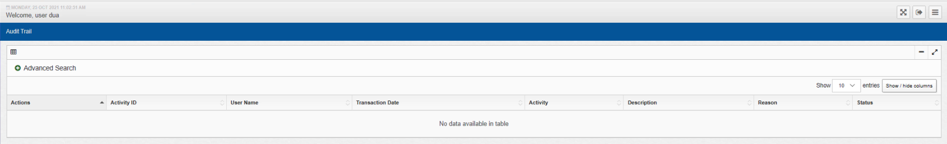

Step 5: System displays Audit Trail Details

-

Step 6: System displays Audit Trail Enquiry screen

-