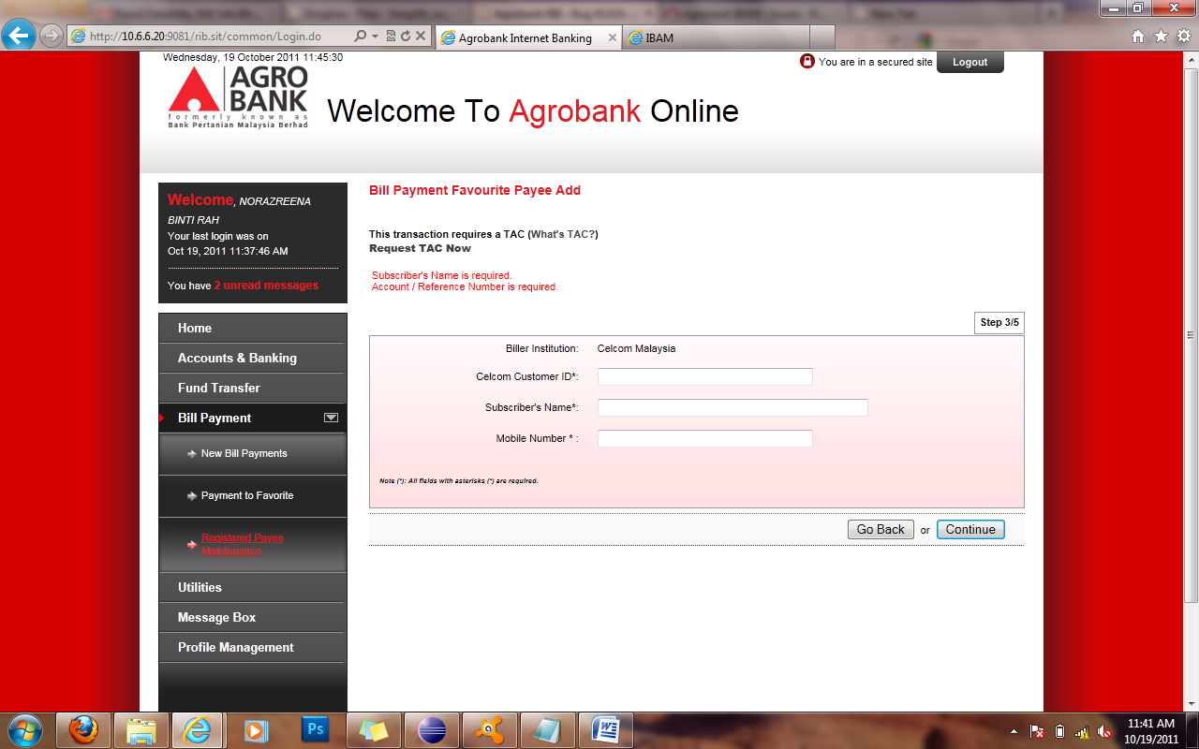

Add validation for Mobile Number as well

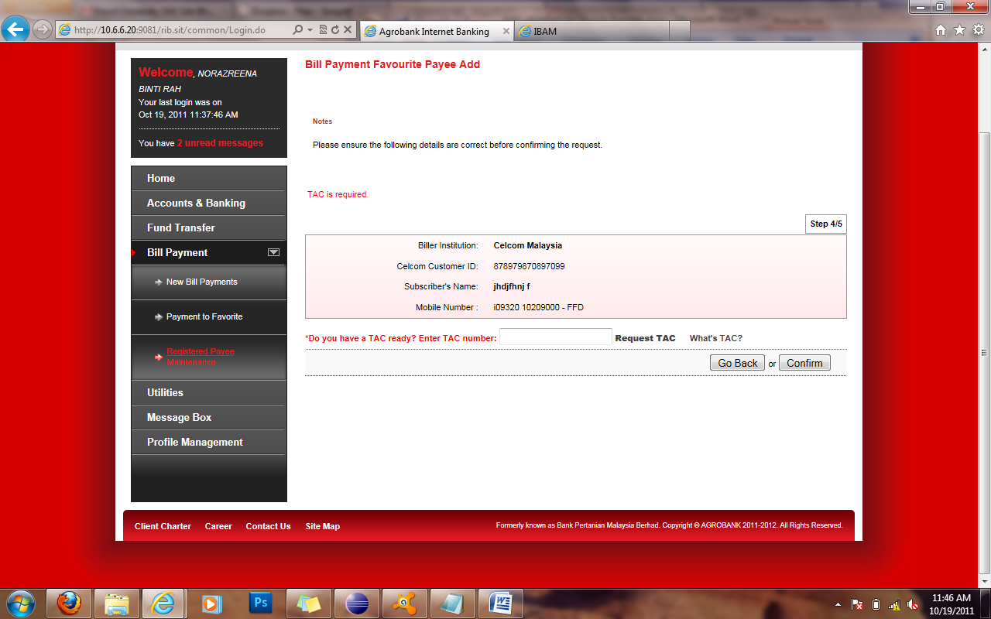

TAC validation label change to red after click confirm button.