Issue Form (PROD)
Originator's Name: Chooi So Fun  Project: Internet Banking  Project Manager: Malarvili / Chris Gunn  Module : Internet Banking  Date Raised: 20.10.11  Phase : Phase 2 – Internet Banking  Functional Area : CIB | Issue ID Number: C11-034  Related Issue ID Number: HD00012024  Classification:  Priority: Critical/High/Medium/Low  Assigned to: Vendor / IT / PMO SA / UPA  Actual Closed Date:
Status: Open/Assigned/Investigated/Resolved/Approved/Deferred/No Action (Circle one)
Description :  2 Prepaid Tranx (RM30, RM10) on 19.10.2011 were not found in the following BVMC Reports:  - Daily Consolidated Transaction Report  - Daily Internet Transaction Report  - Daily Mobile Reload Report  - ePay Recon File  However the 2 transaction were captured in Phoenix Report.  (please refer to attachment for further details) | Impact:
Findings/Root Caused (Description): | Resolution:
Estimated Impact :

Recommendation:

Accepted :  (Vendor / IT / PMO SA / UPA)  Date: | Accepted (KFHMB Tester):  Date:

Phoenix Crystal Report
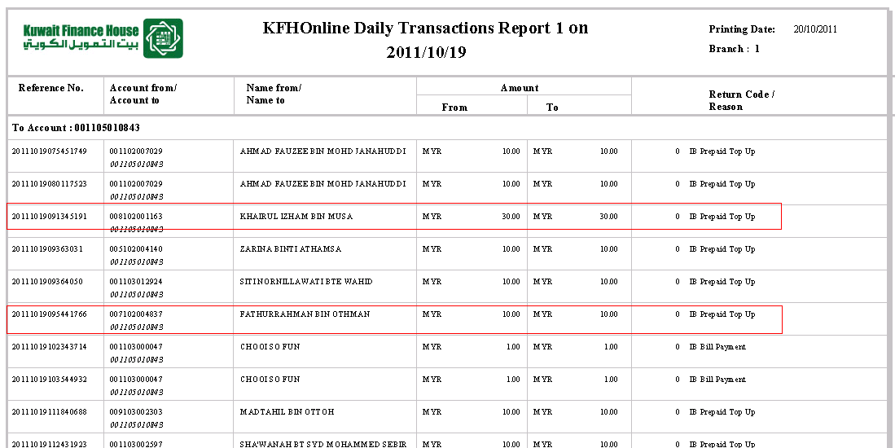

BVMC – Reports

