commons/utils project
ByteToHexaStringUtils.java
Line 27 to 29 is not required, already cater in the else there if filetype is null
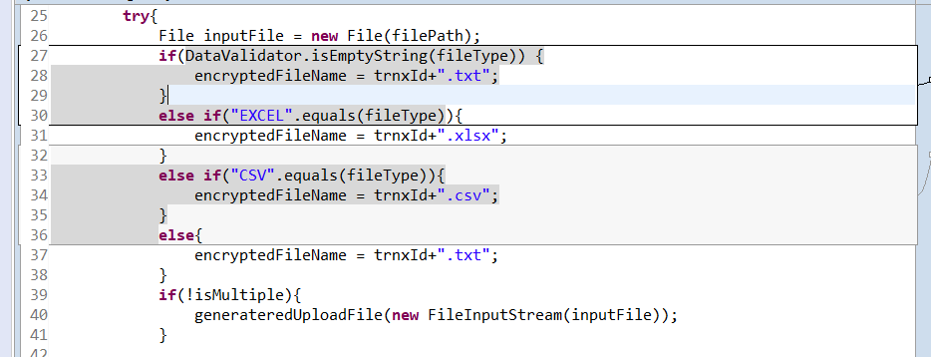

ibssCore project
BibBulkPaymentHistoryDAOImpl.java
This new method should follow others, have try catch and finally only close the session.
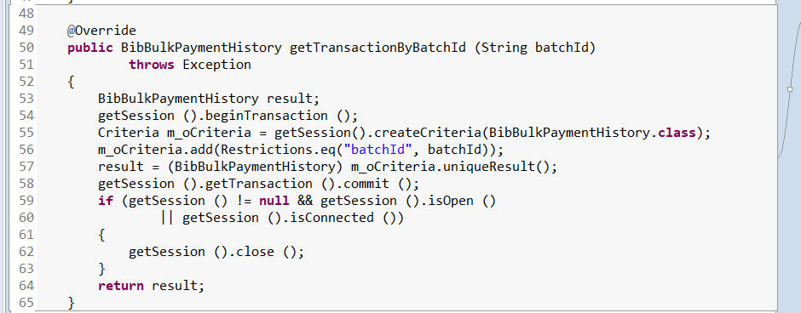
BibBulkAcceptedTrnxDaoImpl.java
This new method should follow others, have try catch and finally only close the session.
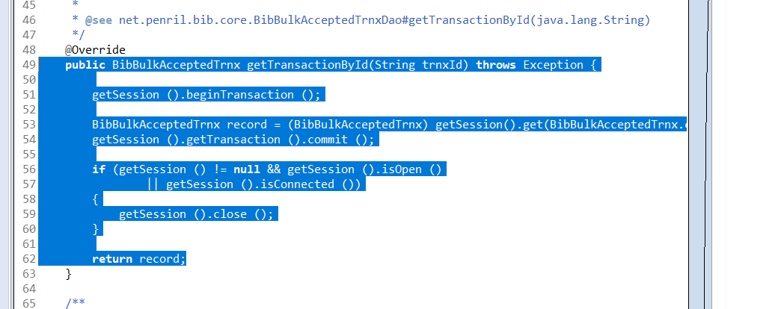
BibBulkJompayAcceptedTrnxDaoImpl.java
This new method should follow others, have try catch and finally only close the session.
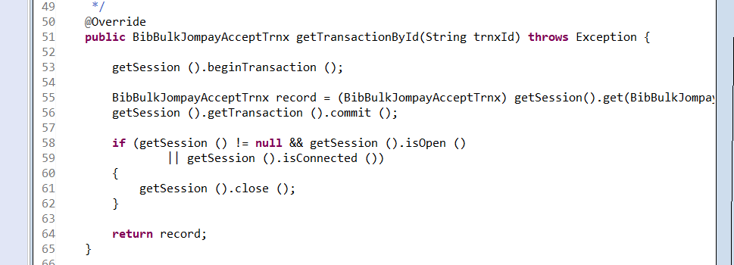
BibBulkJompayHistoryDAOImpl.java
This new method should follow others, have try catch and finally only close the session.
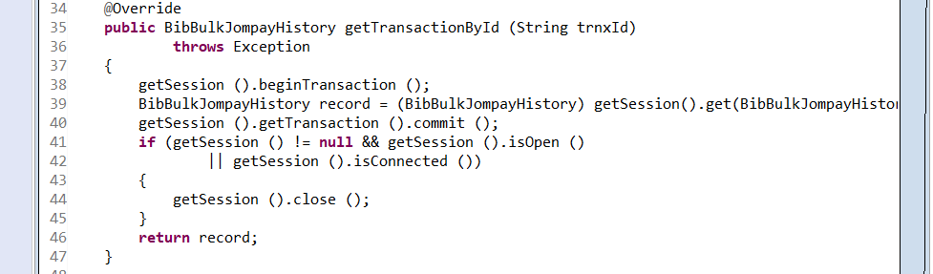
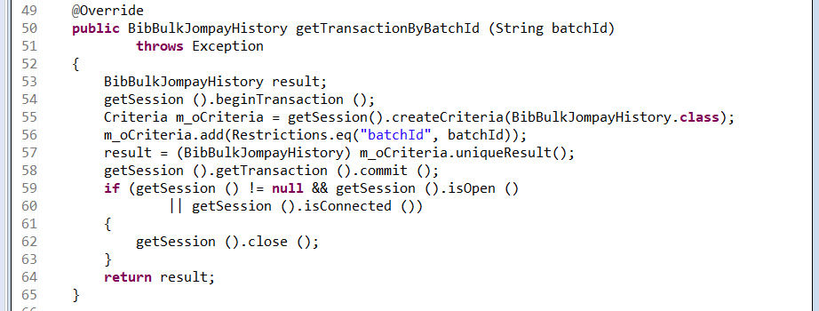
BibBulkJompayRejectTrnxDaoImpl.java
This new method should follow others, have try catch and finally only close the session.
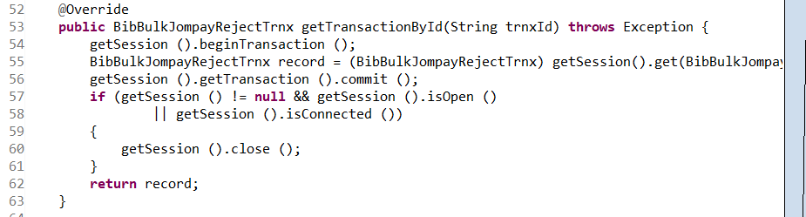

BibBulkJompaySuccessTrnxDaoImpl.java
This new method should follow others, have try catch and finally only close the session.
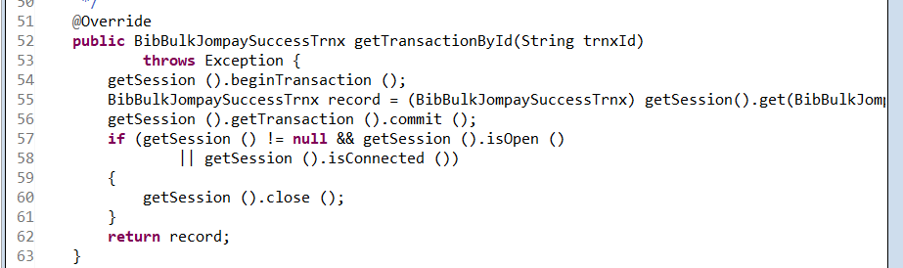

agro-middle-service
IBBPSService.java
Inside BusinessException already have the null checking, if want to set like this, just put null as the err parameter there. Need to change for all
