12266 - 5968- Data Entry-Edit Data transaction Limit
System validate limit 1Milion for other transactions (include IBG) in CDB Data Entry and CDB Edit Data. No issue in File Upload
The limit should be apply to IBG transaction only.

IBAM > Service info > Bulk Payment – Data Entry : Set Max RM10
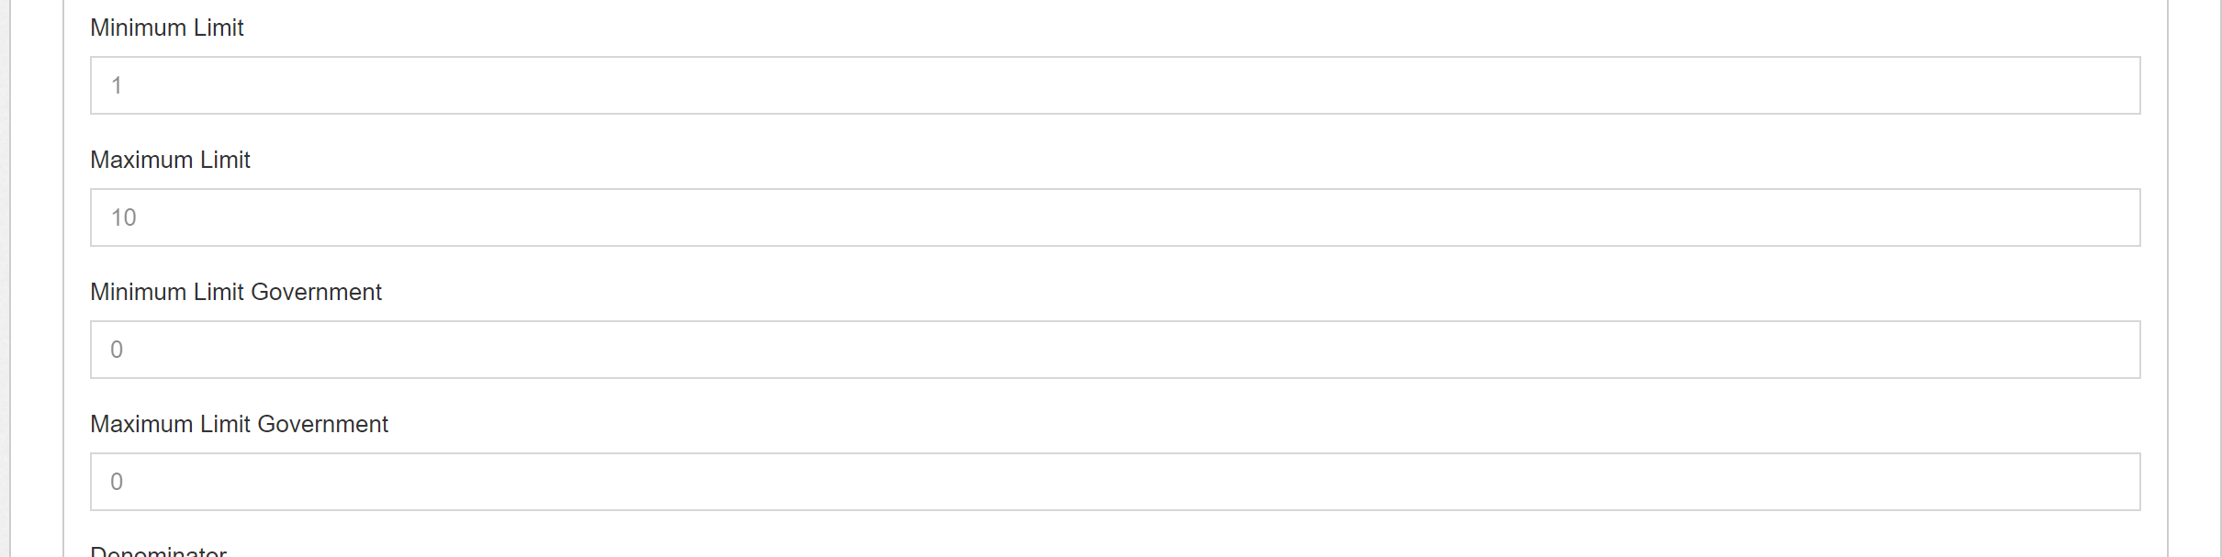

IBG :
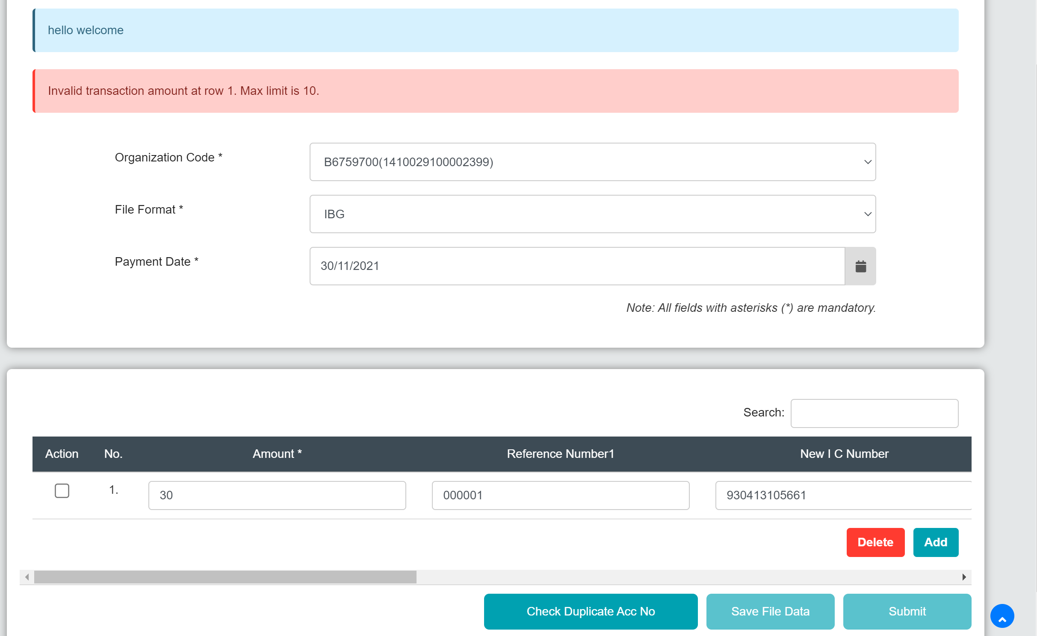

Normal Bulk Payment : SYSTEM ACCEPT
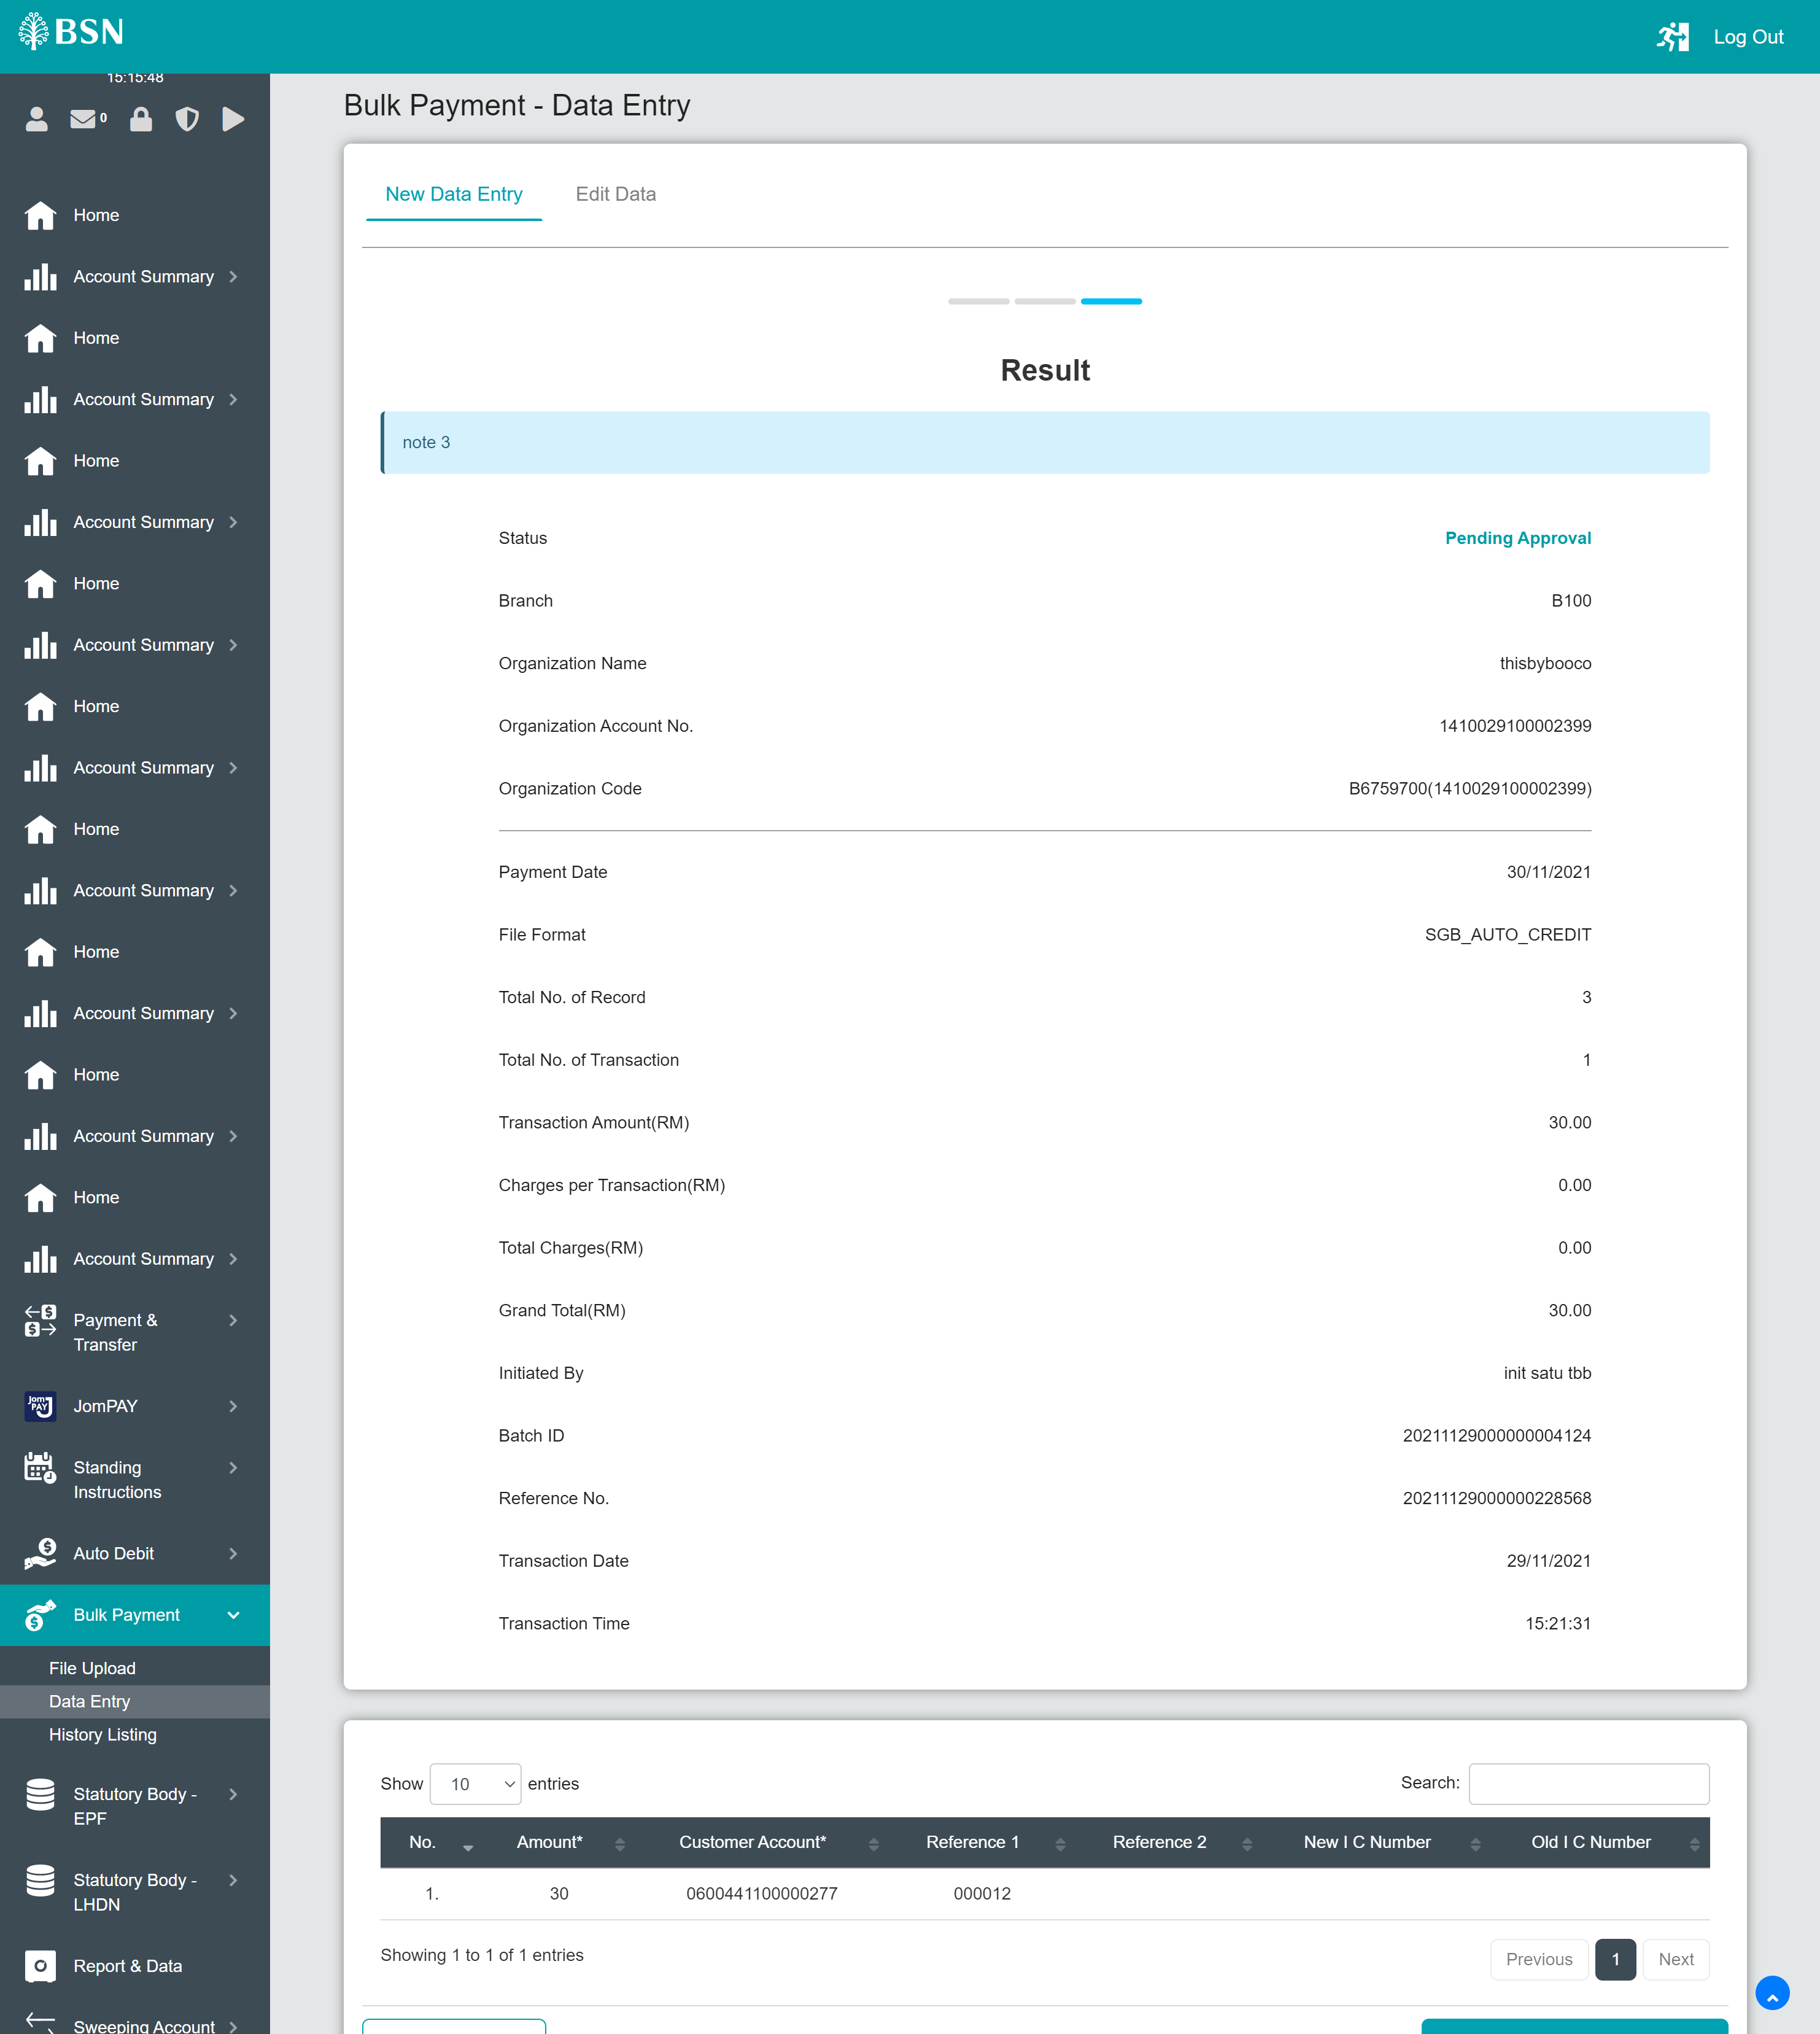

Set limit 0 : System read as no limit
