12464 - SCP ID-6012-Enhancement on Jompay failure
1. Create tbl for failed NC *Done
2. Cronjob to retry failed NC *Done
3. Generate email T+1 for failed NC *Pending
4. Change transaction status from Accepted to Pending Notify Completion for failed NC
*Production status is Successful. Updated SIT status to Accepted if pending NC. After NC, update status to Successful.
Test steps A:
- Login as Initiator
- Make a Jompay payment. Status is Pending Approval
- Login as Approver
- Authorize Jompay payment
- Expected result, status is Successful and money is deducted
Test steps B:
- Login as Initiator
- Make a Jompay payment. Status is Pending Approval
- Request IT to change Jompay IP to invalid IP to simulate connection error
- Login as Approver
- Authorize Jompay payment
- Expected result, status is Accepted and money is deducted
- Wait 15 minutes, check the Jompay status
- Expected result, status is Successful

Test step A
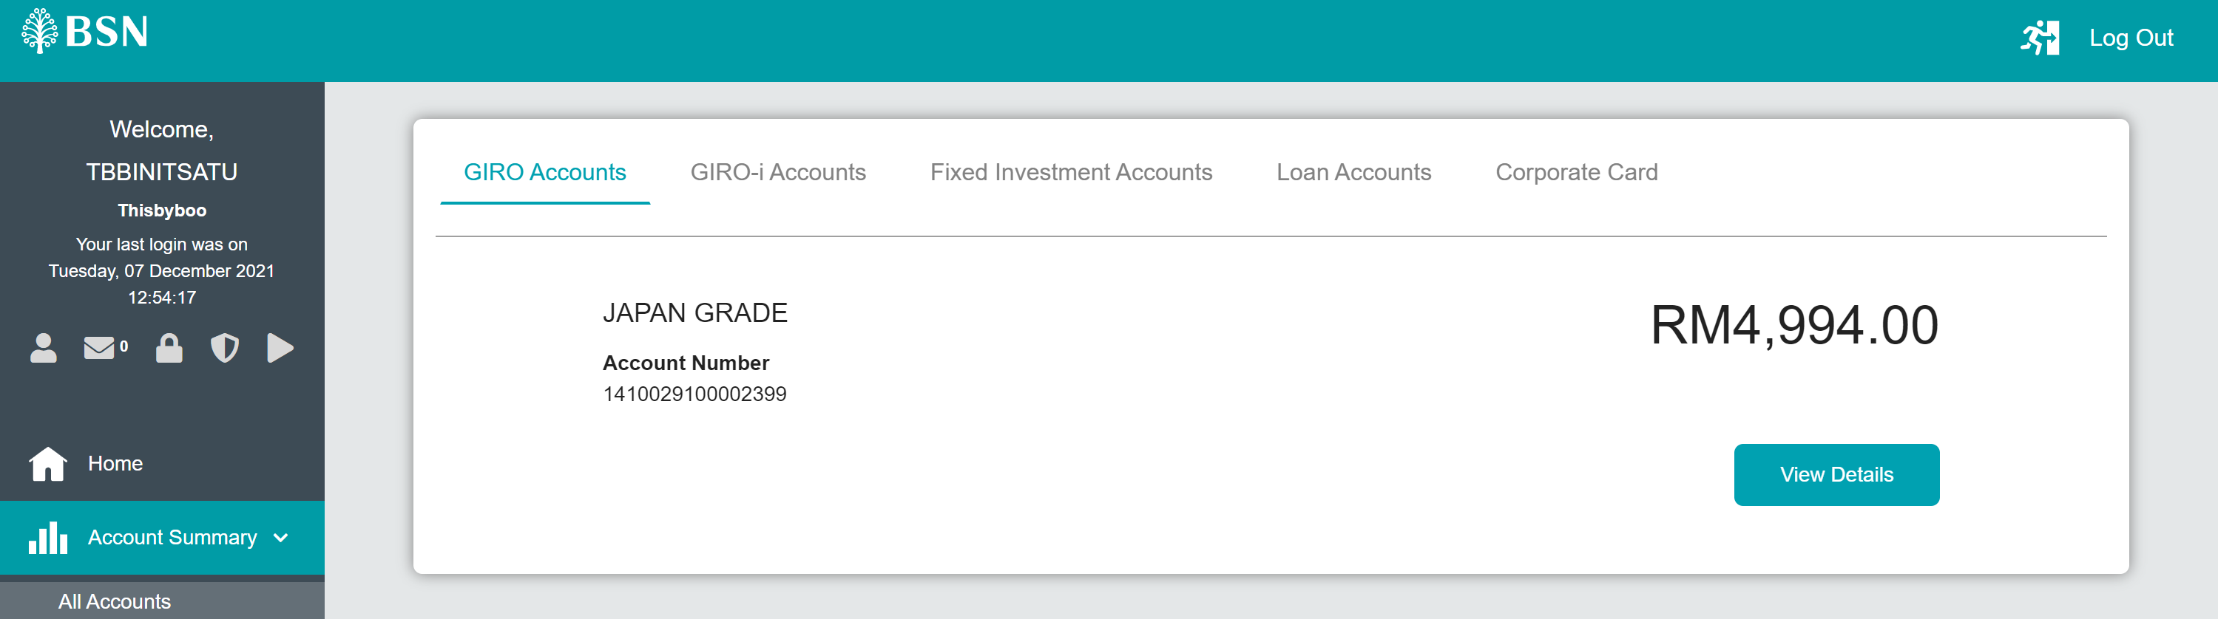
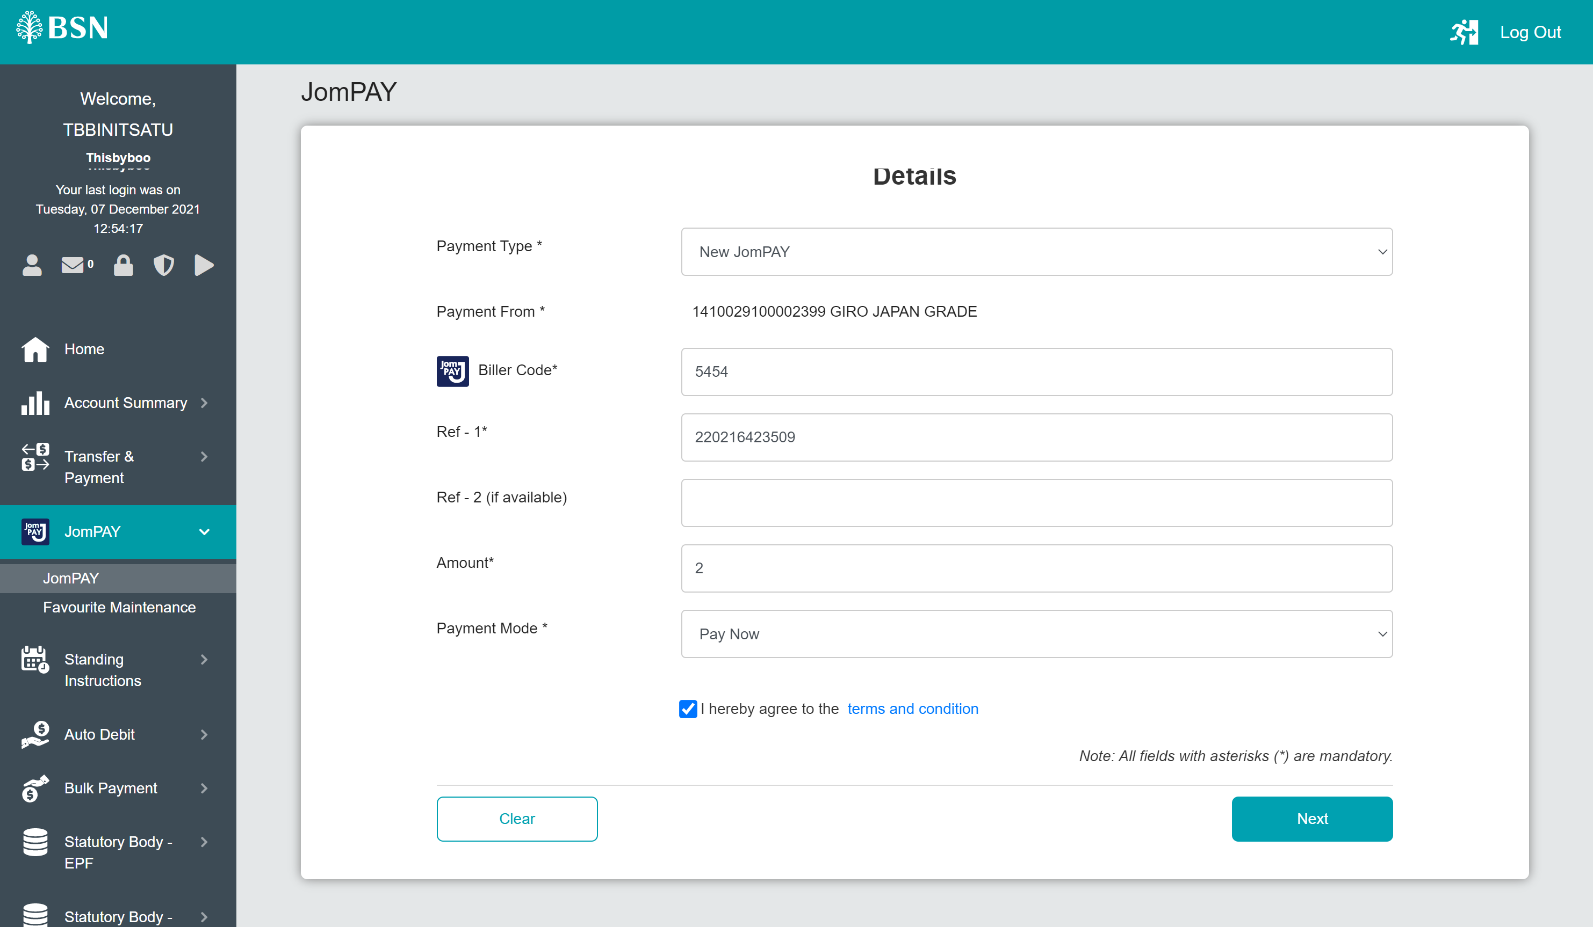
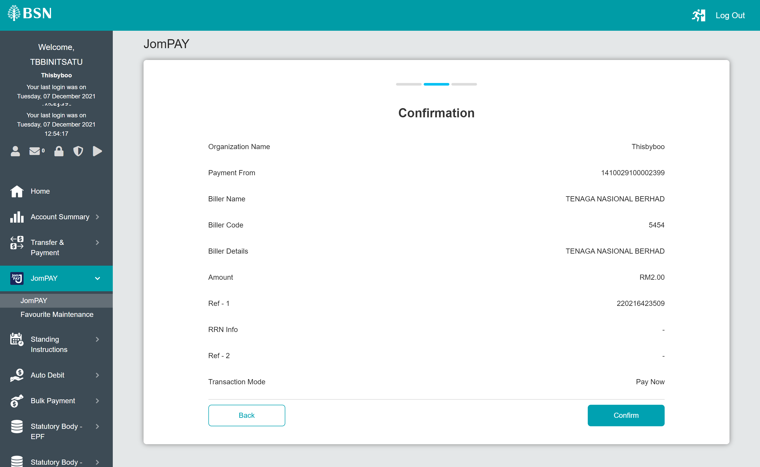
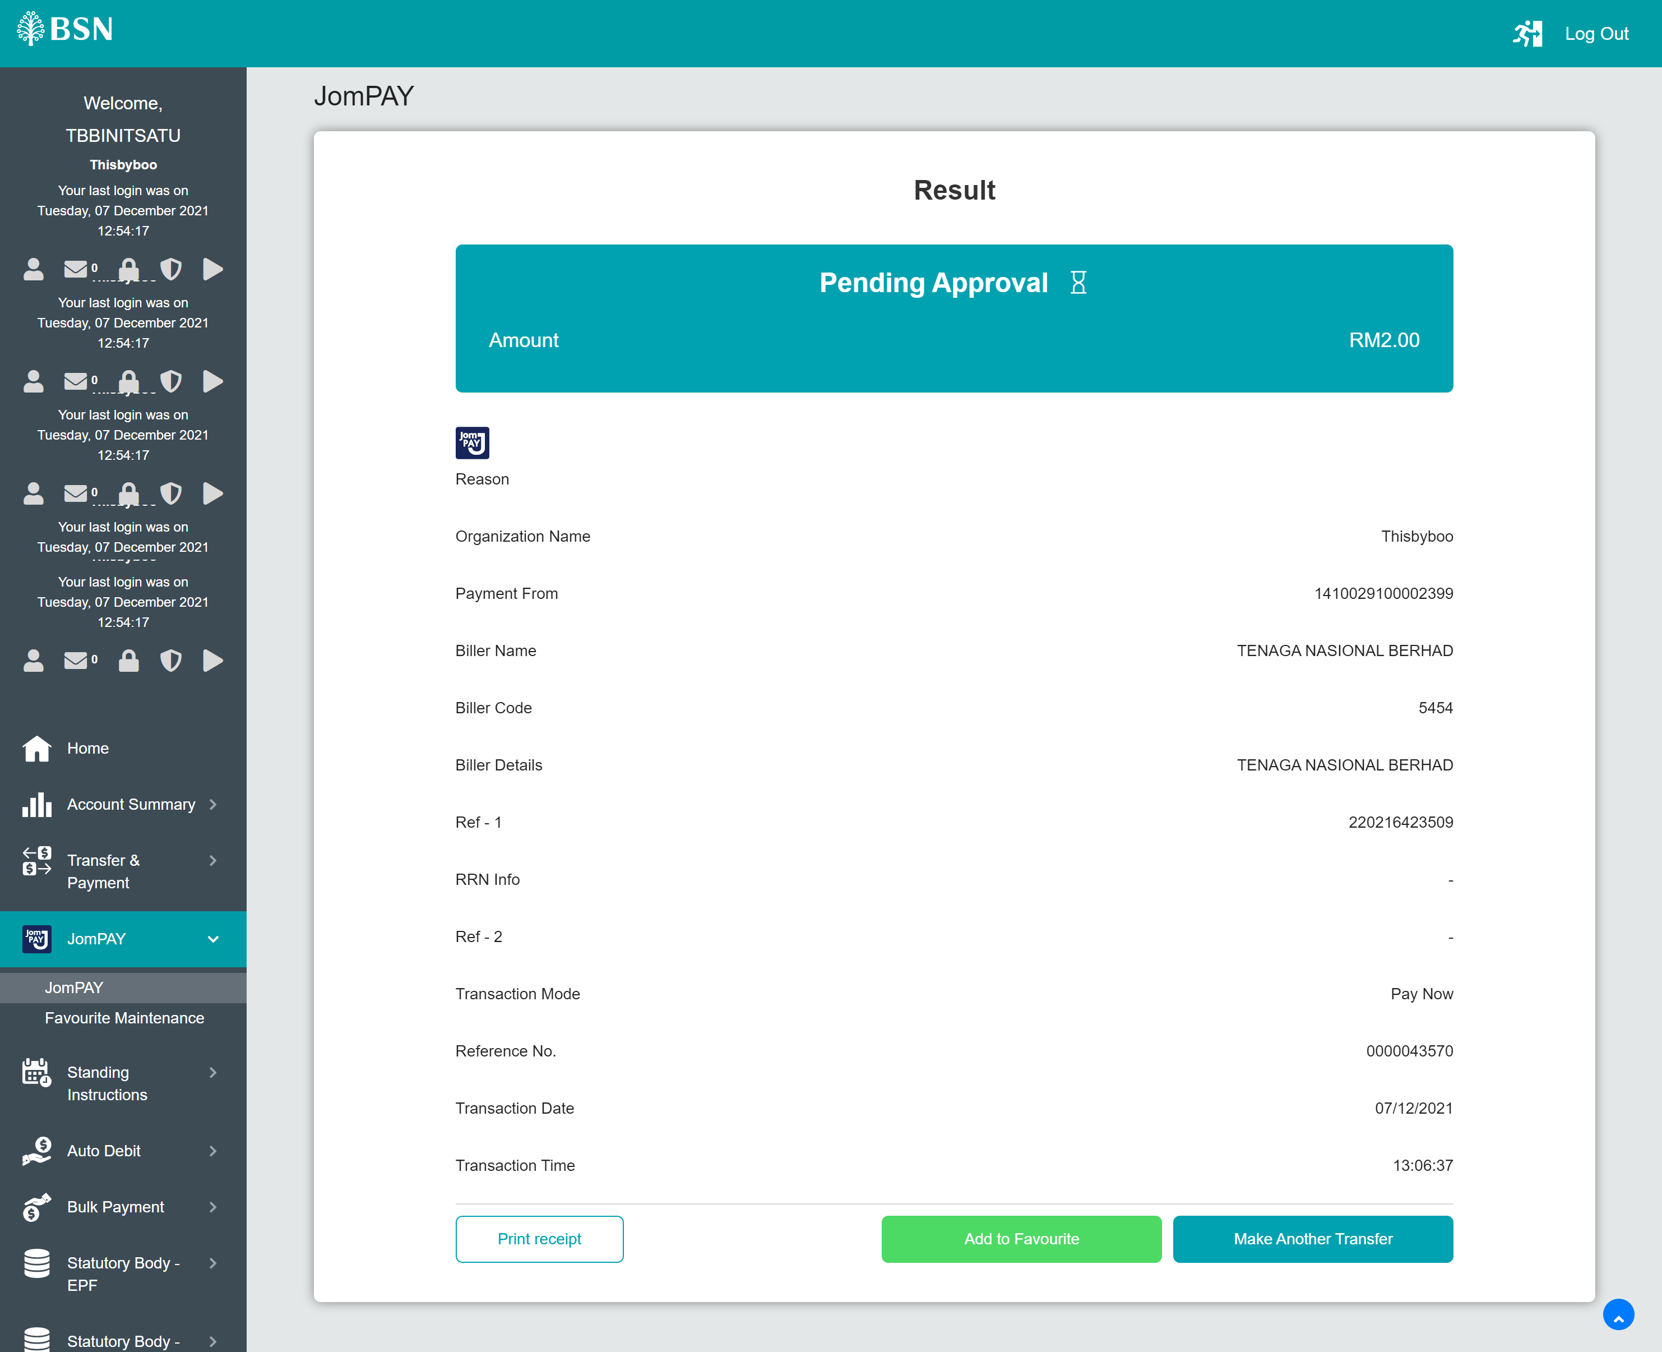

Approver
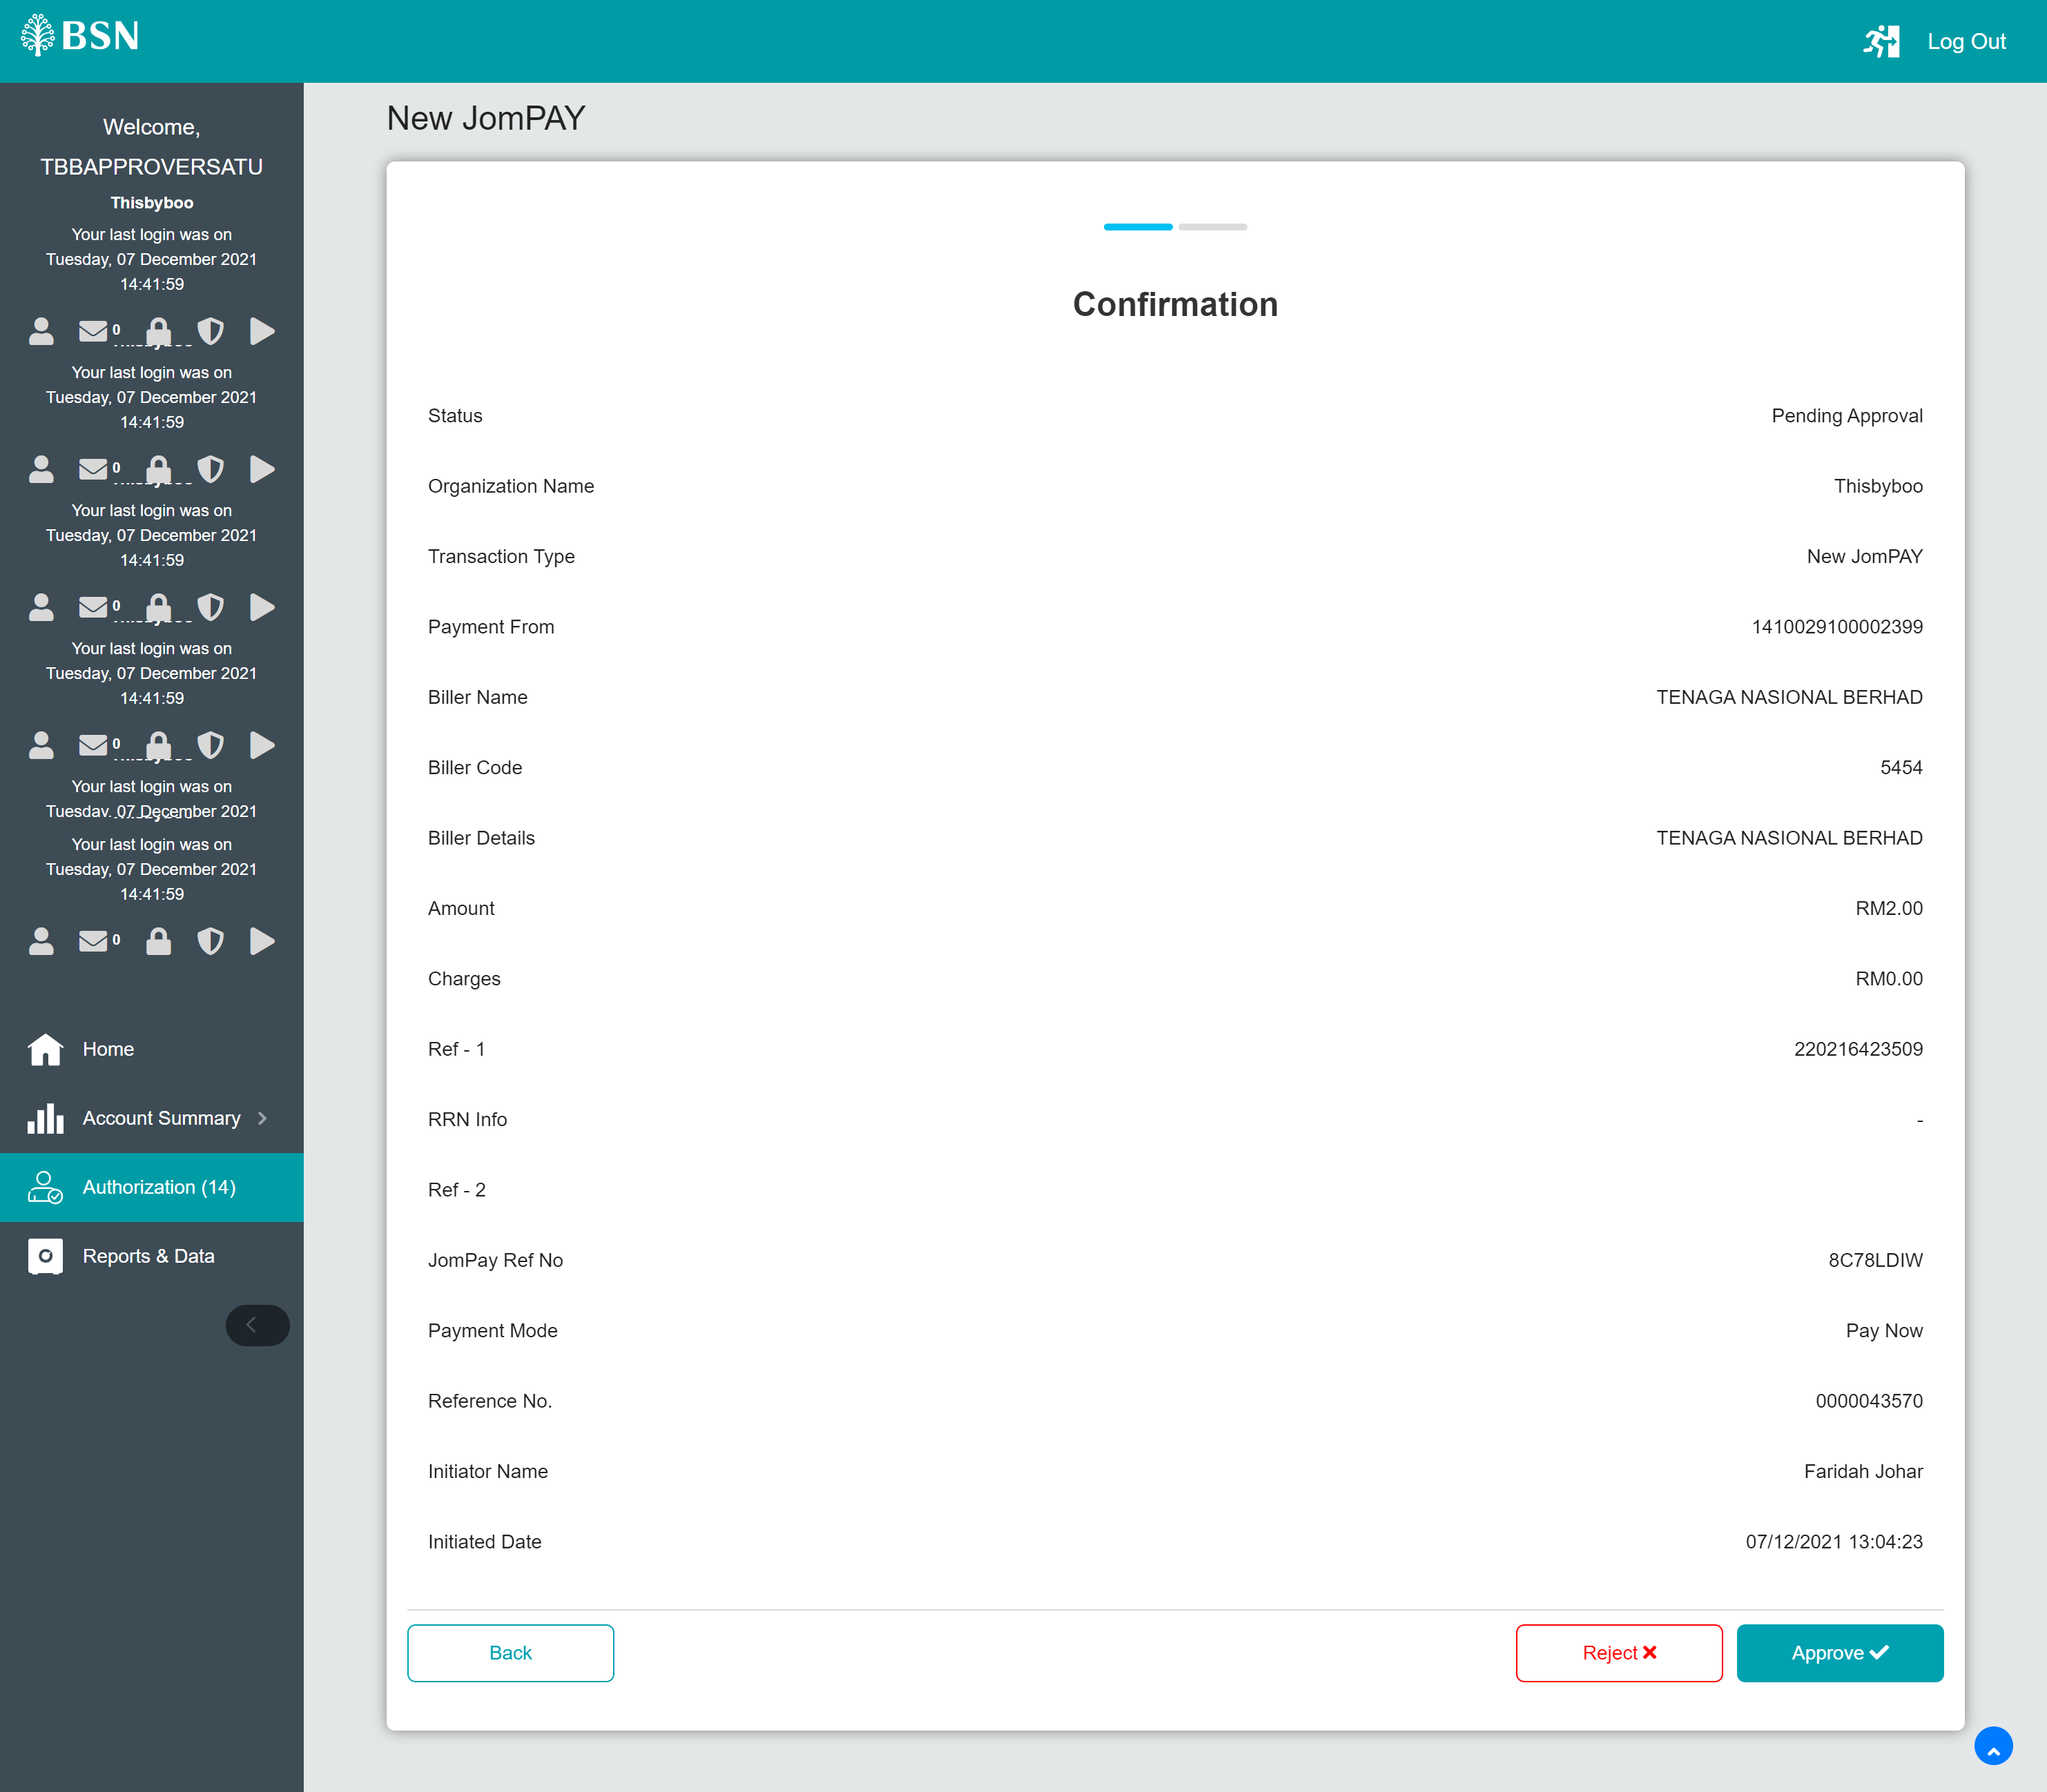
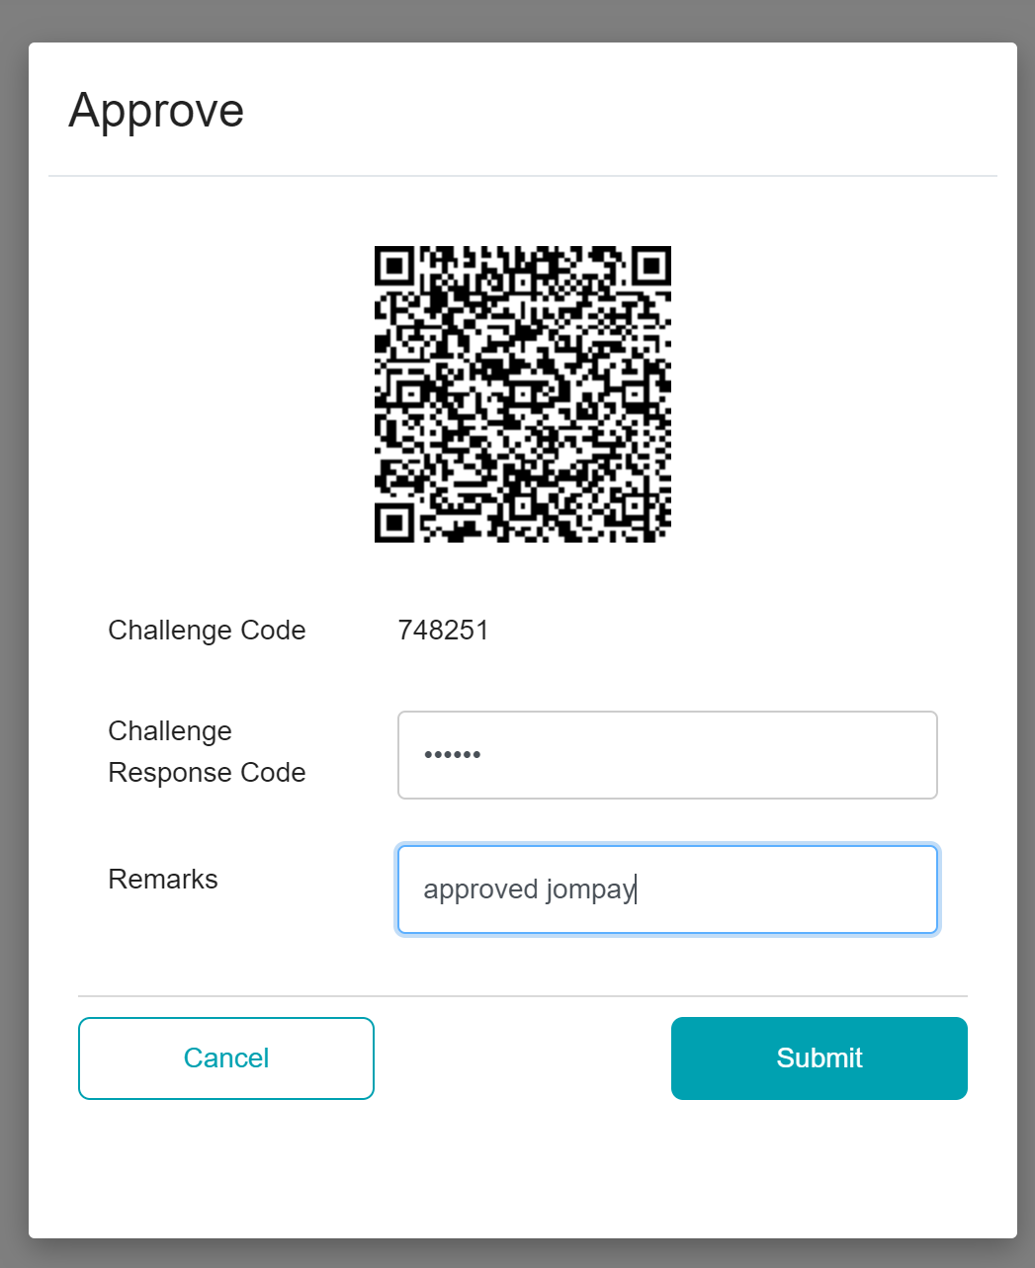
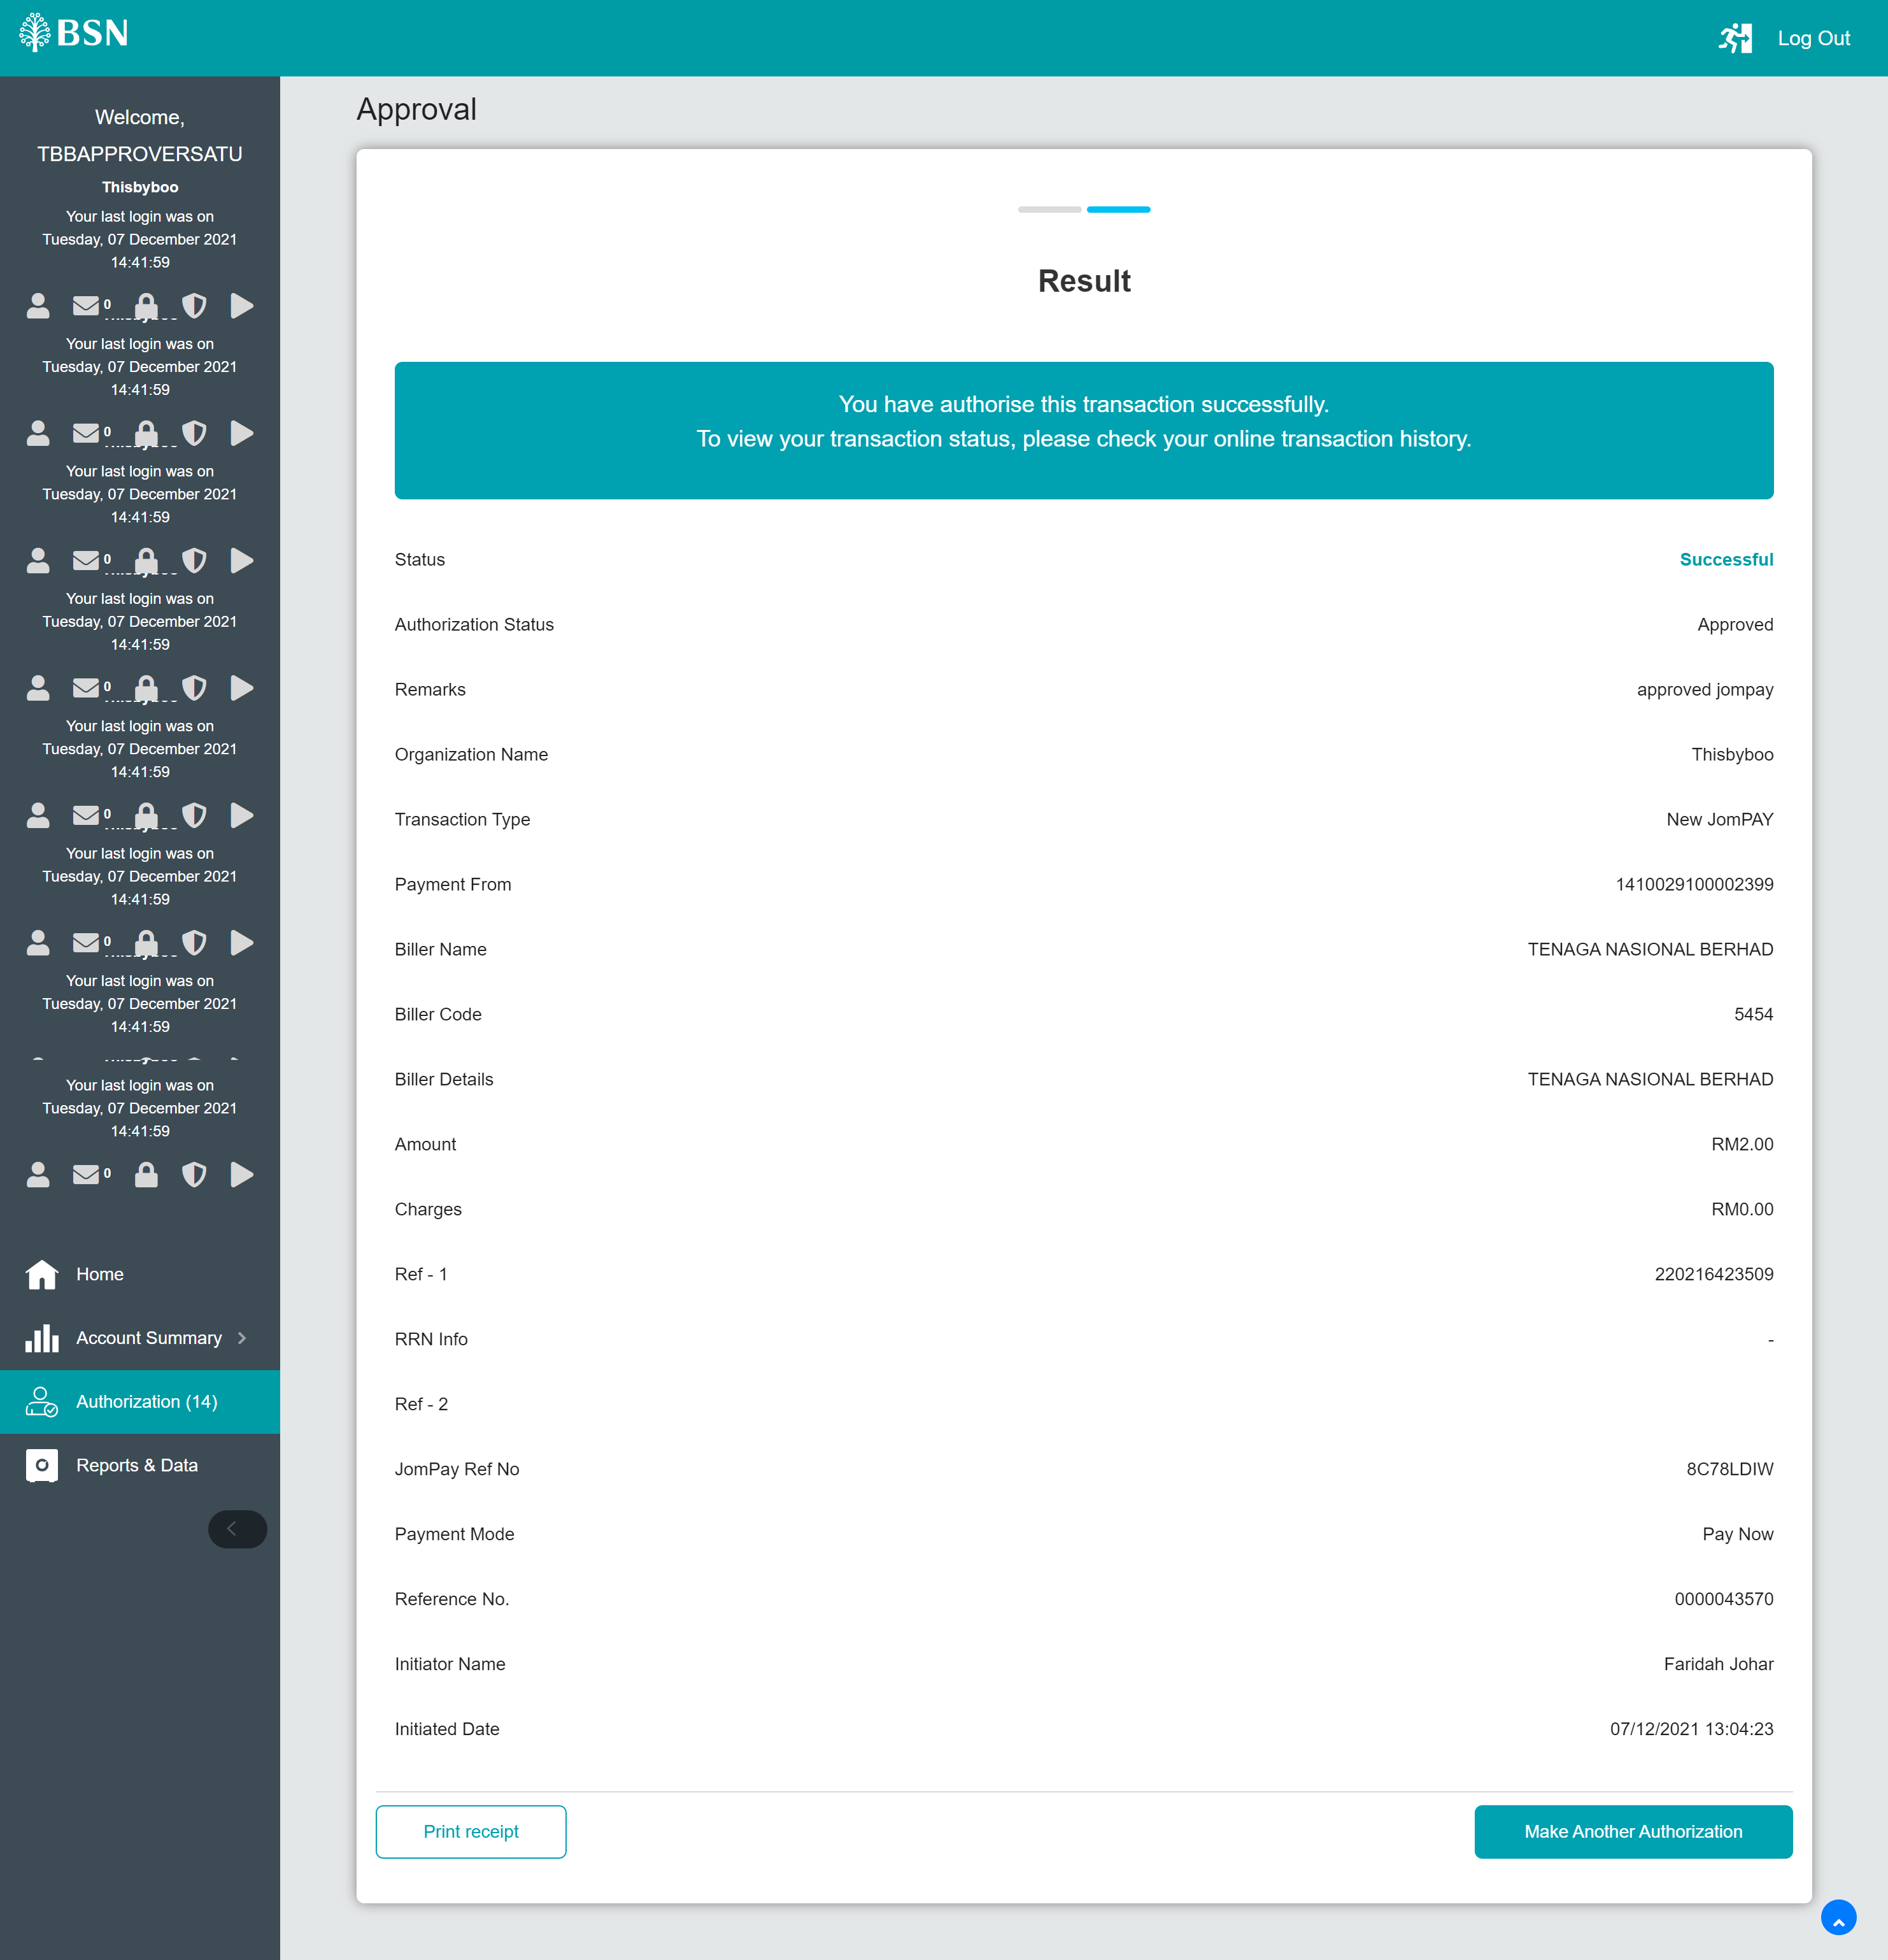
Succeed. Money deducted.
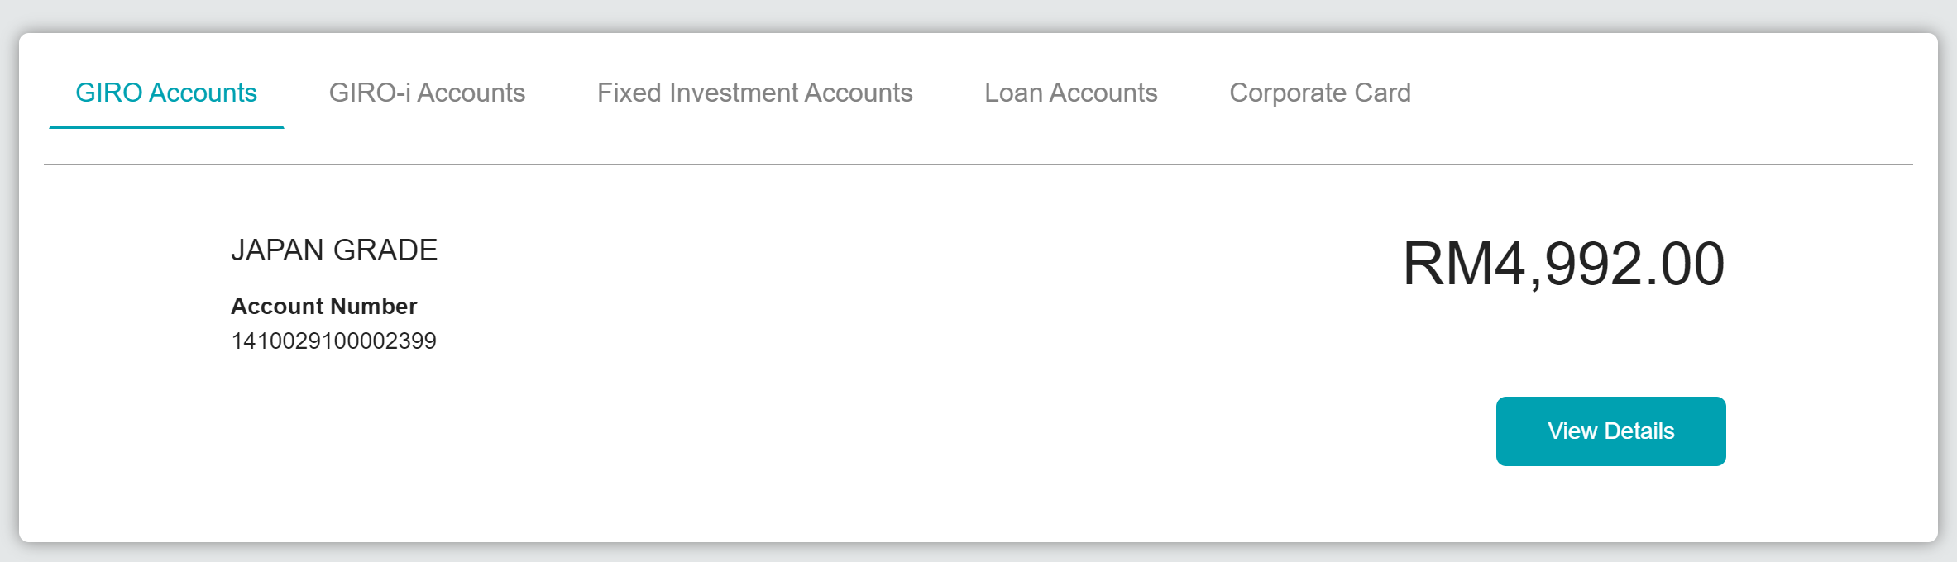

2nd scenario
Approver approved transaction and system return status accepted
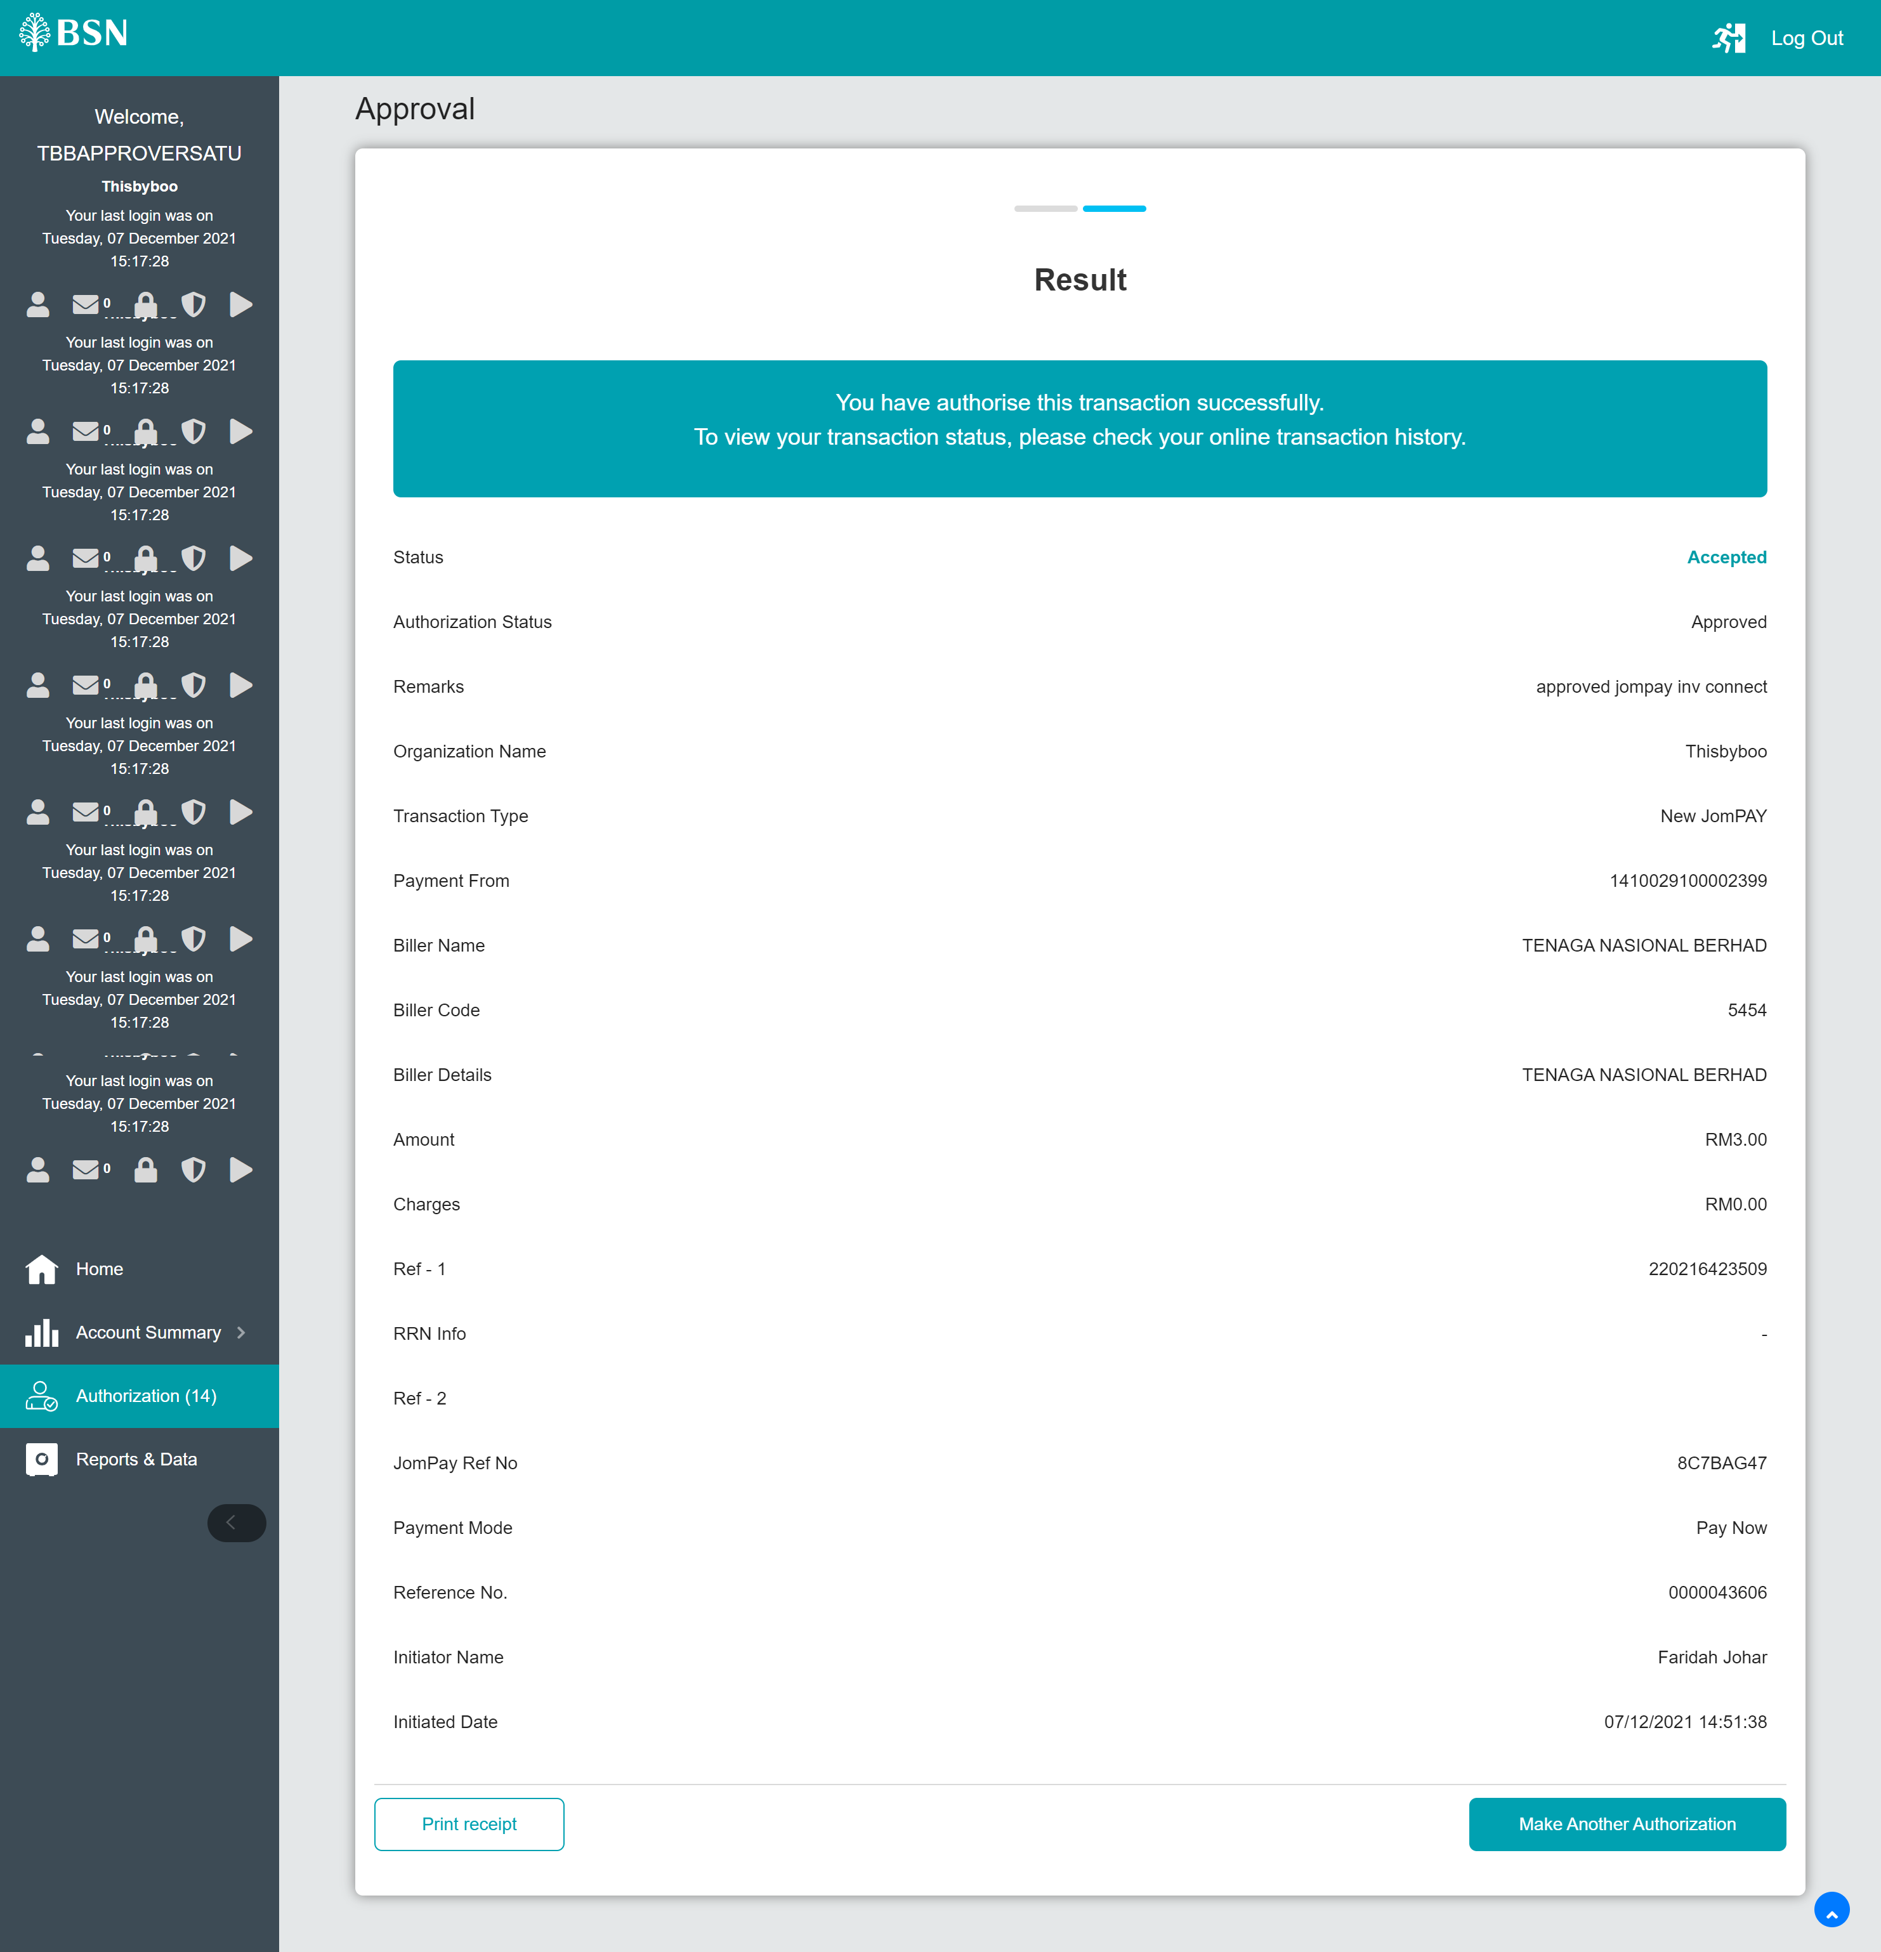

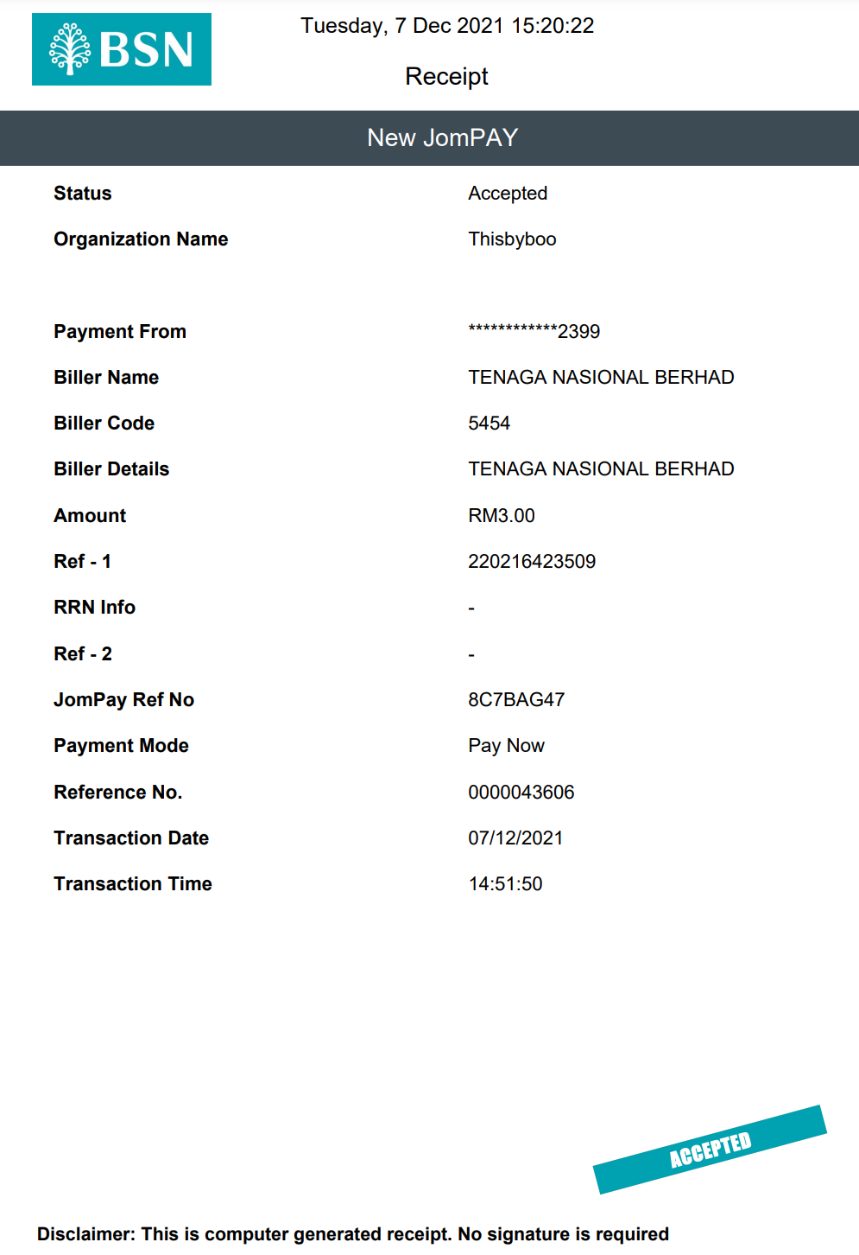
Money deducted
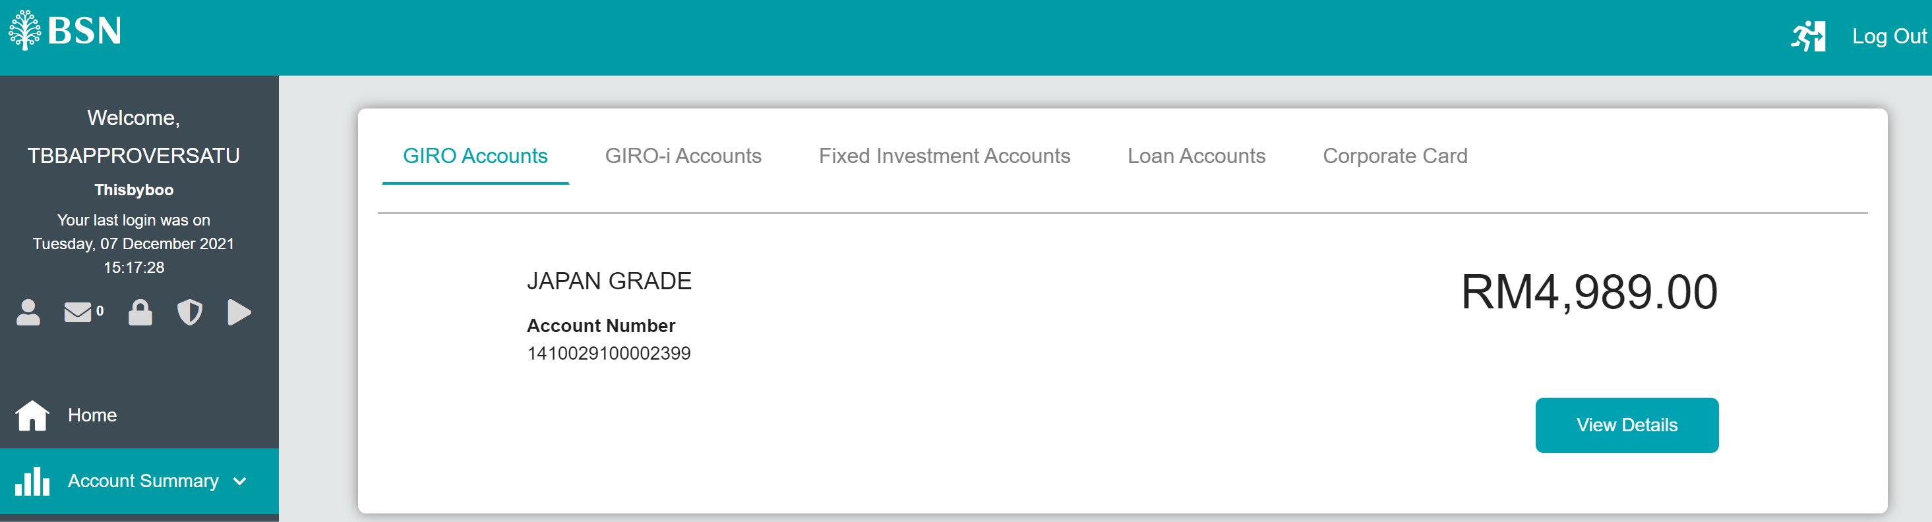

After 15 mins, status changes to successful
