REQUEST TITLE: Customisation for Maxis PINLESS
REQUESTOR DETAIL
System : BVMC

Requested by : Sharon Lai Signature: …………………………………

Reviewed by : Malarvili Muniandy Signature: …………………………………

Department : PDM

Date Request : 8 Sep 2010
REQUEST DESCRIPTION

No | Item | Description
1 | OBJECTIVE of the Project / Enhancement | - Customise Maxis Prepaid to cater for PINLESS request.
2 | General Overview | - To customise Bill Account Number in BVMC for front end (CIB & BIB) to cater for Maxis Prepaid PINLESS, behavior is similar to Bill Account Number for Bill Payment. Bill Account Number field will be mandatory for MAXIS only.  - Front end IB will prompt error message: “Maxis Mobile Number is required” if customer leave the field empty.  - For contingency purposes (PINLESS is down), user will be able to set the Bill Account Number field as NOT REQUIRED in BVMC, and system will still provide the PIN to customer.
3 | Proposed Process Flow | Prepaid Top Up  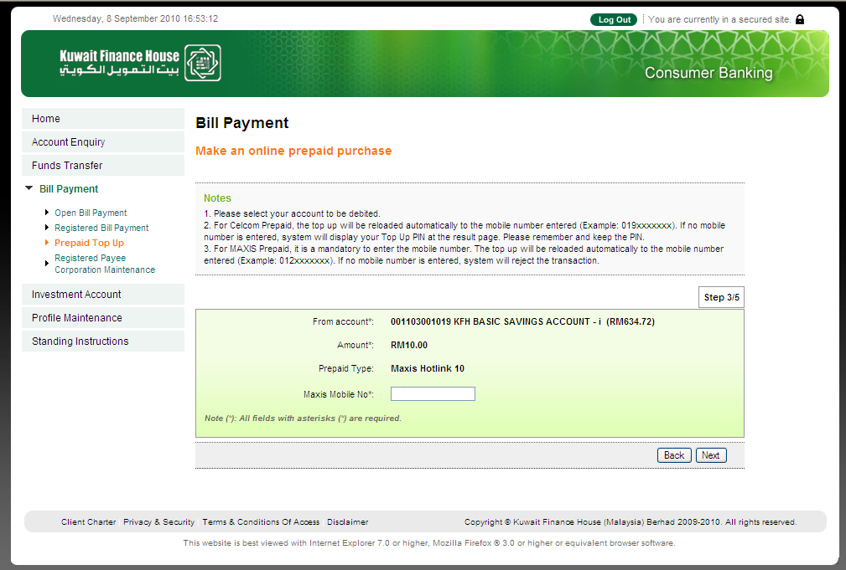  If customer leaves the Maxis Mobile No field empty and clicks Next, should prompt error message  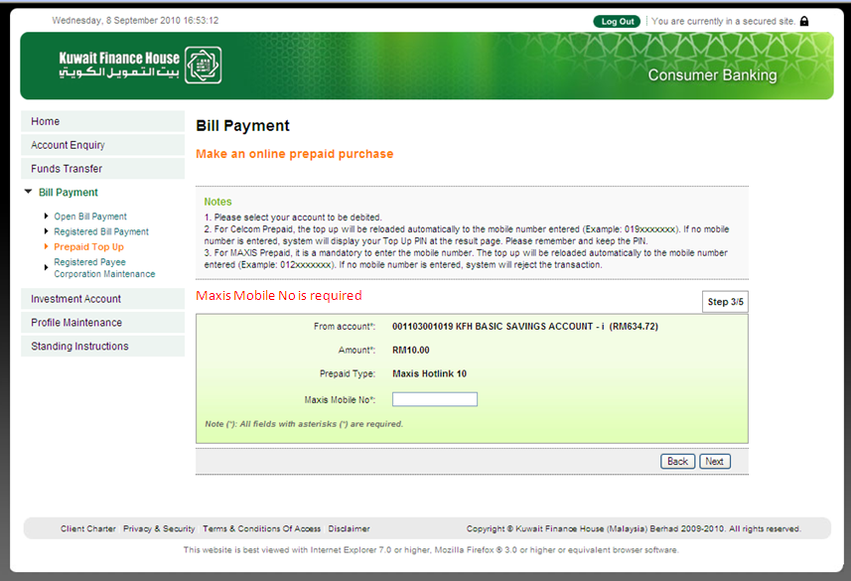  During contingency, user can set Bill Acc No Required to NO and system can still proceed to provide PIN request.  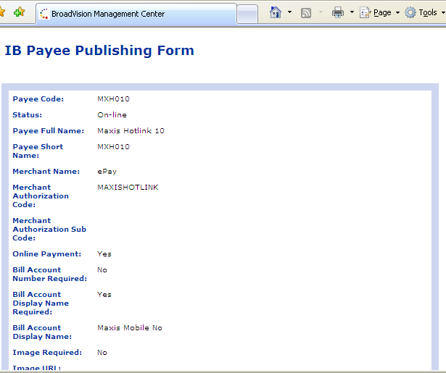  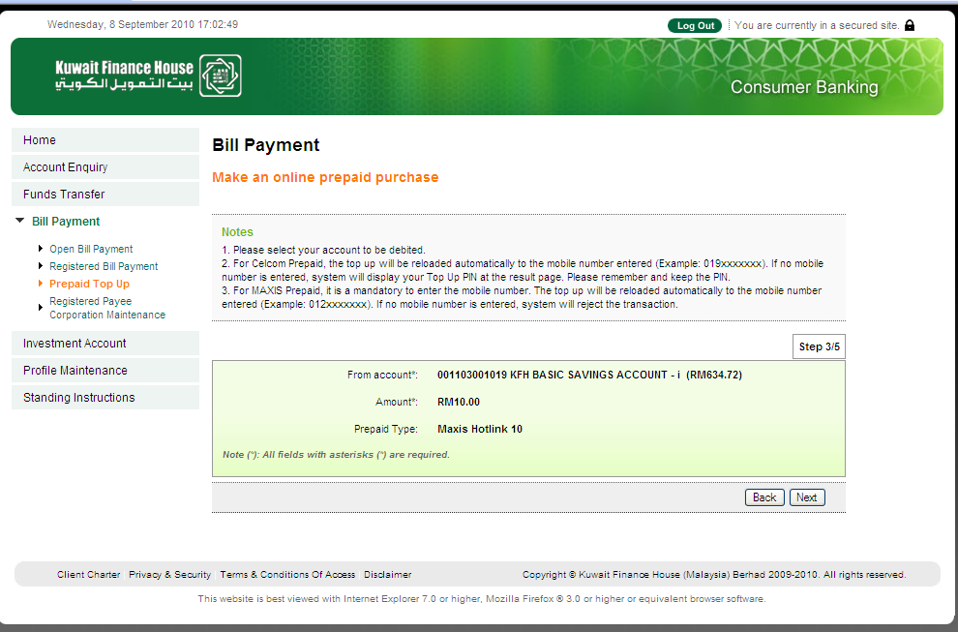  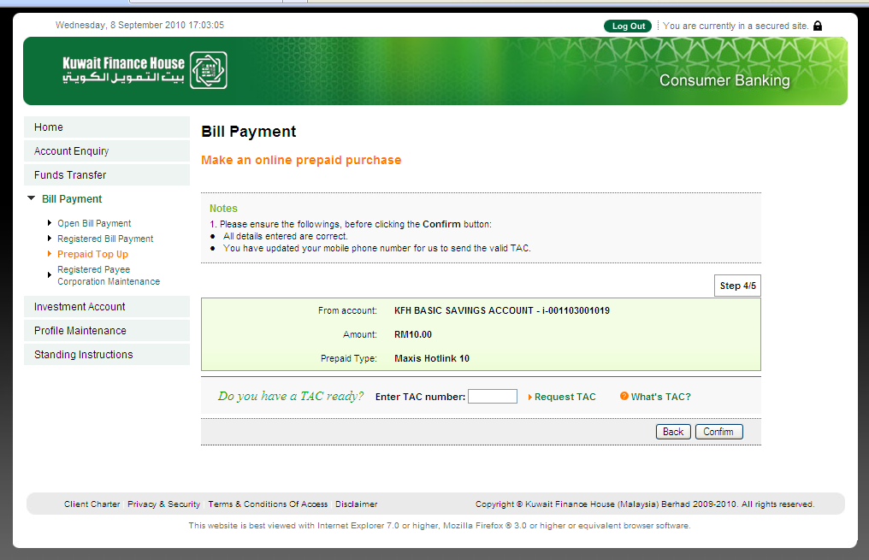
4 | Charges | N/A
5 | Features / Functions
6 | Screen and Design (Include Notes / Messages)
7 | Reports (new / enhancement) and samples | To generate a new report specifically for Maxis only in BVMC  1. Combine transaction from CIB & BIB  2. File name to be KFH Remittance Report yyyymmdd (T+1).  3. Only display successful tranx  4. Filter to display tranx with hp #, need not display tranx with NIL HP#  5. Add Channel at last column - default to 'IB'  6. Add 'Nett Payable (IB - 2%)' with amount (Total deduct 2%)  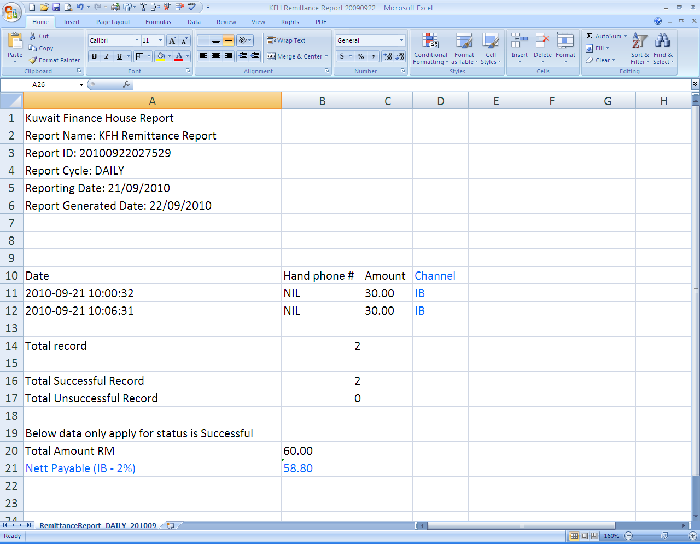
8 | Audit Trails | Yes
9 | BVMC Changes / Enhancements | To explore as per Item 2
10 | Back-end processes / enhancements
11 | ATM / OTC | NA
12 | Timeline | ASAP
13 | Exceptional Handling | As per Item 2.3 (contingency)

