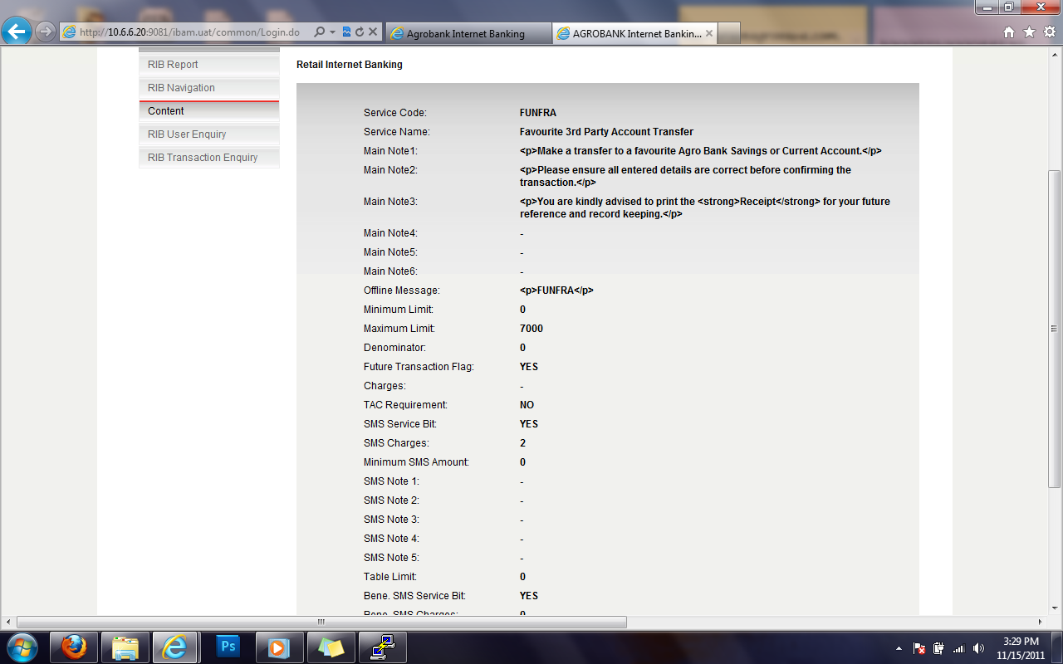

The New Limit is change to RM 7,000 but the current limit still remain RM 5,000

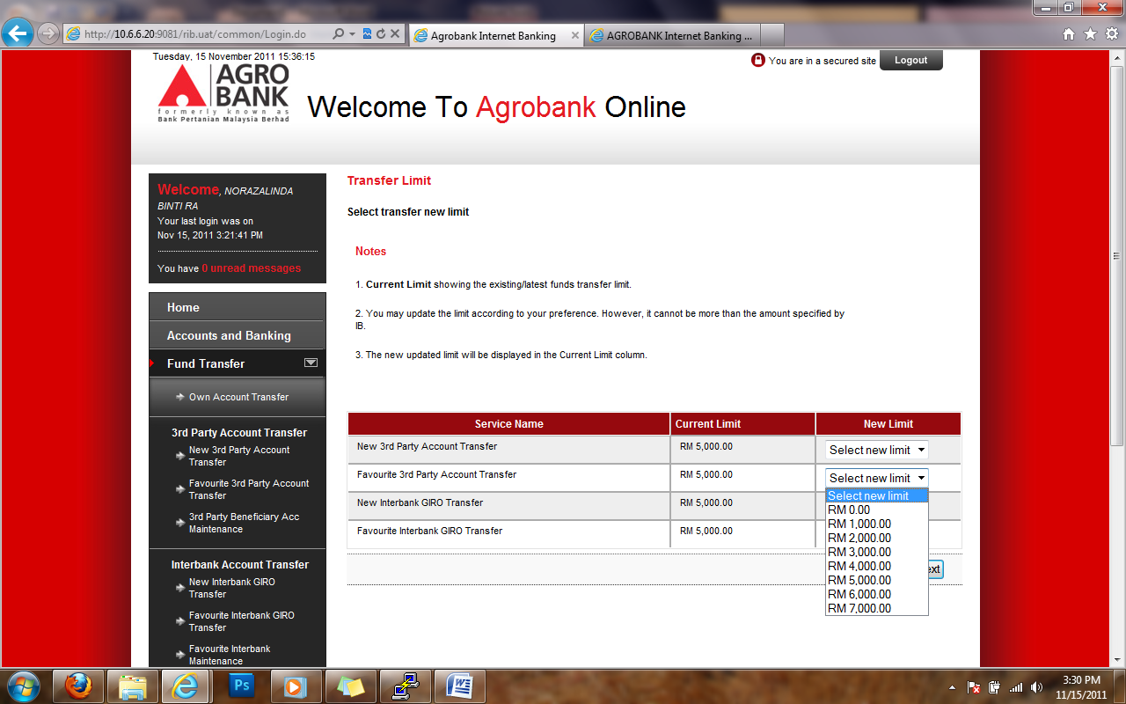

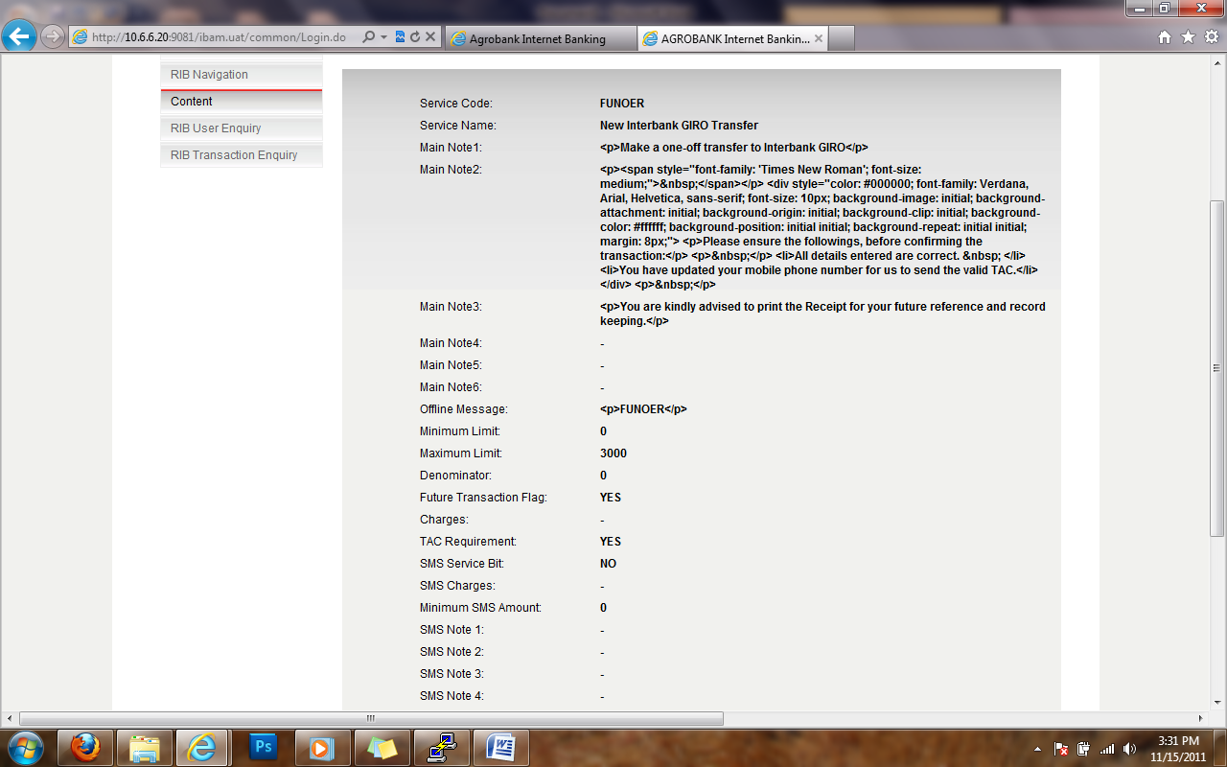

The New Limit is change to RM 3,000 but the current limit still remain RM 5,000

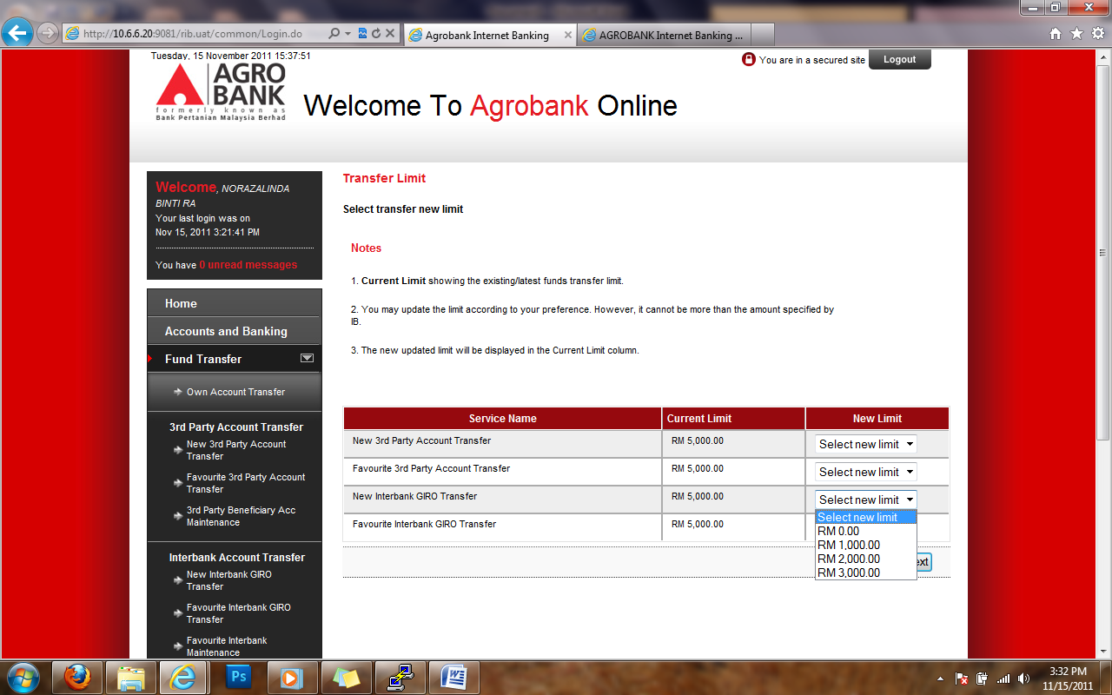

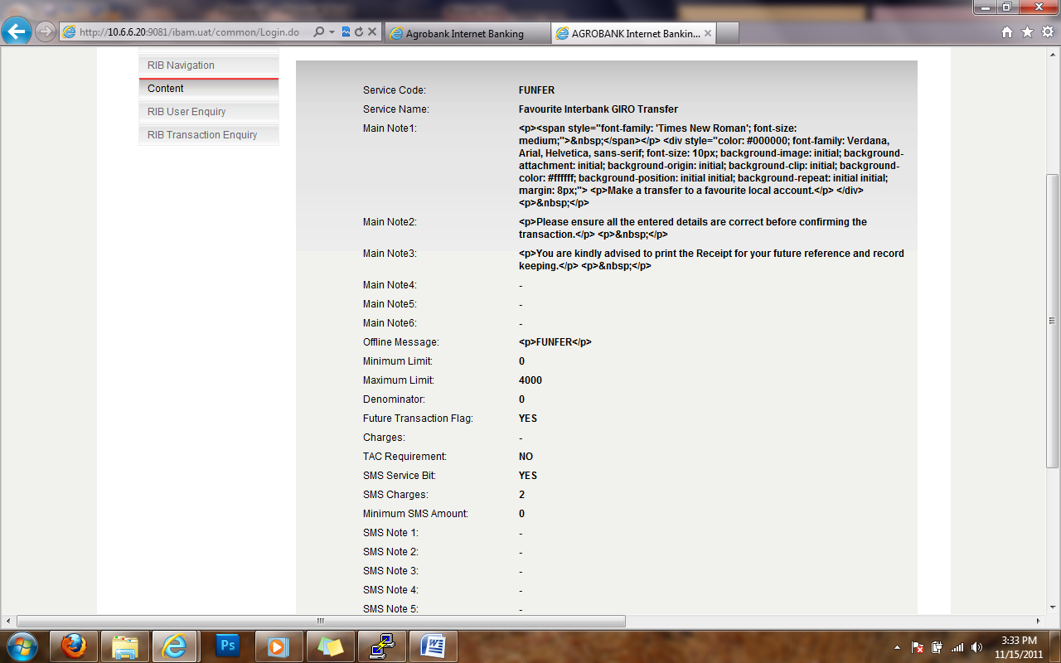

The New Limit is change to RM 4,000 but the current limit still remain RM 5,000

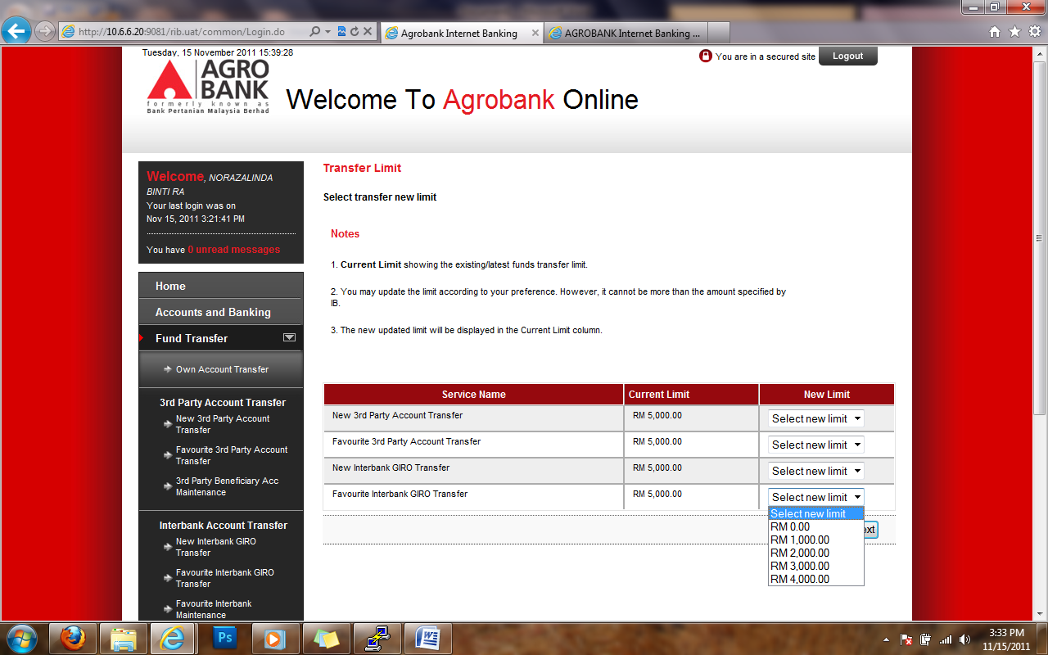

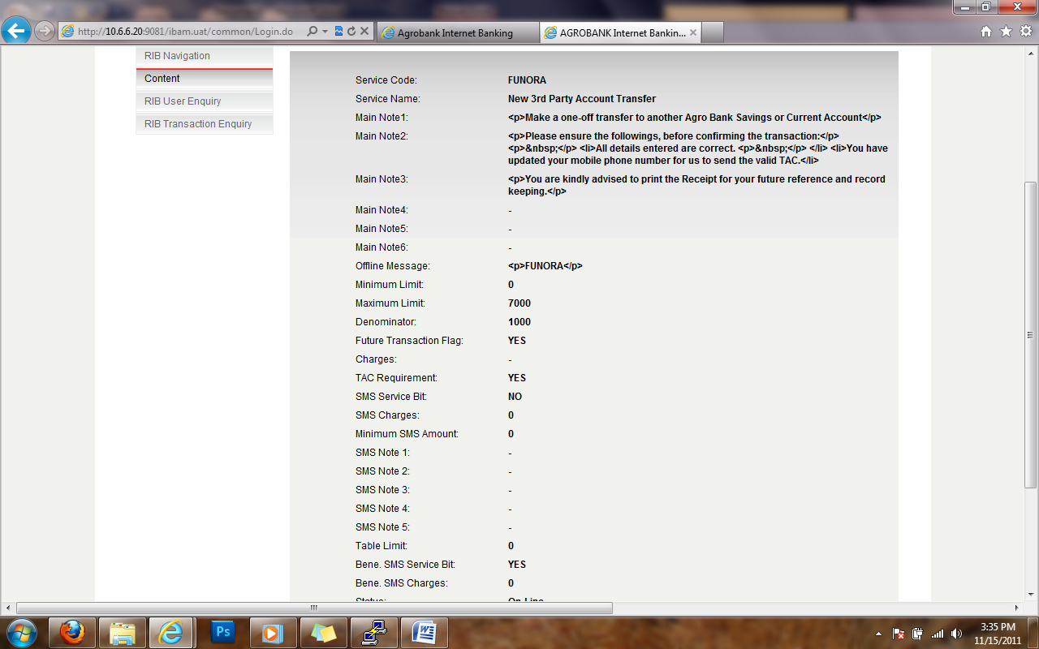

But for New 3rd party account transfer the current limit change to RM 7,000 but it affected to all account transfer

