Change Control Form
Project Name: | BIFAST | Change Number:
Project Manager: |  | Project Number:
Submitted By: |  | Change Title:
Date Submitted: |  | Product:
Customer: | Bank Indonesia | Customer Contact:
Project Phase: | Implementation | Project Type:

Description of Change
BIFAST Portal CBS Balance Sync Adjustment
Business Justification of Change
- Minutes of Meeting No. 22/50/DPSP-GPSP/Rsl/B
- Memorandum No. 22/476/DPSP/M.01/B
- Memorandum No. 22/1723/DPSI-GPSI/M.01/B
- RPS 29 November 2021
- RDG 30 November 2021
- Minutes of Meeting 5 January 2022
Business Requirements of Change and assumptions
This is the process of synchronizing the balances from all participants (direct and indirect participant), over the last reporting period, as well as synchronizing the summary information of Participants' activities with respect to transactions processed.
- Daily Balance Synch to CBS
It is required to post daily (based on schedule in BIFAST Portal) a MT998 containing MT202 records to CBS that contains records for each Individual Participant (Direct and Indirect Participant) either Bank and Non-Bank covering the activities since previous day until current day that parameterize in BIFAST Portal.
MT202 format and filename same as current state.

- Balance Position report, to be sent to App Recon and CBS
It is required to post daily (based on schedule in BIFAST Portal) a MT998 containing MT941 records that contains contains records for each Individual Participant (Direct and Indirect Participant) either Bank and Non-Bank covering the activities since previous day until current day that parameterize in BIFAST Portal.
MT941 format and filename same as current state

Technical Requirements of Change
Current Condition:
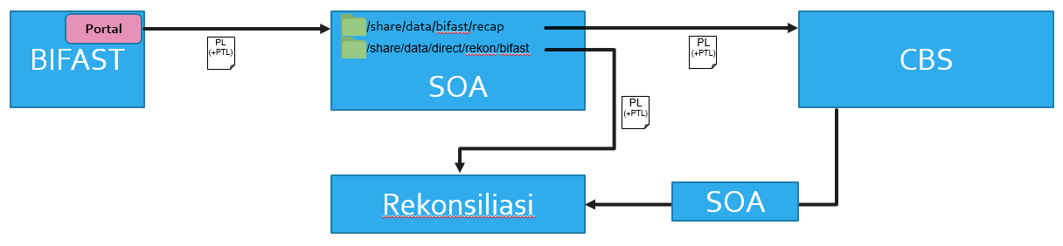
Future Condition:
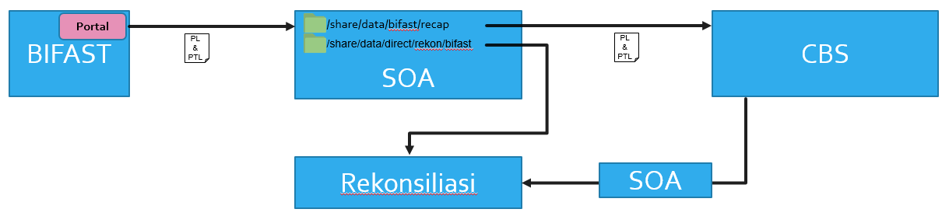
Records contains each Individual Participant (Direct and Indirect Participant) either Bank and Non-Bank covering the activities since previous day until current day that parameterize in BIFAST Portal.
Development Analysis of Change
(please assessment from ACI/PTAP)
Assumptions/Restrictions/Other Comments
(please assessment from ACI/PTAP)

Impacts to Other Projects

- SOA (Direct from BIFAST)
- CBS (Data Input from SOA)
- Reconciliation (Data Input from SOA)
- EDW KI (Data Input from CBS)
- GMMP (Data Input from EDW KI)
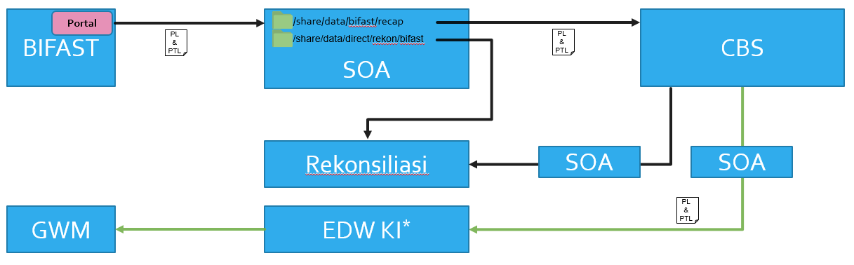

Contract Impacts
Original Services Contract Attachment: |  | Original Project Number/Name:
Original Contract Value: |  | New Project Number:
Type of Service: |  | Pricing Basis:
Currency: |  | Non-Standard Payment Terms:

Support Impacts
CSM Support Contracted: |  | Monthly Cost of Support:
Original Contract Attachment: |  | Support Terms (# of Months):
Support Fee Initiation Date: |  | Original Contract Value:
New Contract Value: |  | Currency:

Project Role | Approve/Reject | Signature | Date
Project Manager
Overall PM
Technical PM
ACI WORLDWIDE (IRELAND) |  |  | PTAP
By: |  |  |  | By:
Name: |  |  |  | Name:
Title: |  |  |  | Title:
Date |  |  |  | Date:

