**ISSUE AUDIT LOG – SEND MESSAGE**

1. Create new notification – approve

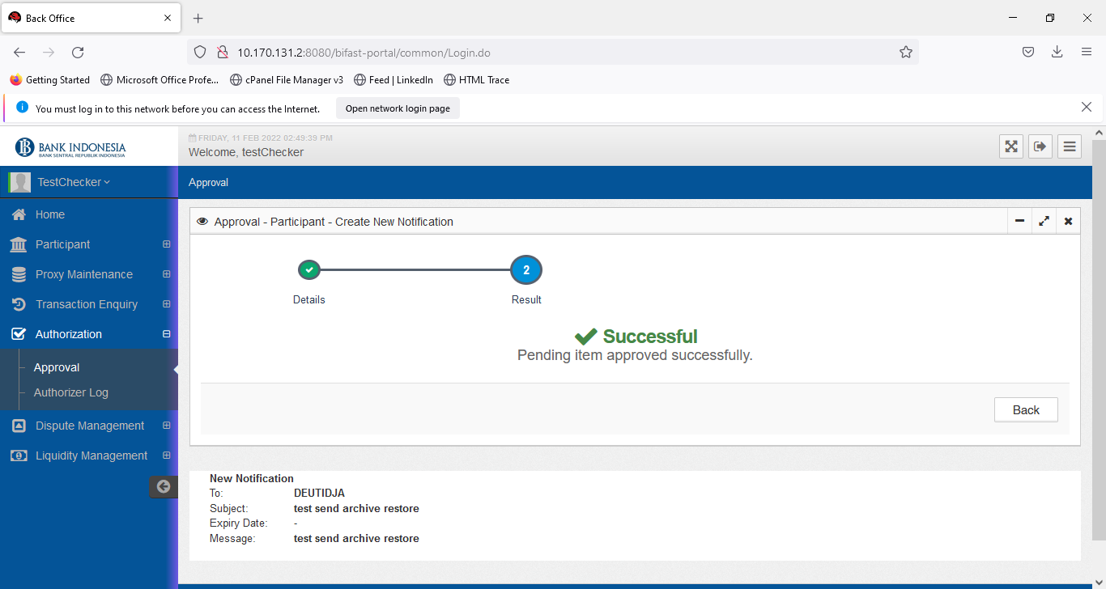

1. Check Audit Log

There is two audit log record on participant Activity title on Activity Column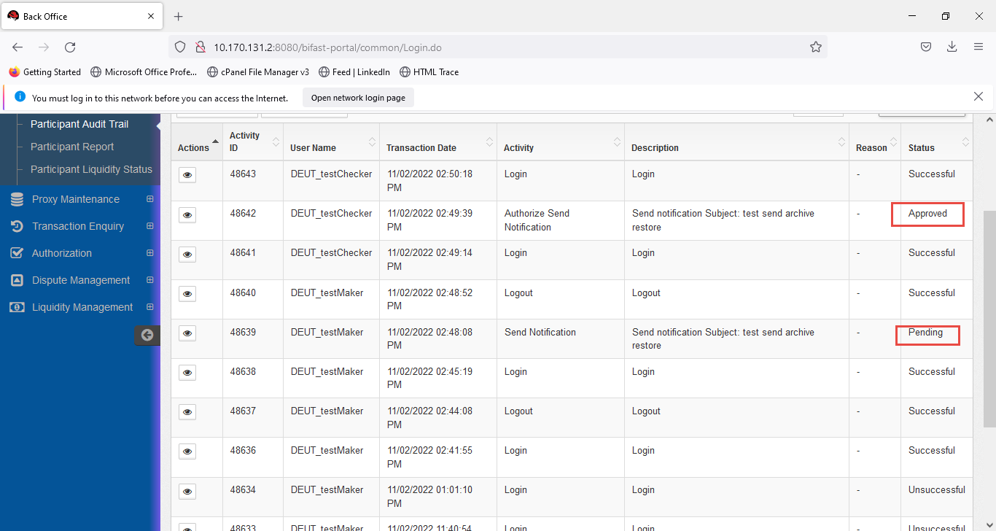

On Participant Audit Trail :

* Audit log for send notification is not empty on activity column (authorize send notification and send notification)
* There is drop down in input drown down activity for authorize send notification and send notification)

**ISSUE AUDIT-LOG ARCHIVE MESSAGE**

1. Archive notification

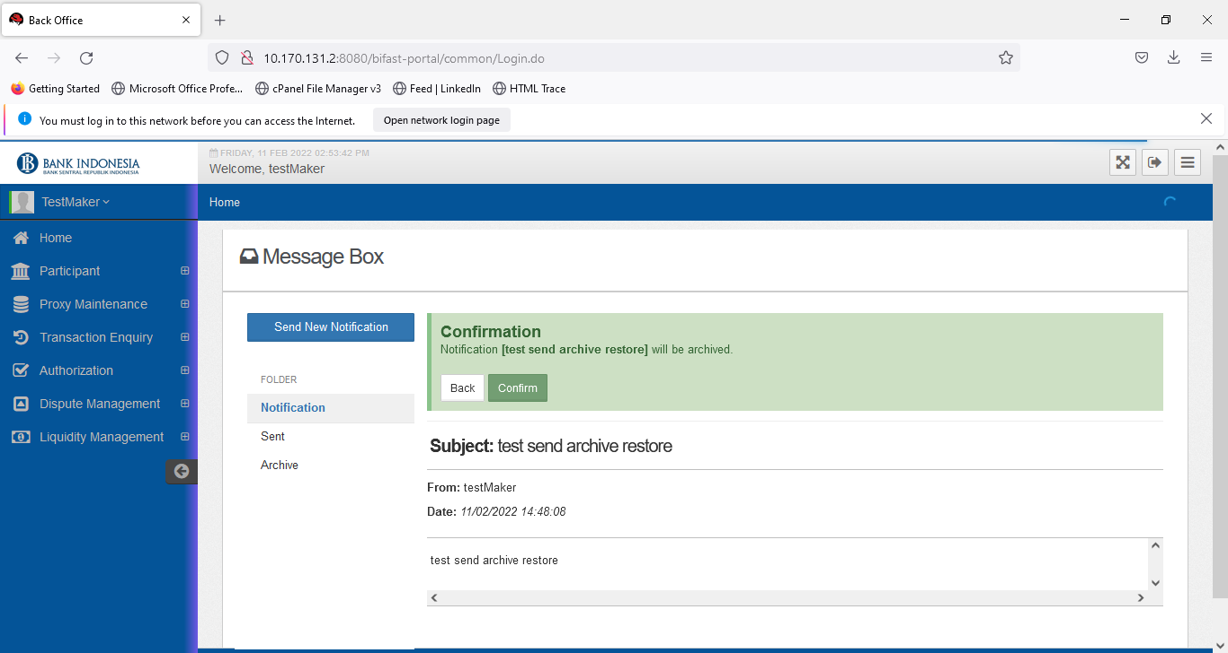

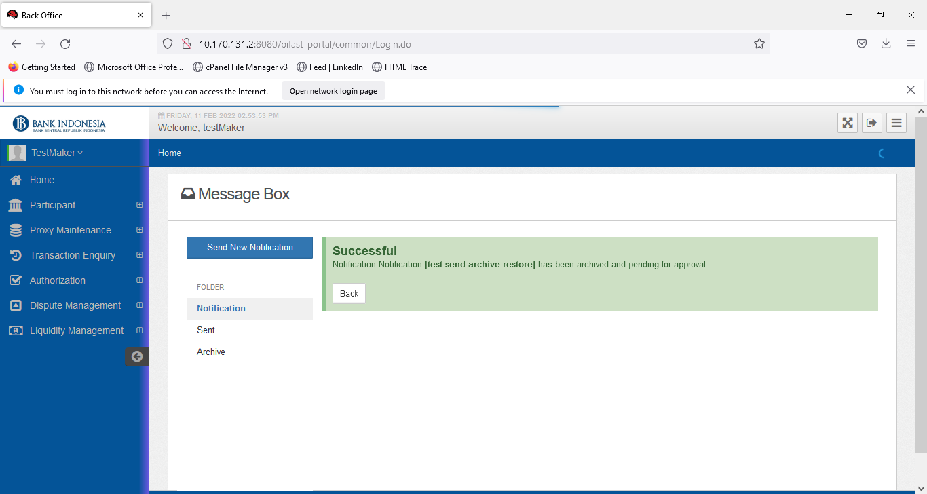

1. Approve

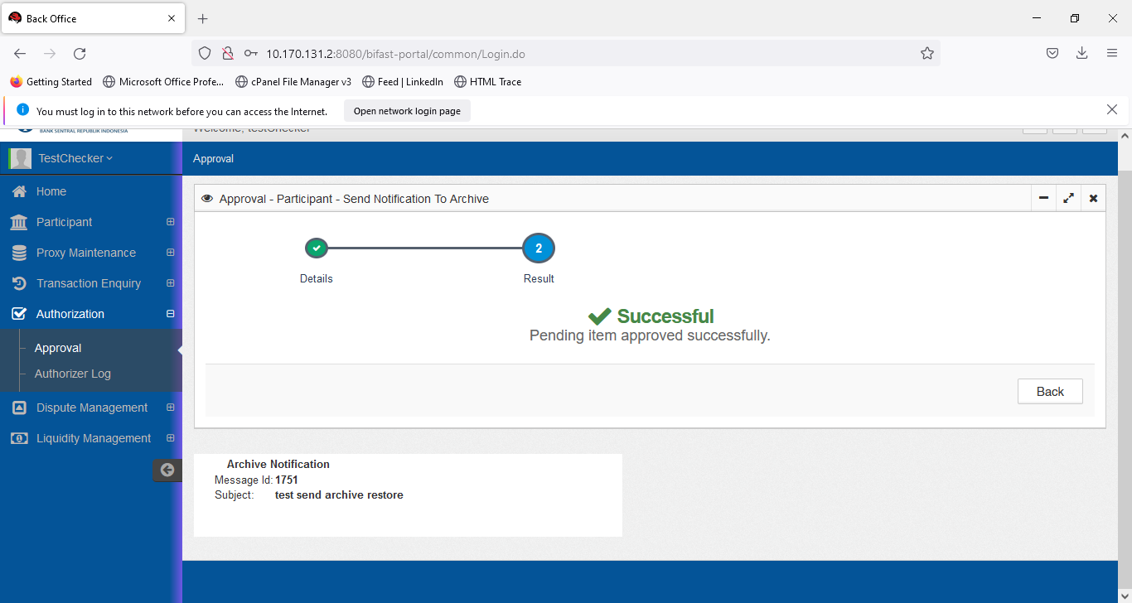

3. Check participant audit log

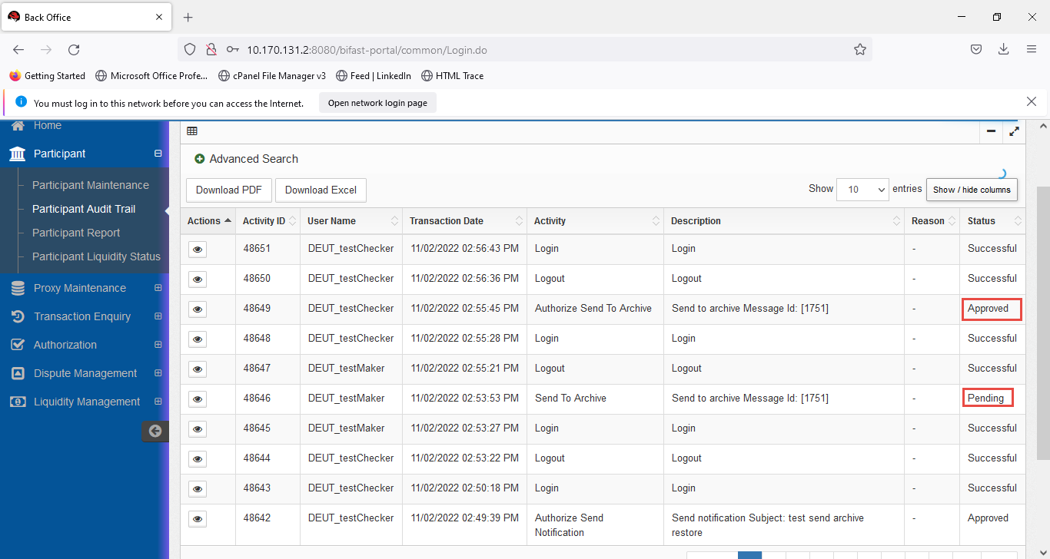

On Participant Audit Trail :

Expected result

* Have ‘authorize’ send archive message record on participant audit trail inquiry
* Audit log for send notification is not empty on activity column for send archive message
* Have drop down send archive message and authorize send archive message on activity drop down

**Issue Message Box – Restore**

1. Restore notification

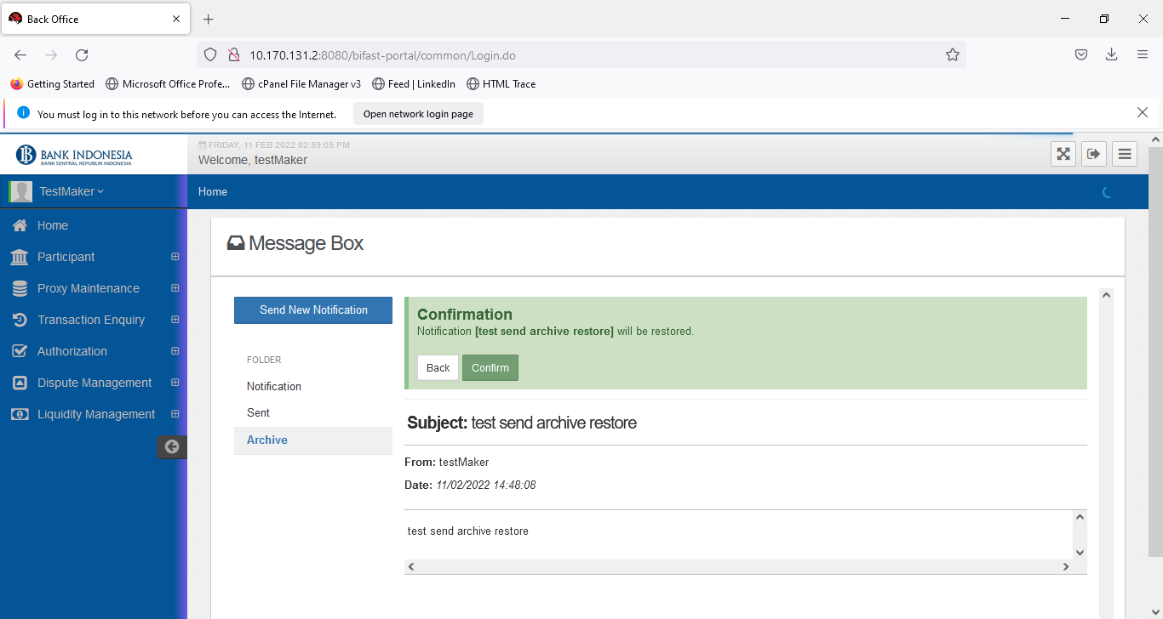

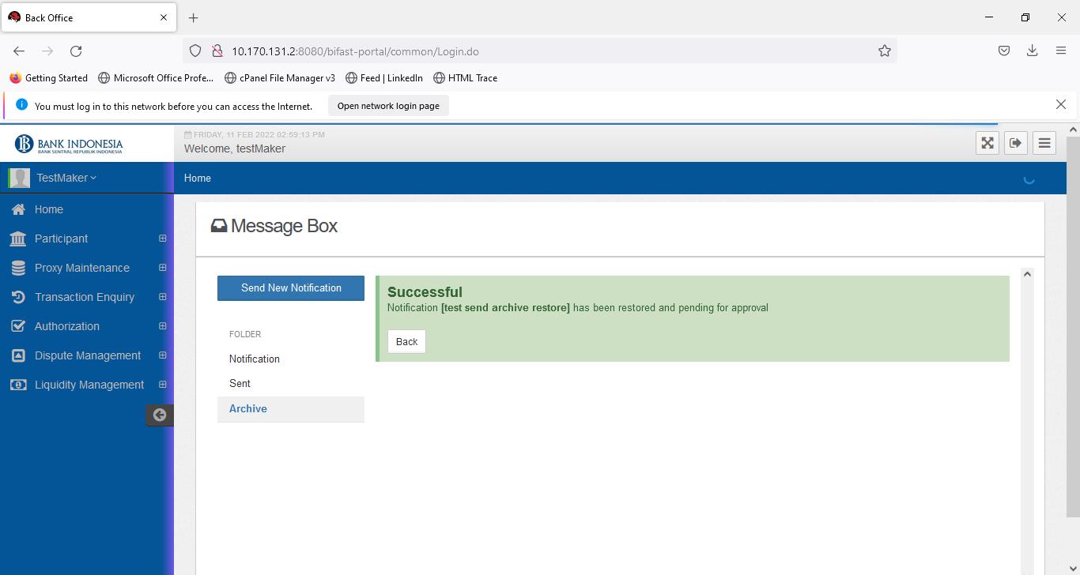

1. Approve

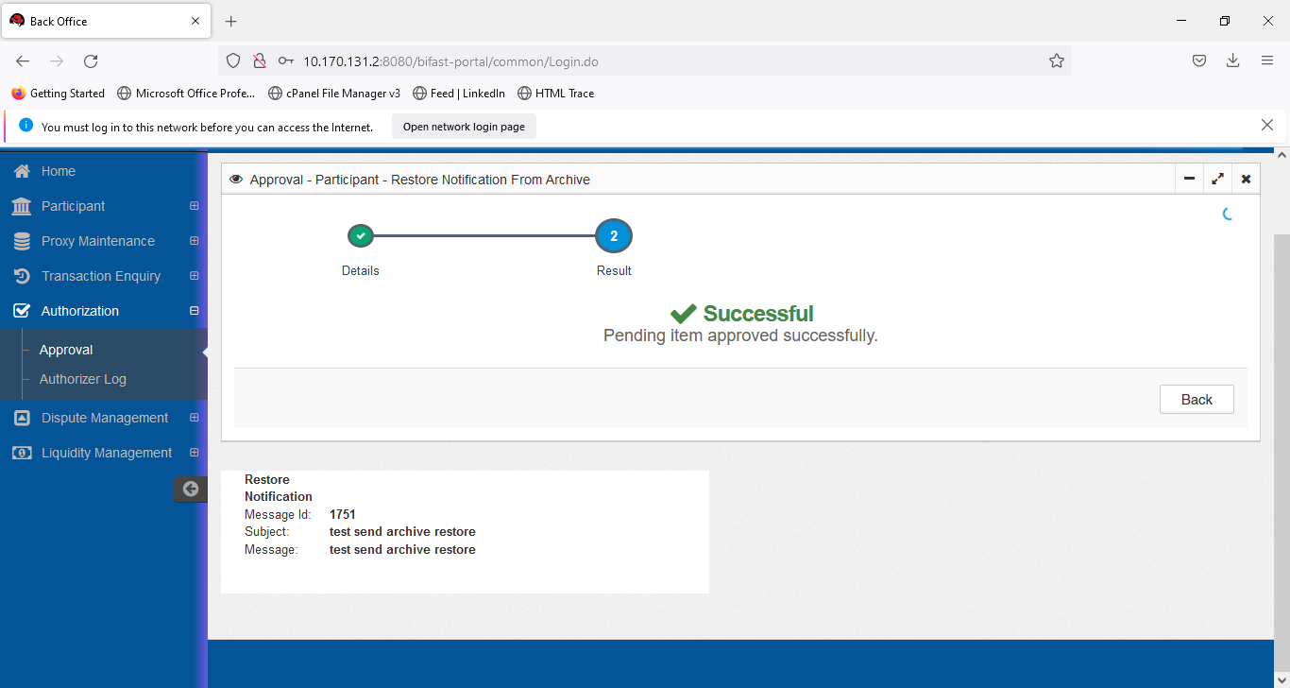

1. Check Participant audit log

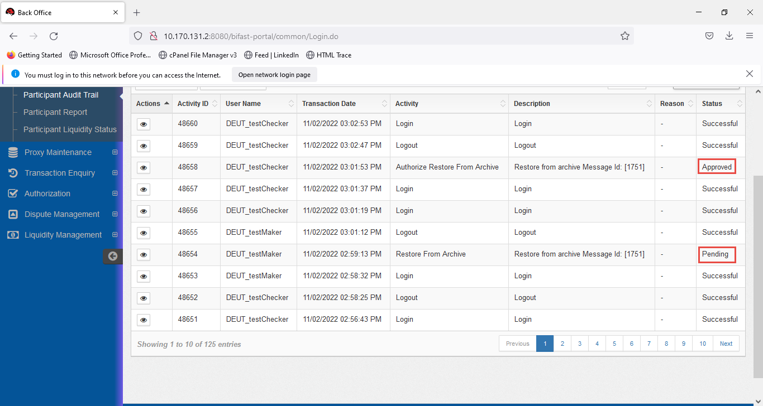

On Participant Audit Trail :

* Have ‘authorize’ send Restore message record on participant audit trail inquiry
* Audit log for send notification is not empty on activity column for send Restore message
* Have drop down send Restore message and authorize send archive message on Restore drop down