**Kuwait Finance House (Malaysia) Berhad**

**Business Internet Banking System**

**Business Requirement Specification (BRS)**

**Secured Mailbox**

10 May 2010

Reference: KFH/KFH20100409/BRS/SMB1.0

**Prepared By:**



Penril Datability (M) Sdn Bhd (384550-U)

Suite A-07-07 Plaza Mon’t Kiara

No. 2, Jalan Kiara, Mon’t Kiara

50480 Kuala Lumpur, Malaysia

Tel: (603) 6201 2622 Fax: (603) 6201 7622

**Document Administration**

**Document Amendment Log**

|  |  |  |  |  |  |
| --- | --- | --- | --- | --- | --- |
| **Version No** | **Date Updated** | **Description of Change** | **Updated By**  **<Name, Dept>** | **Reviewed By**  **<Name, Dept>** | **Approved By <Name, Dept>** |
| 1.0 | 01/04/2010 | Initial Release | Shuhaida, Ayu |  |  |
| 1.1 | 07/07/2010 | Add Subject Management section | Tan Lee Yong |  |  |

# Secured Mailbox Subject Maintenance

### Process flow

***Step 1:***

1. User access Secure Mailbox screen.
2. CORUS System display Secure Mailbox screen.
3. User click on the Subject Maintenance tab.
4. CORUS System displays all the existing subjects
5. User click on one of the subject to go to the user listing page

***Step 2:***

1. CORUS System displays the list of users belong to this subject
2. User can add and delete user
3. User check on the Check Box(es) and click on the Delete button to delete single or multiple users
4. User can click on the Add button to add single or multiple users. See next step.

***Step 3:***

1. CORUS System displays all the CORUS user id that is not belonging to this Subject
2. User check on the Check Box(es) and click on the Add button to add the selected user(s) and then go back the Step 2 with updated user list.

### Screen Design

#### Subject Maintenance

***Step 1:***

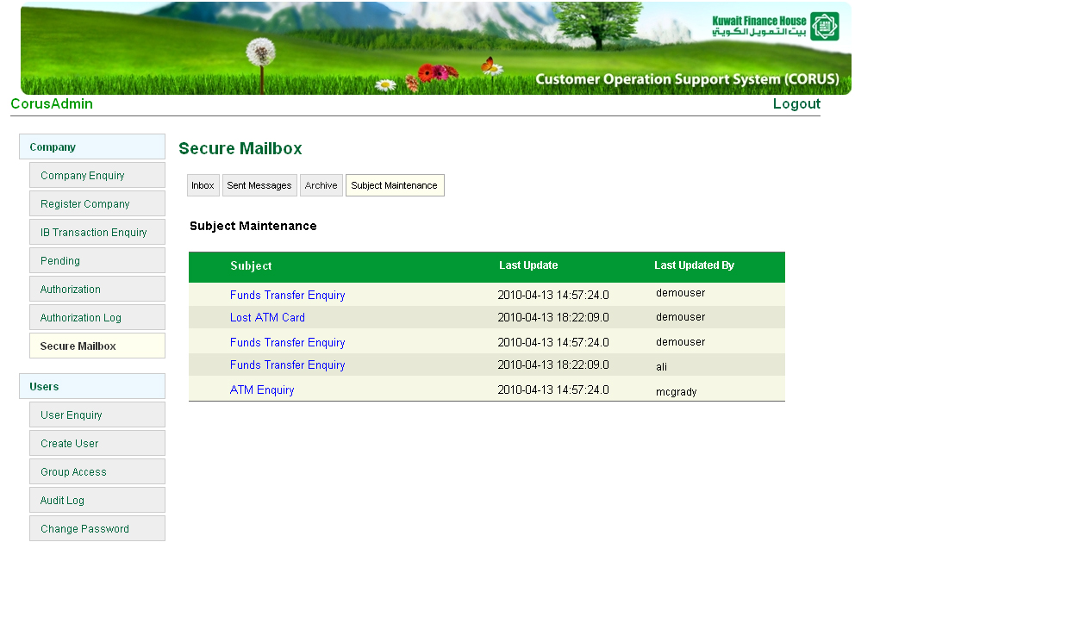

**Figure: Secure Mailbox Subject Maintenance Screen**

Field name: Subject, Last Update, Last Updated By

1. User access Secure Mailbox screen.
2. CORUS System display Secure Mailbox screen.
3. User click on the Subject Maintenance tab.
4. CORUS System displays all the existing subjects
5. User click on one of the subject to go to the user listing page

***Step 2:***

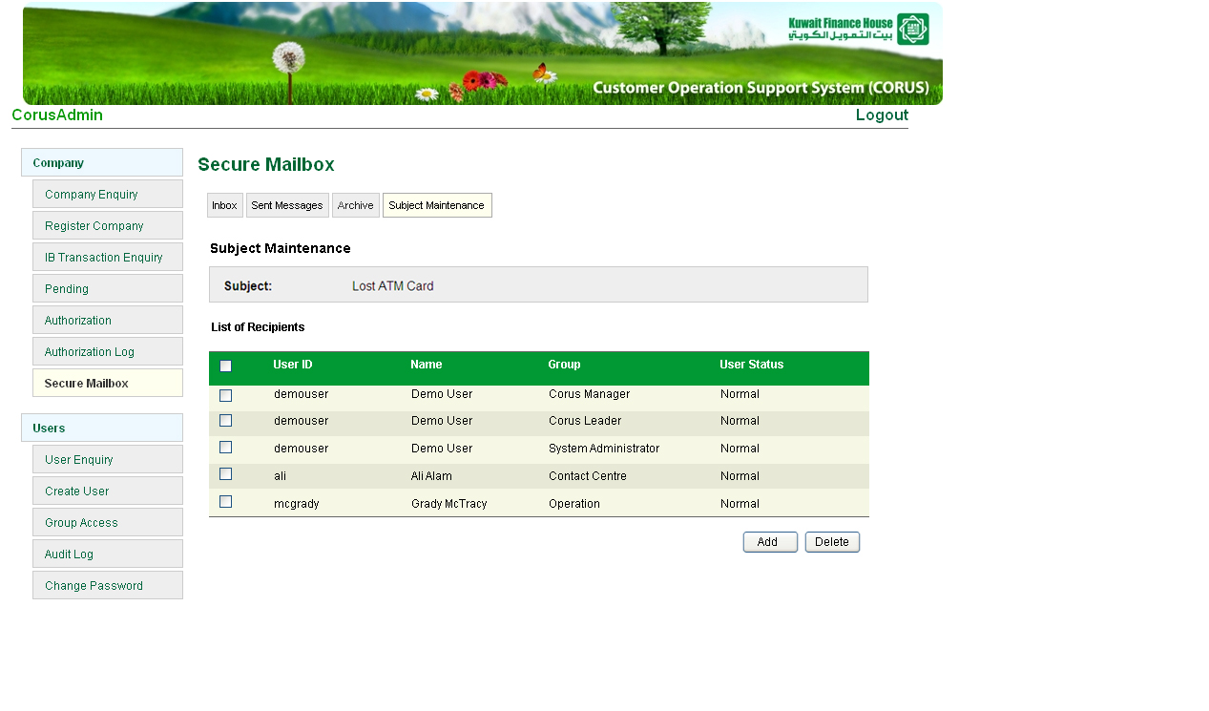

**Figure: Secure Mailbox Subject Maintenance Detail Screen**

1. CORUS System displays the list of users belong to this subject
2. User can add and delete user
3. User check on the Check Box(es) and click on the Delete button to delete single or multiple users
4. User can click on the Add button to add single or multiple users. See next step.

***Step 3:***

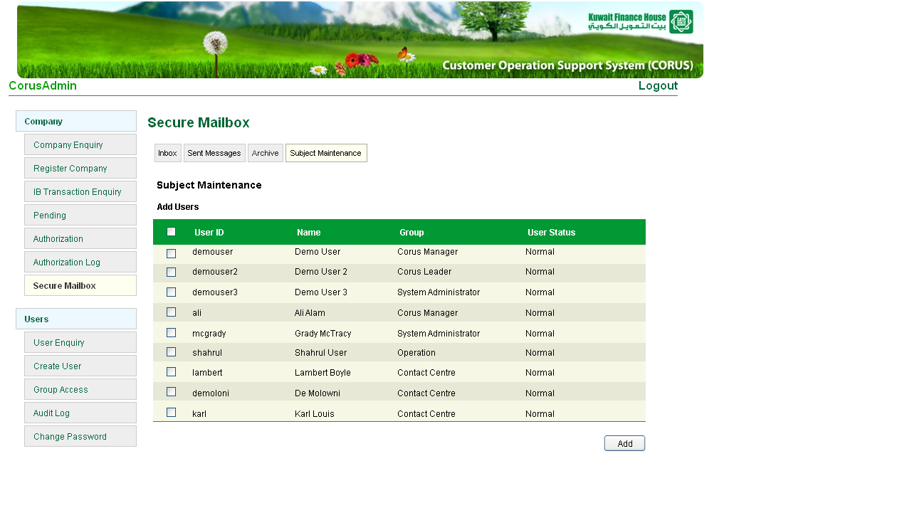

**Figure: Secure Mailbox Subject Maintenance Add Users Screen**

1. CORUS System displays all the CORUS user id that is not belonging to this Subject
2. User check on the Check Box(es) and click on the Add button to add the selected user(s) and then go back the Step 2 with updated user list.