1. Login to RIB @ 6:09pm

uatUser/aaaa1111

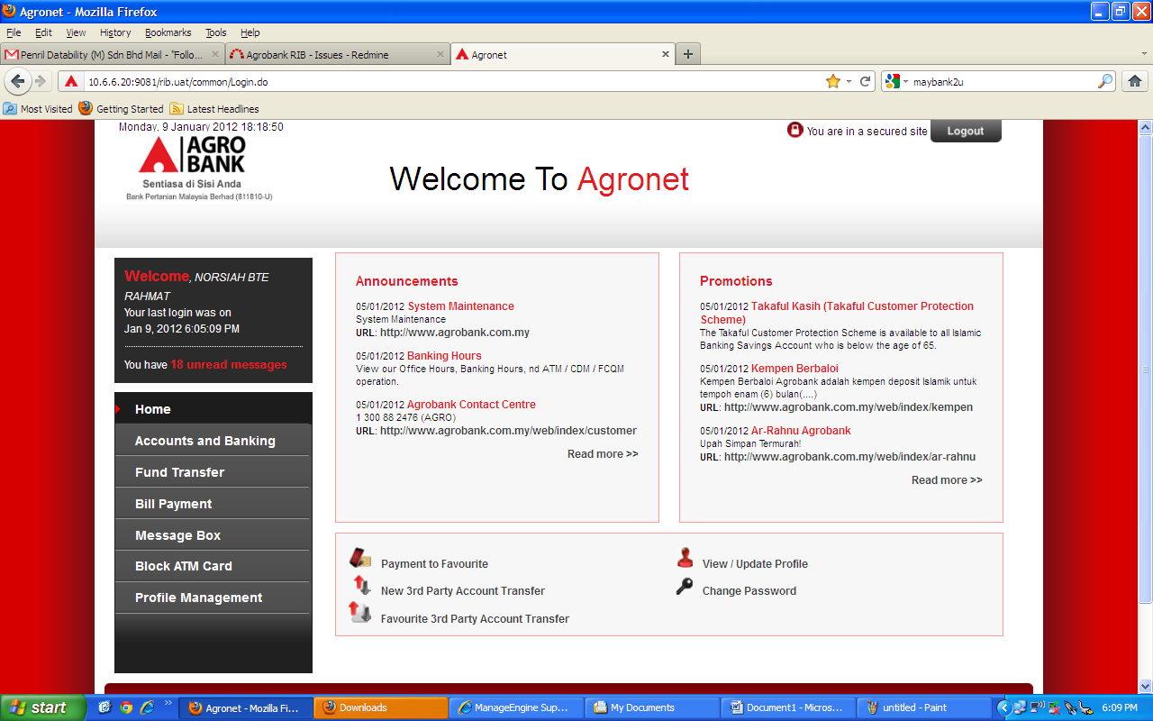

1. Warning Notification @ 6:14pm

Click on “Cancel” button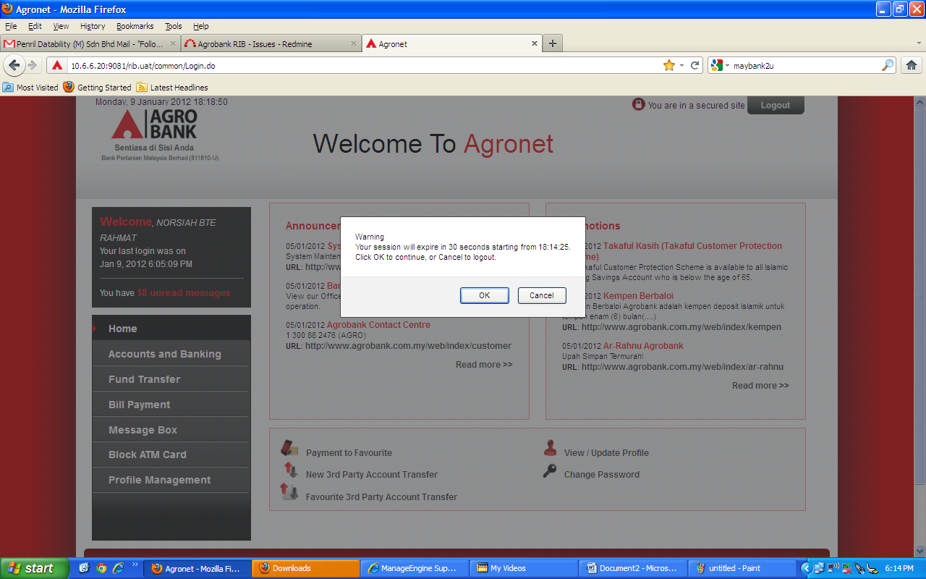

1. Logout page after click “Cancel” button @ 6:16pm

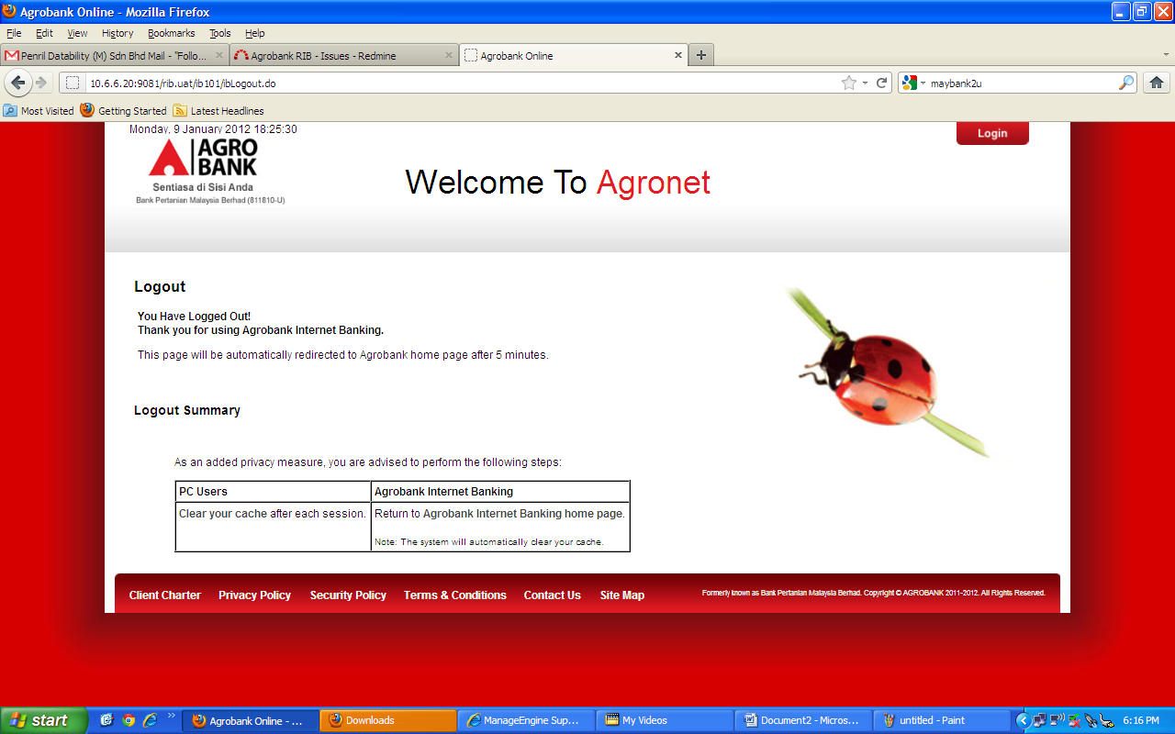

1. Error Page Exception after idle at Logout page for 6 minute.

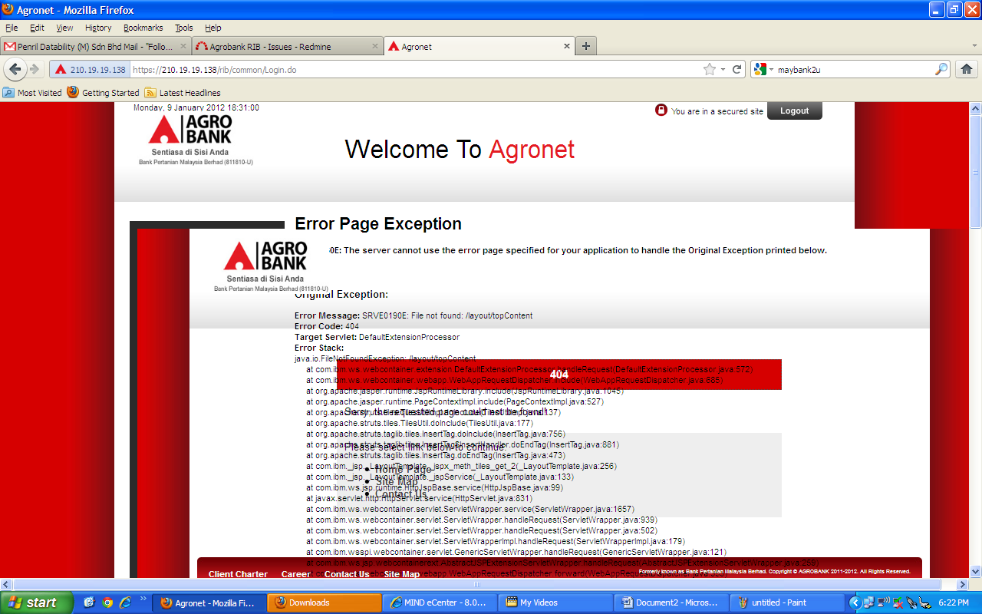

1. View in different browser (IE). Page redirect to [www.agronet.com.my](http://www.agronet.com.my) instead of [www.agrobank.com.my](http://www.agrobank.com.my)

