12938 - SCP ID-6252 - Converted EPFG file unable to upload to Portal
- Entered long organization name
- Entered all required field
- Save file
- Review file length
SKDG
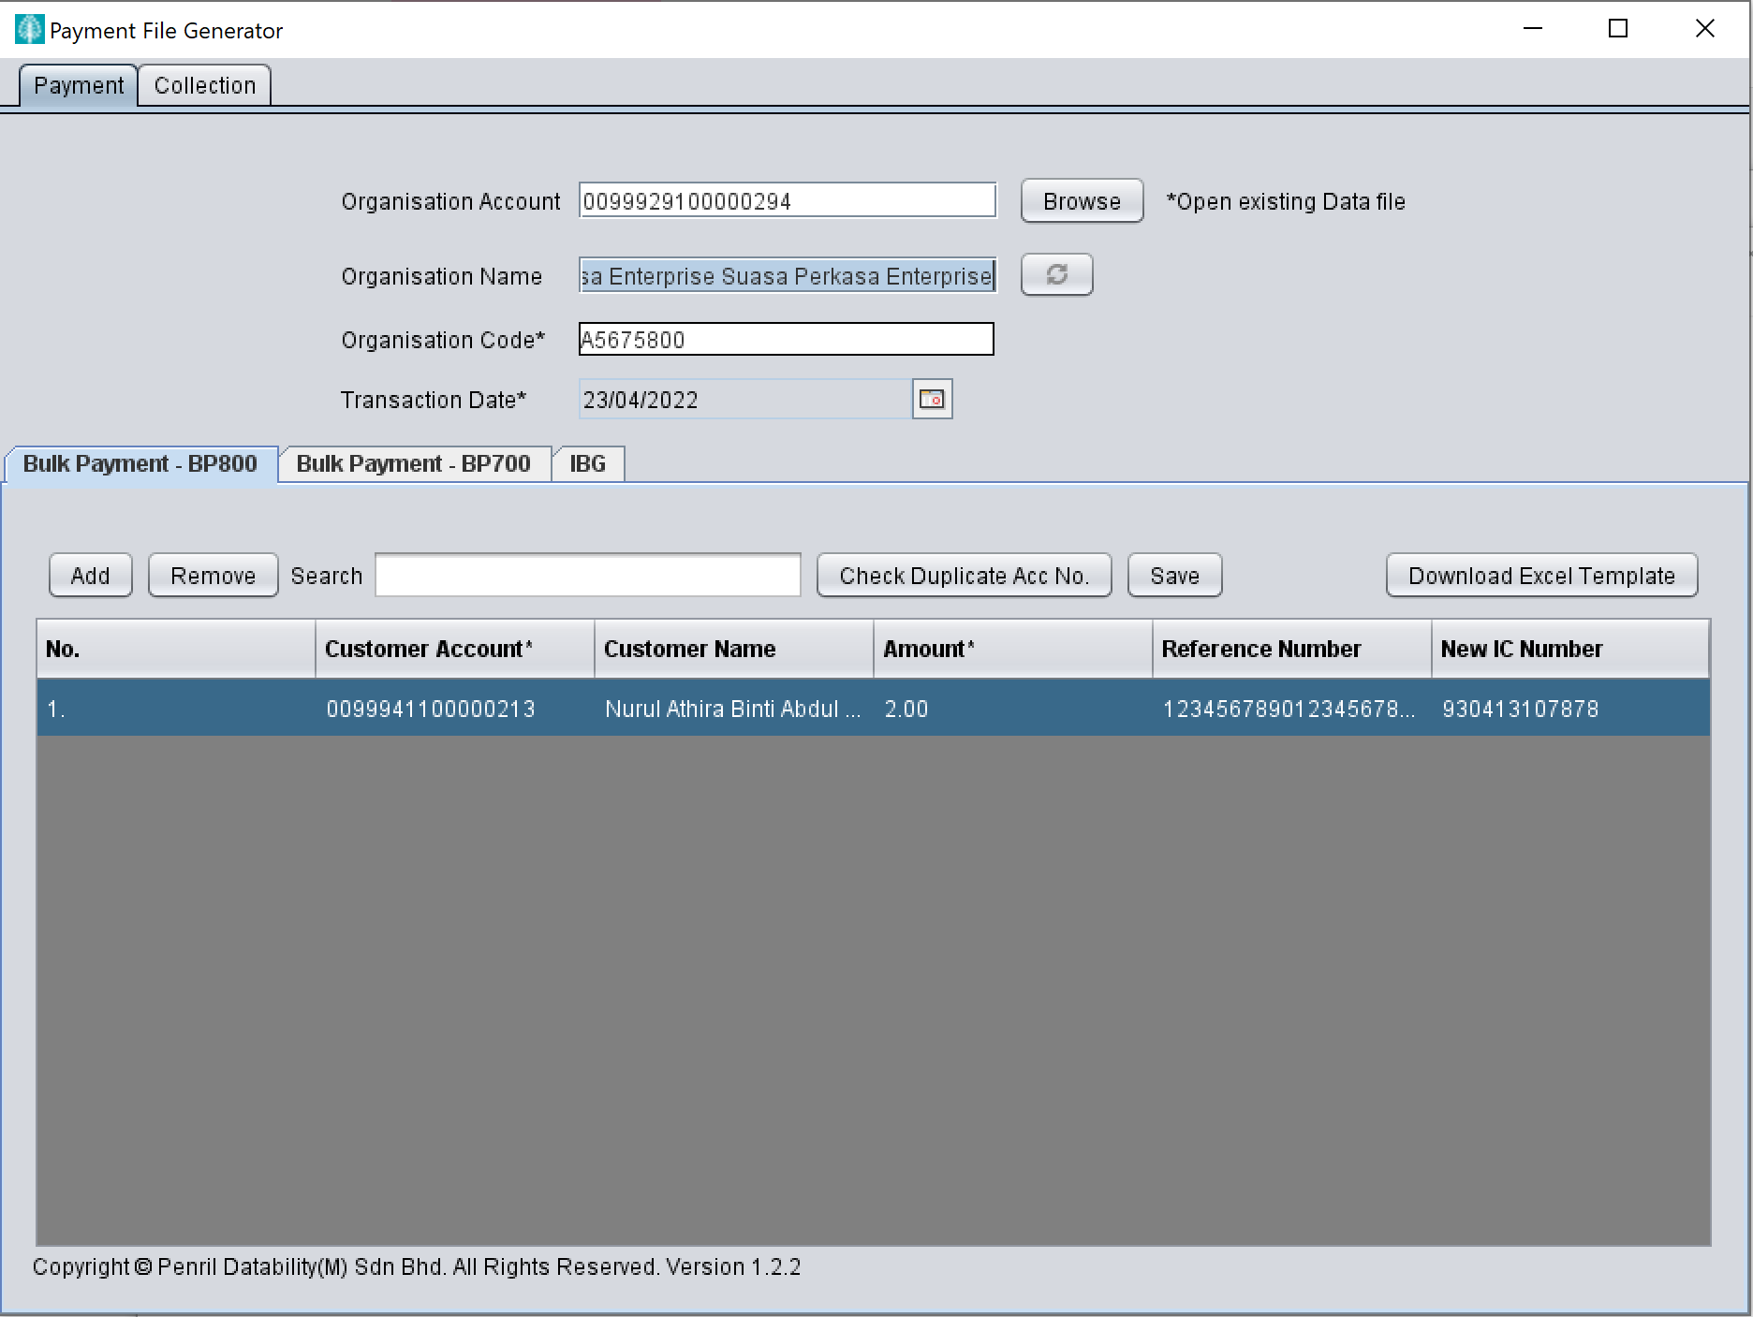

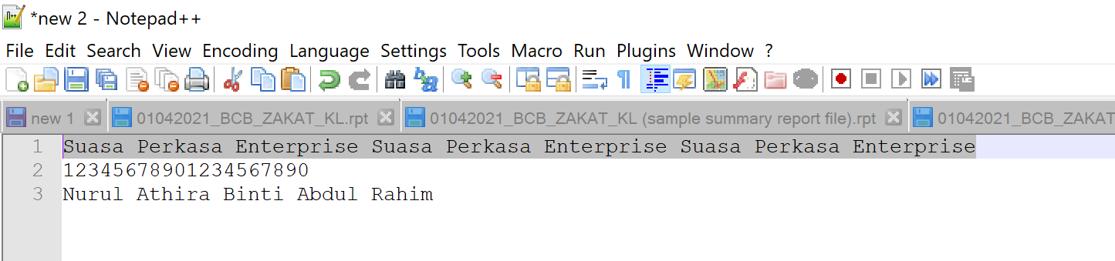

File length
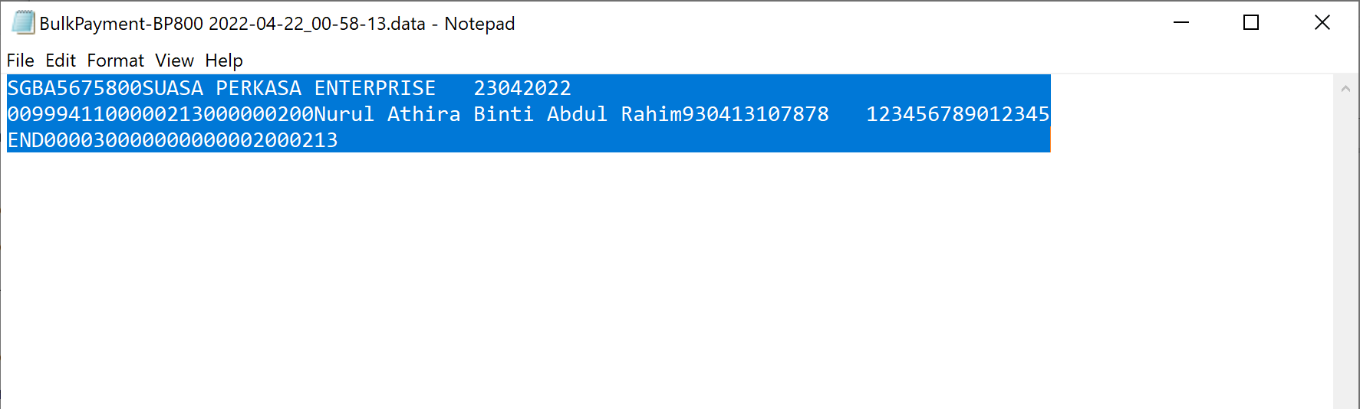

Result : System trim the length following setup at BSNeBiz - file format setup

