Change Description

Request:
- To have a ‘Delete’ action button for New Application navigation.
- Assigned IBAM users are allowed to delete any not pertinent new application

Proposed Resolution:
- To provide “Delete” action button at IBAM > New Application
- To soft delete the new application. All deleted new application will still keep in DB for future record.
*Refer Scope of Works in Appendix A.
Requested By |  | Rahmat Bin Bohari  Jabatan Perbankan Digital |  |  |  |  | Acknowledge By |  |  |  | Khairul Firas  Channel & Non-Core Application, JTM
System Impact Analysis
IBAM |  |  |  |  | - BSNeBiz > New Application
Effort Analysis
# | Resource |  |  | Effort  (mandays) |  | Unit Cost (RM) |  | Cost  (RM) |  | Description
1 | 1 |  |  | 5 |  |  |  |  |  | Development and internal testing
2 | 1 |  |  | 6 |  |  |  |  |  | Requirement study, SIT, UAT, Documentation and migration support
Sub Total
SST (6%)
Total Cost
3 | Annual Software Maintenance & Support (AMC) |  |  |  |  |  |  |  |  | 12 months support
SST (6%)
Total Cost
Total Investment
Prepared by [PENRIL DATABILITY (M) SDN BHD]:
Initiated by |  |  | Name & Role |  |  |  |  |  | Signature (Date)
Norhaidah Md Dasuki
Senior Manager, Profesional Services
Verified by |  |  | Tan Lee Yong  Project Director

Management Approval [BANK SIMPANAN NASIONAL]

Approved by:
Name & Position |  | Signature (Date) |  | Decision | ☐ Accepted  ☐ Rejected

Comments

Verified by:
Name & Position |  | Signature (Date)

Terms

Payment Schedule

No | Milestone | (%) | Amount before SST (RM) | SST Amount (RM) | Payable Amount (RM)
 | Upon Purchase Order (PO) | 10%
 | Upon SIT Sign-Off | 30%
 | Upon UAT Sign-Off | 30%
 | Upon LIVE or 30 days after UAT Sign Off (whichever comes first) | 20%
 | Upon end of warranty or 60 days after UAT Sign Off (whichever comes first) | 10%
Total |  | 100%

Annual Software Maintenance & Support (AMC)

Item | Description | Unit Cost (RM) | Total Cost (RM)
1 | 12-months Software Maintenance & Support subscription  - AMC of 20% of the total development cost (RM ) will kick in for the 12-month support.  - The commencement date of the support period is effective from 60 days after LIVE or UAT sign-off (whichever comes first).
SST (6%)
Total

Payment Terms & Conditions
- All prices are quoted in Malaysian Ringgit unless otherwise stated.
- Customer shall fully settle all invoices issued by Penril Datability (M) Sdn Bhd within thirty (30) days from the date of the invoice received by Customer, failing which late payment interest at the rate of twelve percent (12%) per annum shall be payable by the Customer for all outstanding sums until full payment.
- The Customer agrees that terms and conditions herein is governed by and shall be construed in accordance with the Malaysian laws and agrees to submit the exclusive jurisdiction of the courts of Malaysia.
- Any out of scope changes in specifications shall necessitate a re-quotation mutually agreed by both parties.
- Agreement stamping cost to be borne by Penril.
- For any clarification of this quotation,

For commercial purpose, please contact Koh Mui Tong
Email : mtkoh@penril.net or Mobile : 012 2038087

For technical, scope & schedule, please contact Tan Lee Yong
Email : leeyong.tan@penril.net or Mobile : 019 559 8816

Assumptions

General Assumptions

- Customer will set up a dedicated task-force made by a sufficient number of resources to guarantee that Customer’s required skills are available to the project when required according to the agreed project schedule.
- Customer will make available to Penril staff facilities on site similar to those that Customer makes available to their own staff.
- Customer will respond to all Penril requests for information in a timely manner.
- Customer shall be responsible for timely availability of software, hardware, applications and other necessary assistance required to develop/customize or implement the proposed solution.
- Customer will provide appropriate testing, training and production environment for the proposed solution.
- Customer will fulfill any other request, which may arise and needed to ensure the success of the overall project. Some of the activities shall be done off-site where and when required and Penril project manager will periodically report the progress of these tasks to Customer steering committee and project manager.
- Civil work and Site Preparation are not part of this scope of work.
- Customer will arrange all necessary authorizations on LAN or any other infrastructure for Penril employees to be able to carry out the project.
- Customer has to develop all the suitable test data cases according to the test plan submitted by Penril. The test plan and test cases will be the foundation for accepting the proposed solution.
- Penril will require a mobilization period of 2 weeks starting from the date of signing the contract.

Solution Assumptions

- Customer will be responsible for arrangements with other project parties.

APPENDIX A

SCOPE OF WORK
 | SOW |  | TASK |  | EFFORT  (Man Days)
Enhancement of EPF - RPA
 | SOW01 |  | - IBAM > File Processing – Download Report  - To have “Delete” button for assigned IBAM user to delete / remove not pertinent new application. |  | 5
Professional Services
1 |  | To conduct Planning & Design services inclusive of Requirement Gathering and preparation and delivery of the following Documentations: |  | 2
2 |  | To Perform SIT support and test result compilation |  | 3
3 |  | To perform the following support  - UAT support  - Go live support |  | 3
TOTAL |  |  |  | 20

APPENDIX B

PROCESS FLOW / SCREEN FLOW

Step 1
      - Access to BSNeBiz New Application
      - Click “X” icon at selected application to delete

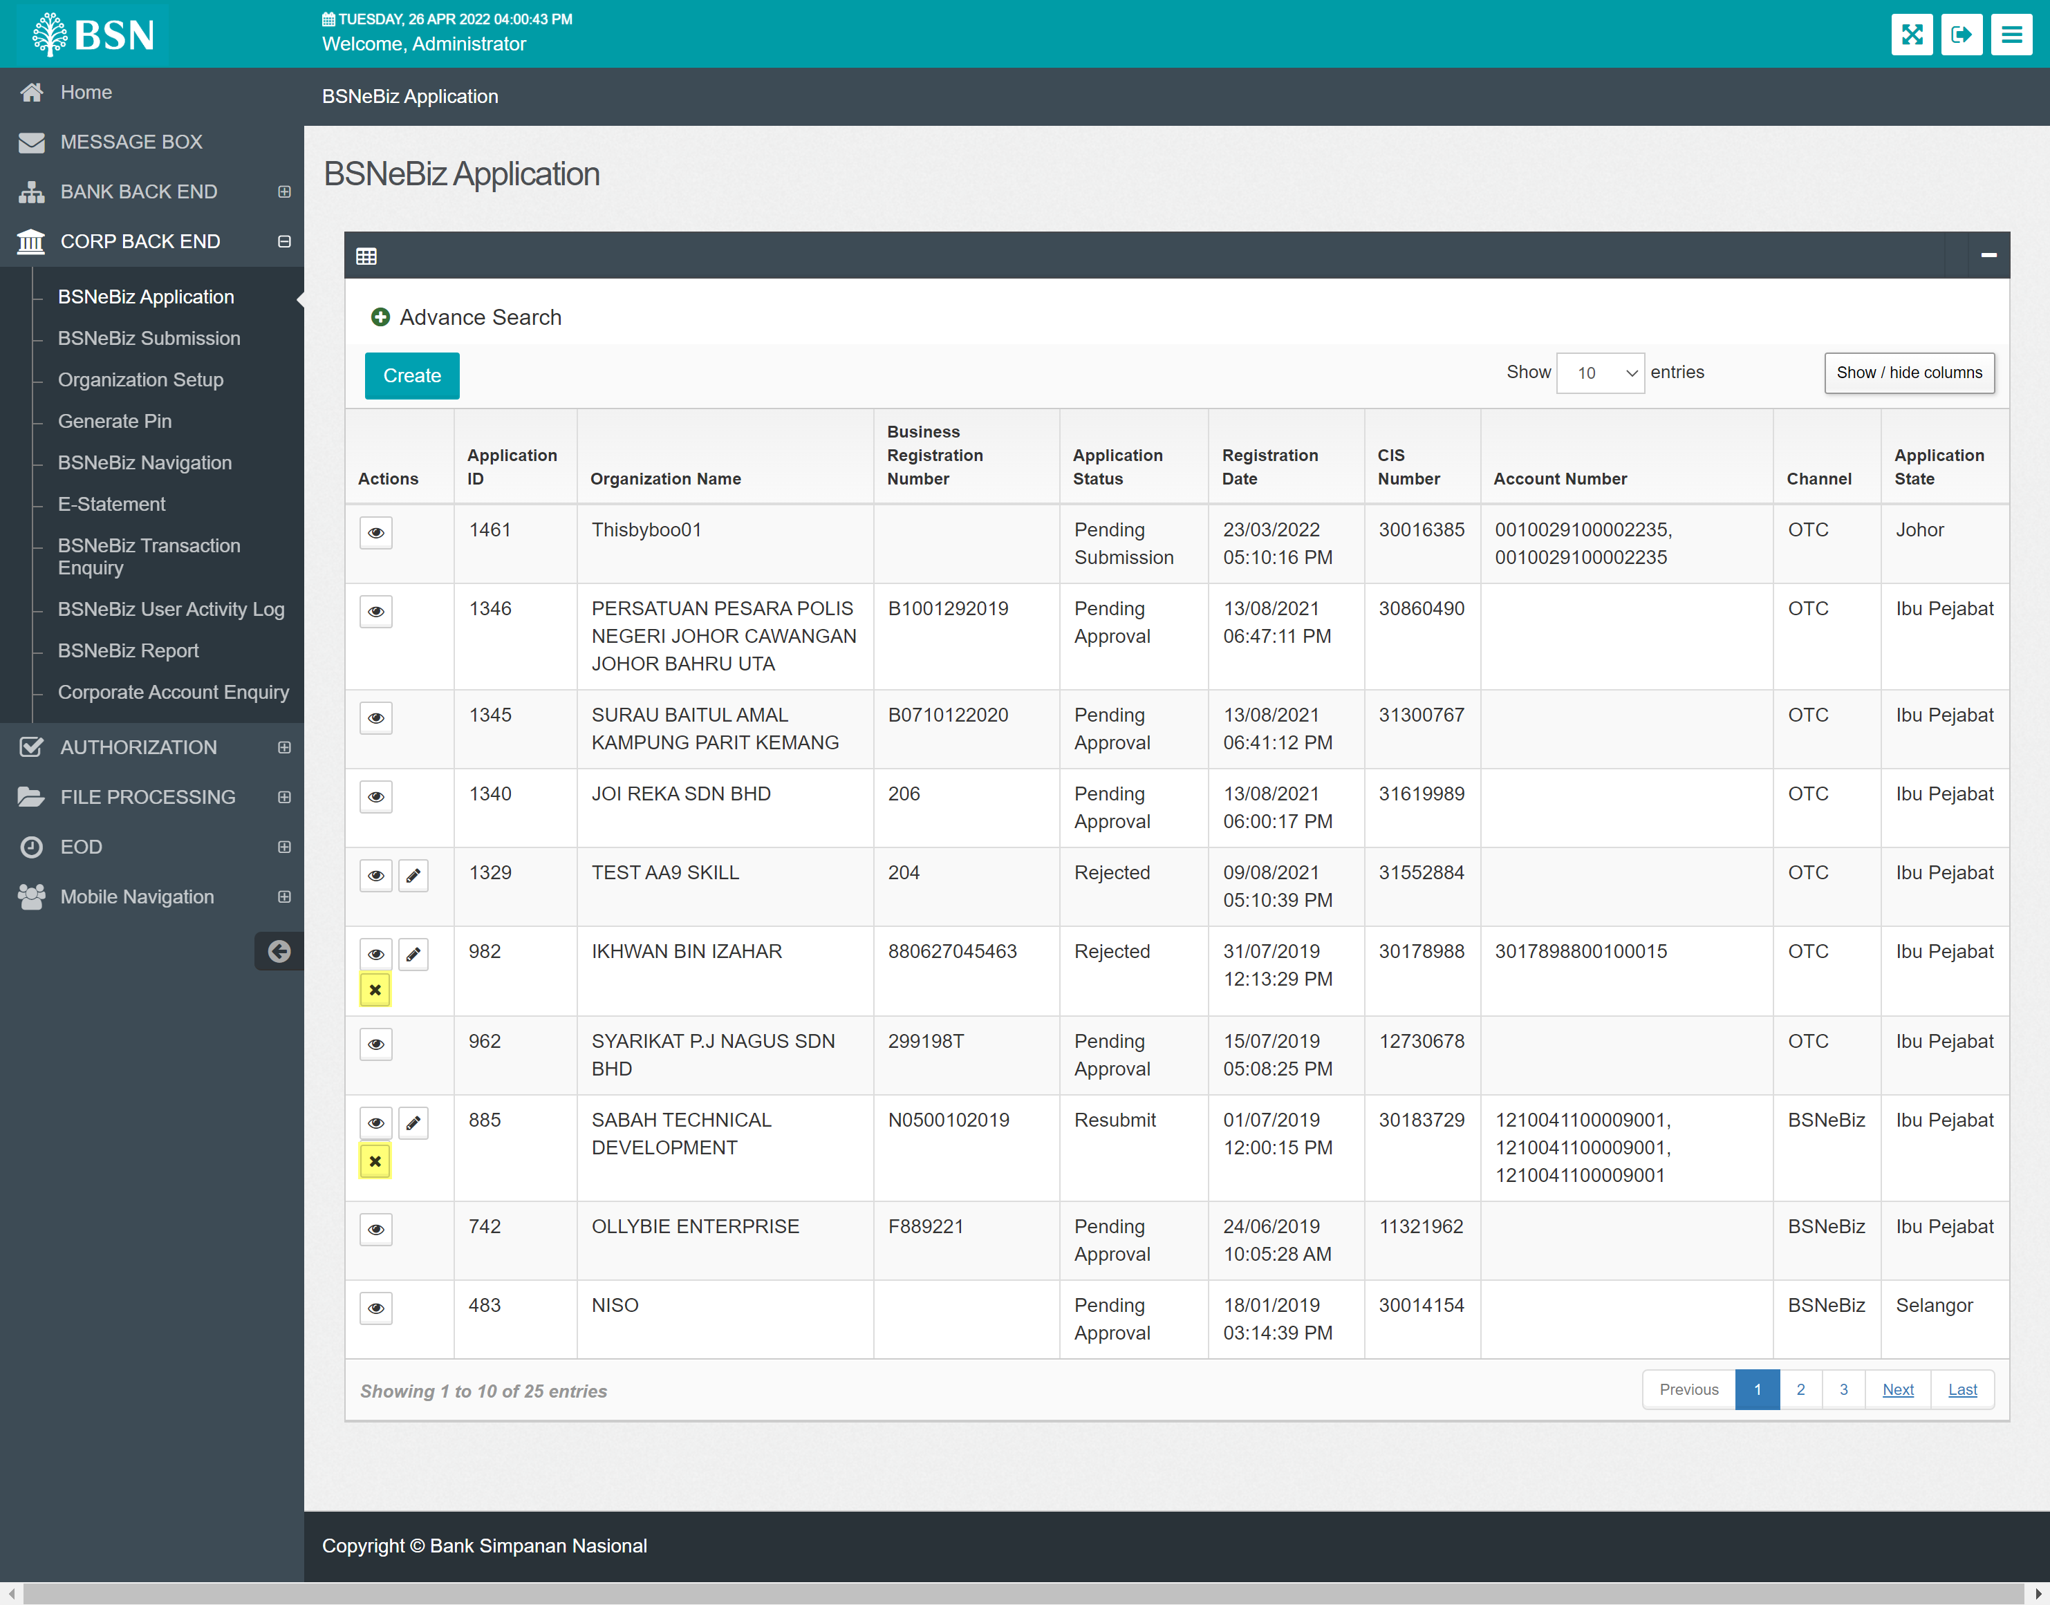

Step 2
      - System will display confirmation screen
      - Review the details and click confirm

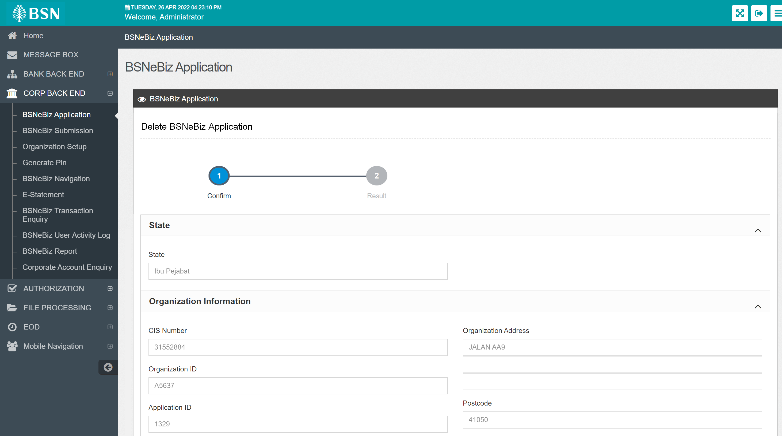

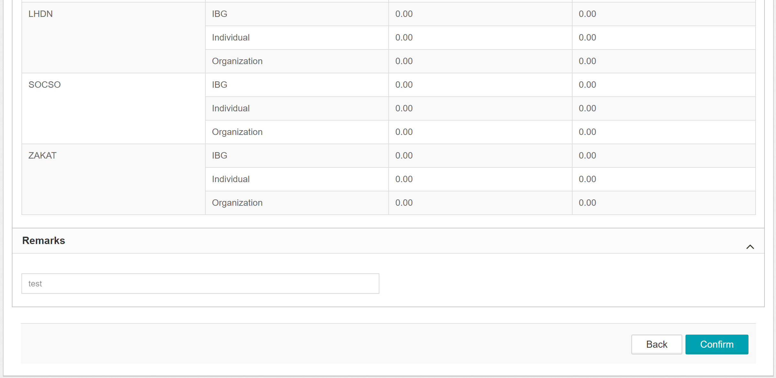

Step 3
      - System display result screen.

