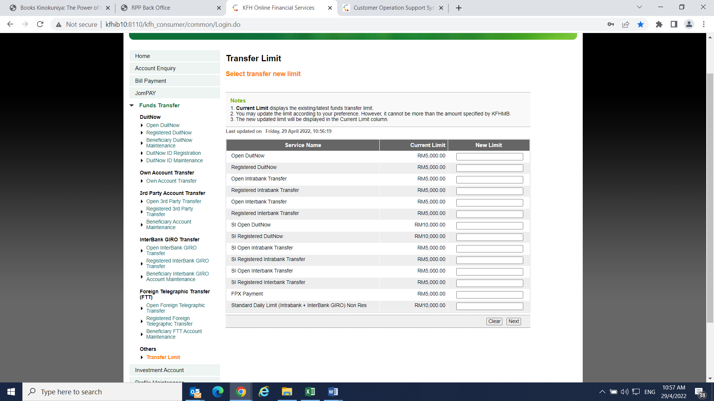The SI Open DuiNow Limit is RM10,000.00

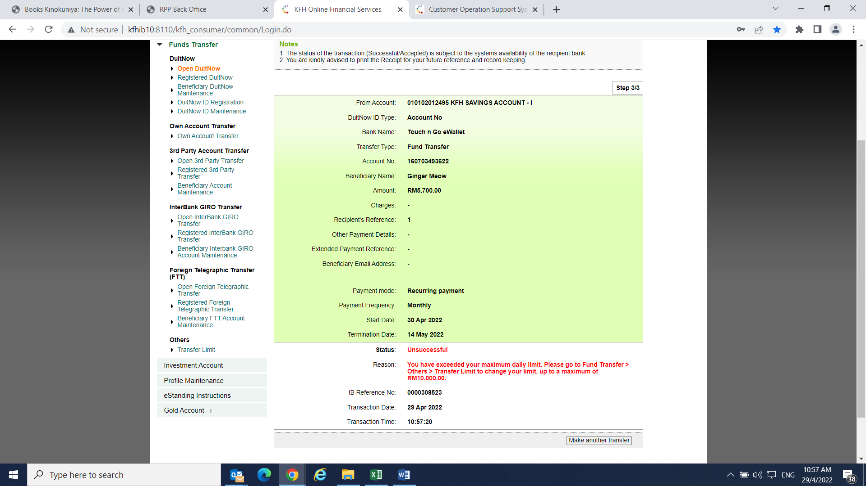  
Perform SI Open DuitNow RM5,700.00 – received an error “You have exceeded your minimum daily limit.