SCPID# 6251
Test Title: |  | Stop Payment / Reversal Maker Checker
Test Description: |  | System shows error upon authorizing the stop payment/ reverse payment
Test Functionality: |  | To test system should shows no error upon authorizing the stop payment/ reverse payment
Test Procedure: |  | Test steps:  - Access BSNeBiz and make Bulk Payment Without Account. IE IBG, SKDG or SGB.  - Access IBAM as maker  - Access File Processing>File Enquiry>Open details Bulk Payment Without Account at no.1  - Click the checkbox for Bulk Payment Without Account payment details. Refer image sc1.png.  - Click button Stop Payment  - Access IBAM as checker  - Access Authorization>Approval>Select Stop Bulk Payment Details at no.4  - Approve the item  - Expected result, approval success and the status in File Processing is STOPPED  - Repeat testing for Reversal Details Bulk Payment Without Account, Stop Details Bulk Payment With Account and Reversal Details Bulk Payment With Account
Response Message:
- Stop: Status in File Processing is STOPPED
- Reversal: Status in File Processing is PENDING PROCESSED/PENDING ENTER AMOUNT
Test Result: | Pass: Fail: |  | Tested by: | Syahirah (9/5/2022)
Reason for Failure:
Remarks: |  | - Transaction Bulk Payment Without Account  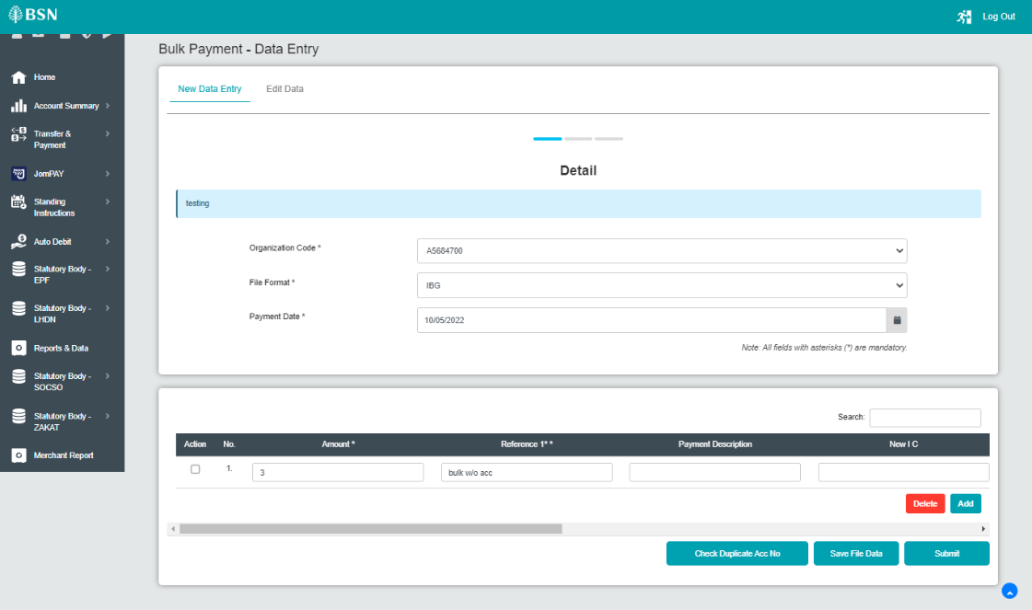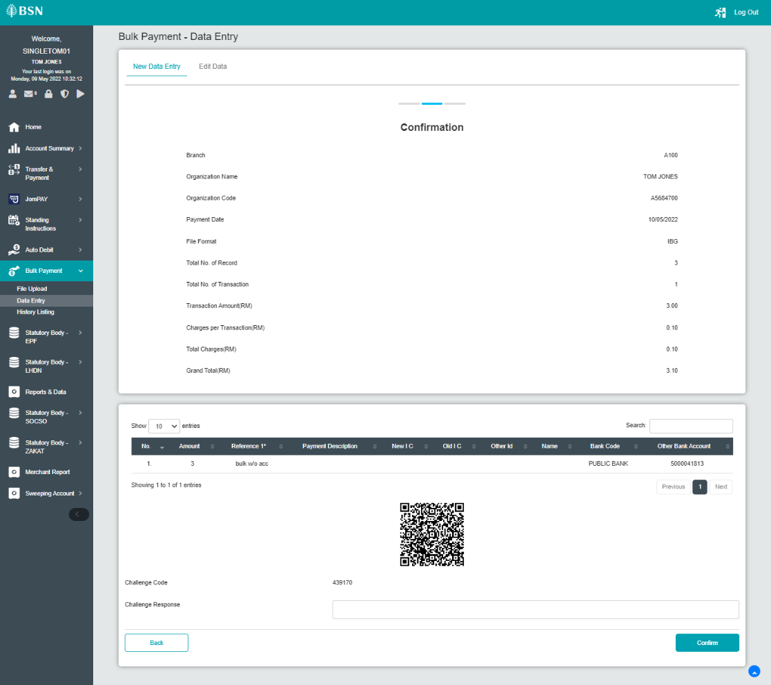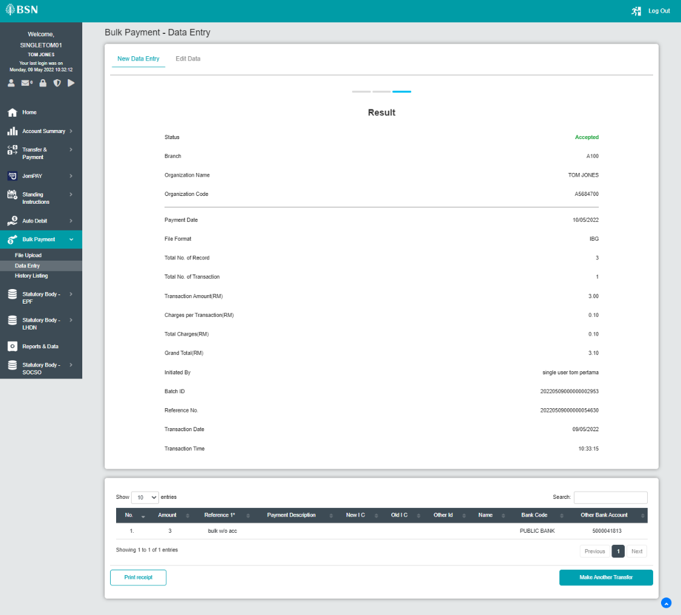  - Transaction Bulk Payment With Account  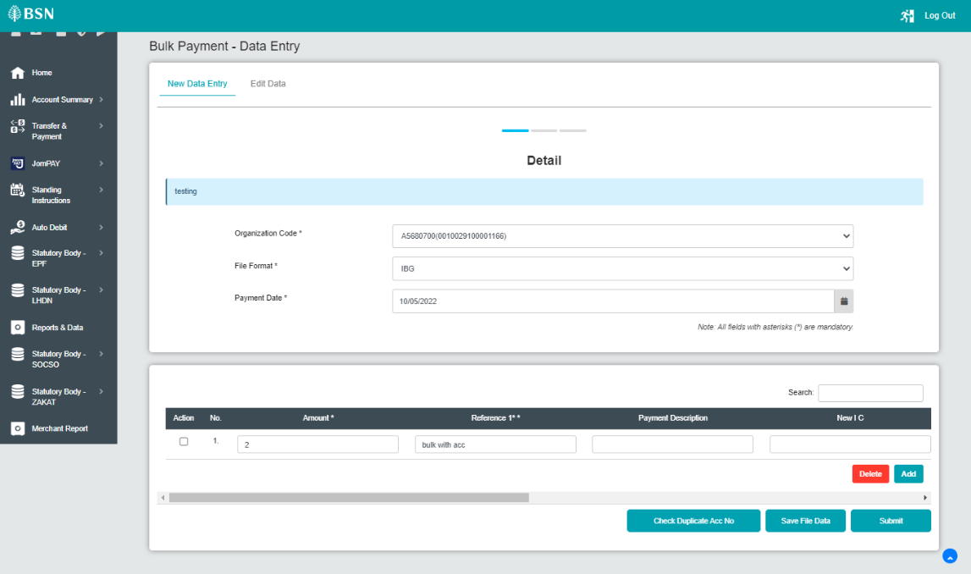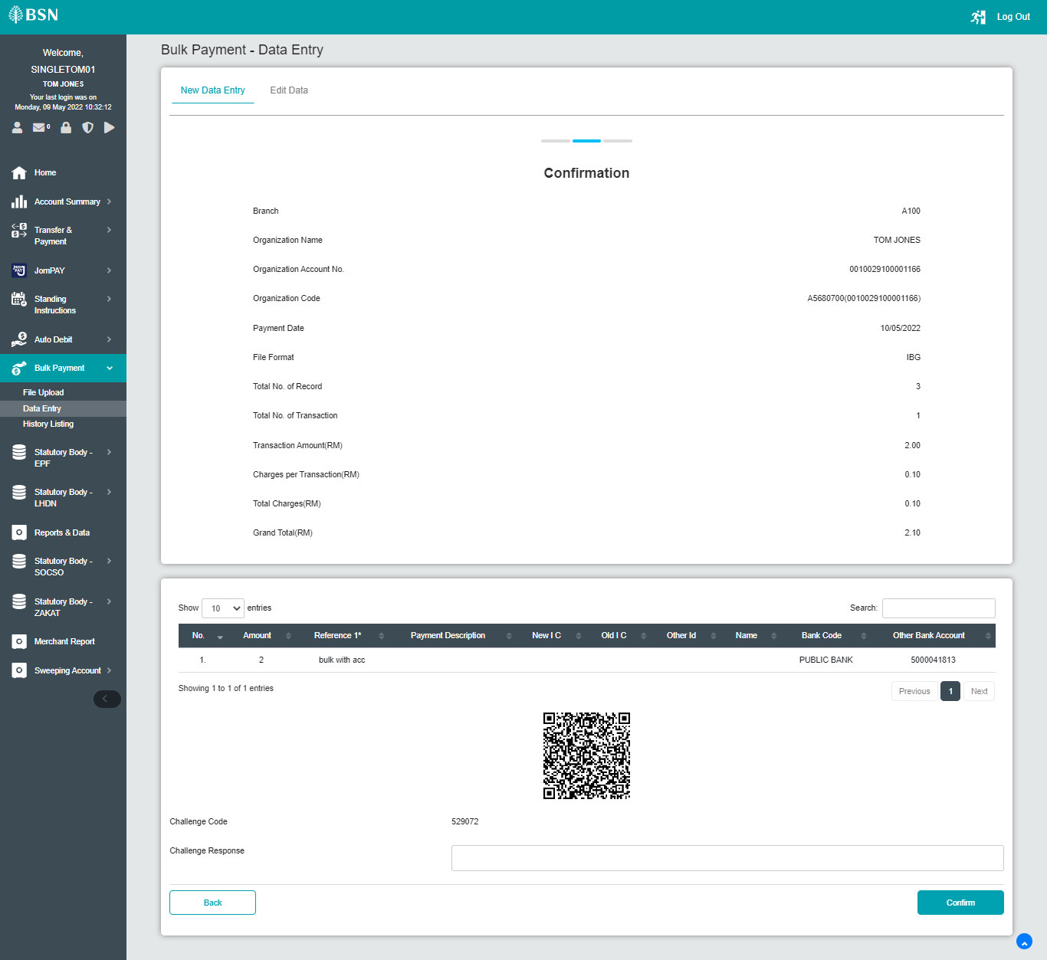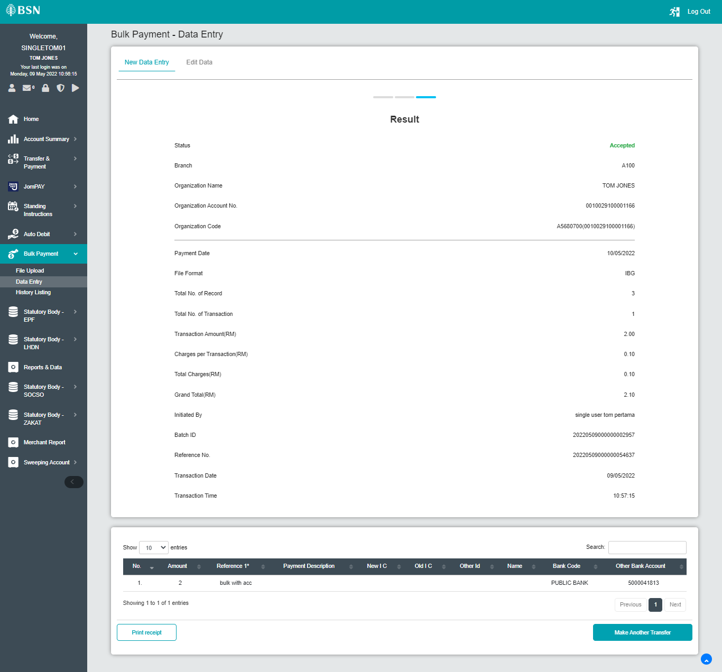  Bulk Payment Without Account  - Stop  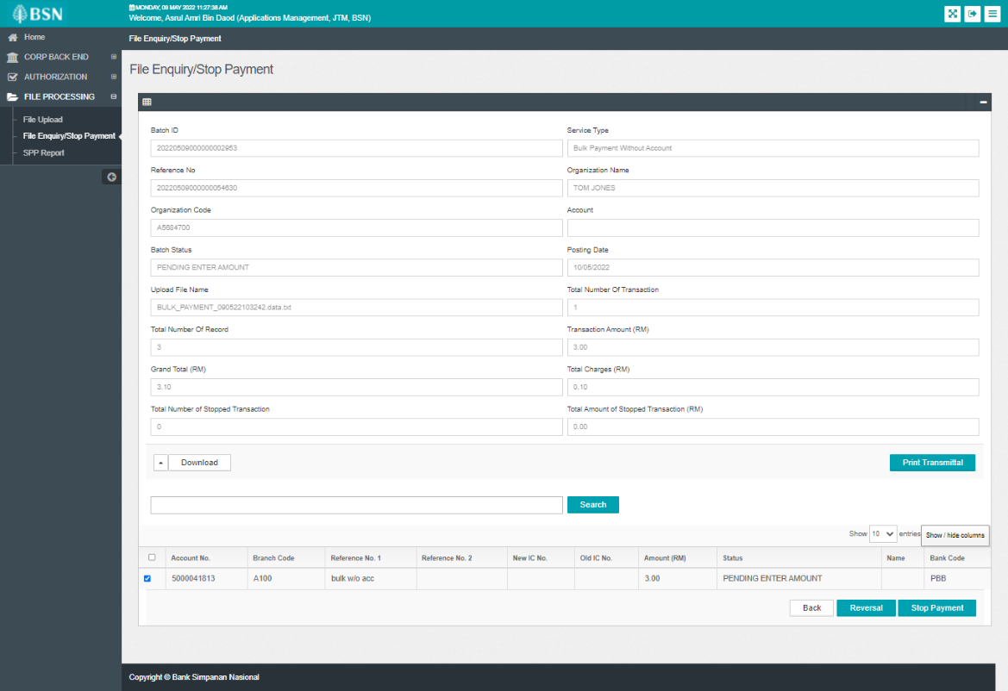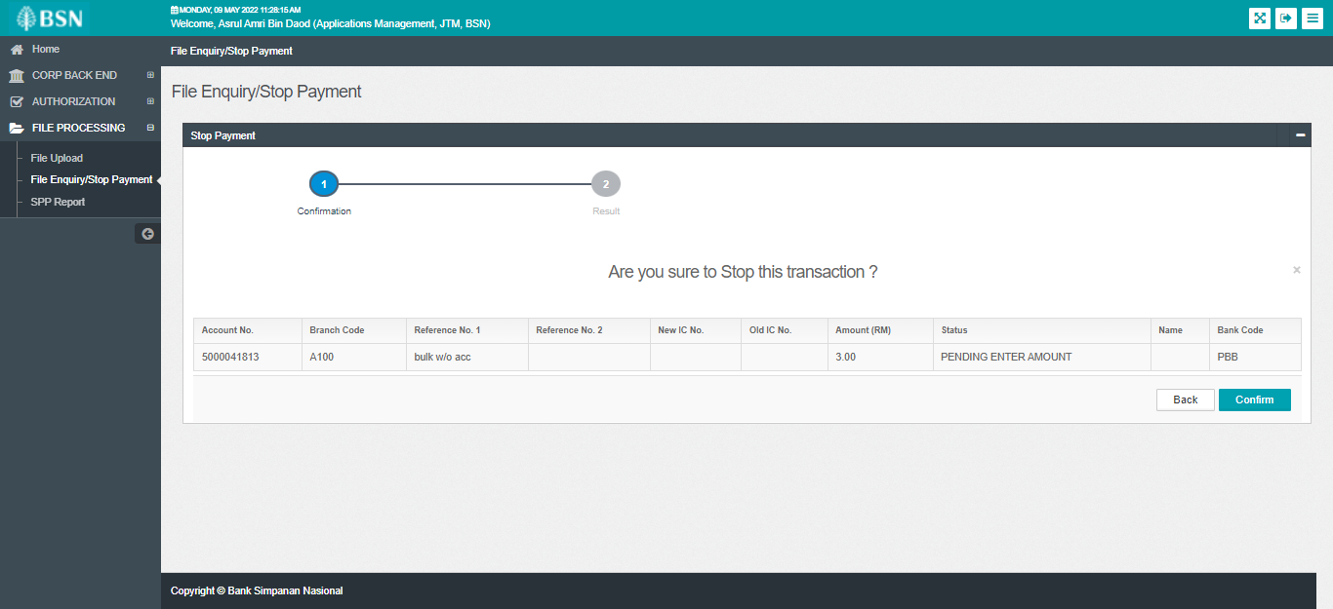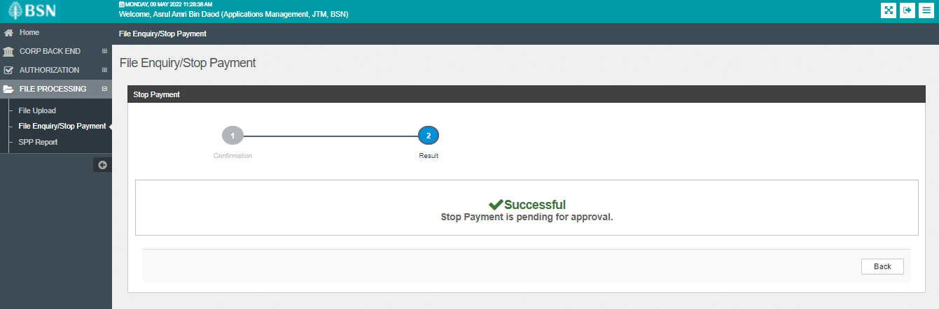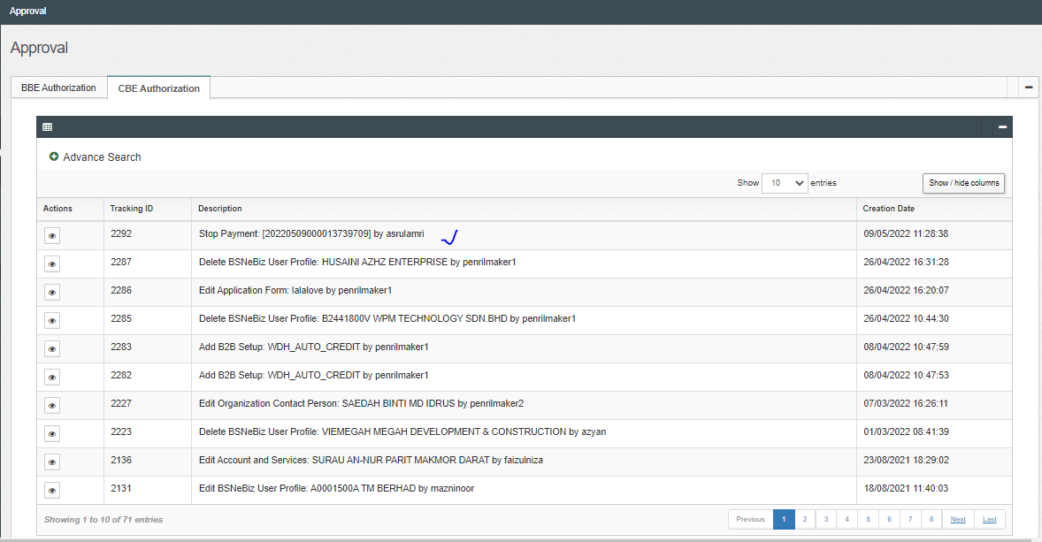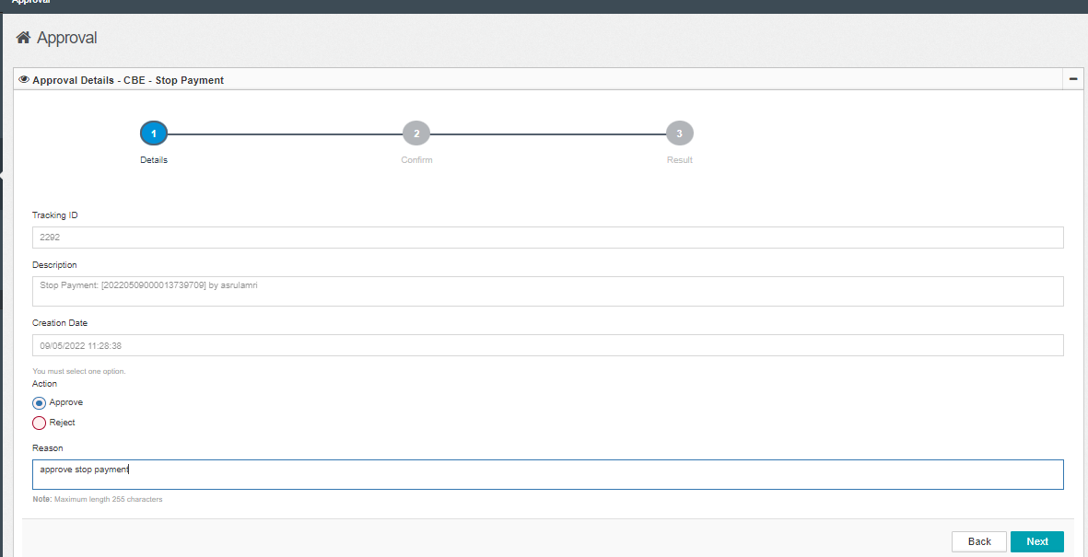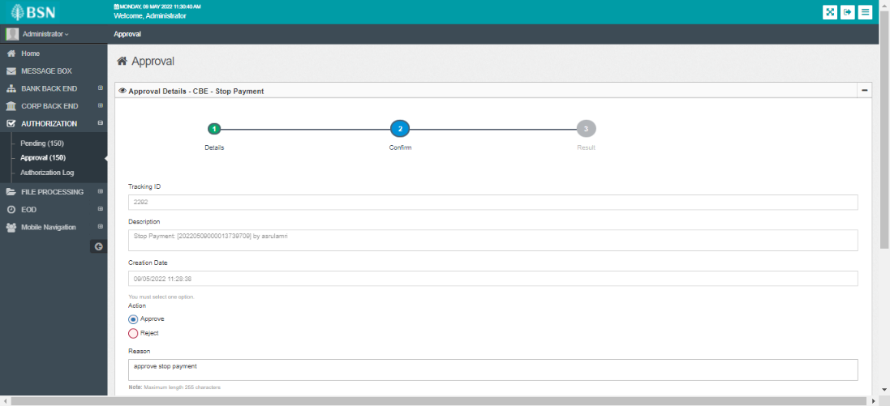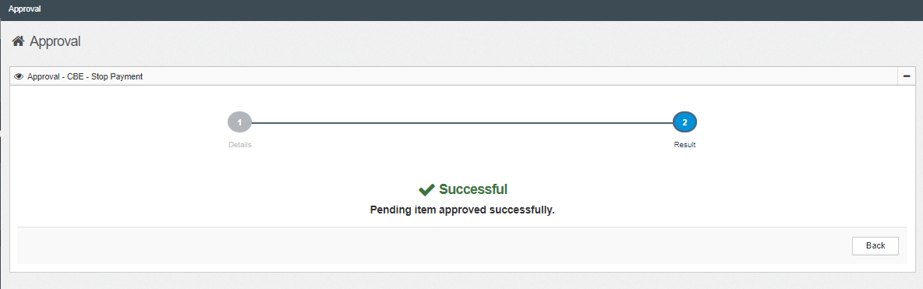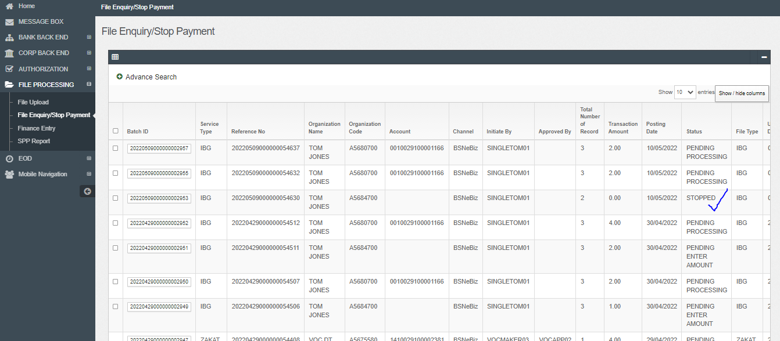  - Reversal  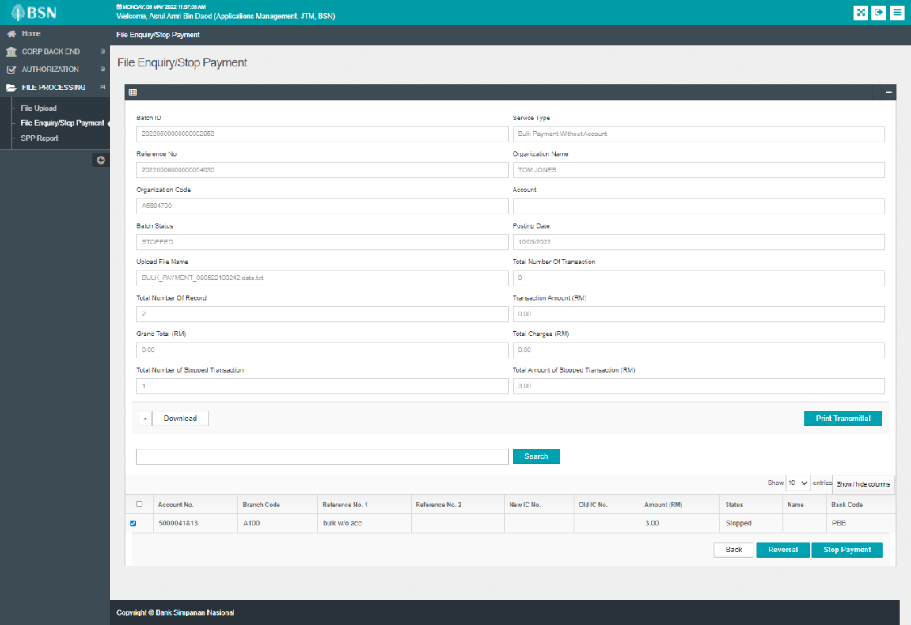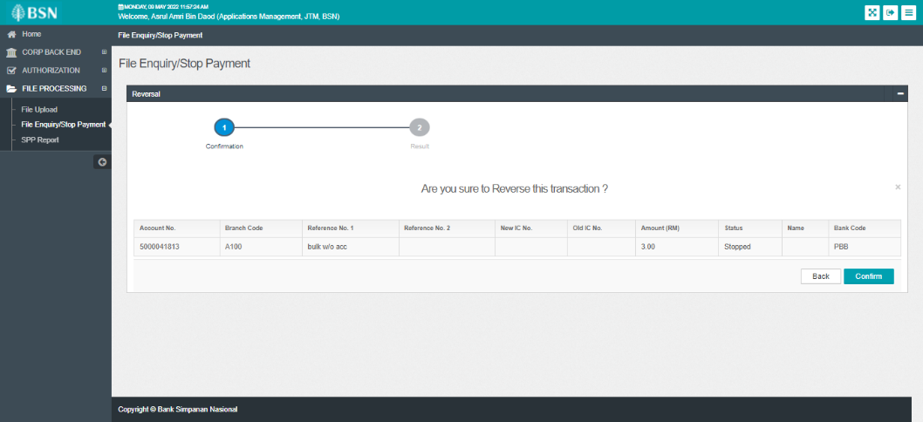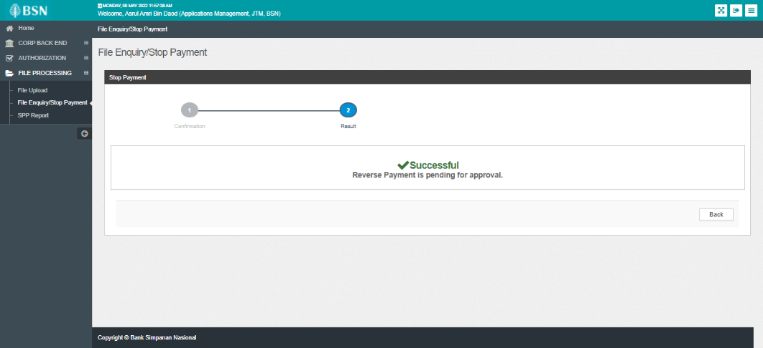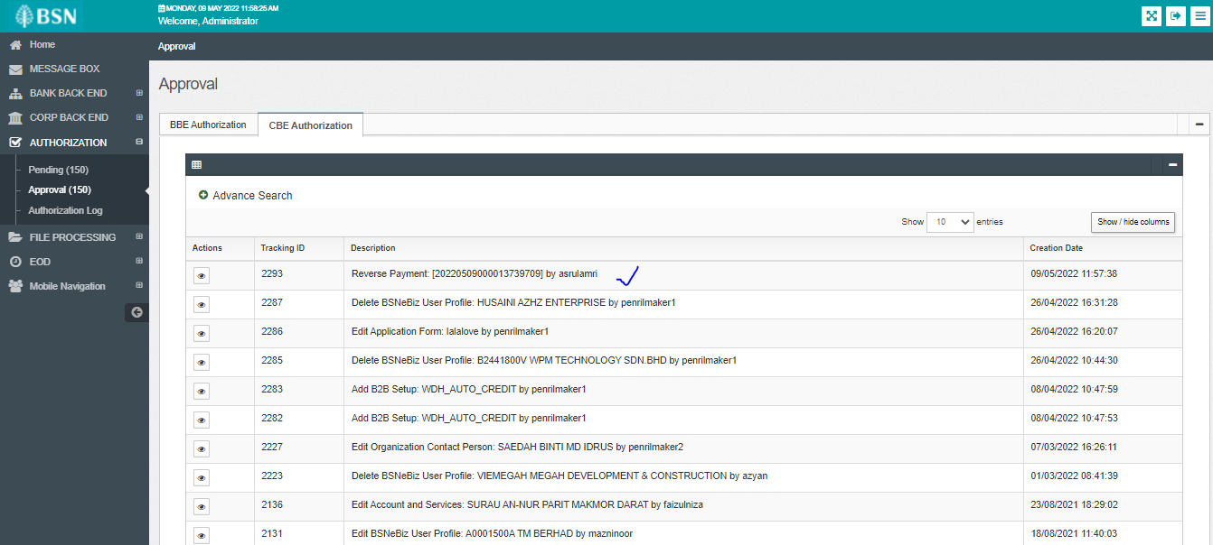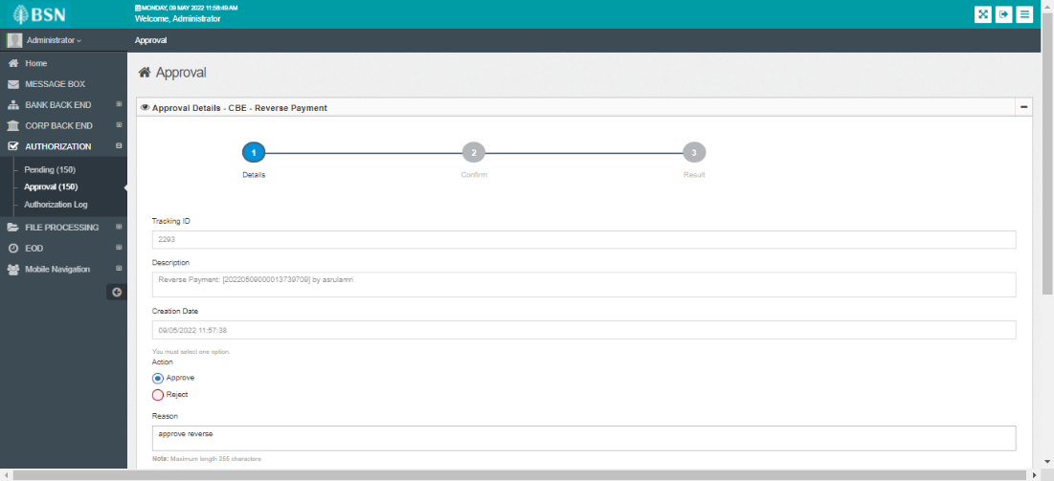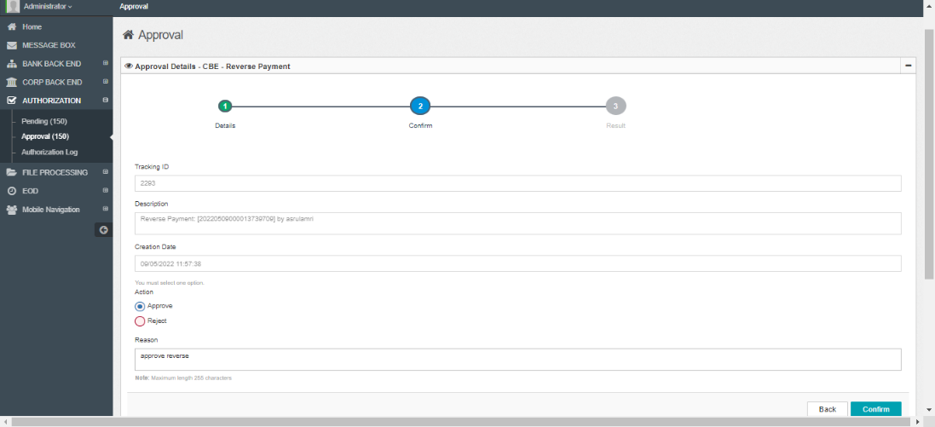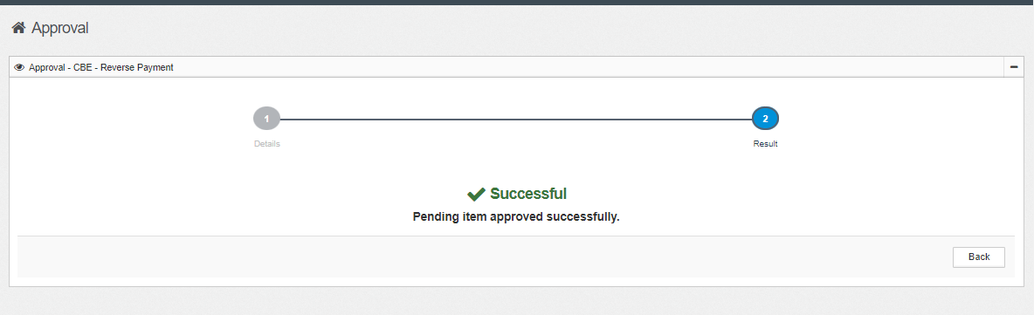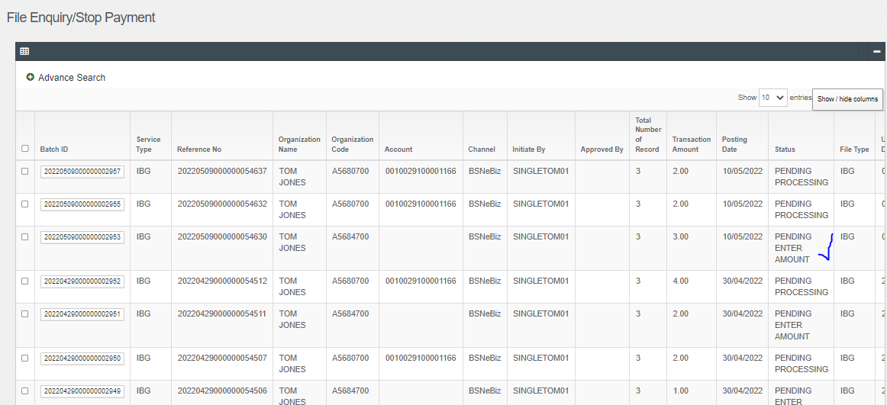  Bulk Payment With Account  - Stop  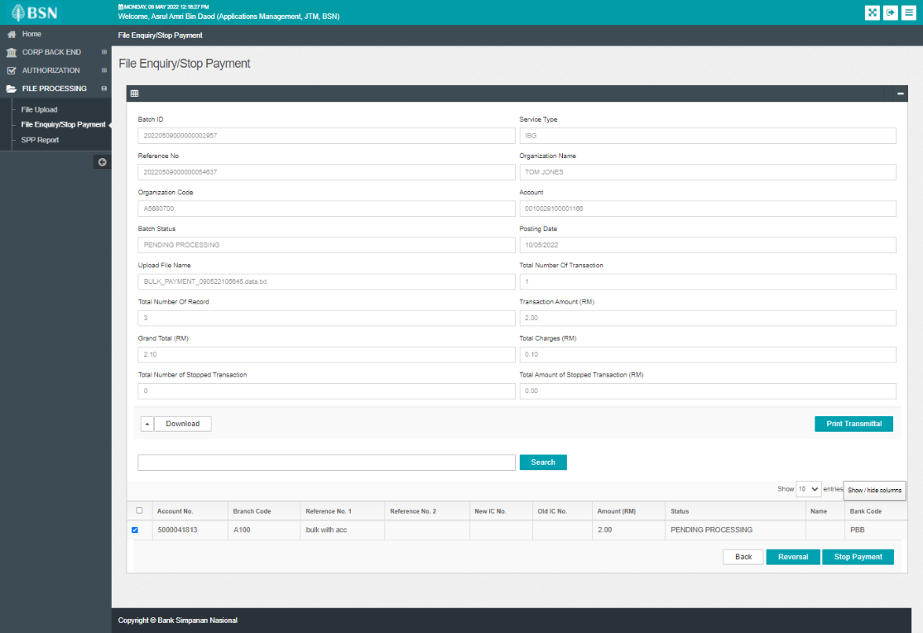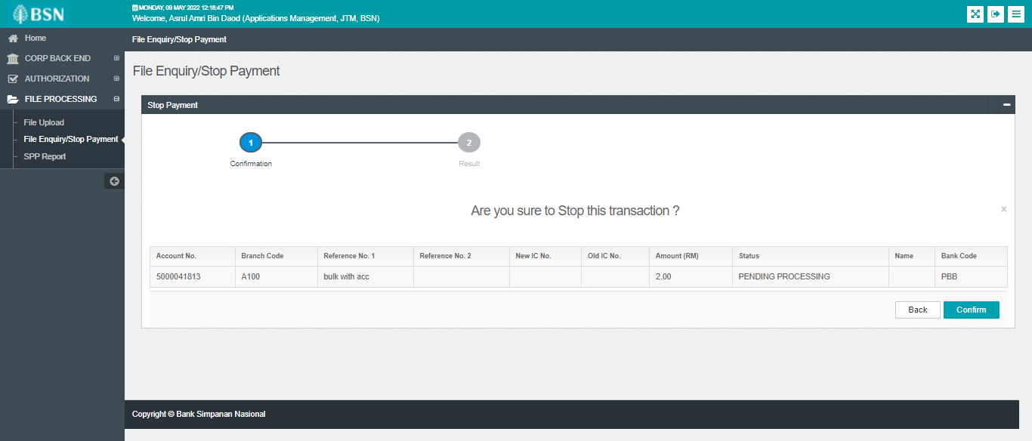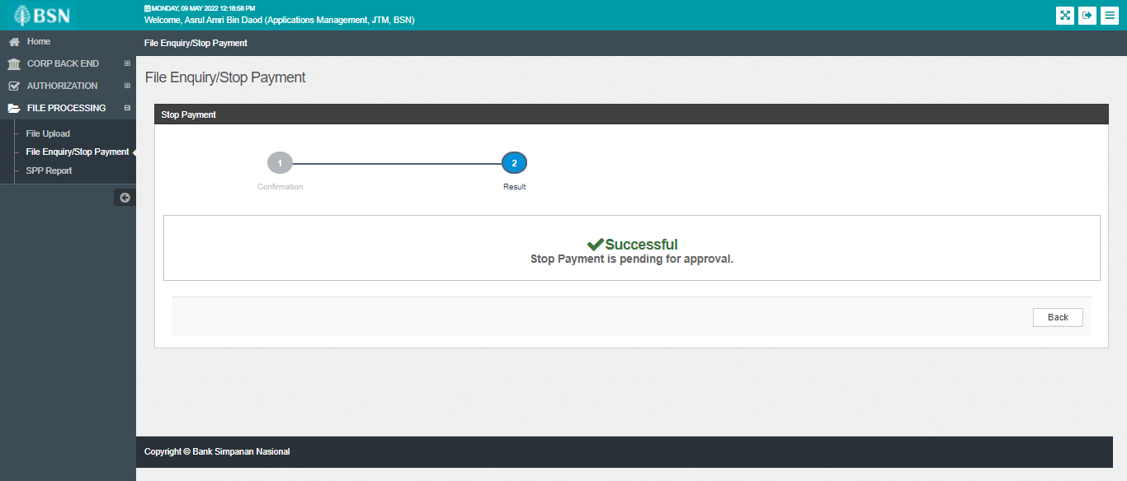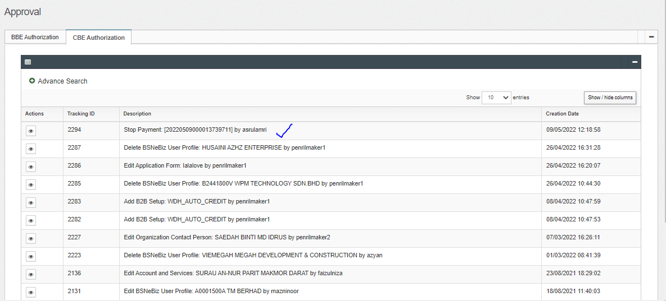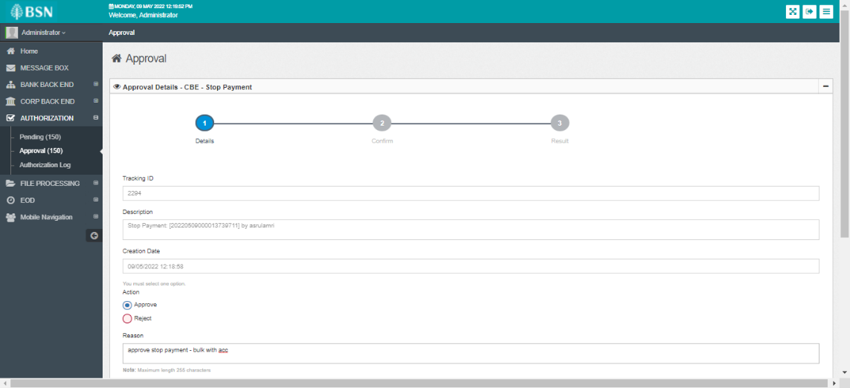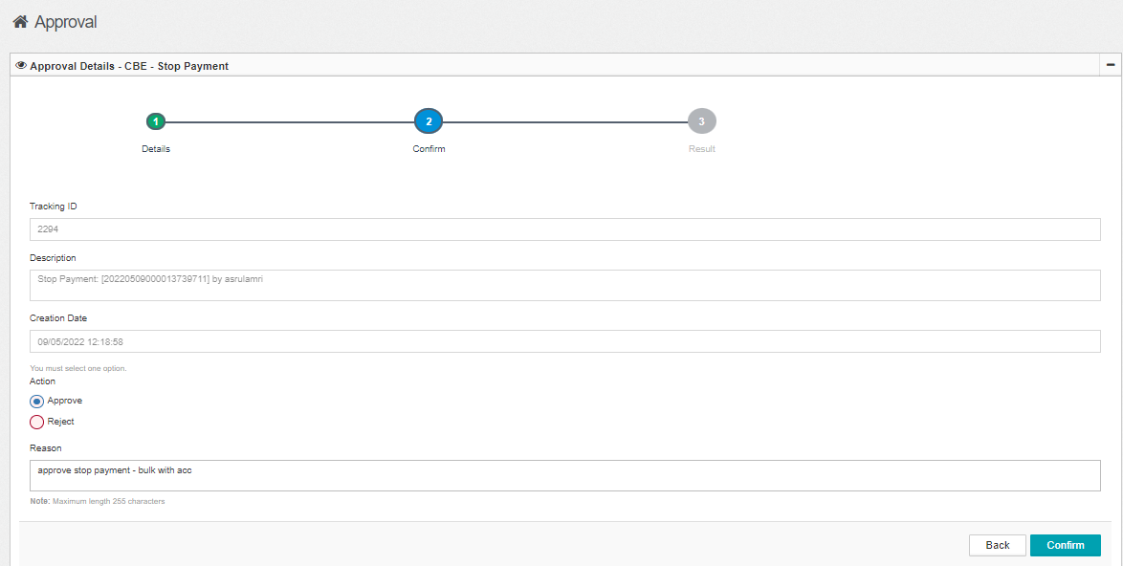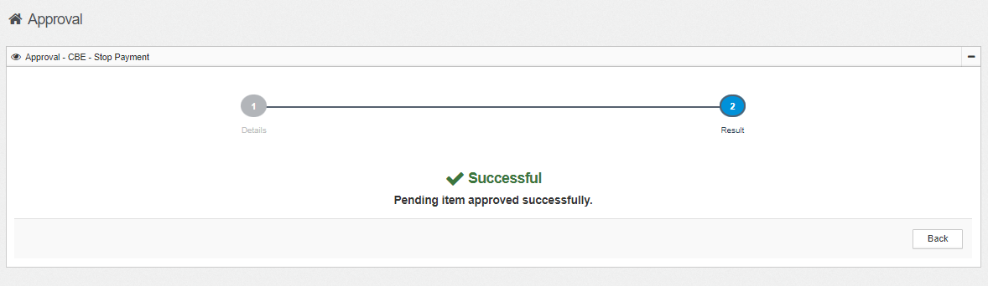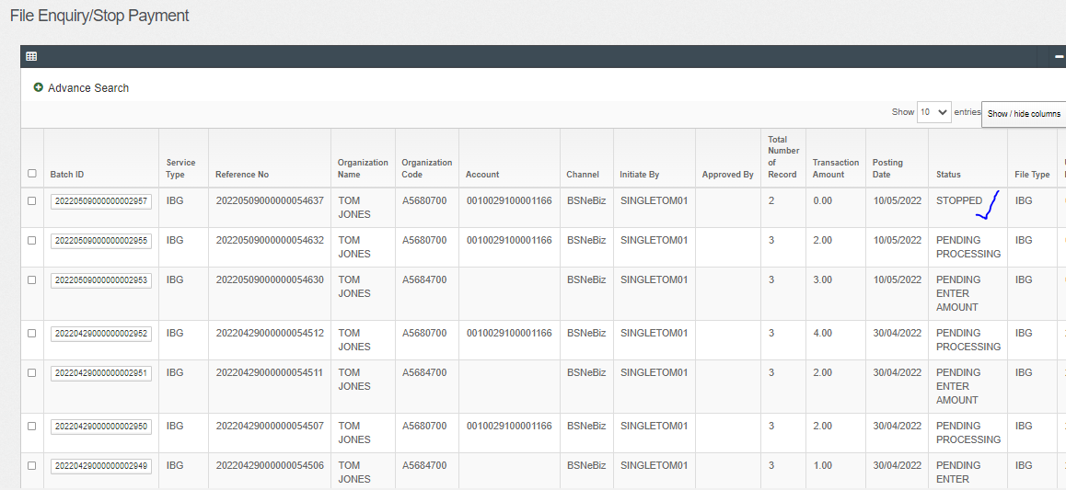  - Reversal  