SCPID# 6150
Test Title: |  | Duitnow Immediate Reversal Error Code Mapping and special character removal
Test Description: |  | To test reversal & special character in DuitNow transactions
Test Functionality: |  | - To test rejected DuitNow not included in reversal.  - To test DuitNow transaction rejected because of special character.
Test Procedure: |  | Test steps A Rejected DuitNow Payment  - Access BSNeBiz as Initiator and make a DuitNow transfer  - Access BSNeBiz as Approver and approve the DuitNow transfer  - The status is Unsuccessful  - Access Account Summary > Account Details > Transaction History  - Expected result, money is debited(payment) and credited(reversal)  Test steps B Account holder name with special character  - Access BSNeBiz as Initiator and make a DuitNow transfer with Public Bank 3099020502  - Access BSNeBiz as Approver and approve the DuitNow transfer  - Expected result, status is successful  - If status is unsuccessful, make sure money is debited(payment) and credited(reversal)  Test steps C Account holder name with more than 30 character  - Access BSNeBiz as Initiator and make a DuitNow transfer with CIMB 7611534894  - Access BSNeBiz as Approver and approve the DuitNow transfer  - Expected result, status is successful  - If status is unsuccessful, make sure money is debited(payment) and credited(reversal)  Test steps D Single user  - Please repeat test A,B and C with single user
Response Message:
If DuitNow is Unsuccessful, expected money is debited(payment) and credited(reversal) at Transaction History
Test Result: | Pass: Fail: |  | Tested by: | Syahirah (11/05/2022)
Reason for Failure:
Remarks: |  | - Workflow - Test steps A Rejected DuitNow Payment  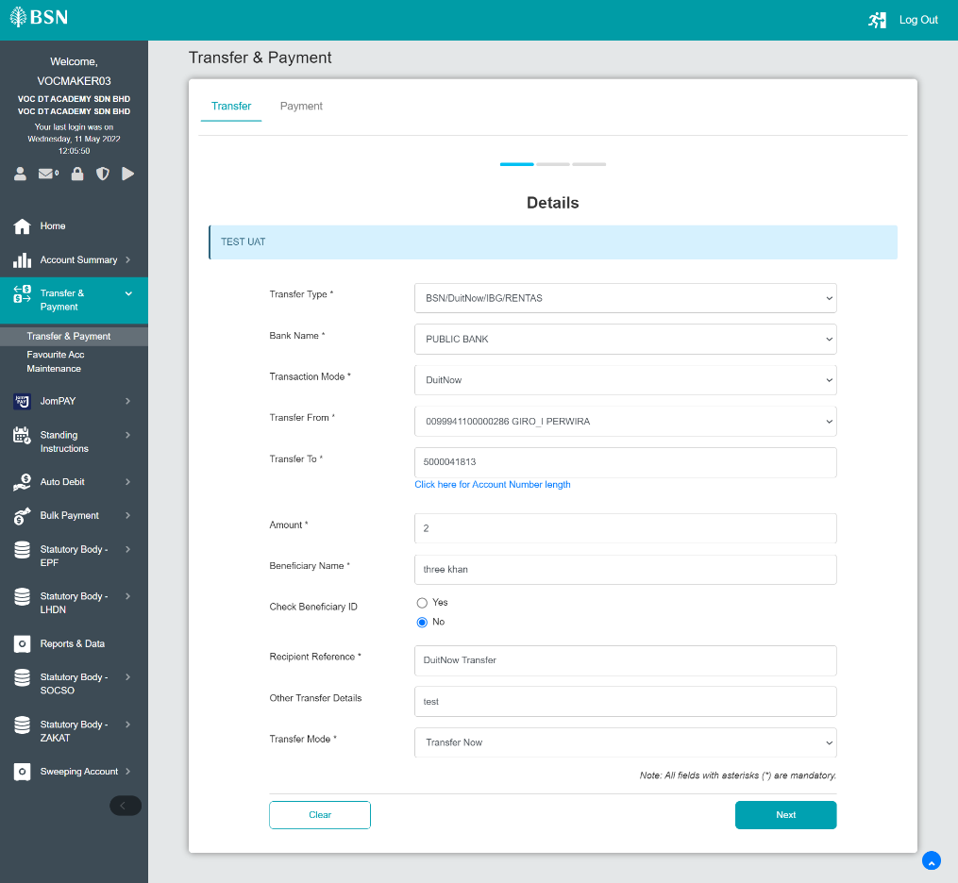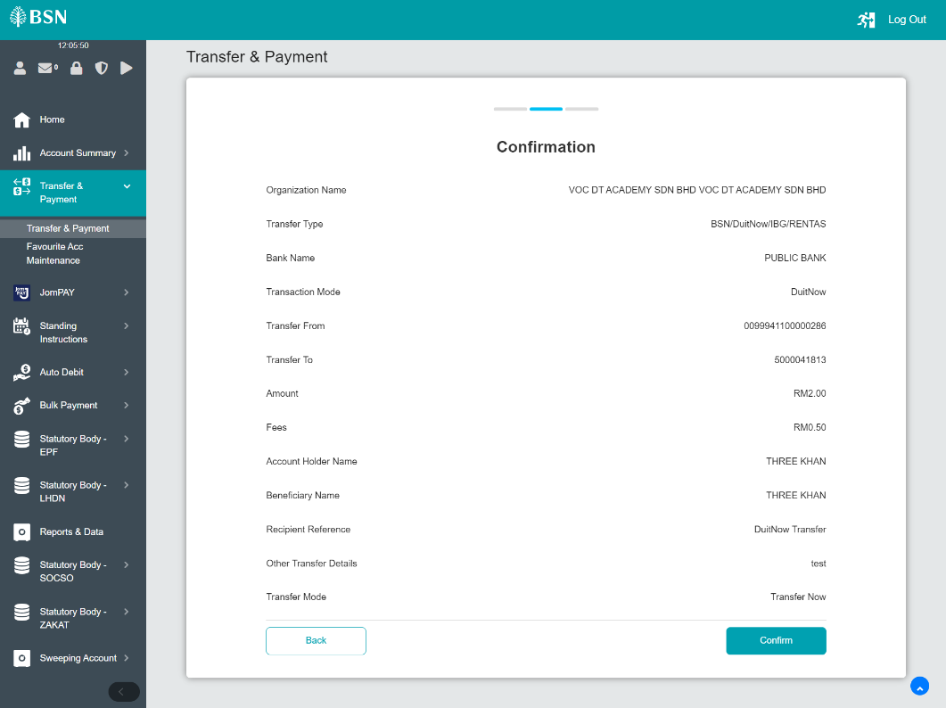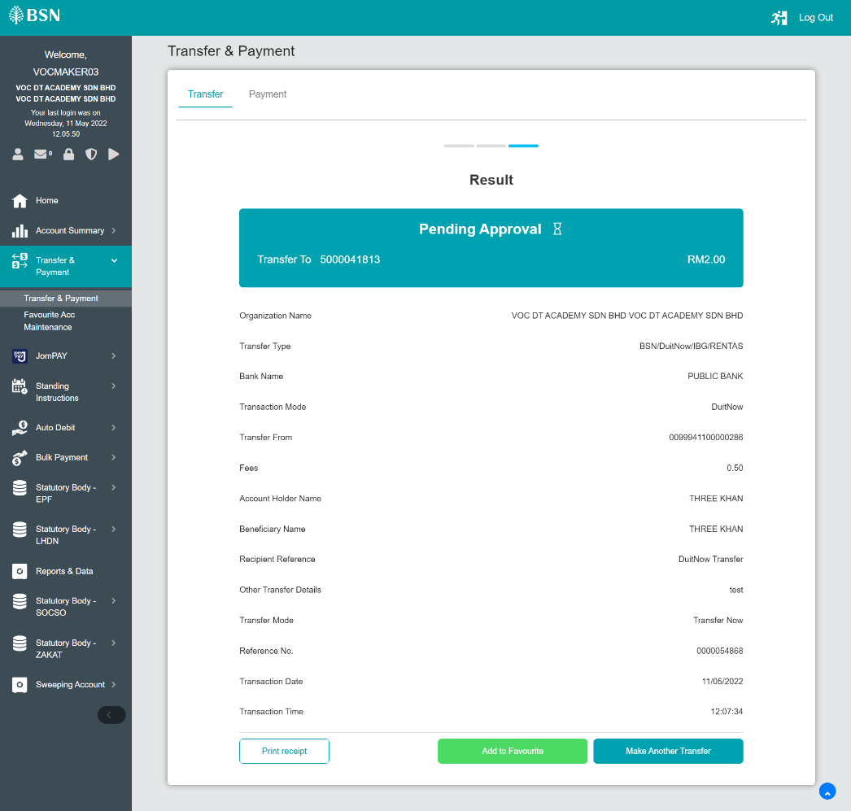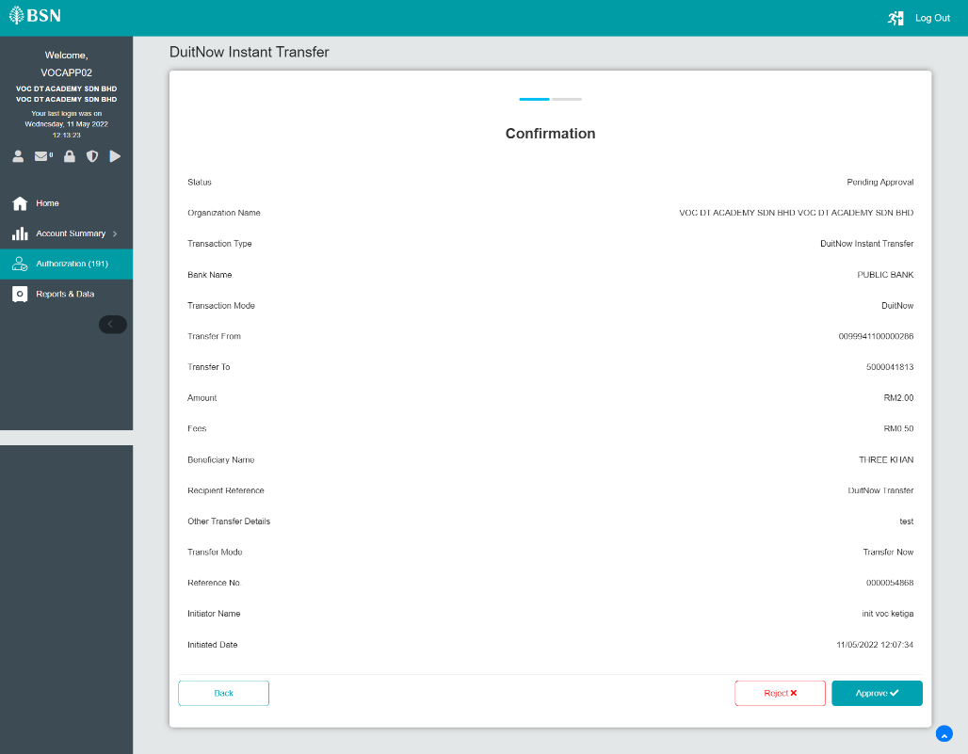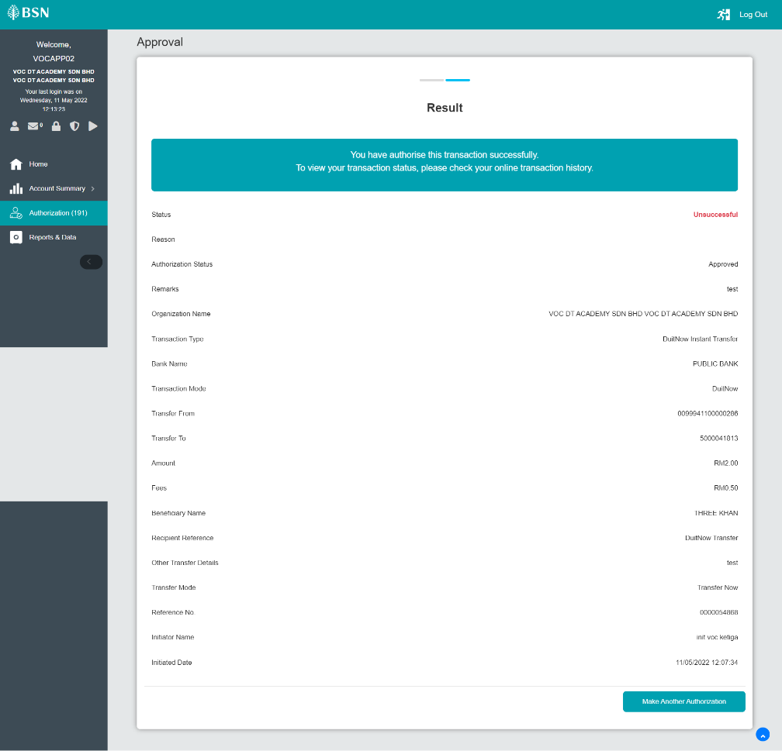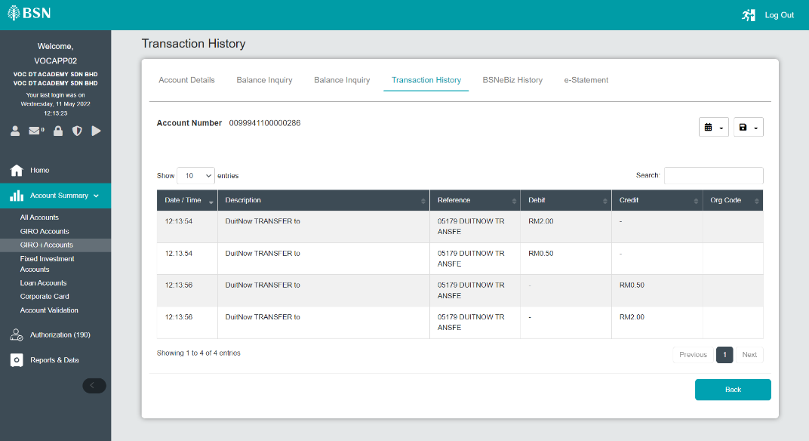  - Workflow - Test steps B Account holder name with special character  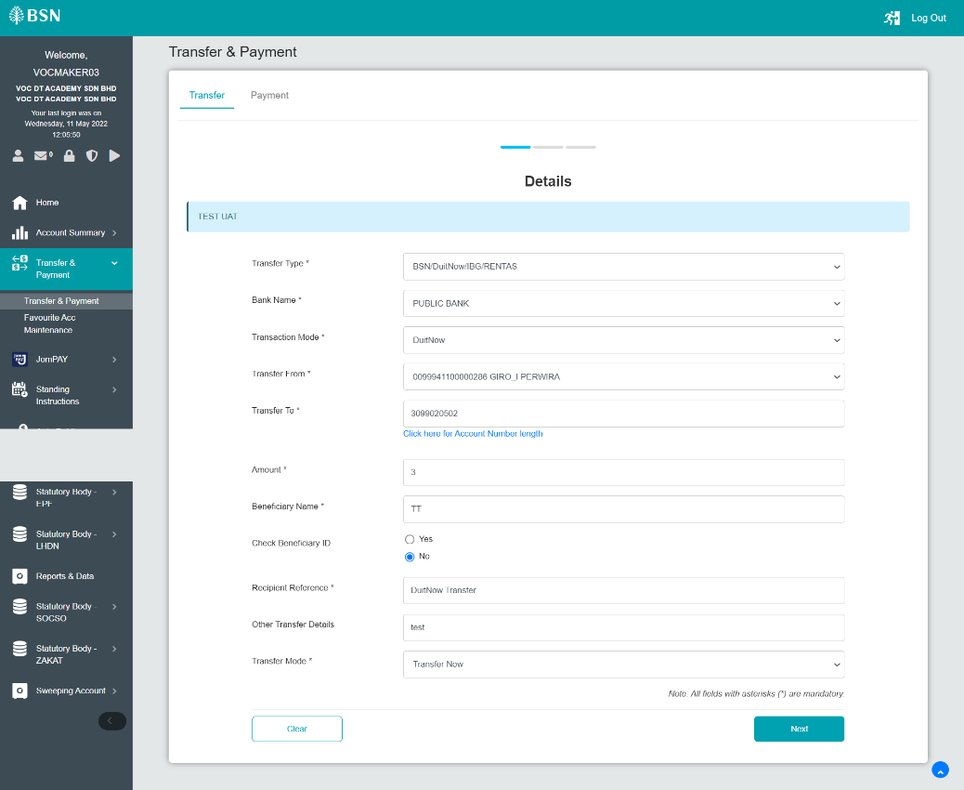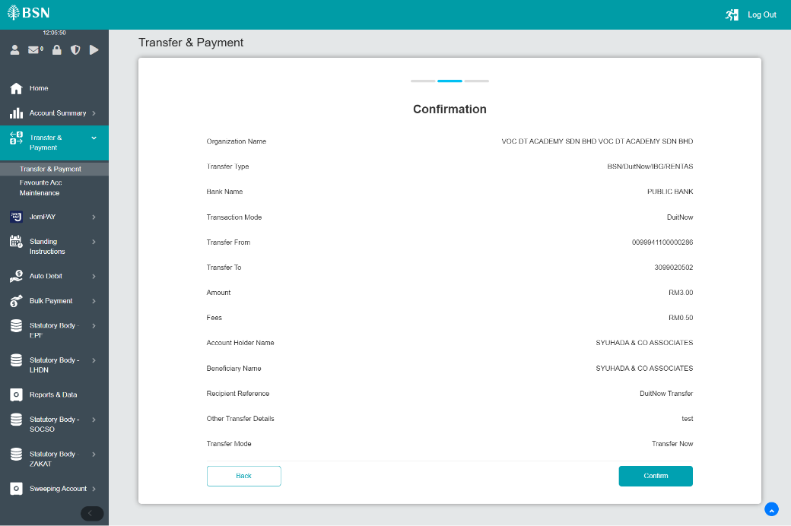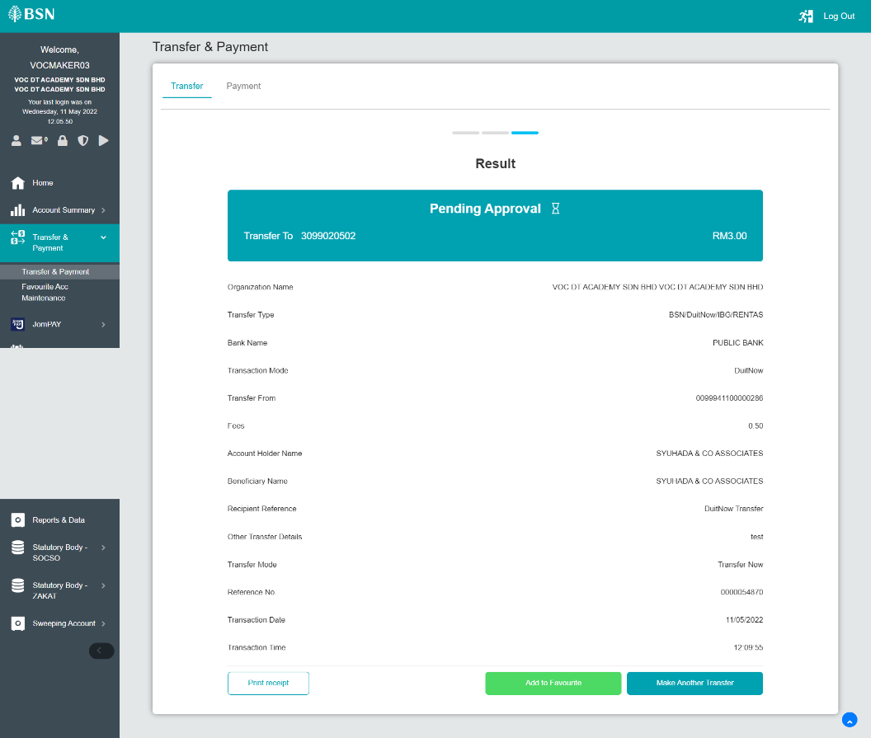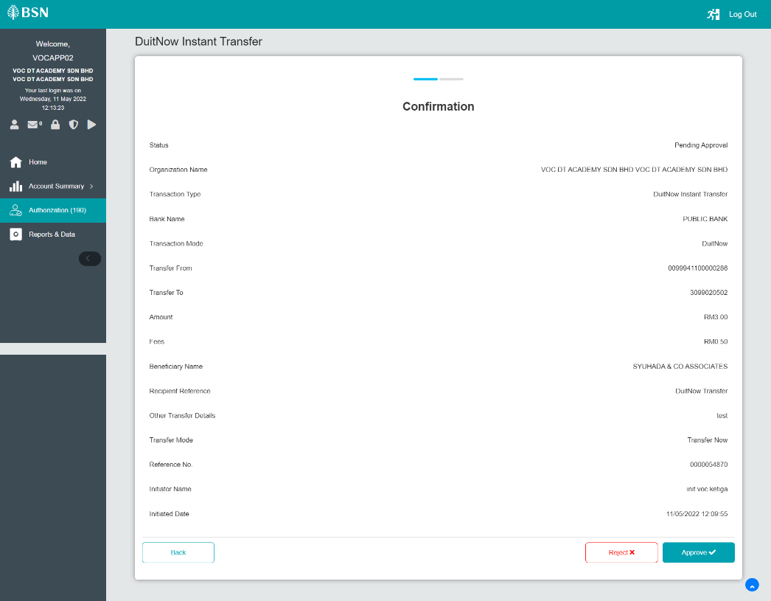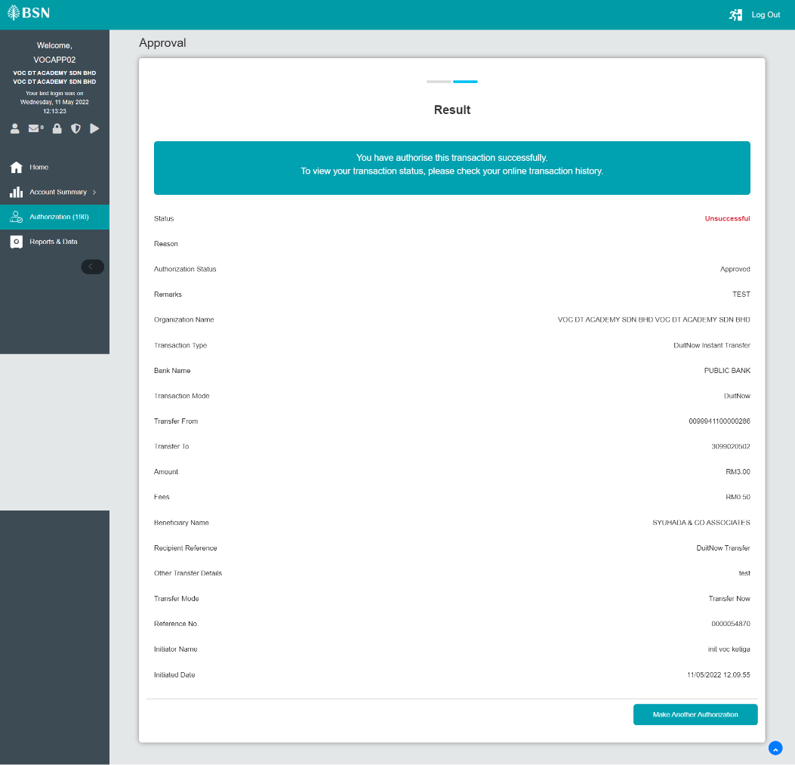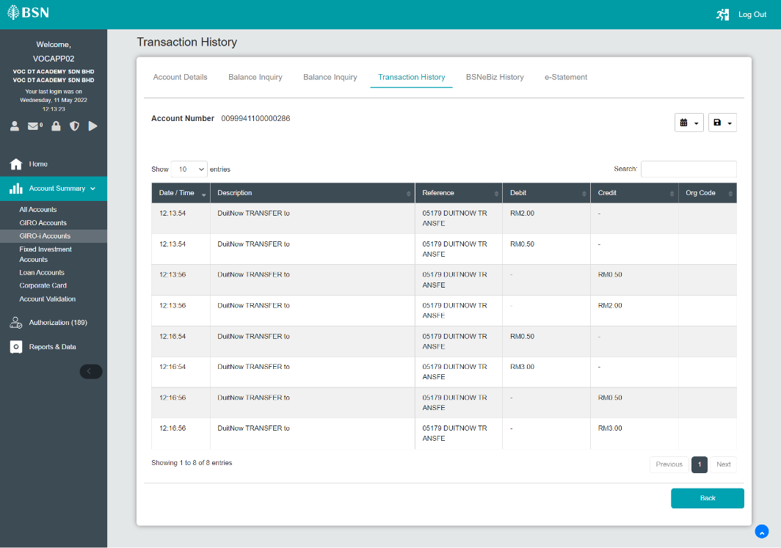  - Workflow - Test steps C Account holder name with more than 30 character  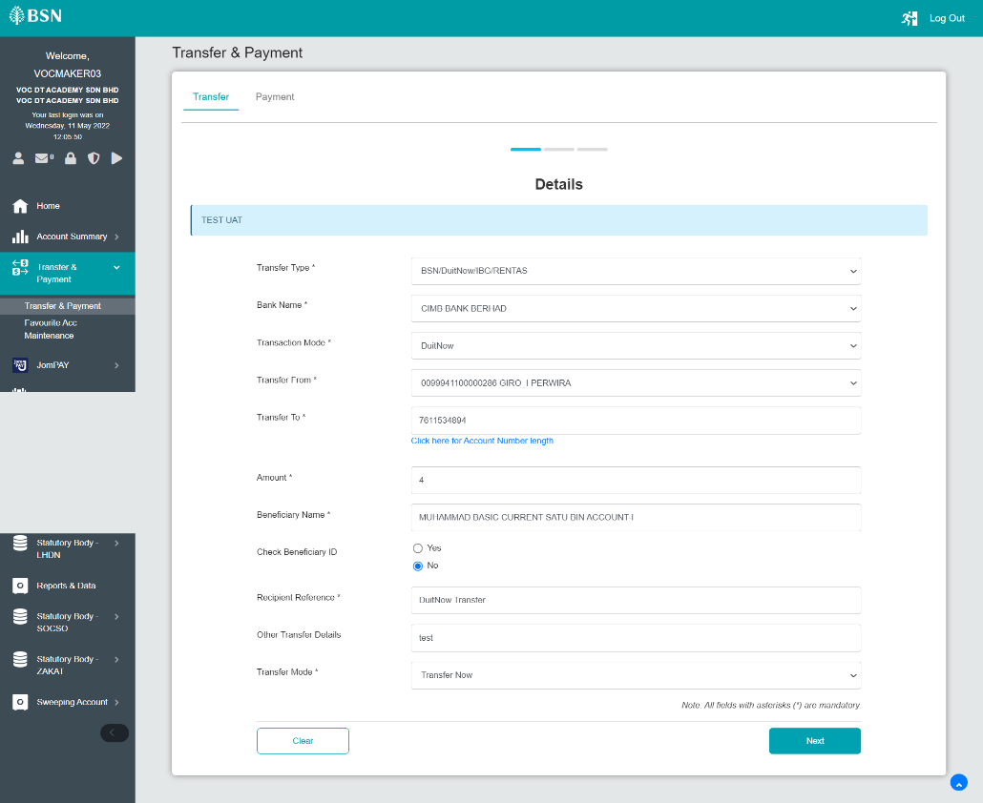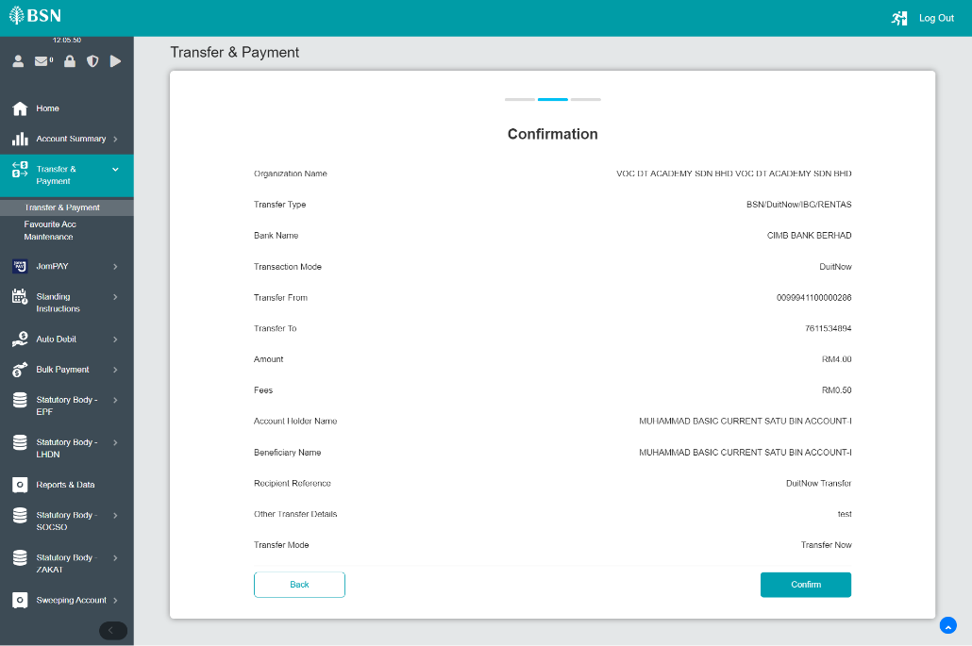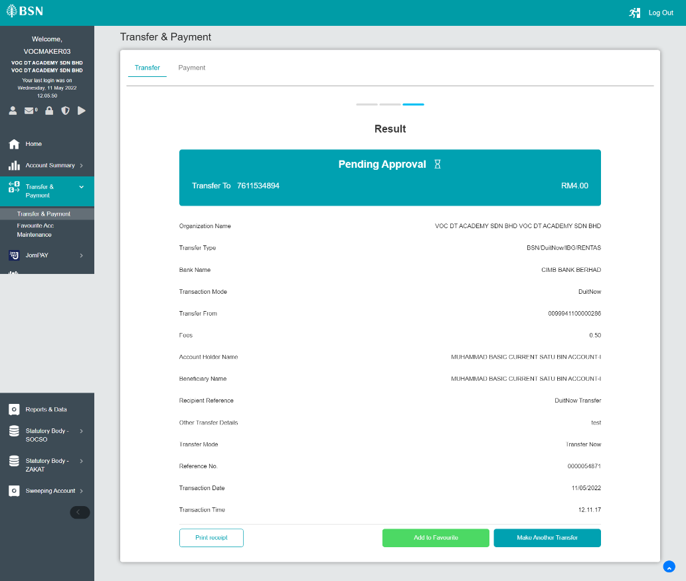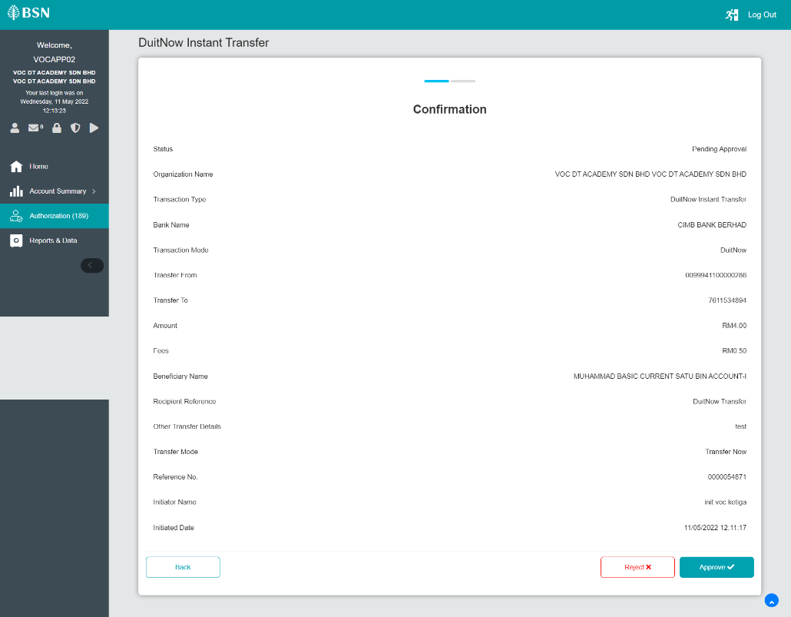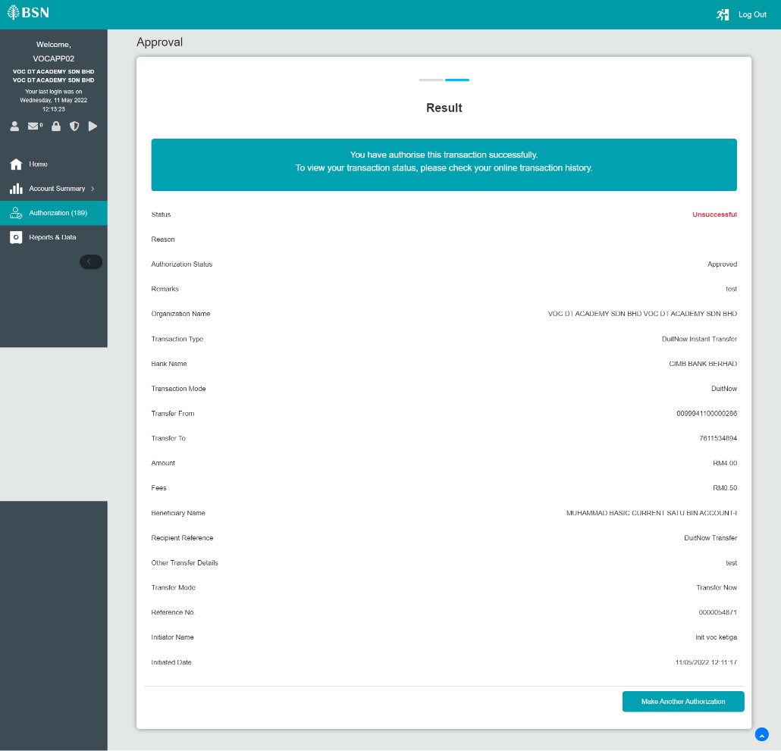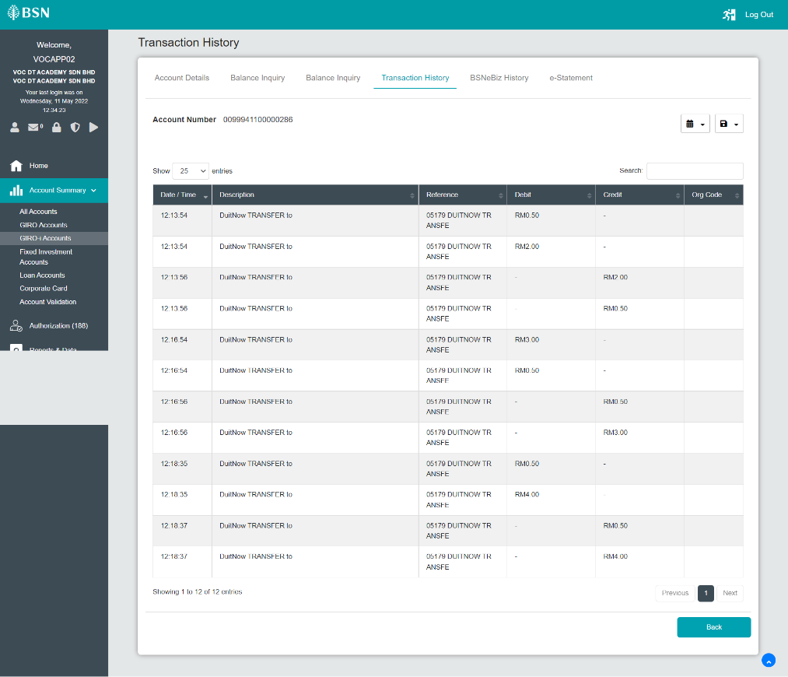  - Single User - Test steps A Rejected DuitNow Payment  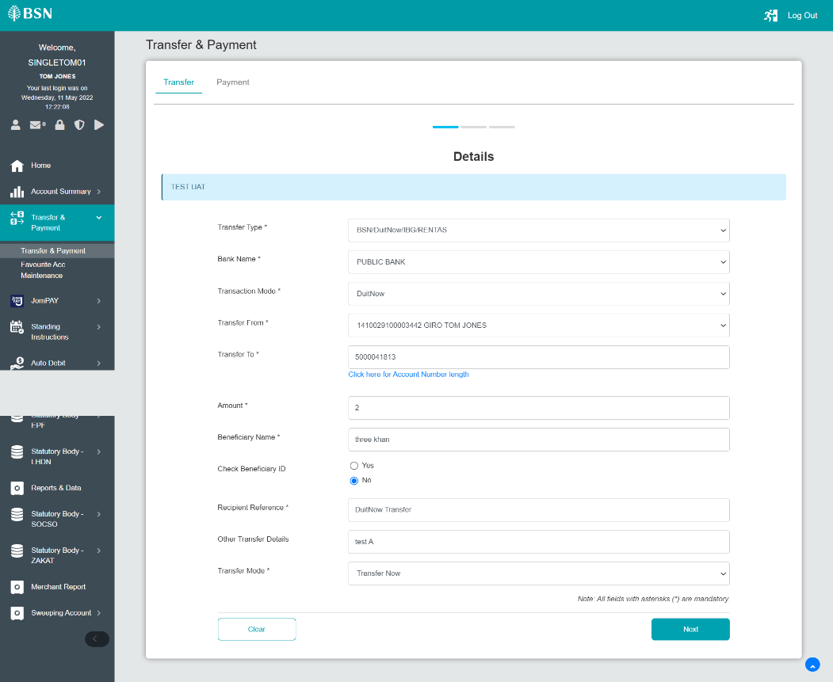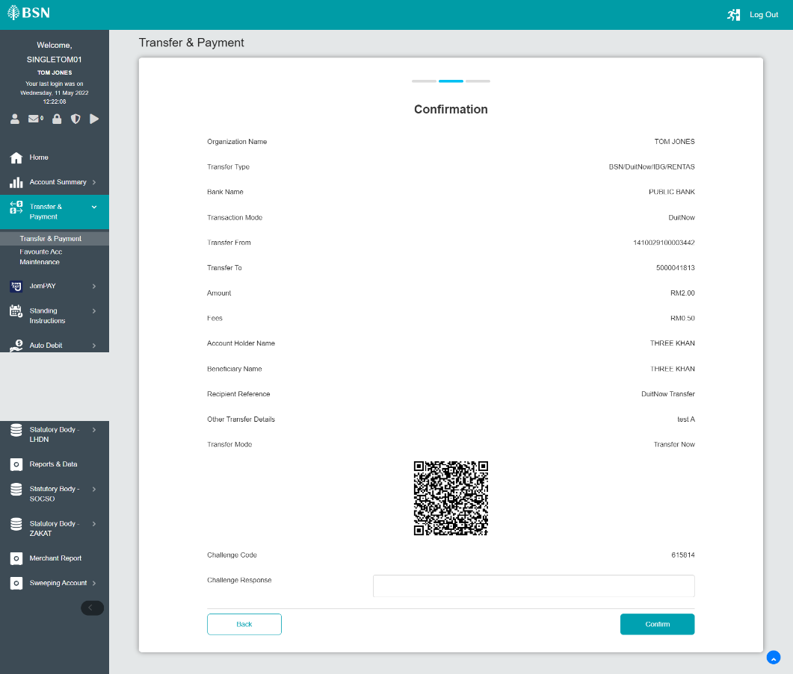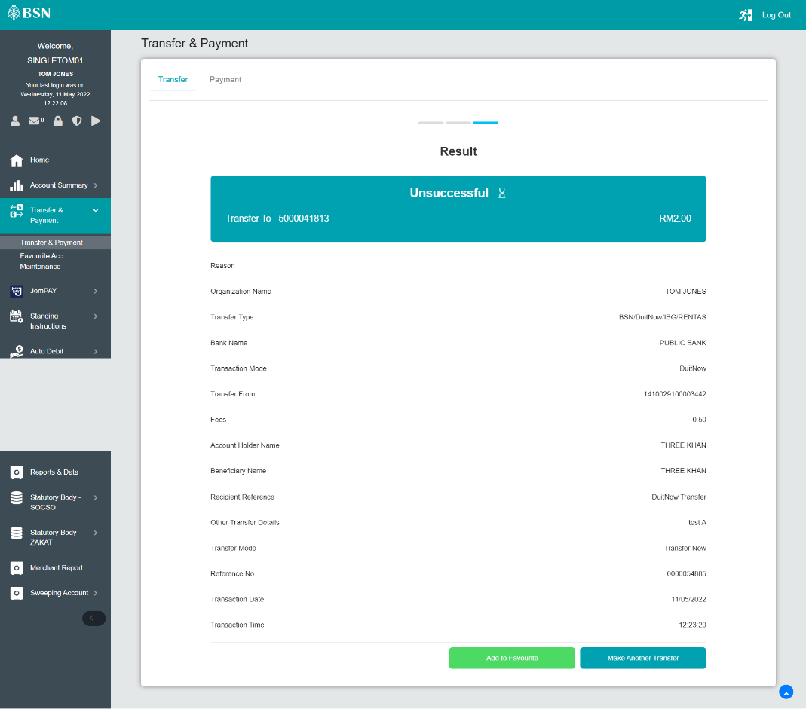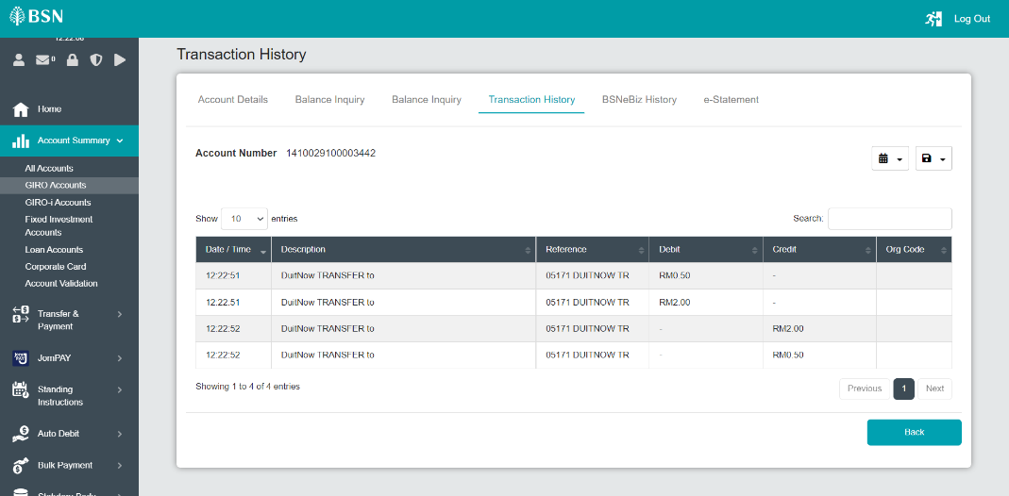  - Single User - Test steps B Account holder name with special character  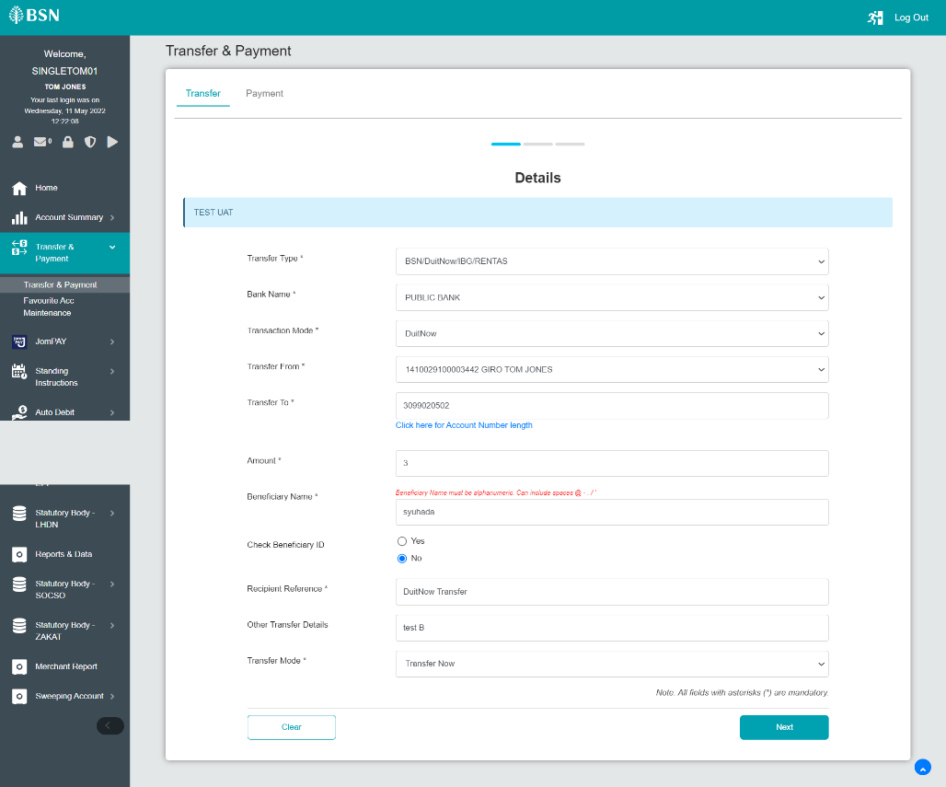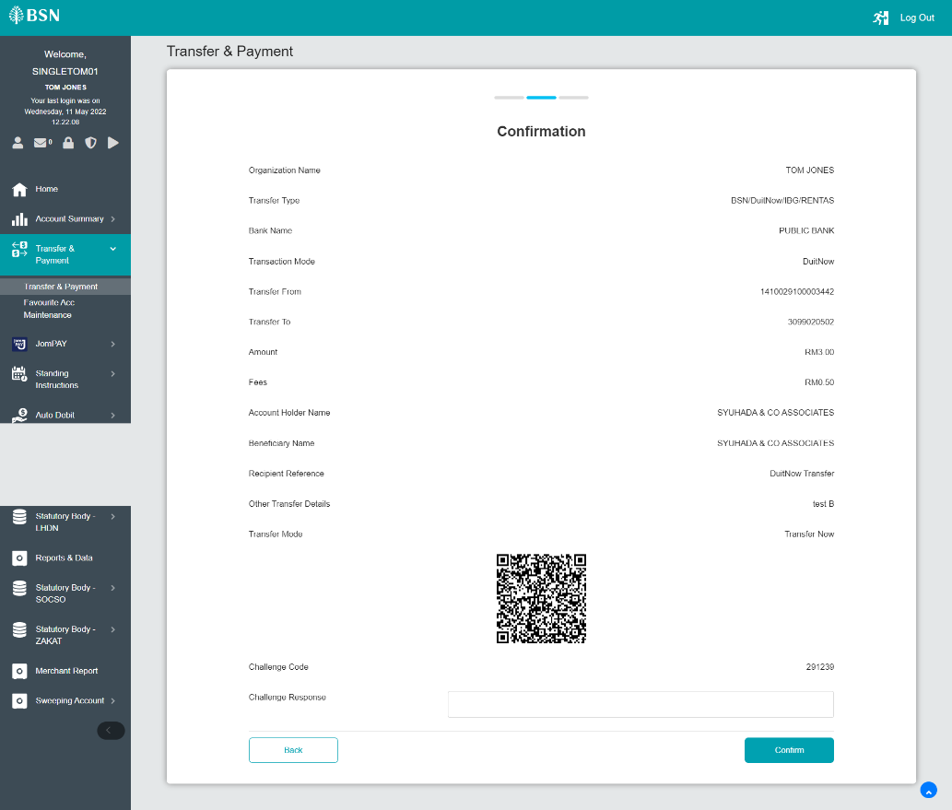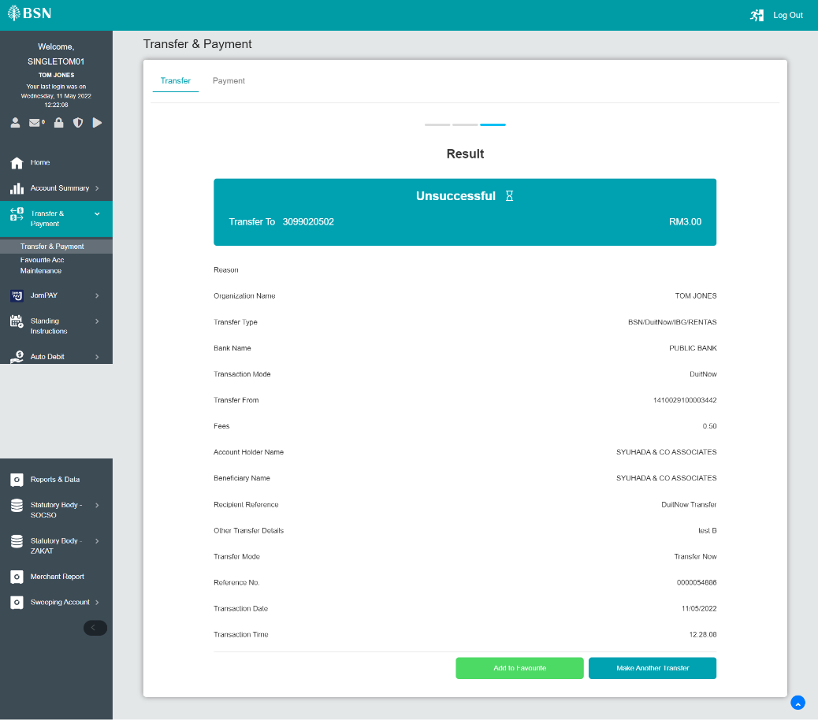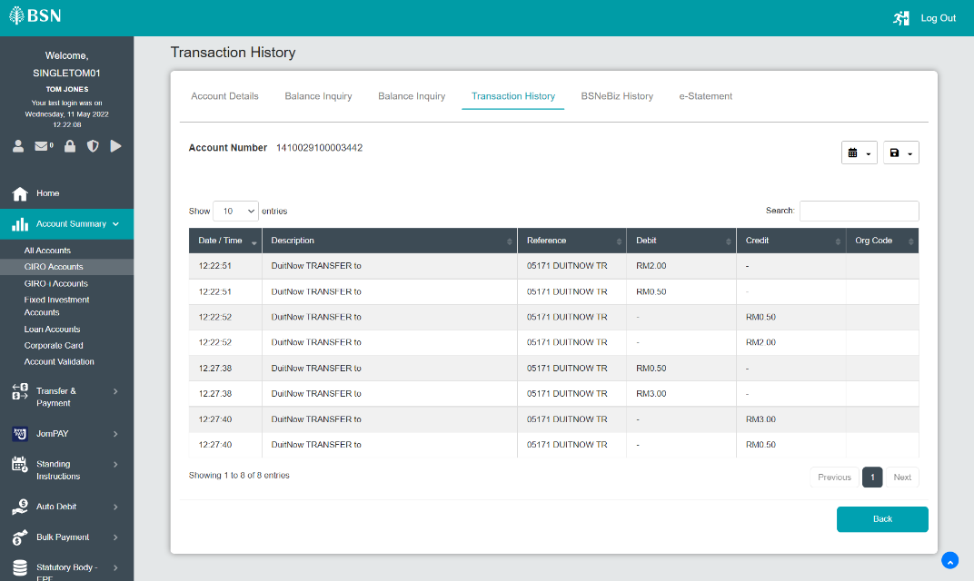  - Single User - Test steps C Account holder name with more than 30 character  