SCPID# 6267
Test Title: |  | Fail receipt shown at Auto Debit Billing
Test Description: |  | Auto Debit file upload status is Pending Validate but the receipt stamp shows Failed
Test Functionality: |  | To test Add receipt image for stamp Pending Validate
Test Procedure: |  | Test steps:  - Update IBAM service info for Auto Debit Billing File Upload. Example, refer to attachment ibamContentServiceInfo.png  - Access BSNeBiz Web as Initiator or Single User  - Access Auto Debit Billing File Upload  - Upload a file with size more than 250KB. Example, refer to attachment Billing_120522123915.data.txt  - Submit file upload  - Download receipt  - Expected result, the status stamp (at the bottom) in the receipt is Pending Validate. Example, refer to attachment receipt.pdf #
Response Message:
The status stamp (at the bottom) in the receipt is Pending Validate.
Test Result: | Pass: Fail: |  | Tested by: | Syahirah (12/5/2022)
Reason for Failure:
Remarks: |  | - IBAM Service Info  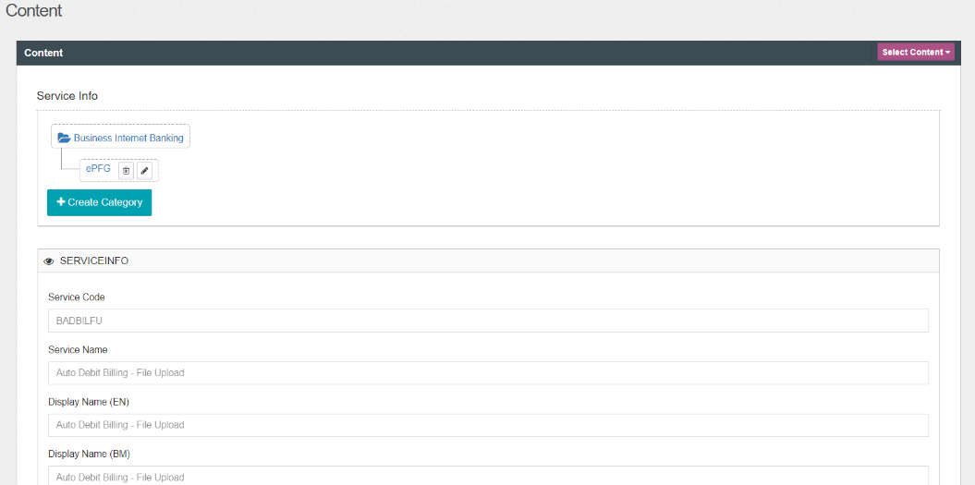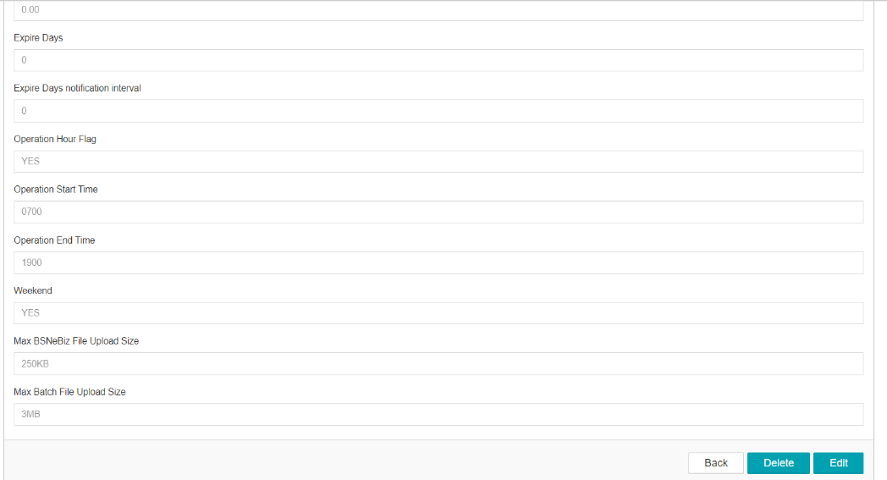  - Auto Debit Billing File Upload  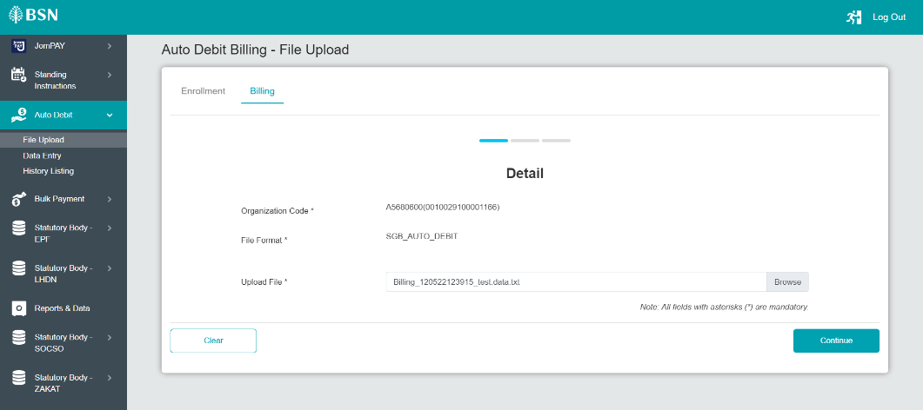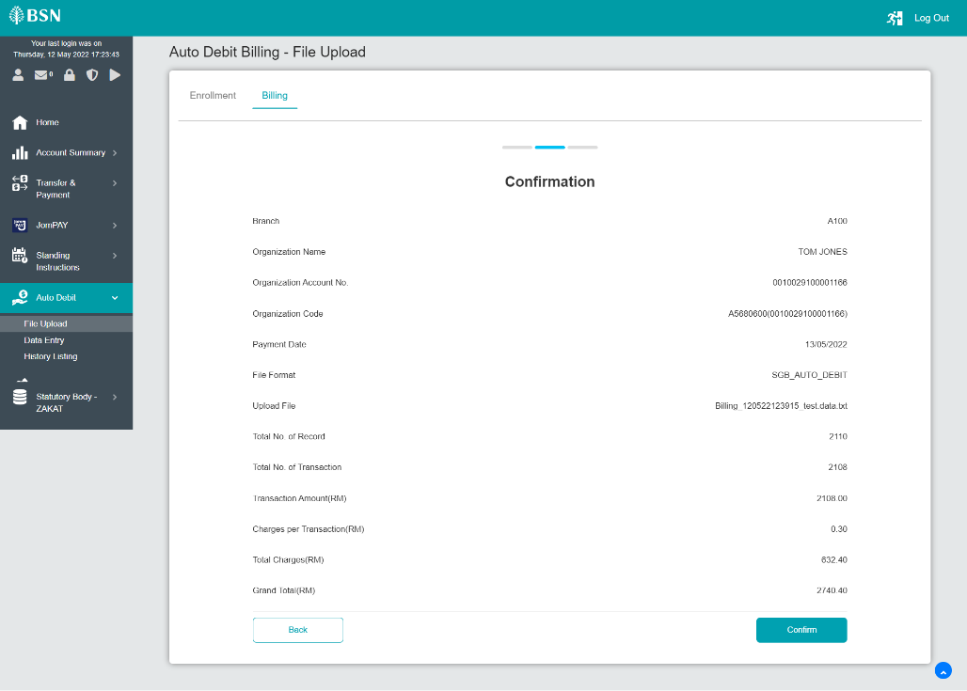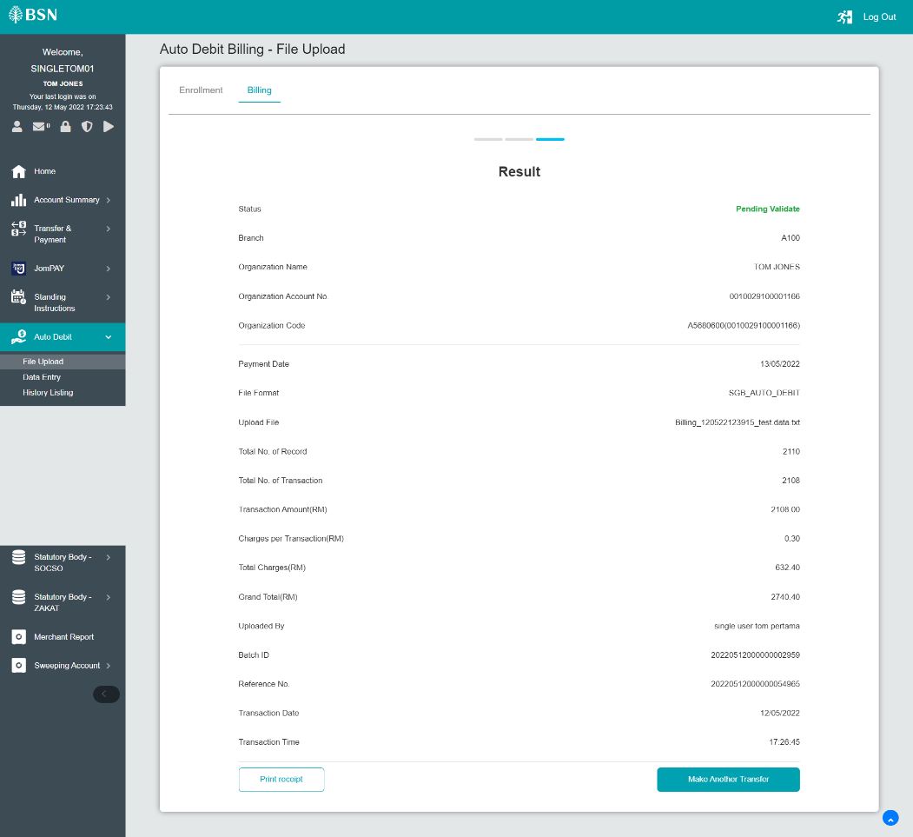  - Receipt  