SCPID# 6283
Test Title: |  | Jompay Charges not display in Transaction History and BSNeBiz History
Test Description: |  | Test JomPAY transaction & check amount deducted including in Transaction History & BSNeBiz History
Test Functionality: |  | - To test JomPAY transaction with charges and check amount deducted included charges  - To test Transaction History & BSNeBiz History has JomPAY transaction with charges
Test Procedure: |  | Test steps:  1. Set charges for JomPay at online payment charges (IBAM)  2. Make JomPAY transaction from android  3. Approve and check balance  4. Check Transaction History & BSNeBiz History
Response Message:
Amount deducted should included charges & JomPAY transaction is displayed in Transaction History & BSNeBiz History
Test Result: | Pass: Fail: |  | Tested by: | Syahirah (26/05/2022)
Reason for Failure:
Remarks: |  | - Set charges for JomPAY at IBAM  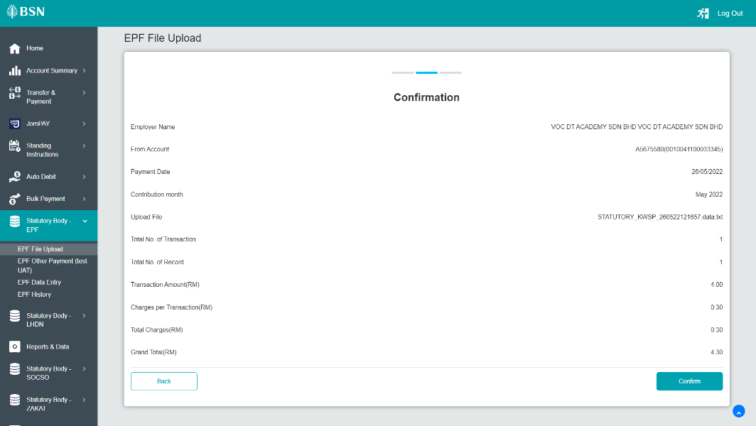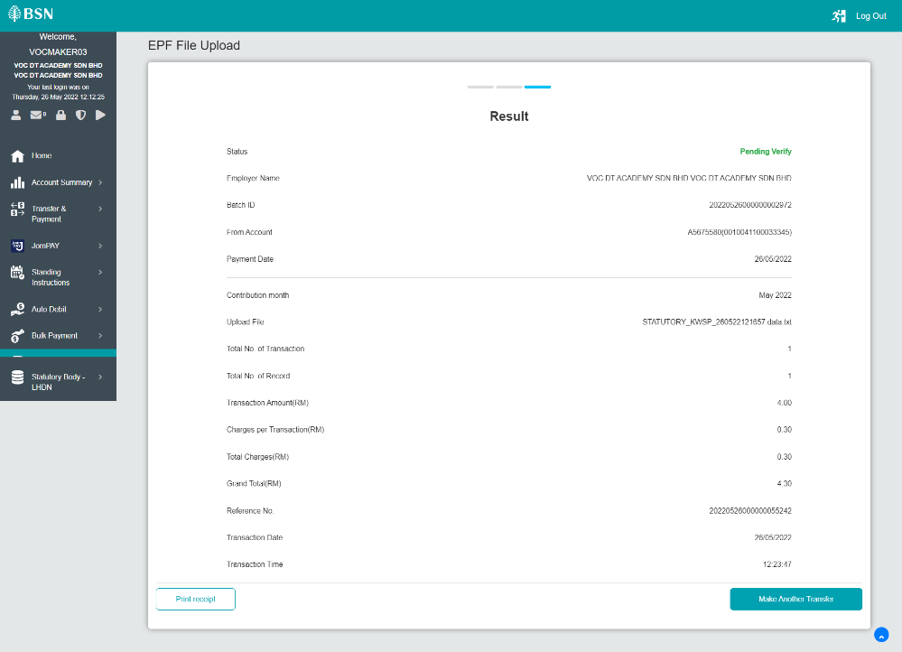  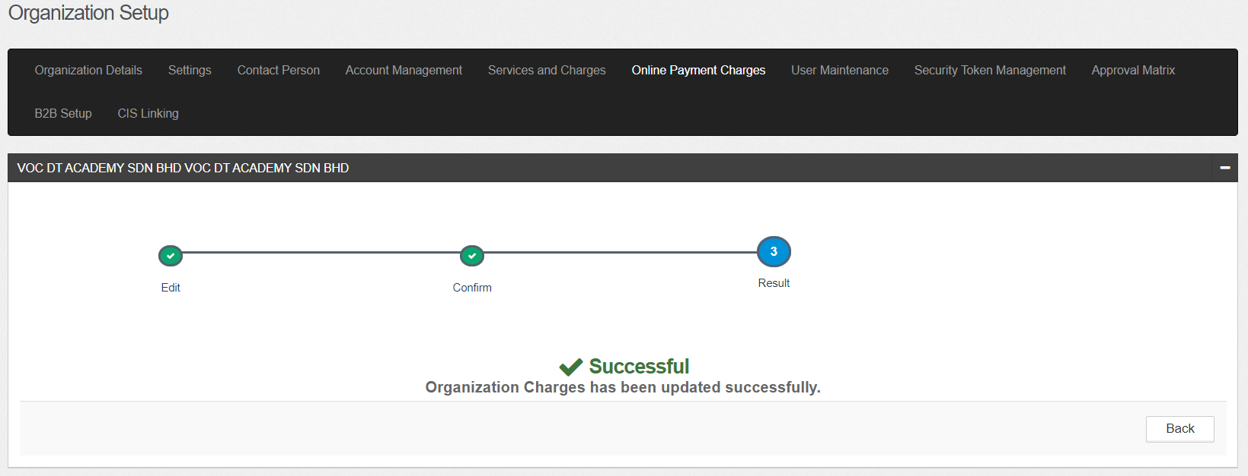  - Make transaction from Android – Workflow  - Initiator  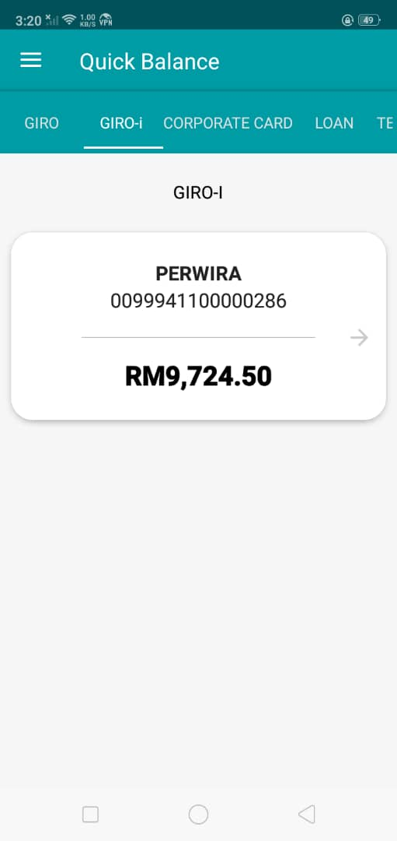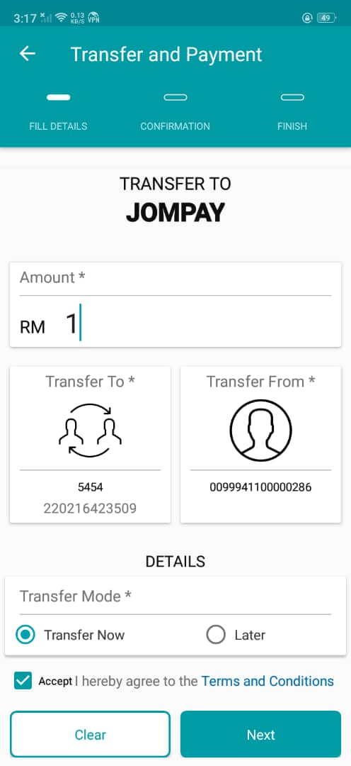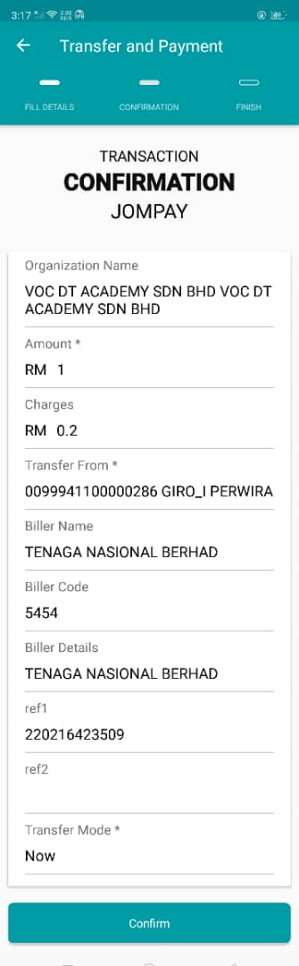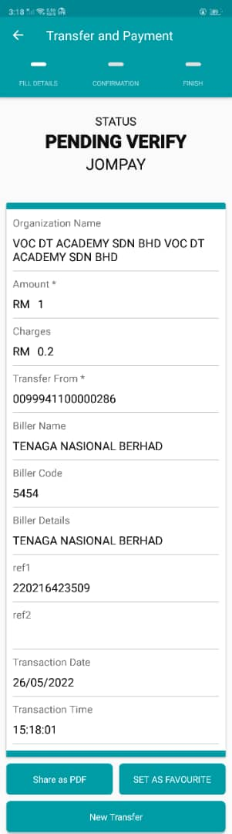  - Verifier  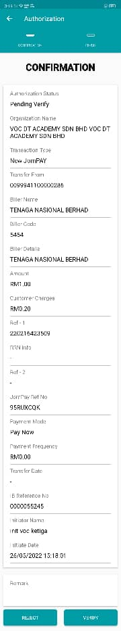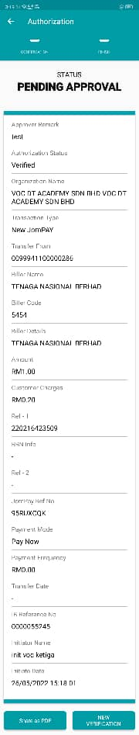  - Approver  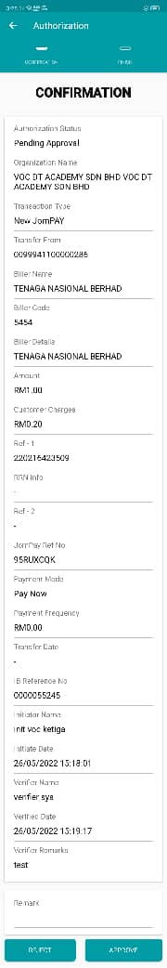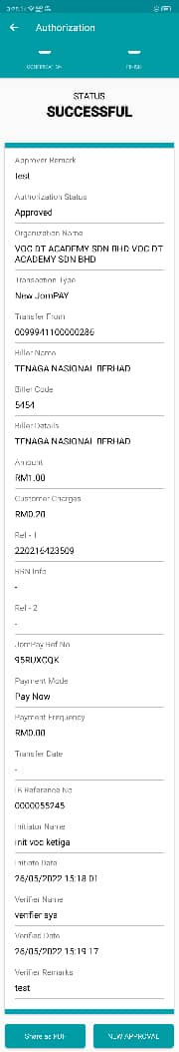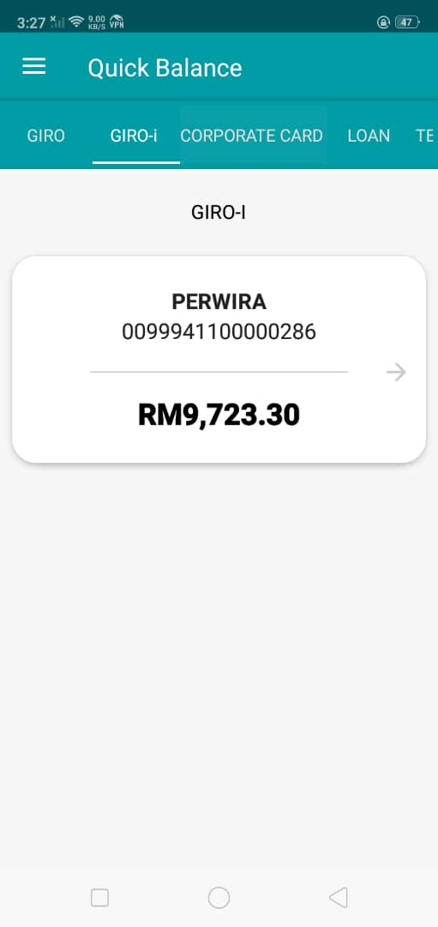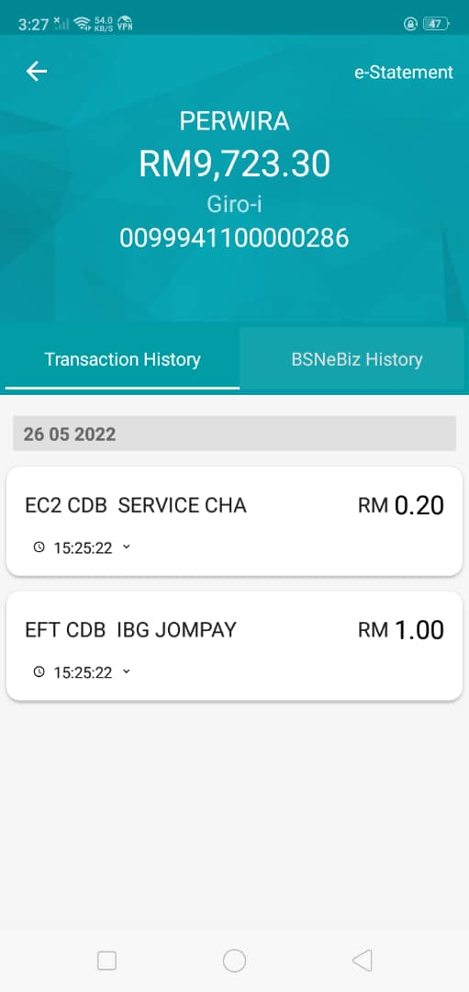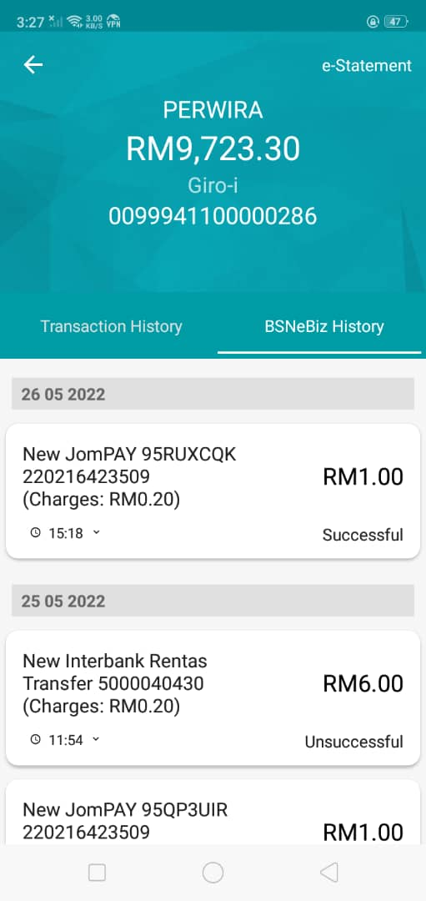  - Make transaction from Android – Single User  