SCPID# 6249
Test Title: |  | [ANDROID] - Pentest - I1 - Application Allows Use of Third-Party Keyboards
Test Description: |  | The application allows the use of third-party keyboards when entering sensitive data. A malicious third-party keyboard could spy and log users' input.  Action Plan:  Already set the program following the reported issue on last Pentest scanning.
Test Functionality: |  | To test alert popup will be displayed to notice user about the third-party keyboard usage.
Test Procedure: |  | Test steps:  1. Go to Device settings  2. Find Language and Input  3. Click Default Keyboard  4. If the Default Keyboard is using third party keyboard, after Login the BSNeBiz Mobile App, an alert popup should be displayed to notice user about the third party keyboard usage.  5. For Samsung device, if the Default Keyboard is using Samsung Keyboard, try to change to another keyboard. Open the BSNeBiz Mobile App, then alert popup should be displayed to notice user about the third party keyboard usage.
Response Message:
Alert popup will be displayed to notify user about the third-party keyboard usage.
Test Result: | Pass: Fail: |  | Tested by: | Syahirah (2/6/2022) – Oppo A3s Androidv8.1.0
Reason for Failure:
Remarks: |  | - Keyboard settings:  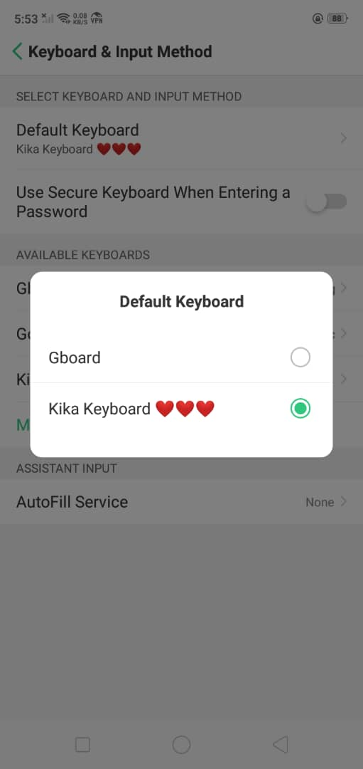  - Alert popup for 3rd party keyboard usage:  