SCPID# 6249
Test Title: |  | [ANDROID] - Pentest - I2 - Application Screenshot (Unintended Data Leakage)
Test Description: |  | The application allows users to take a screenshot of the application's current state on their mobile device. Data may be disclosed if a screenshot is taken when the application screen contains sensitive data. Additionally, if a device is infected by malware, it may record the user's activities and data shown on the application screen to steal sensitive data.  Action Plan:  Already set the program following the reported issue on last Pentest scanning.
Test Functionality: |  | To test alert popup
Test Procedure: |  | Test steps:  - Login to BSNeBiz Mobile app  - Screenshot or screen record any page
Response Message:
- Message alert displayed to remind user cannot capture screenshot.
- Video of screen record is blank
Test Result: | Pass: Fail: |  | Tested by: | Syahirah (2/6/2022) – Oppo A3s Androidv8.1.0
Reason for Failure:
Remarks: |  | - Home page:  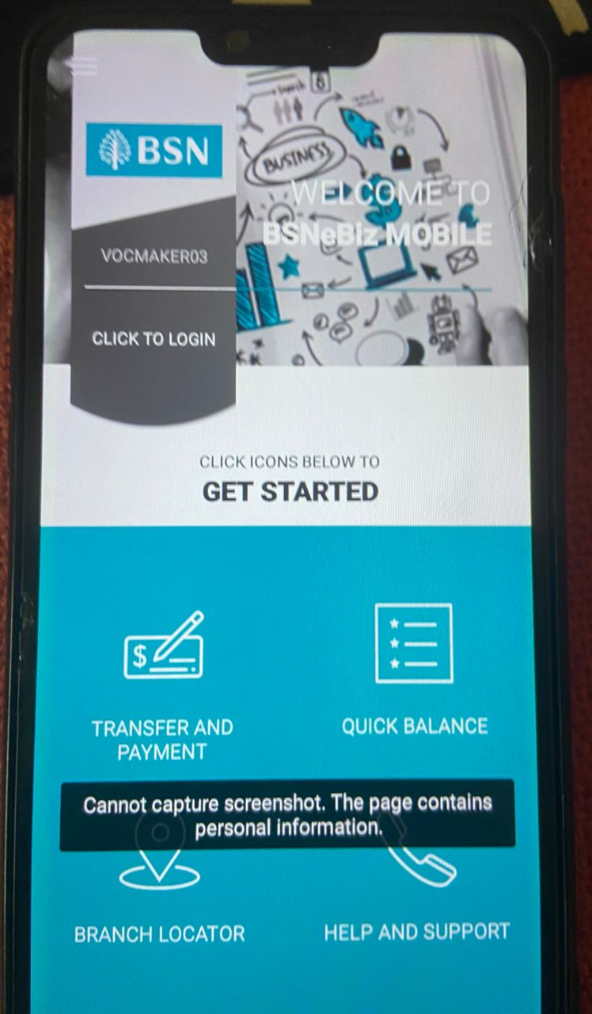  - Payment & Transfer page  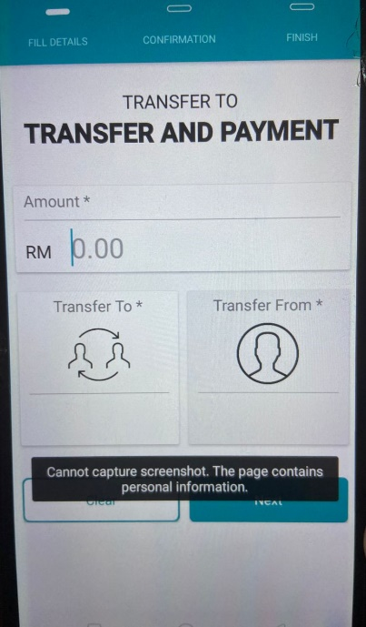  - Quick Balance  