SCPID# 6303
Test Title: |  | Unable to approve company creation
Test Description: |  | Edit organization & approved
Test Functionality: |  | To test approve edited organization
Test Procedure: |  | Test steps:  - Access IBAM as maker  - Access CBE>Org Setup>Select Company>Account Management and remove all account  - Access CBE>Org Setup>Select Company>Setting and edit setting  - Access IBAM as checker  - Access Authorization>Approval  - Approve Company Account Management  - Approve Company setting  - Expected result, both approval success and changes is reflected in Org Setup Account and Setting
Response Message:
Amount deducted should included charges & JomPAY transaction is displayed in Transaction History & BSNeBiz History
Test Result: | Pass: Fail: |  | Tested by: | Syahirah (16/06/2022)
Reason for Failure:
Remarks: |  | - IBAM Maker – Account Management  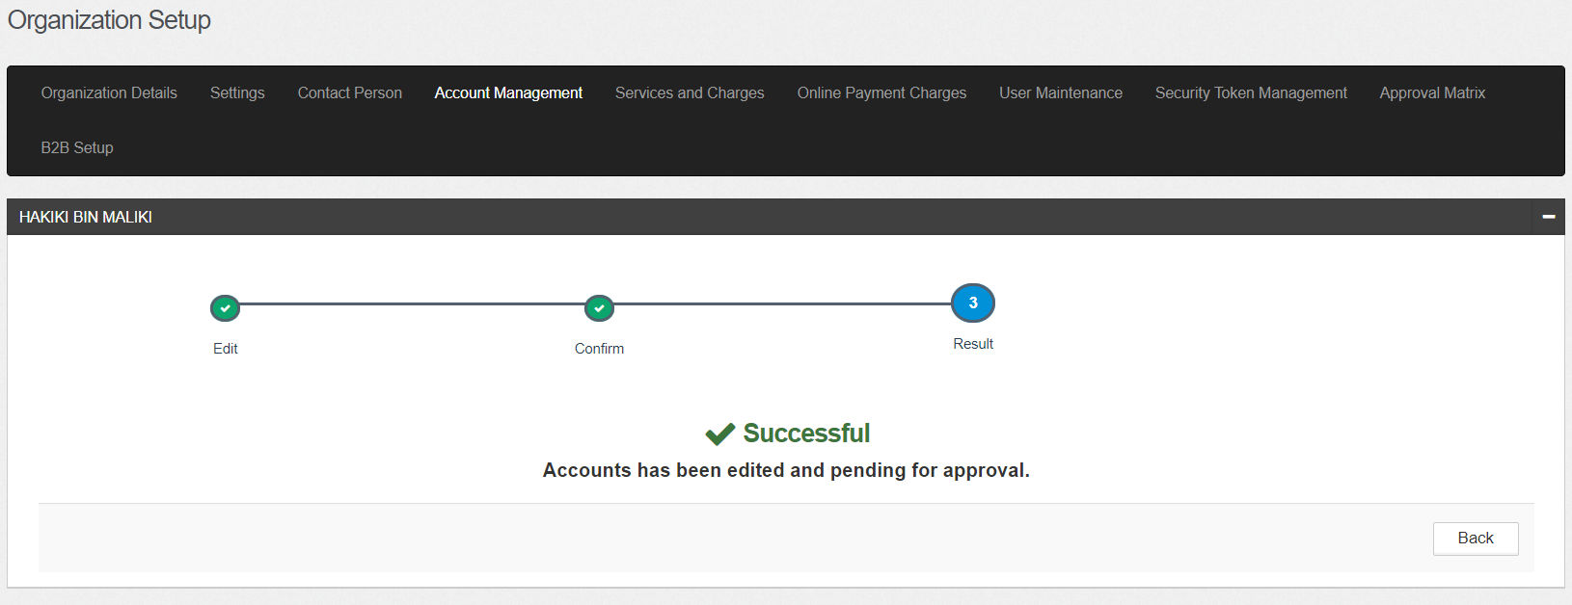  - IBAM Maker – Settings  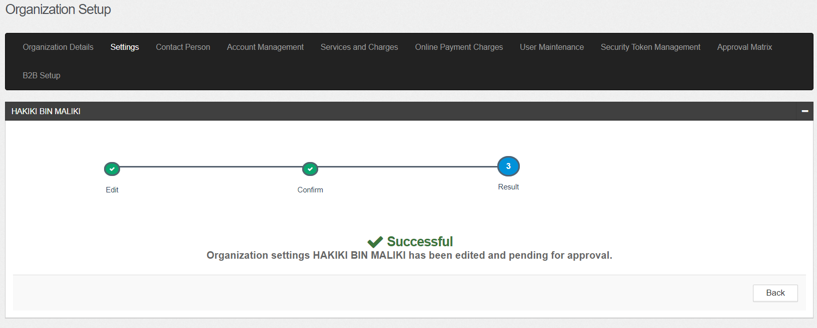  - IBAM Checker – Account Management  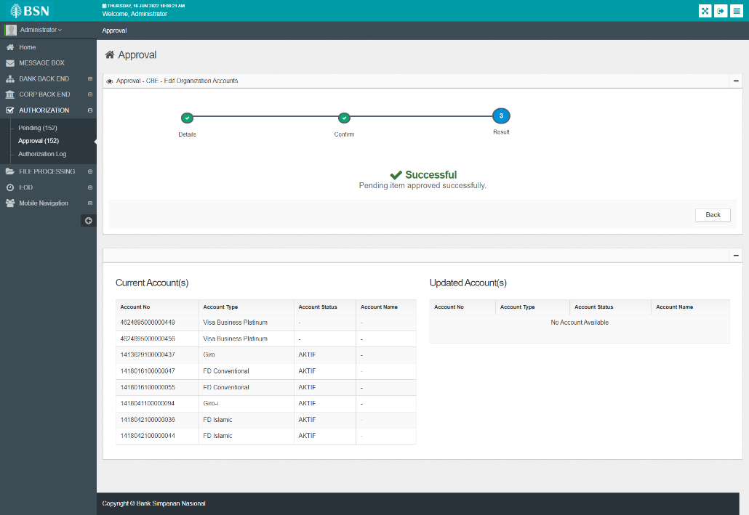  - IBAM Checker – Settings  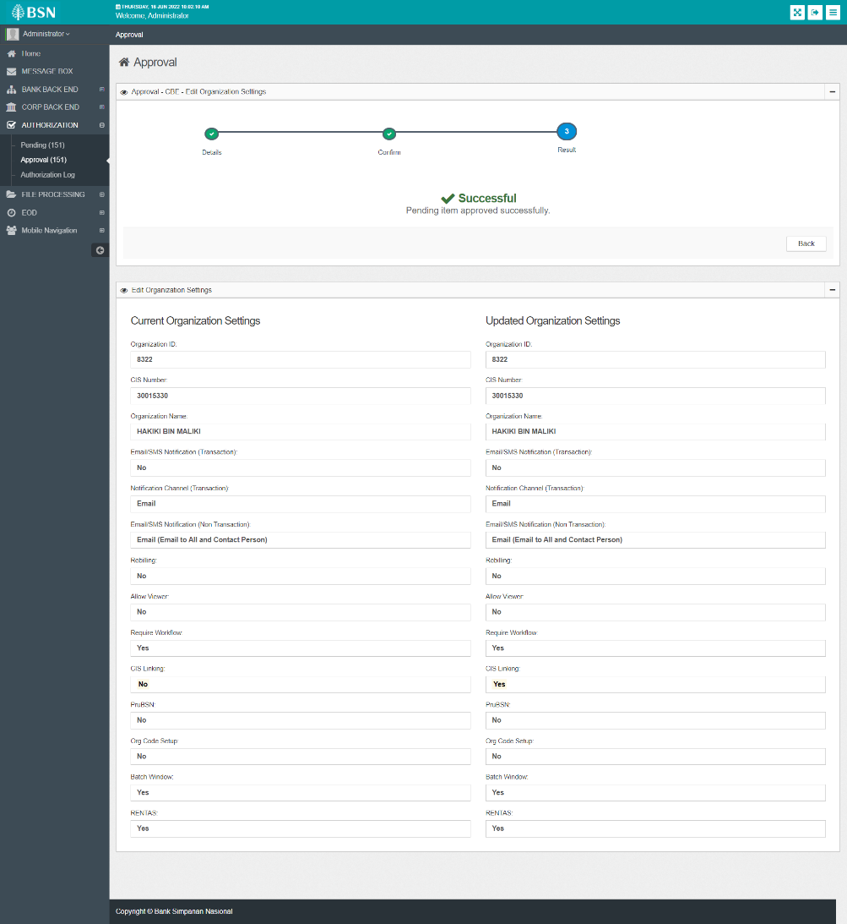  - Changes is reflected in Organization Setup – Account Management  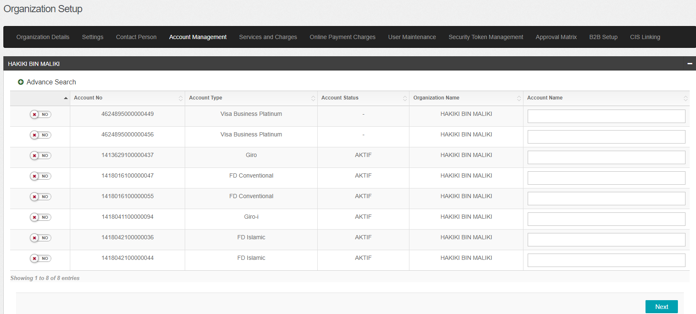  - Changes is reflected in Organization Setup – Settings  