SCPID# 6313
Test Title: |  | BSNebiz Summary Report
Test Description:
Test Functionality: |  | To test new report type for Corporate Summary, Single Transaction & Bulk Transaction by State
Test Procedure: |  | Test steps:  - Access IBAM  - Click Corporate Back End > BSNeBiz Reports  - Click New Report button.  - At Report Type, select BSNeBiz Corporate Summary by State  - Select file format at File Type.  - Click Next button until Result page.  - Click BSNeBiz Report navigation.  - At Report Type, select BSNeBiz Corporate Summary by State and click Search button.  - Click Download button for selected report.  - Check content of report.  - Repeat testing for Report Type: BSNeBiz Single Transaction by State & BSNeBiz Bulk Transaction by State
Response Message:
New report for Corporate Summary by State, Single Transaction by State & Bulk Transaction by State can be view & downloaded in both PDF & Excel format.
Test Result: | Pass: Fail: |  | Tested by: | Syahirah (28/06/2022)
Reason for Failure:
Remarks: |  | - BSNeBiz Corporate Summary by State (PDF)  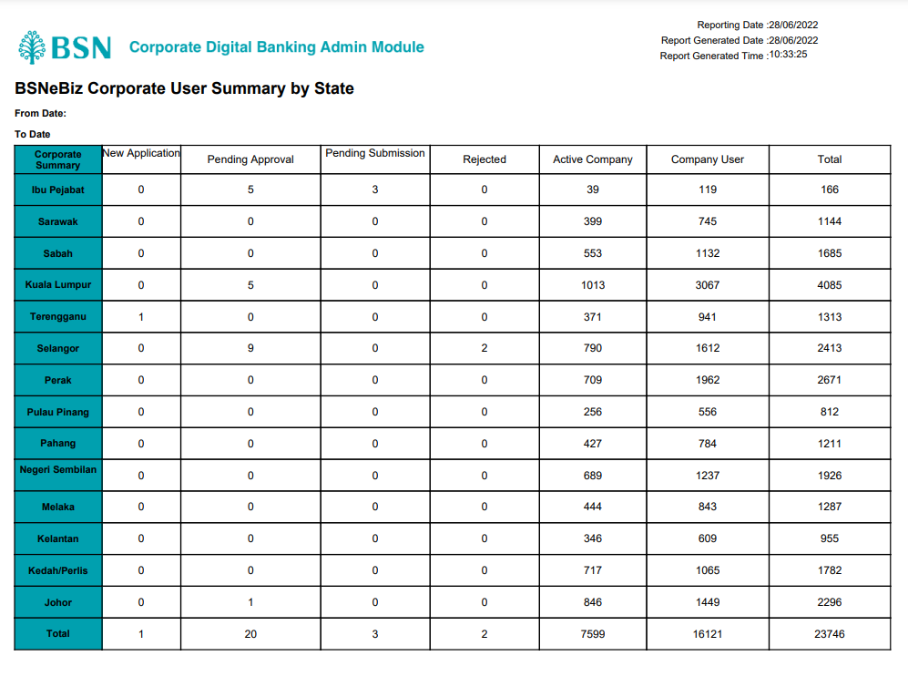  - BSNeBiz Corporate Summary by State (Excel)  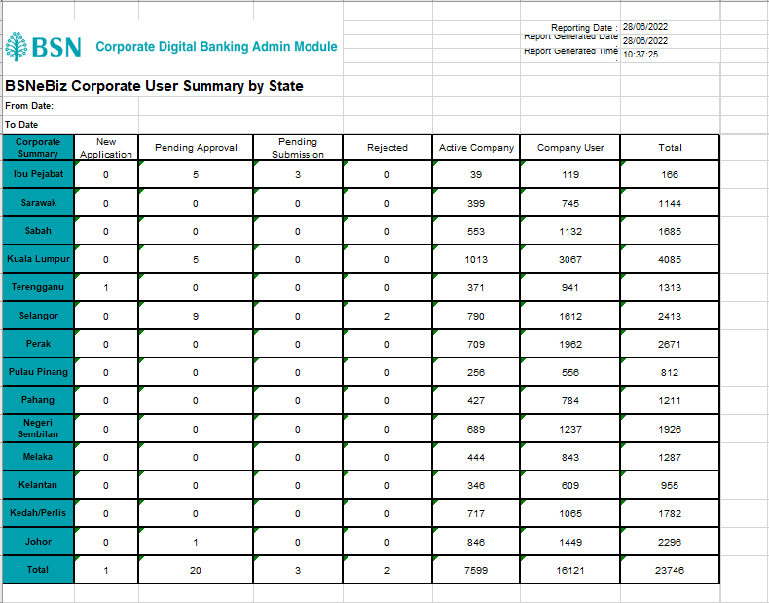  - BSNeBiz Single Transaction by State (PDF)  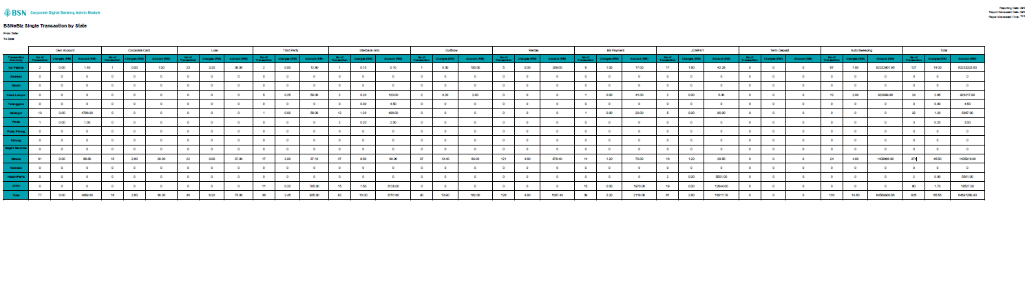  - BSNeBiz Single Transaction by State (Excel)  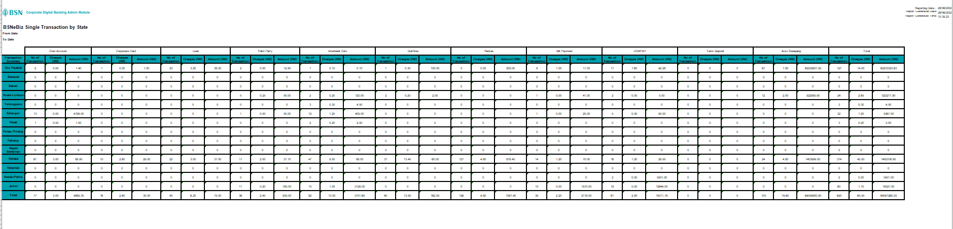  - BSNeBiz Bulk Transaction by State (PDF)  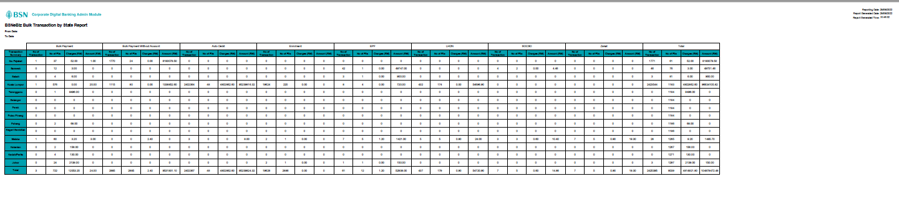  - BSNeBiz Bulk Transaction by State (Excel)  