SCPID#6345
Test Title: |  | BSNebiz Report – Enhancement 6/7/22
Test Description: |  | New Request:  BSNebiz Summary Report  - New Application – to calculate based on actual application by date NOT by status  - Labelling  - To includes field contains No of Charges  BSNebiz Corporate User Report by state  - To calculate based on actual application by date NOT by status  - To remove total column and only remain the total row
Test Functionality: |  | To test new enhancement for BSNeBiz Summary Report
Test Procedure: |  | Test steps:  - Access IBAM  - Click Corporate Back End > BSNeBiz Reports  - Click New Report button.  - At Report Type, select BSNeBiz Summary Report  - Select file format at File Type. (PDF and Excel)  - Click Next button until Result page.  - Click BSNeBiz Report navigation.  - At Report Type, select BSNeBiz Summary Report and click Search button.  - Click Download button for selected report.  - Check content of report.
Response Message:
New report for Corporate Summary by State, Single Transaction by State & Bulk Transaction by State can be view & downloaded in both PDF & Excel format.
Test Result: | Pass: Fail: |  | Tested by: | Nurul Athira Abdul Rahim (05072022)
Reason for Failure:
Remarks: |  | BSNeBiz Summary Report  - To add calculation based on actual (date) not only by status  - To includes field contains “No of Charges”  - BSNeBiz Summary Report (PDF)  Generate new Report  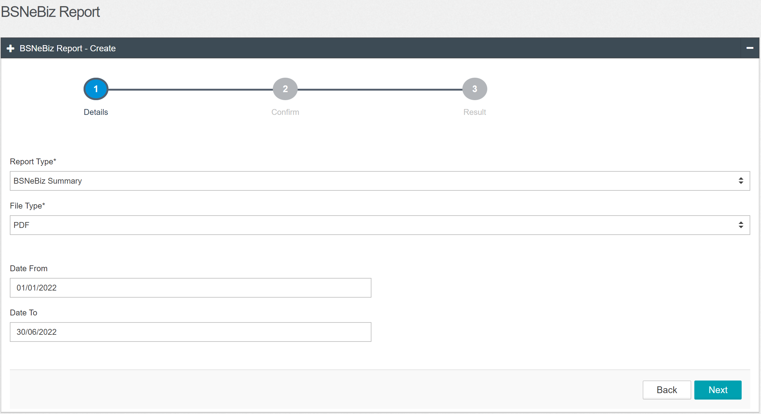  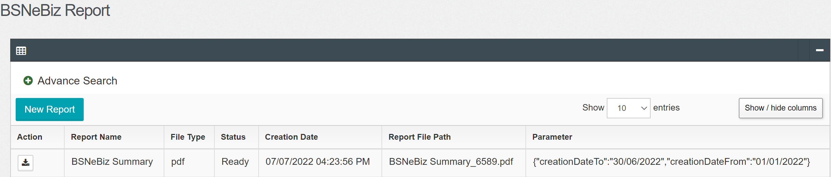  Result:  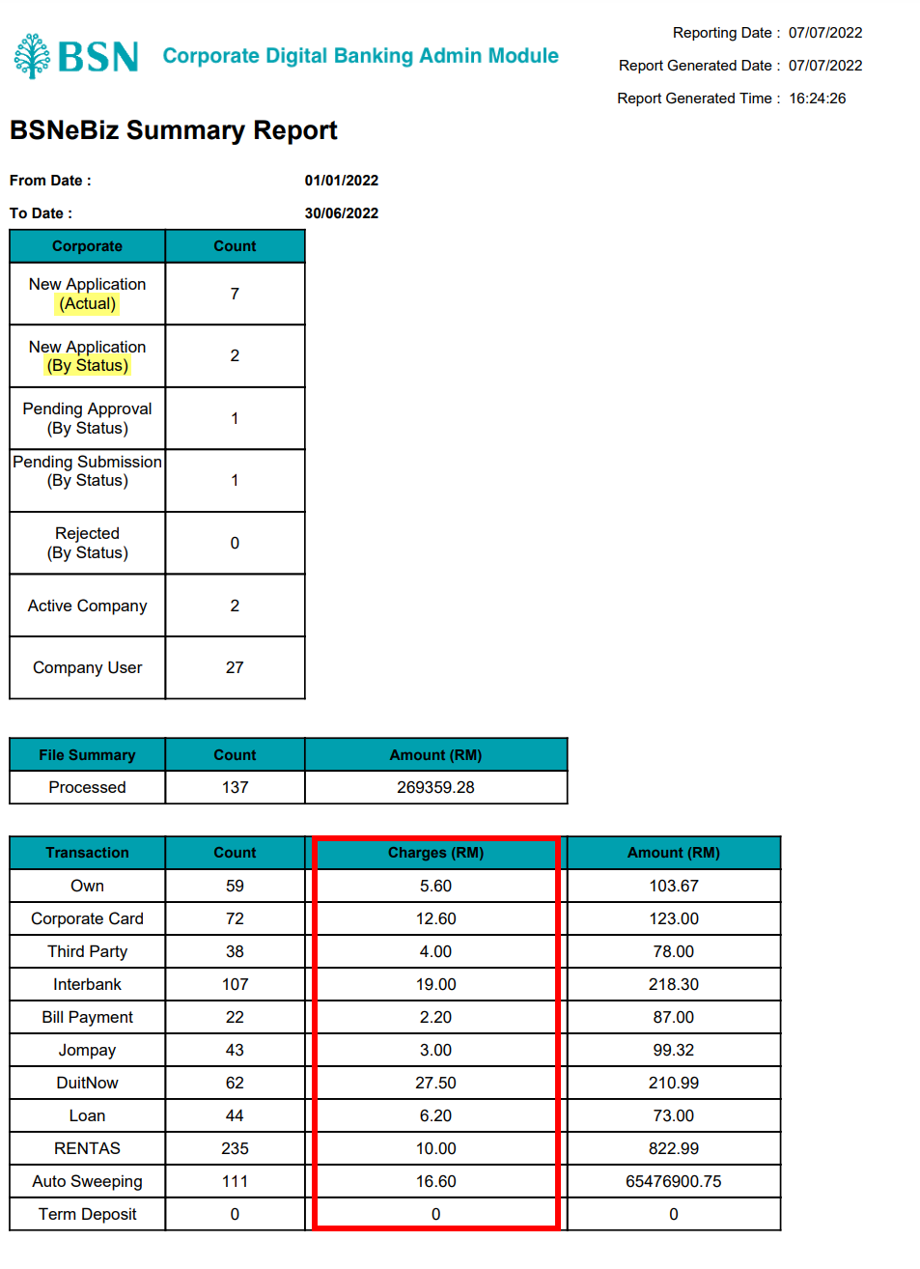  - BSNeBiz Summary (Excel)  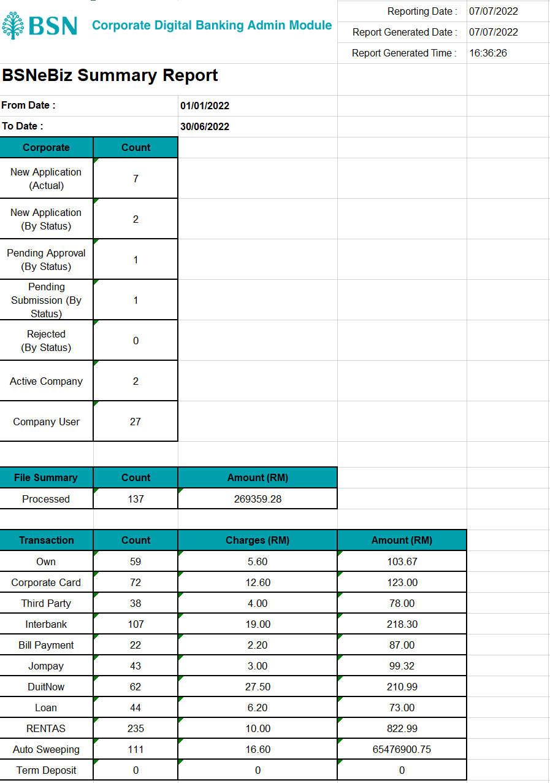  BSNeBiz Corporate Summary Report  - To add calculation based on actual (date) not only by status  - To remove total column and only remain total row  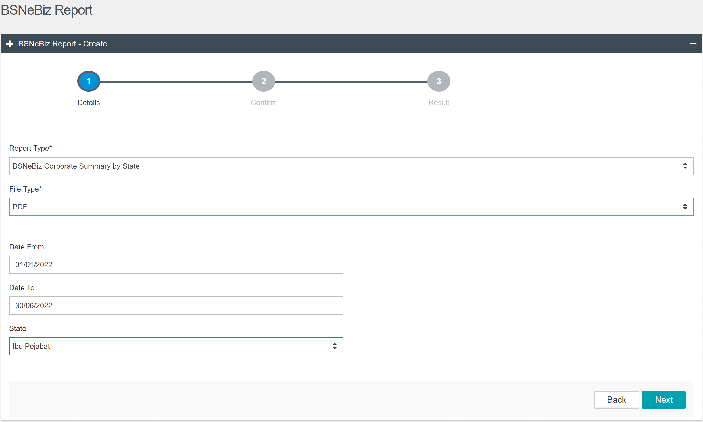  Result PDF :  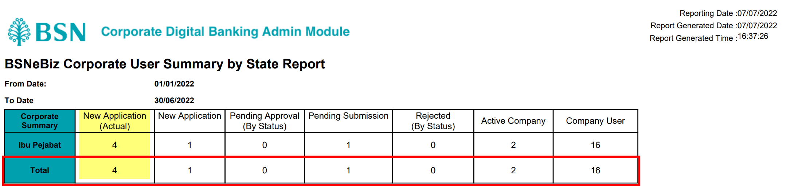  Result Excel :  