SCPID#6361
Test Title: |  | IBAM Authorization Log Template Missing
Test Description: |  | Issue:  Error when downloading IBAM Authorization Log excel report  Finding:  Report template path is pointing to external folder instead of the exiting template in the war file  Solution:  Update the report template path to the exiting template in the war file
Test Functionality: |  | To test on downloading the Authorization Log Report
Test Procedure: |  | Test steps:  - Access IBAM>Authorization>Authorization Log  - Search for any data to populate the list  - Click 'Download report' button  - Expected result, an excel file is download with search data
Response Message:

Test Result: | Pass: Fail: |  | Tested by: | Nor Athirah Umairah (26/07/2022)
Reason for Failure:
Remarks: |  | Logged in as Administrator.  - Access>Authorization>Authorization Log  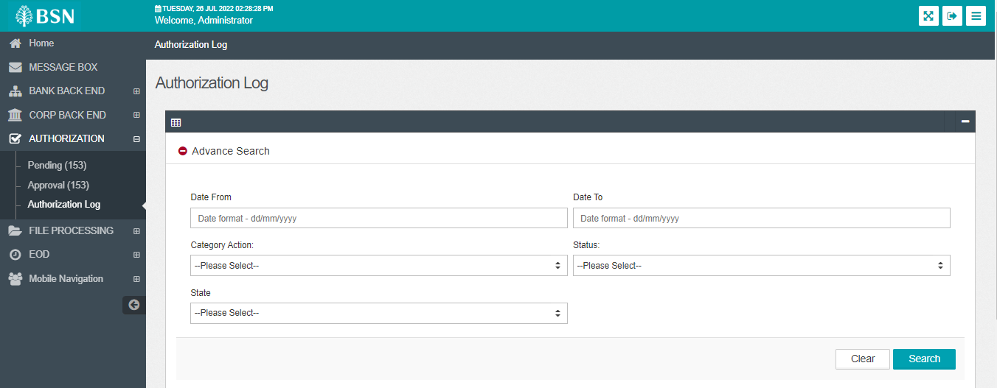  - Search for any data to populate the list  Category Action: Create BSNeBiz Application Form  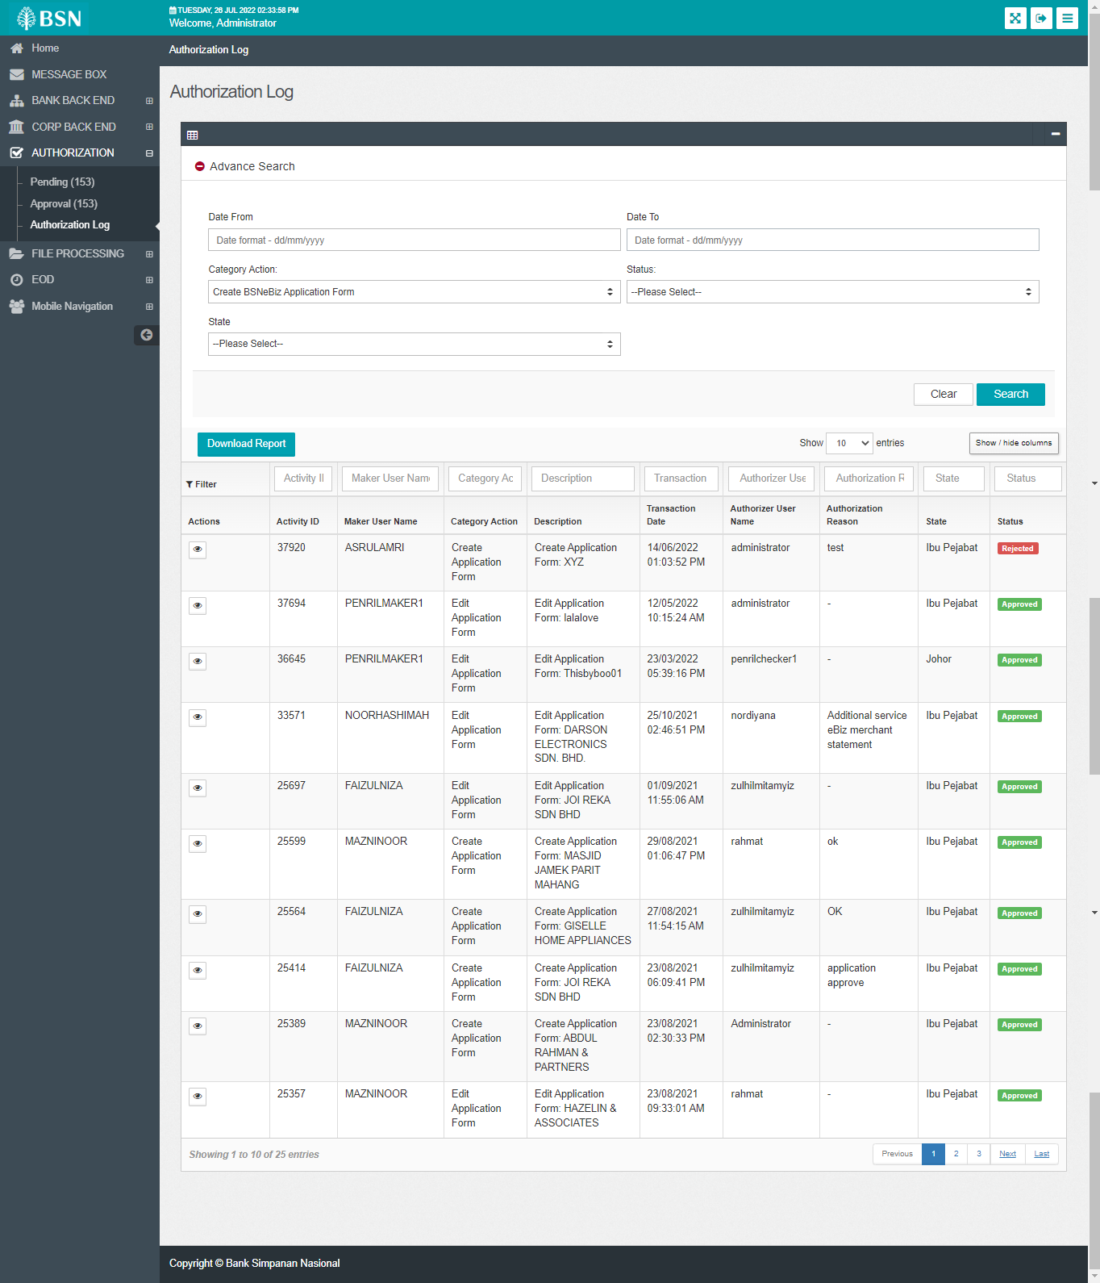  - Click 'Download report' button  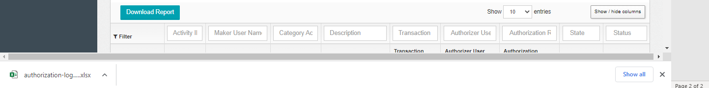  Result:  An excel file is download with search data  