SCPID# 6249
Test Title: |  | Support #12933 : Pentest - L7 - Packet Replay (Fund Transfer)
Test Description: |  | Description  During the time of assessment, LGMS security team identified that packet replay for the fund transfer function is possible by reusing the HTTP request packet. As a result, it is possible for a malicious user to perform duplicate transactions consecutively. It is worth noting that by performing packet replay, it may potential causes service interruption if high volume of packet being triggered  A replay attack is a form of network attack in which a valid data transmission is maliciously or fraudulently repeated or delayed. This is carried out either by the originator or by an adversary who intercepts the data and re-transmits it, possibly as part of a masquerade attack by IP packet substitution.  Solution:  Add JID to user session at database for  - Own transfer  - Third party transfer  - Interbank transfer  - DuitNow transfer  - RENTAS transfer  - Bill payment  - Jompay  - Authorization for above modules
Test Functionality:
Test Procedure:
Response Message:

Test Result: | Pass: Fail: |  | Tested by:
Reason for Failure:
Remarks: |  | Screenshot fixes ANDROID:  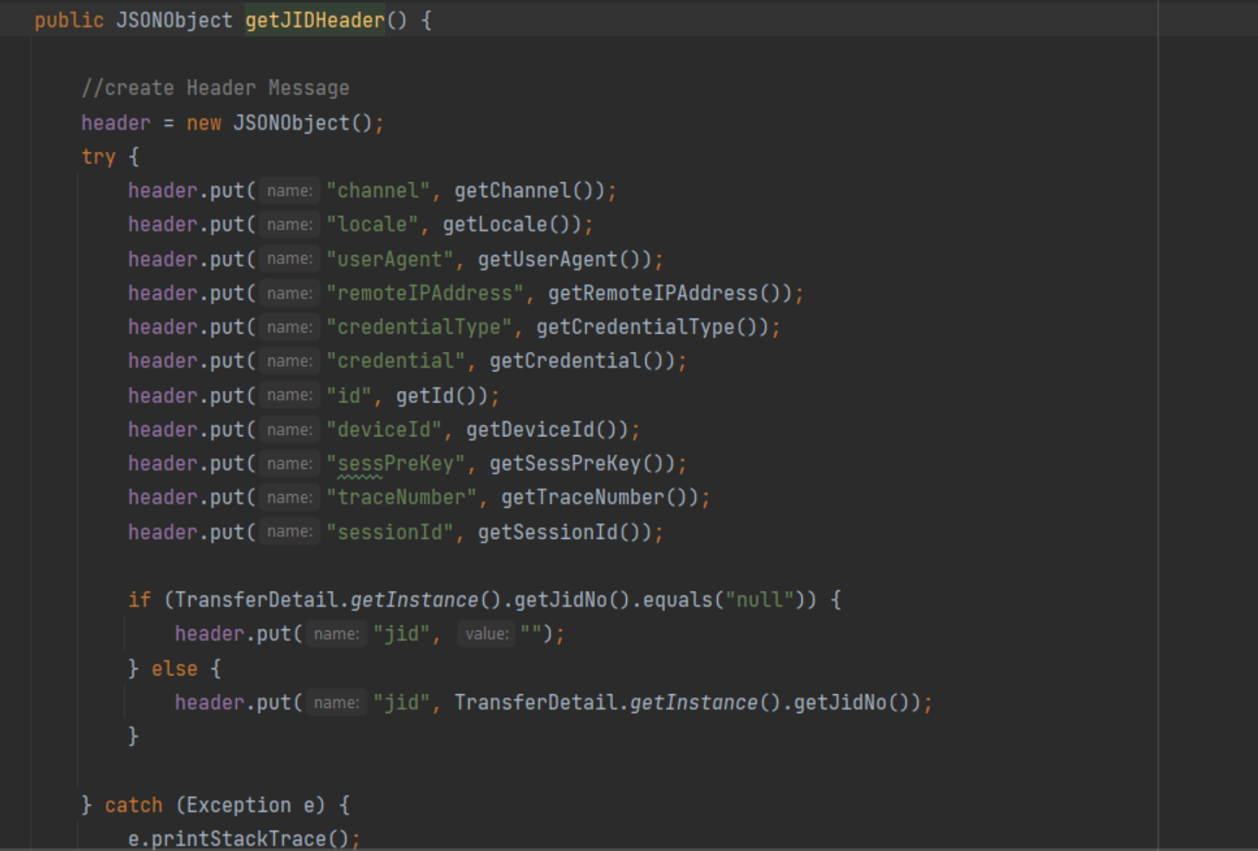  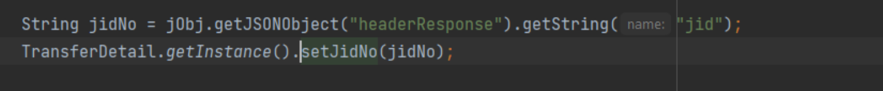  Capture JID example  Screenshot fixes IOS:  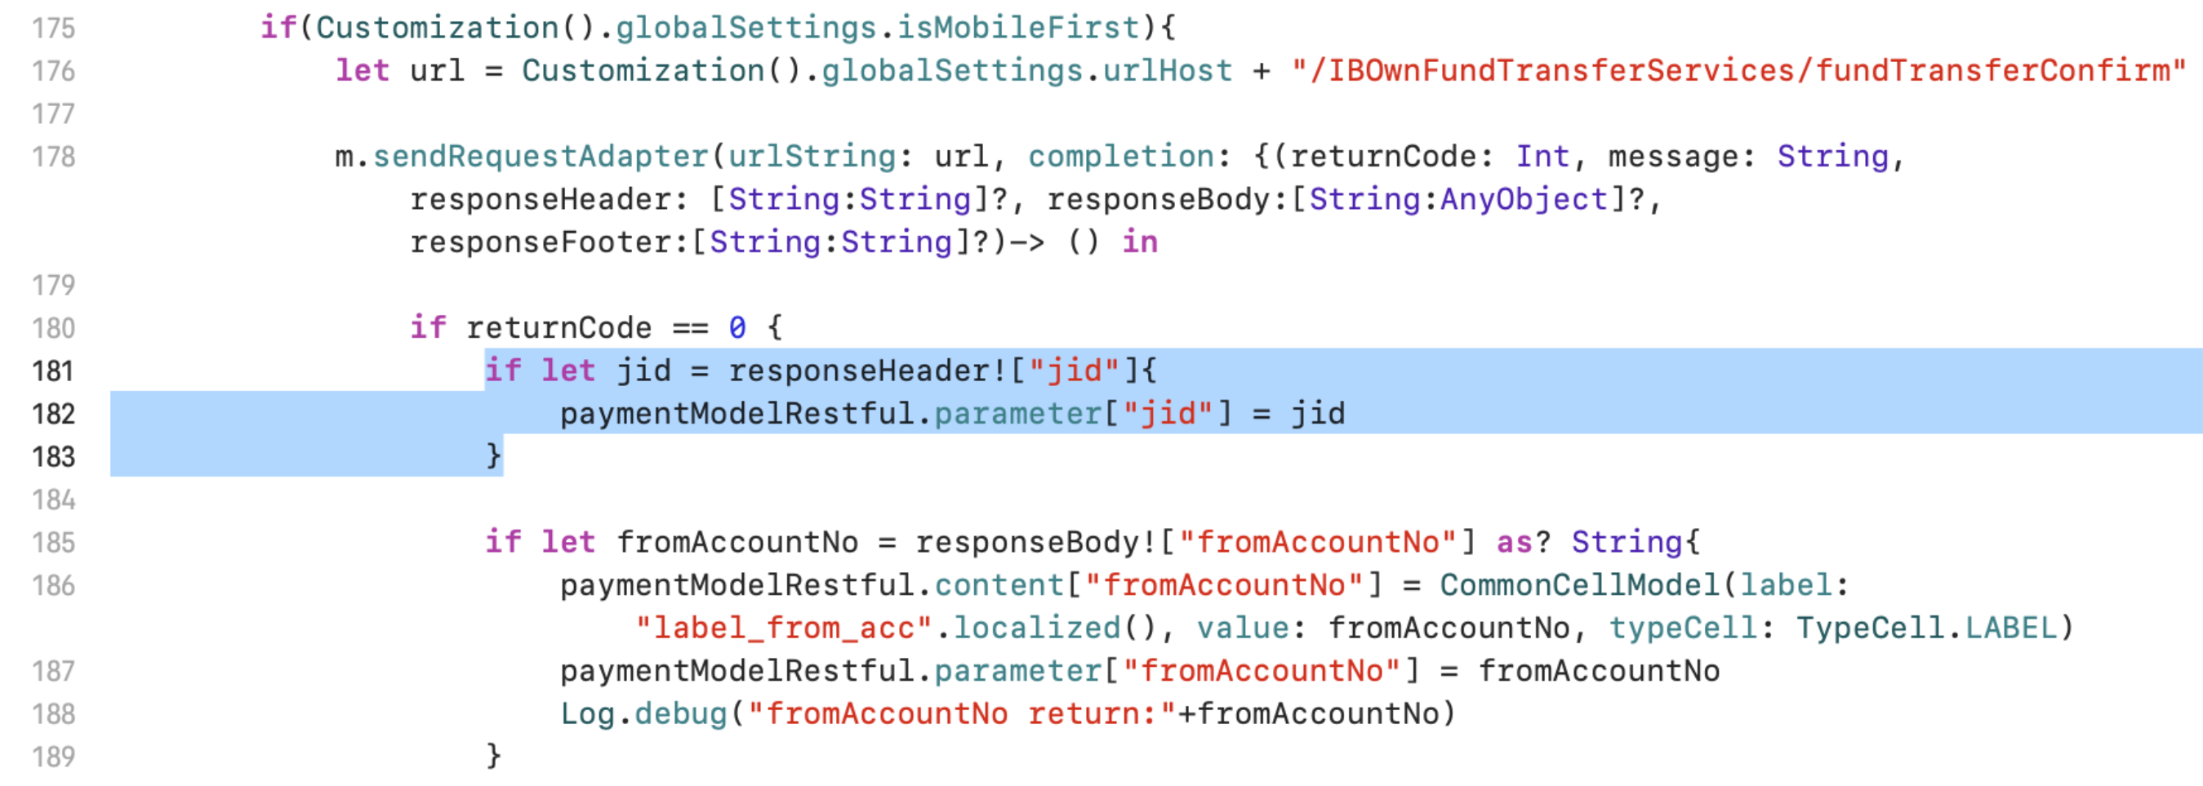  Received JID Value  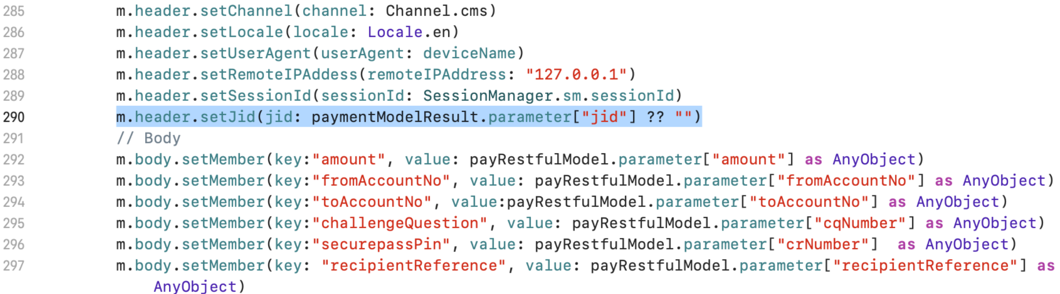  Send JID Value

