SCPID#6369
Test Title: |  | Status not updated
Test Description: |  | Issue:  Occur in Recent Activities inquiry in CDB Welcome page. Status not updated in BibTrnxHistory table after batch process pending validate trnx status. Only occur on single user.  Finding:  There is redundant code in checking user role. The first condition checking single user flag cause the program skip the next condition checking method which already contains checking user role, set and update status.  Solution:  Remove the first condition checking single user flag as there is another method already contains checking user role, set and update status.
Test Functionality: |  | To test on the status for bulk payment file upload.
Test Procedure: |  | Test Scenario:  Login as Single User  - Make auto credit file upload trnx. Upload file size greater than set web file size in IBAM > Content > Service Info  - Wait for a while, when the batch process finish and success, the expected file status should be Pending Processing and the Recent Activity status should be Accepted  Login as Initiator  - Make auto credit file upload trnx. Upload file size greater than set web file size in IBAM > Content > Service Info  - Wait for a while, when the batch process finish and success, the expected file status should be Pending Approval and the Recent Activity status should be Pending Approval.  Login as Approver  - Approve the transaction and the expected file status should be Pending Processing and the Recent Activity status should be Accepted.
Response Message:

Test Result: | Pass: Fail: |  | Tested by: | Nor Athirah Umairah (02/08/2022)
Reason for Failure:
Remarks: |  | Large File Size  Logged in as Single User.  - Set web file size in IBAM > Content > Service Info  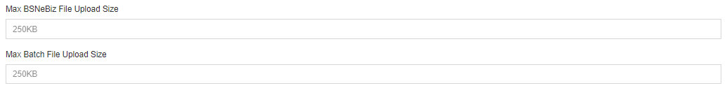  Figure 1: IBAM > Content > Service Info  - Make auto credit file upload trnx with large size.  Figure 2: File Size Uploaded  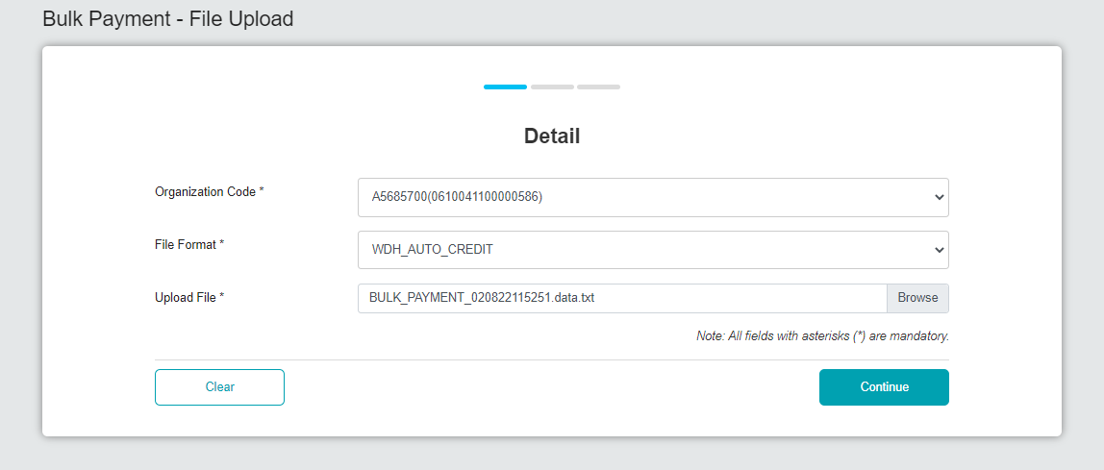  Figure 3: Bulk Payment - File Upload (Detail)  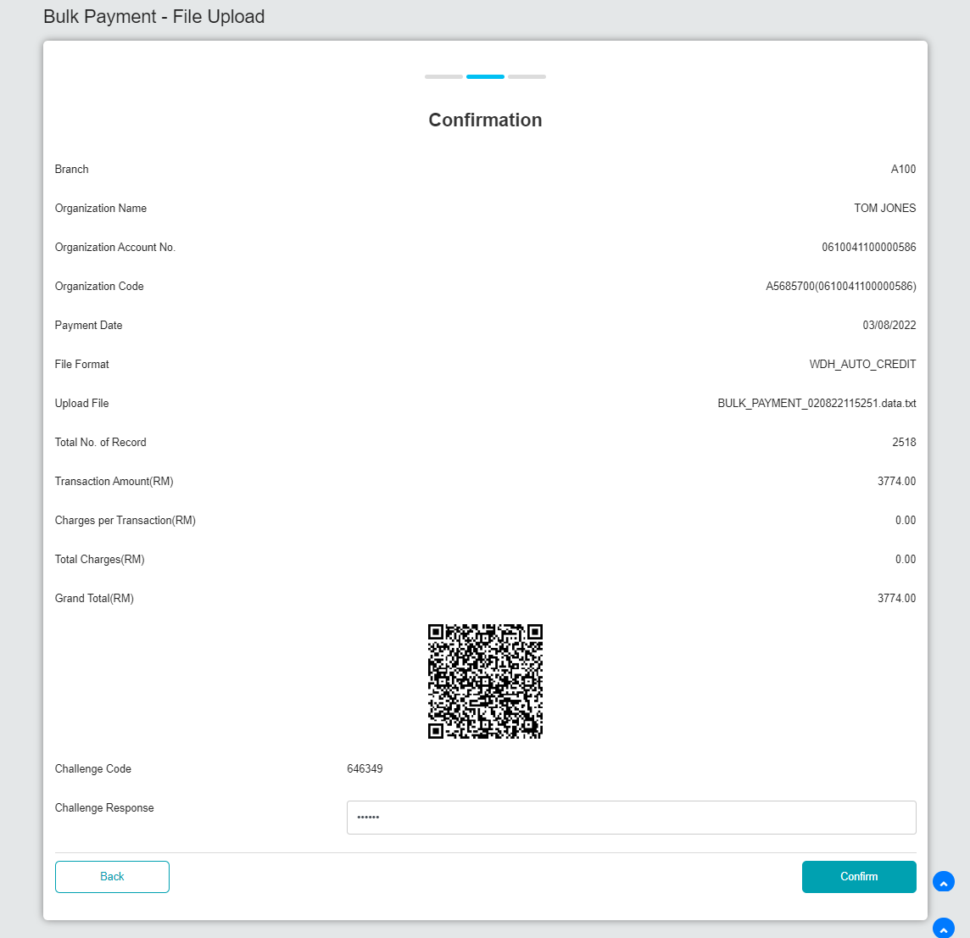  Figure 4: Bulk Payment - File Upload (Confirmation)  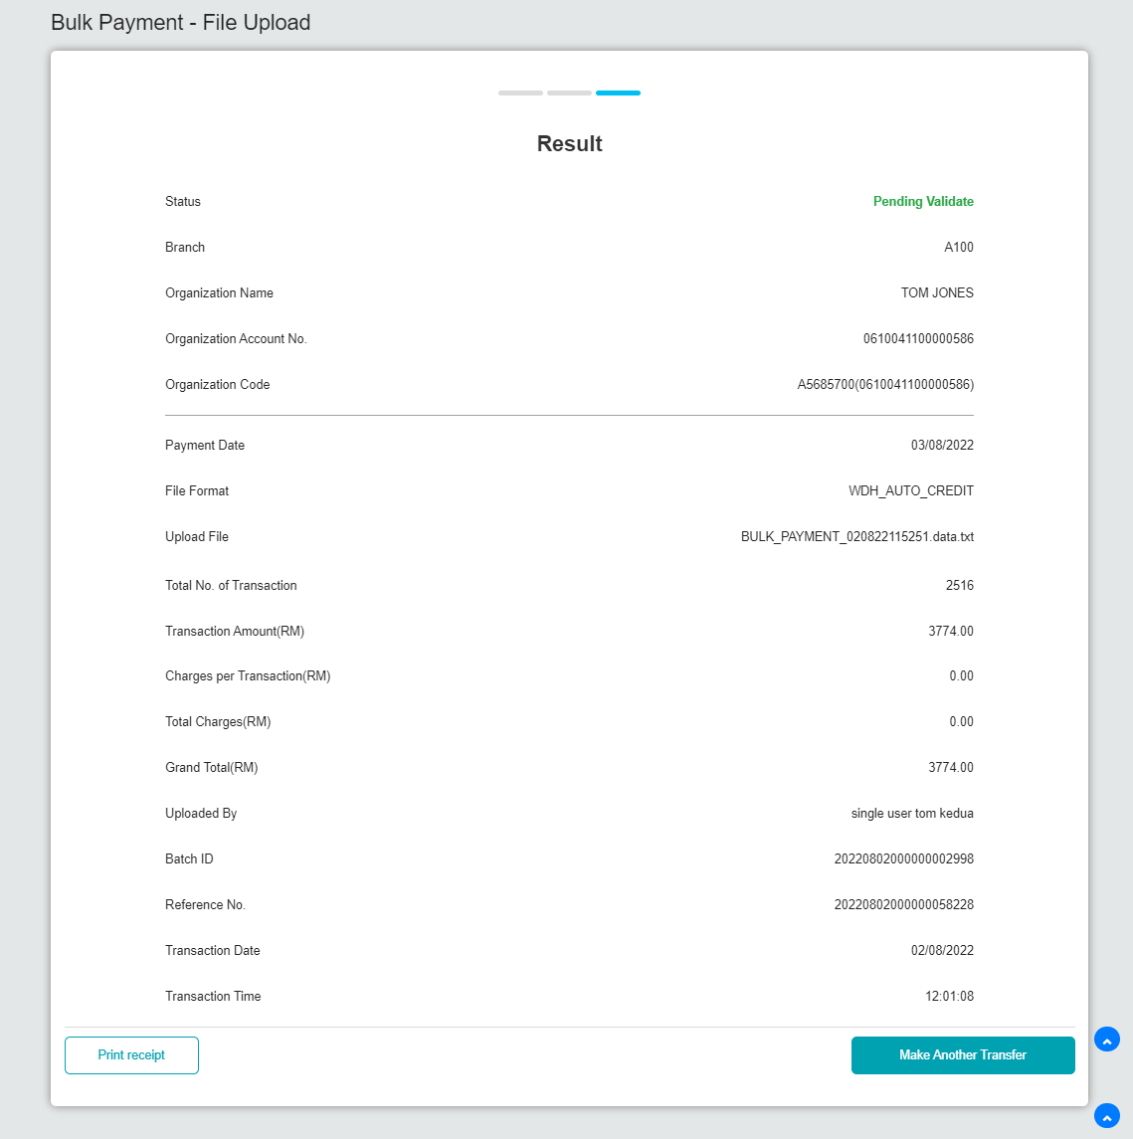  Figure 5: Bulk Payment - File Upload (Result)  Result:  The expected file status should be Pending Processing and the Recent Activity status should be Accepted  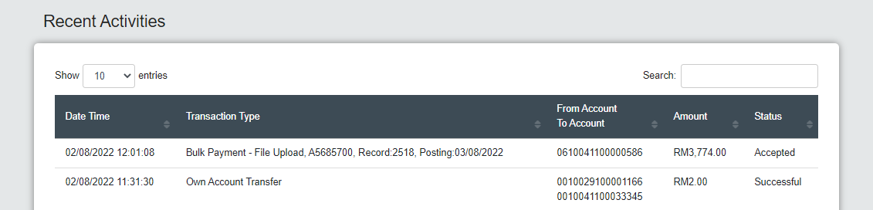  Figure 6: Recent Activities (Accepted)  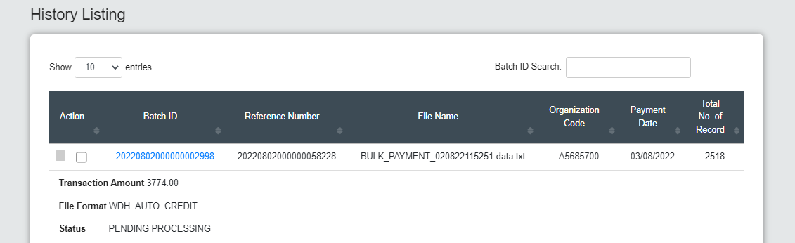  Figure 7: History Listing (Pending Processing)  Login as Initiator  - Make auto credit file upload trnx with large size.  Figure 8: File Size Uploaded  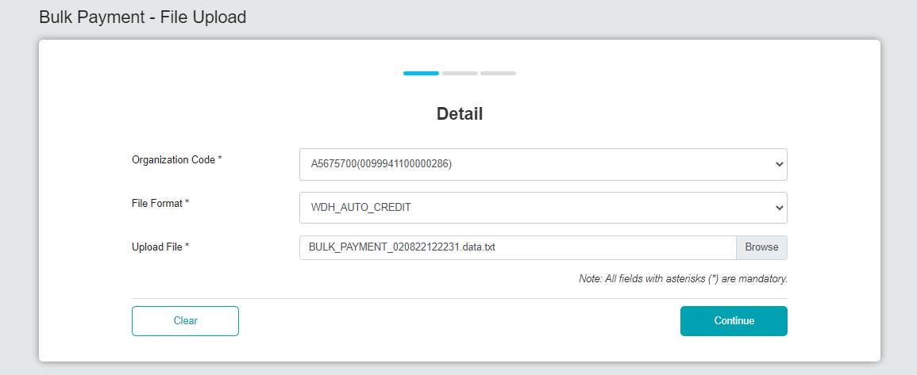  Figure 9: Bulk Payment – File Upload (Detail)  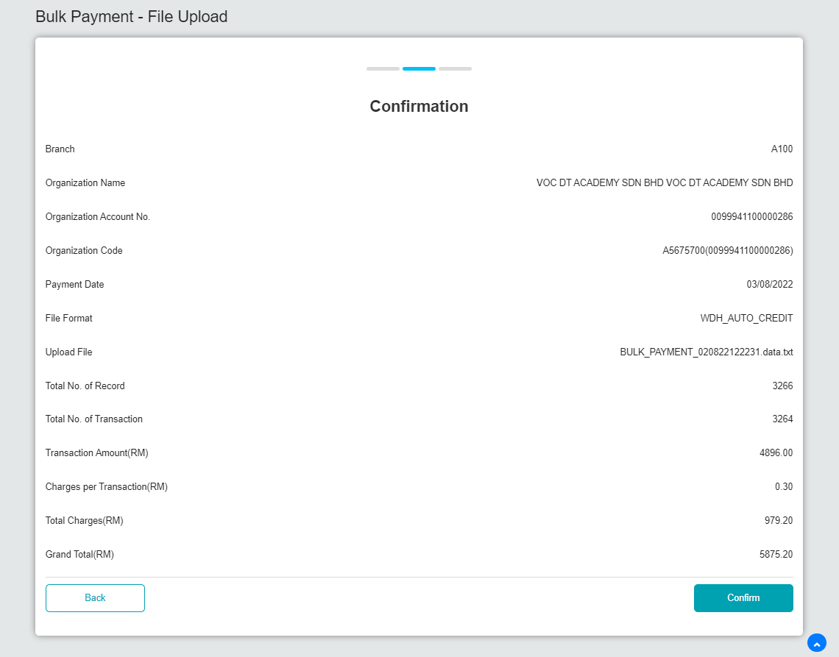  Figure 10: Bulk Payment – File Upload (Confirmation)  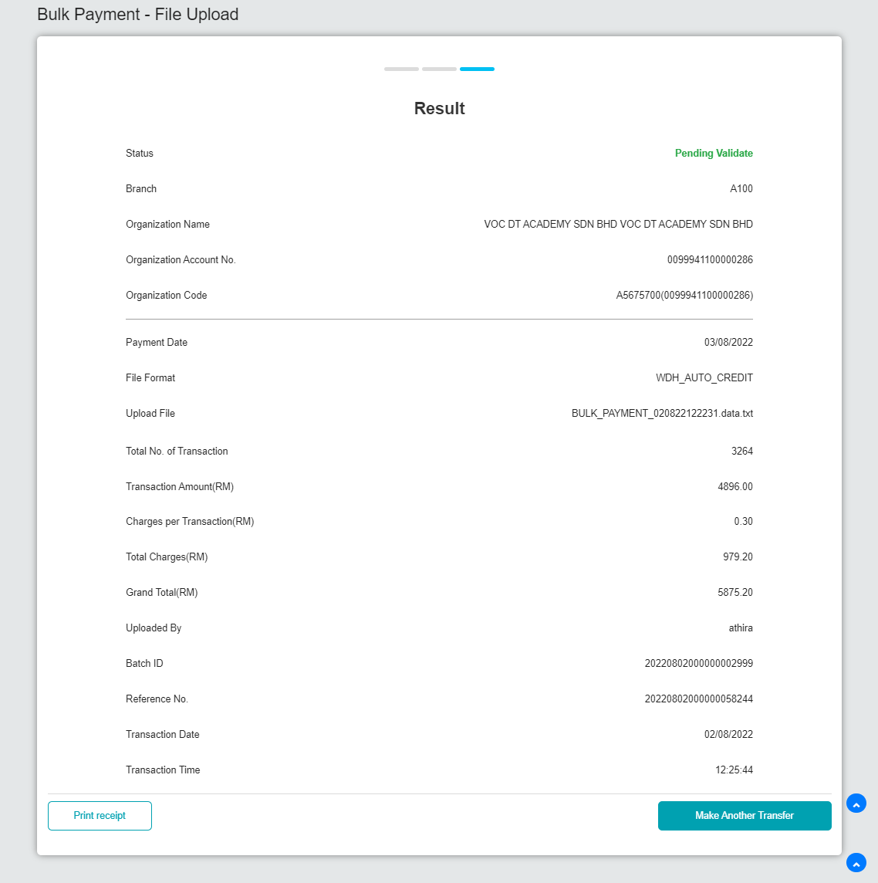  Figure 11: Bulk Payment – File Upload (Result)  Result:  The expected file status should be Pending Approval and the Recent Activity status should be Pending Approval.  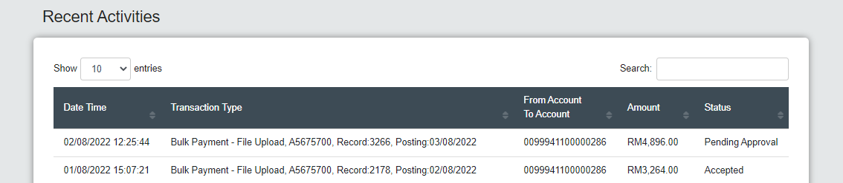  Figure 12: Recent Activities (Pending Approval)  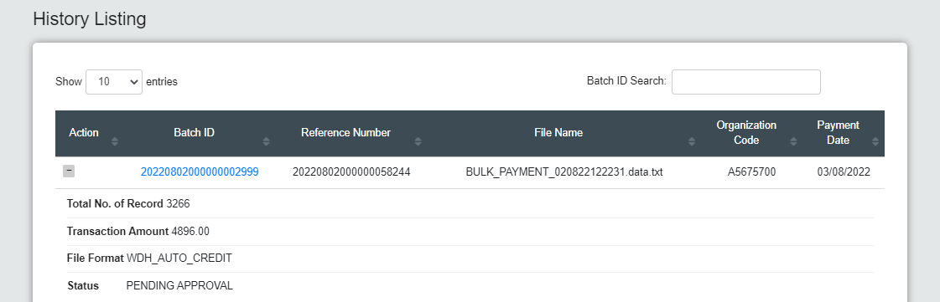  Figure 13: History Listing (Pending Approval)  Login as Approver  - Approve the transaction.  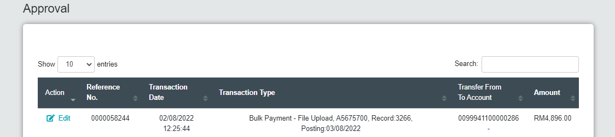  Figure 14: Approval  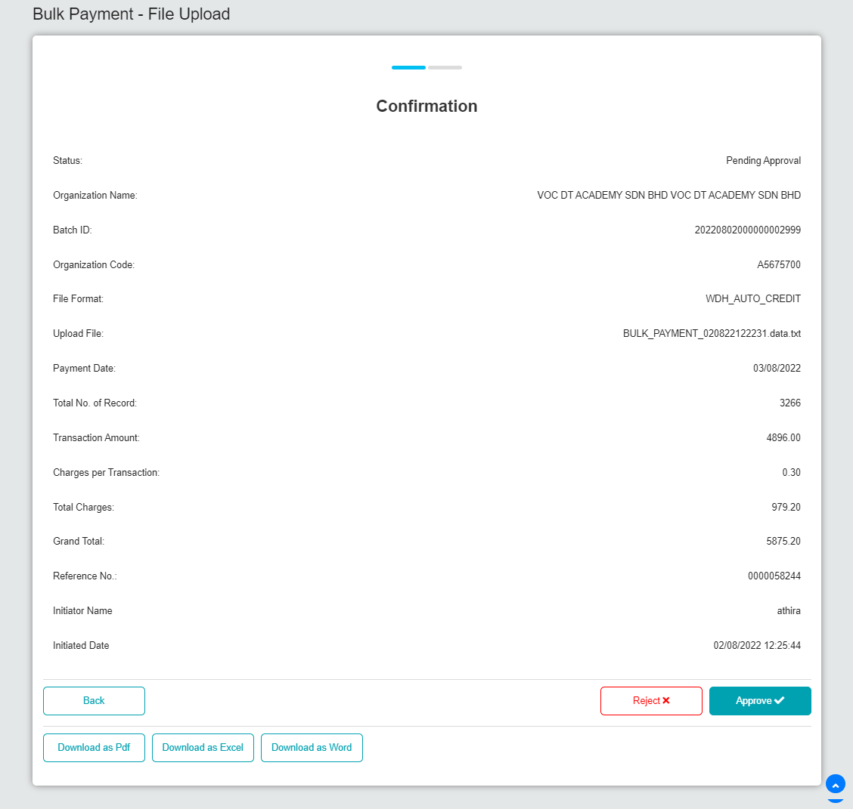  Figure 15: Approval Bulk Payment – File Upload (Confirmation)  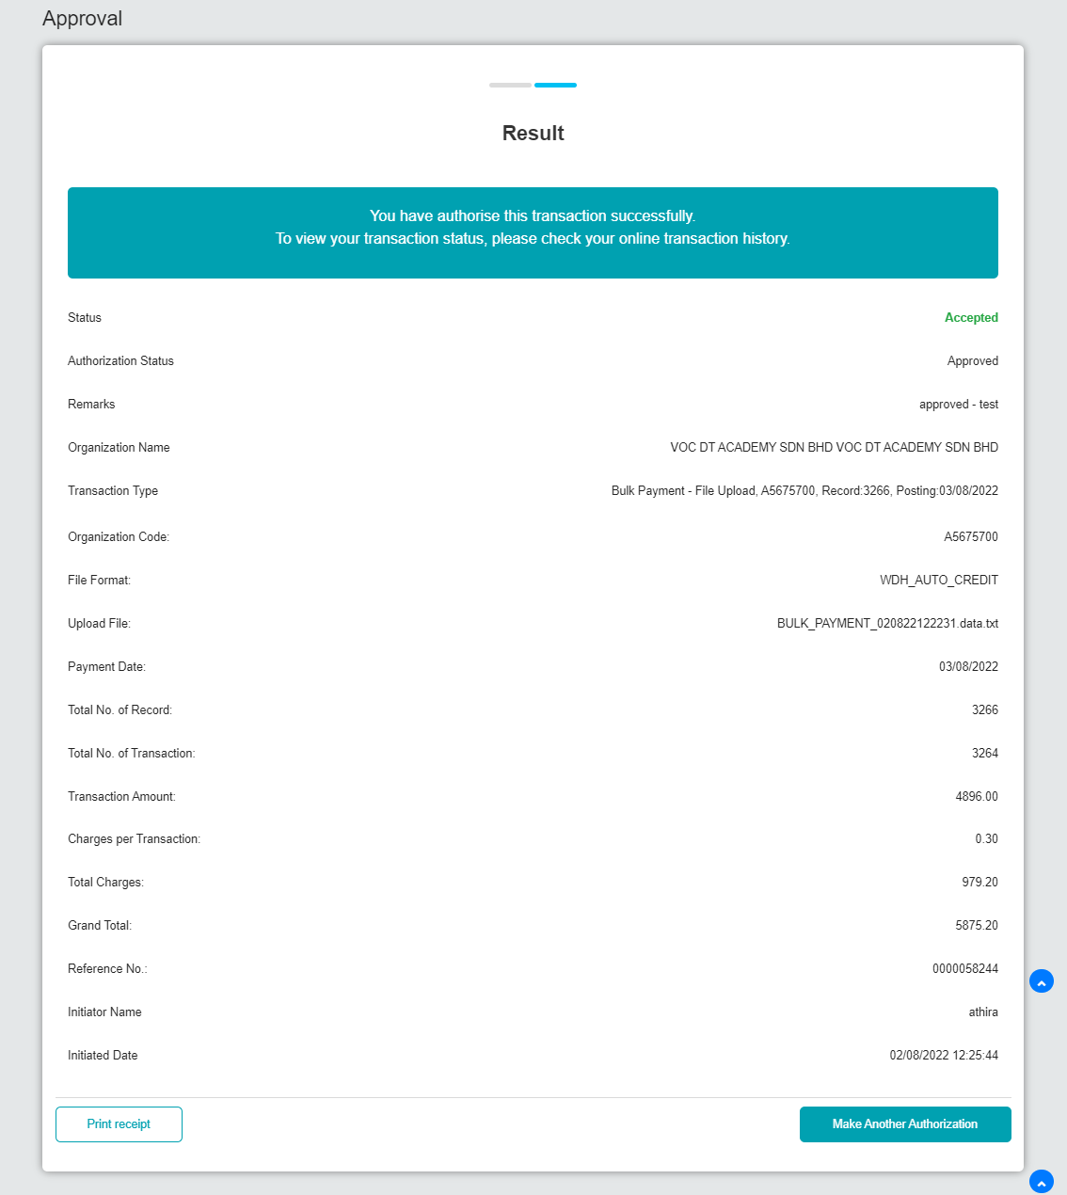  Figure 16: Approval Bulk Payment – File Upload (Result)  Result:  The expected file status should be Pending Processing and the Recent Activity status should be Accepted.  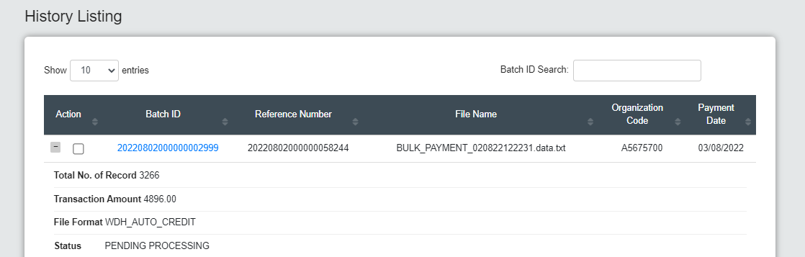  Figure 17: History Listing (Pending Processing)  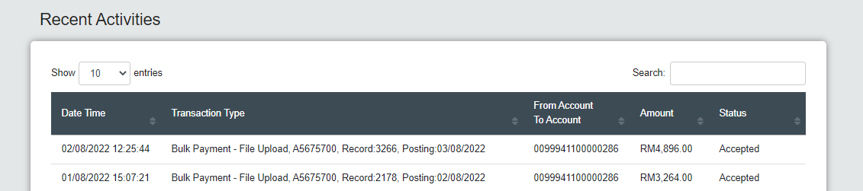  Figure 18: Recent Activities (Accepted)  Normal File Size  Logged in as Single User.  - Set web file size in IBAM > Content > Service Info  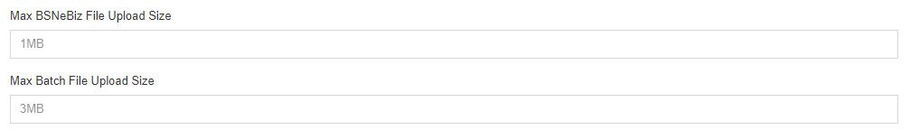 Figure 19: IBAM > Content > Service Info  - Make auto credit file upload trnx with normal size.  Figure 20: File Size Uploaded  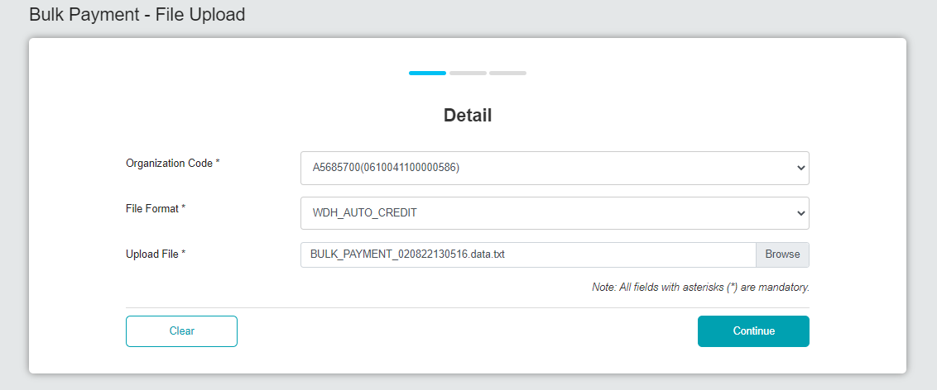  Figure 21: Bulk Payment - File Upload (Detail)  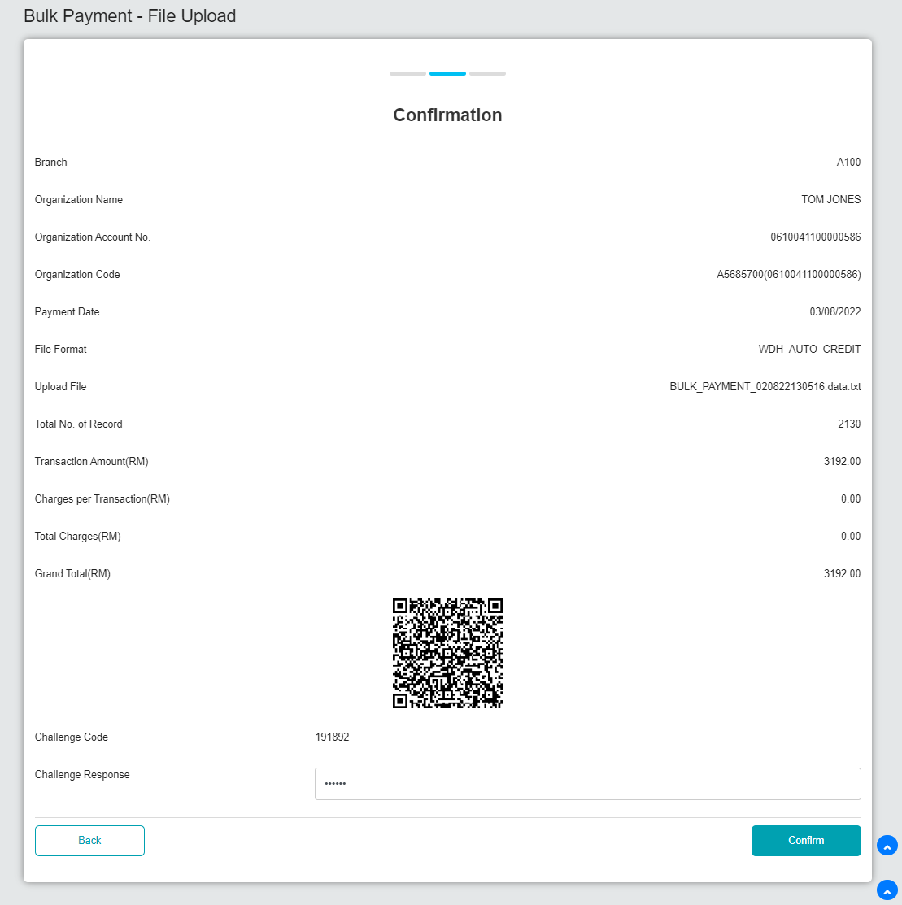  Figure 22: Bulk Payment - File Upload (Confirmation)  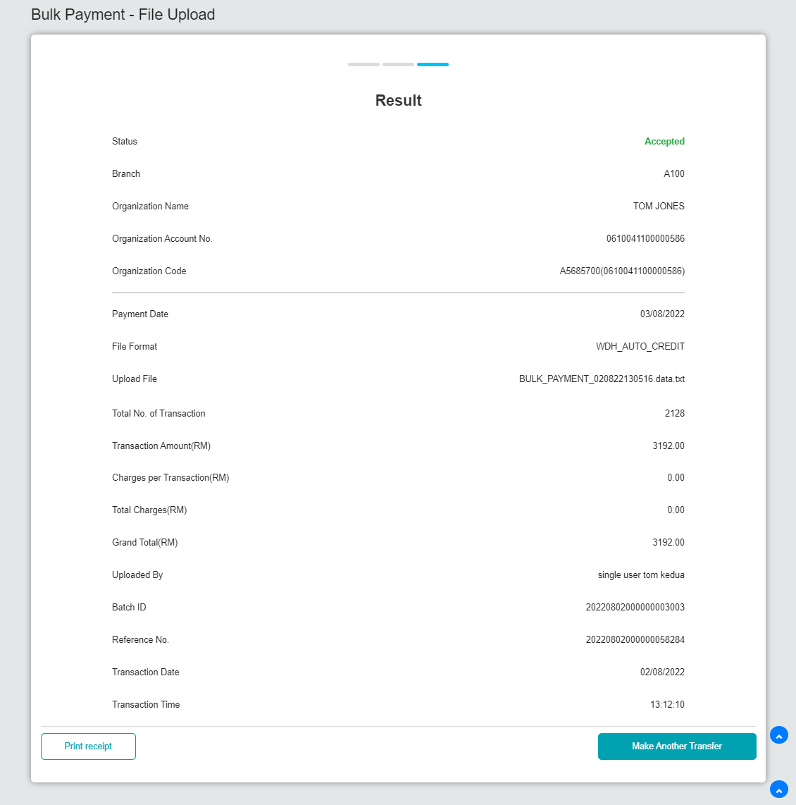  Figure 23: Bulk Payment - File Upload (Result)  Result:  The expected file status should be Pending Processing and the Recent Activity status should be Accepted  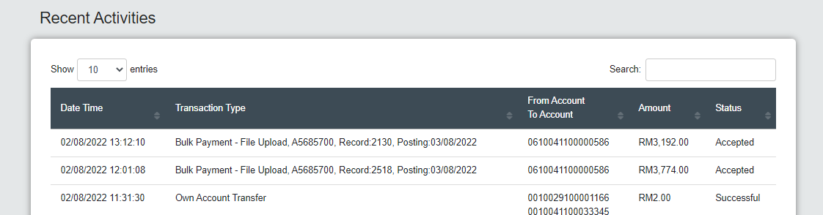  Figure 24: Recent Activities (Accepted)  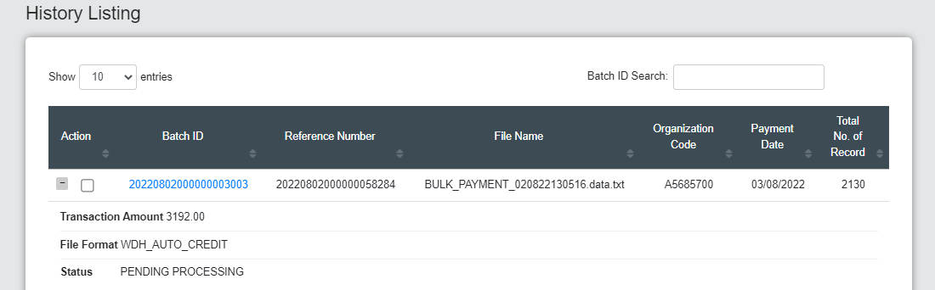  Figure 25: History Listing (Pending Processing)  Login as Initiator  - Make auto credit file upload trnx with normal size.  Figure 26: File Size Uploaded  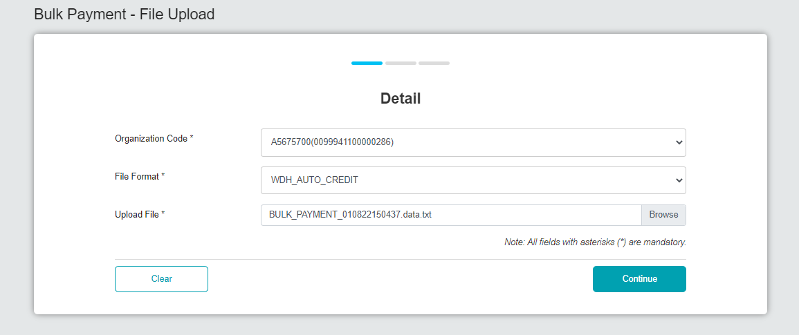  Figure 27: Bulk Payment – File Upload (Detail)  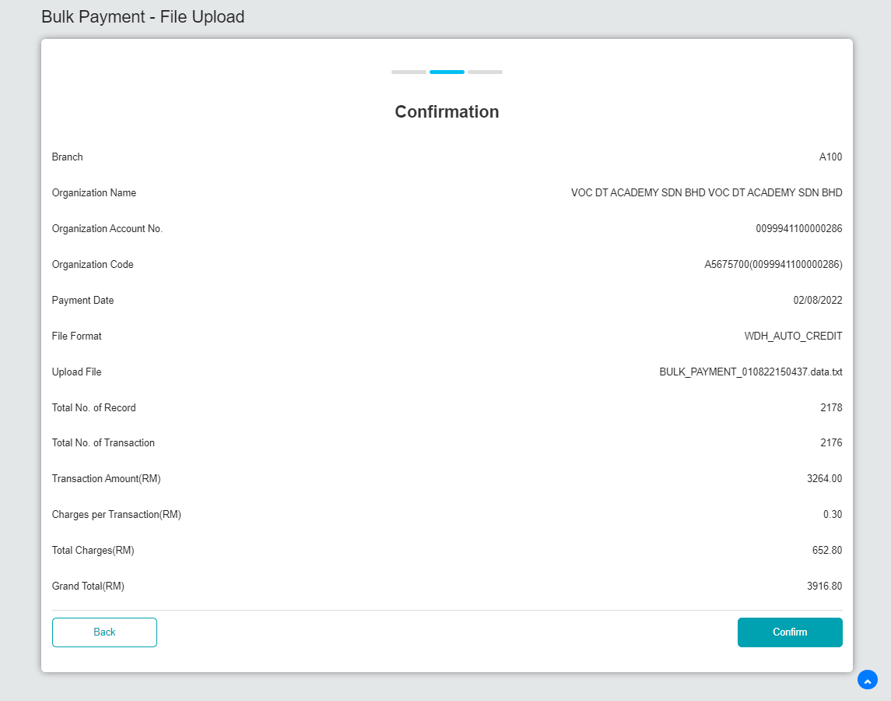  Figure 28: Bulk Payment – File Upload (Confirmation)  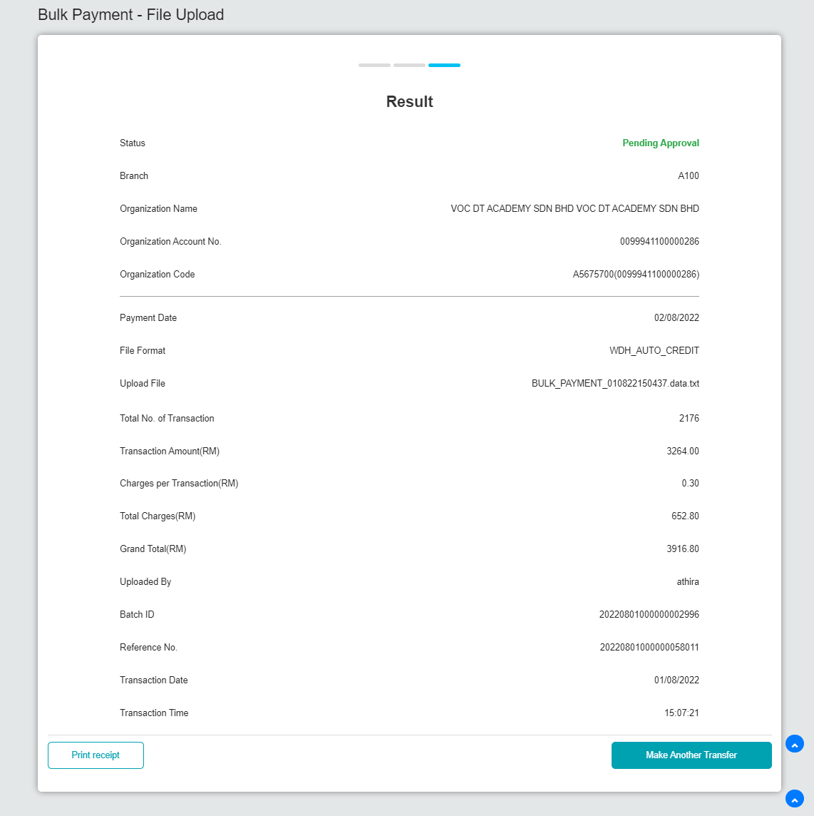  Figure 29: Bulk Payment – File Upload (Result)  Result:  The expected file status should be Pending Approval and the Recent Activity status should be Pending Approval.  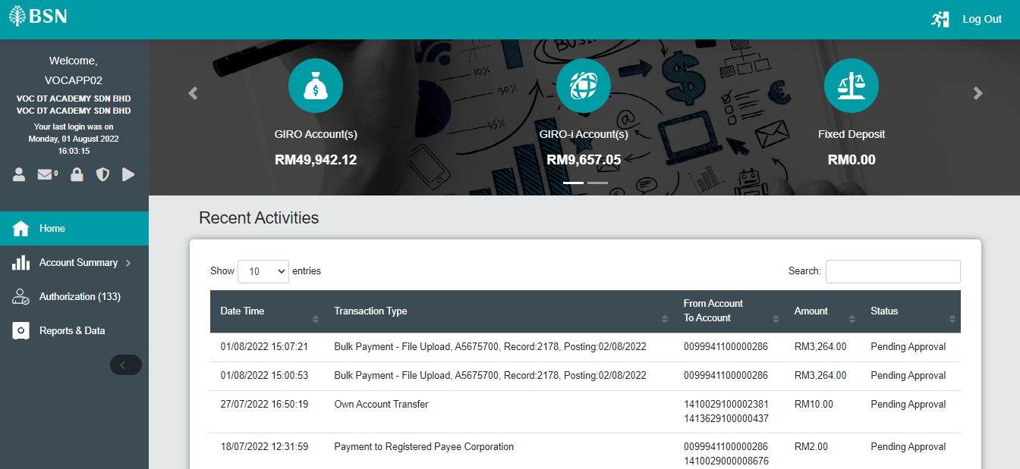  Figure 30: Recent Activities (Pending Approval)  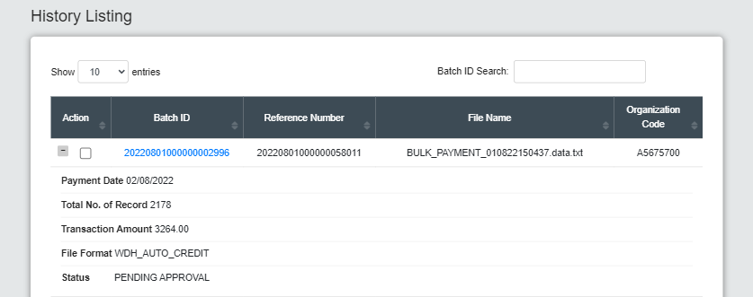  Figure 31: History Listing (Pending Approval)  Login as Approver  - Approve the transaction.  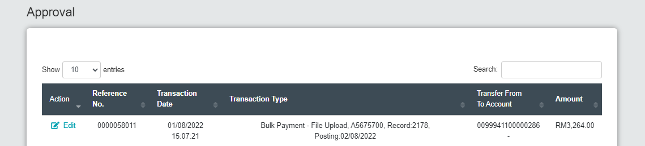  Figure 32: Approval  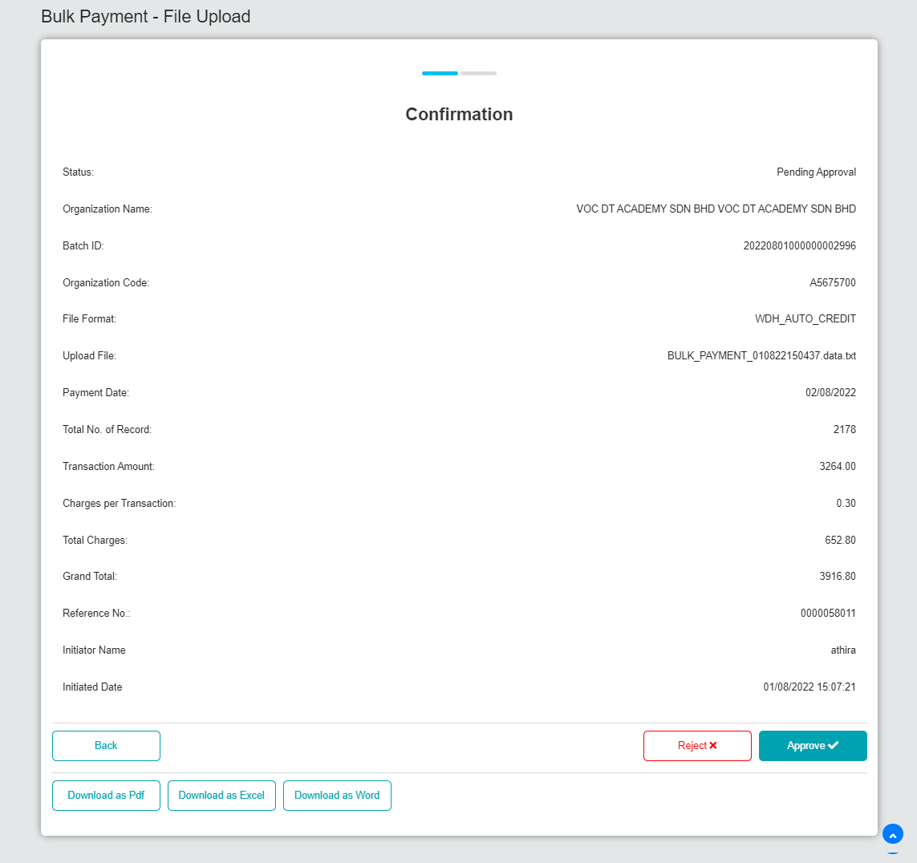  Figure 33: Approval Bulk Payment – File Upload (Confirmation)  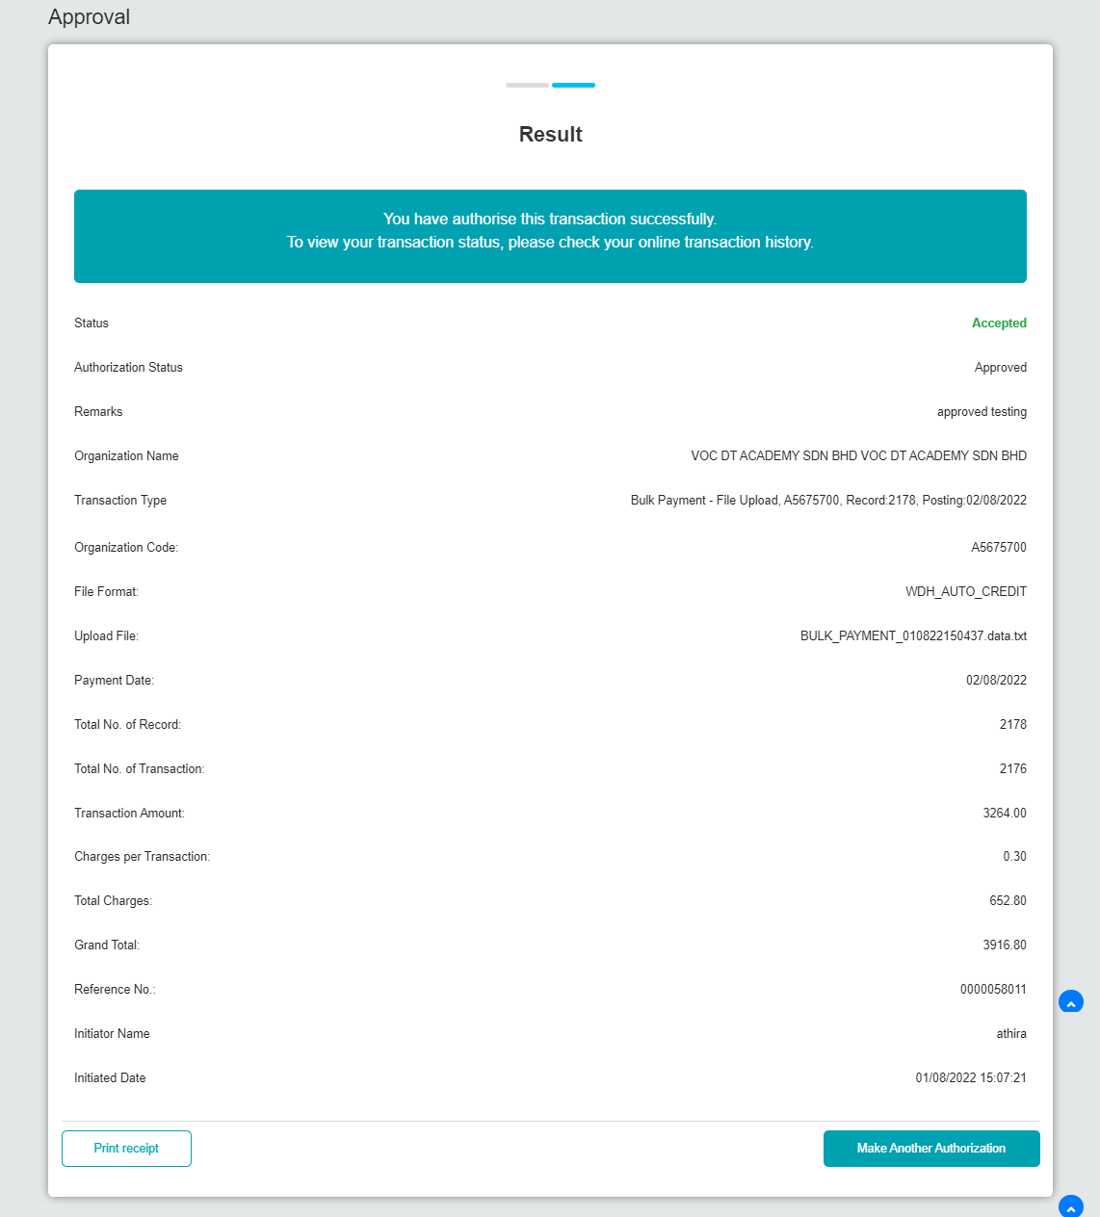  Figure 34: Approval Bulk Payment – File Upload (Result)  Result:  The expected file status should be Pending Processing and the Recent Activity status should be Accepted.  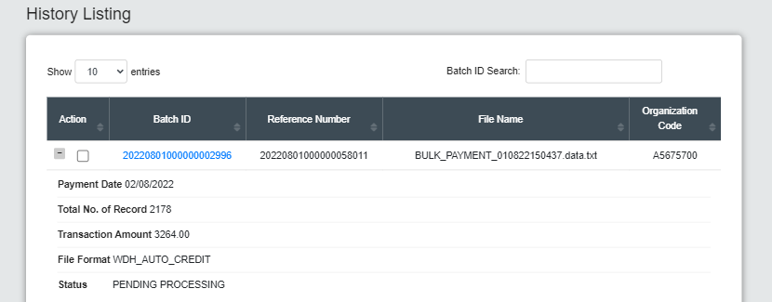  Figure 35: History Listing (Pending Processing)  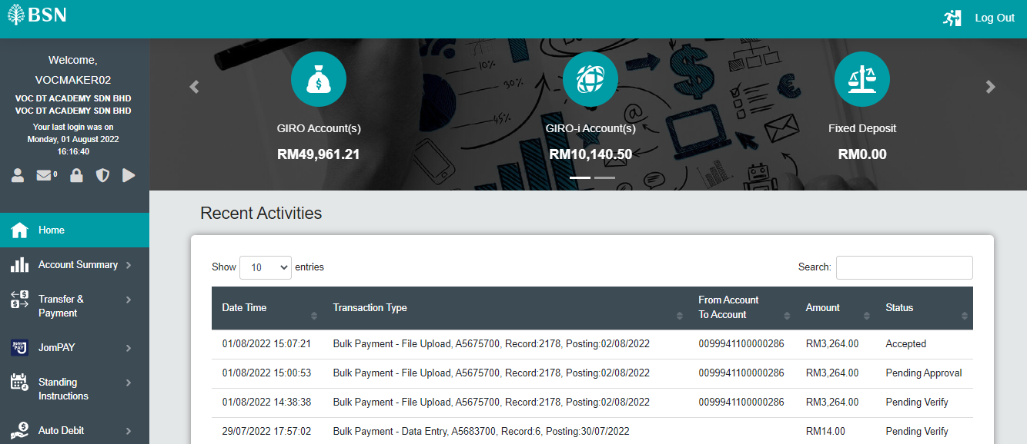  Figure 36: Recent Activities (Accepted)

