SCPID#6388
Test Title: |  | Duit now error - Sender ID has symbol dot
Test Description: |  | Issue:  DuitNow request for parameter sender id has dot  Finding:  BSNeBiz user id allow dot  Solution:  Remove all symbol from parameter sender id
Test Functionality: |  | To test successful DuitNow transaction with dot in login user id.
Test Procedure: |  | Test step:  - Use a BSNeBiz single user with dot in the login user id  - Make BSNeBiz > DuitNow transfer  - Expected result, DuitNow is successful  - Repeat testing with initiator and approver with dot in the login user id
Response Message:
Test Result: | Pass: Fail: |  | Tested by: | Nor Athirah Umairah (19/08/2022)
Reason for Failure:
Remarks: |  | Single User  - Login BSNeBiz as single user with dot in the login user id  Username: umai.singleuser  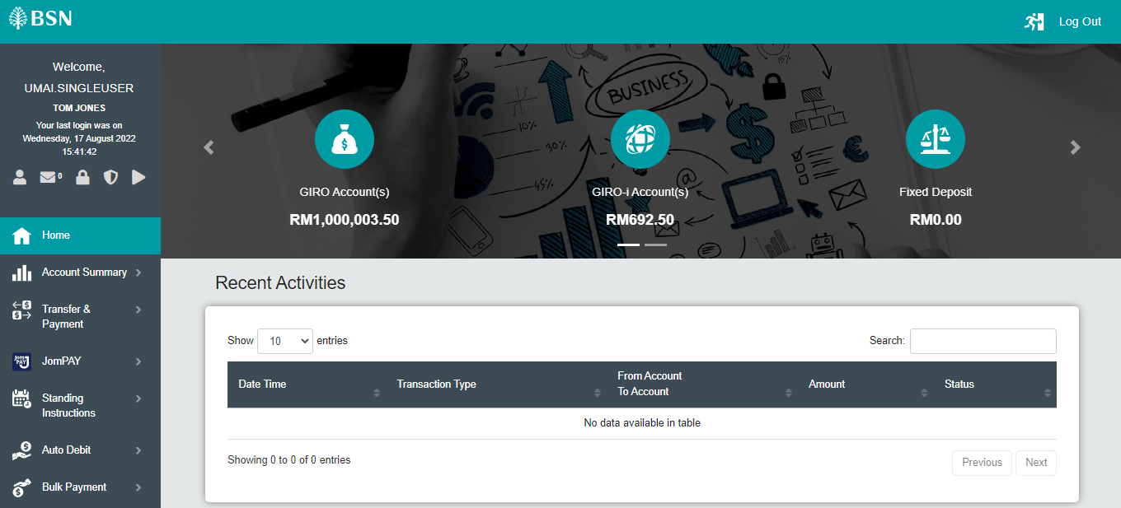  Figure 1: BSNeBiz > Home  - Make BSNeBiz > DuitNow transfer  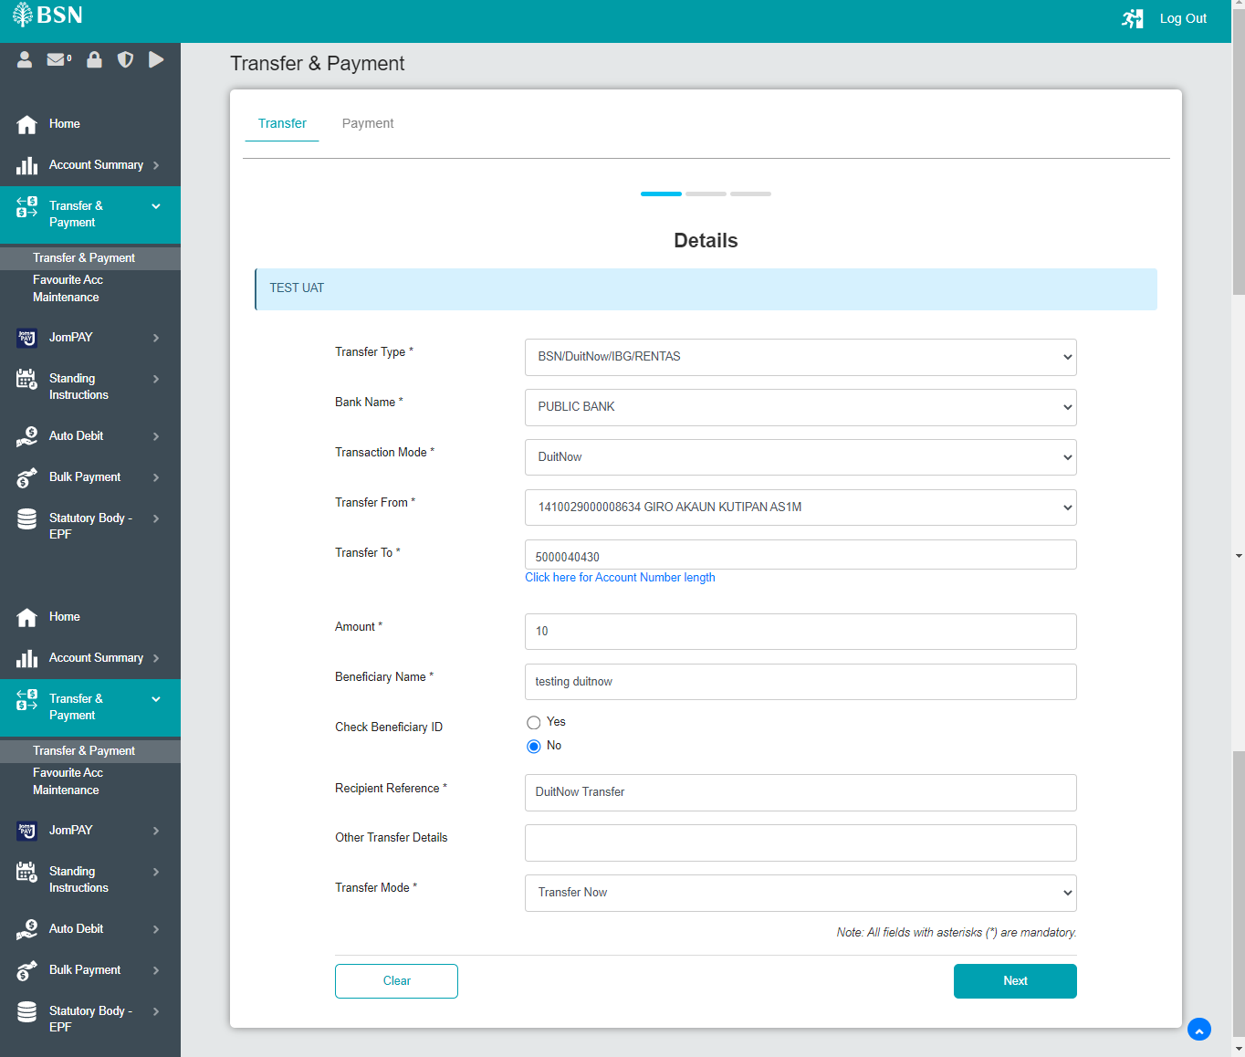  Figure 2: Transfer & Payment > Transfer (Details)  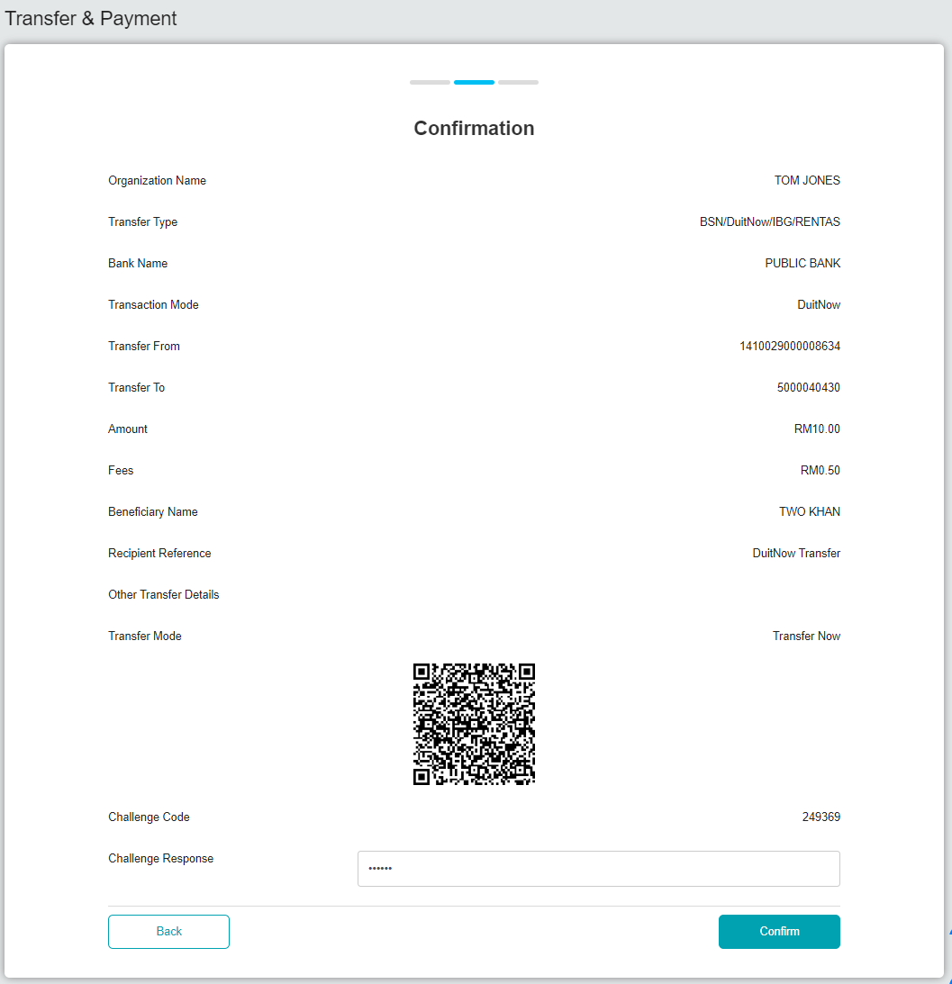  Figure 3: Transfer & Payment > Transfer (Confirmation)  - Result: DuitNow is successful.  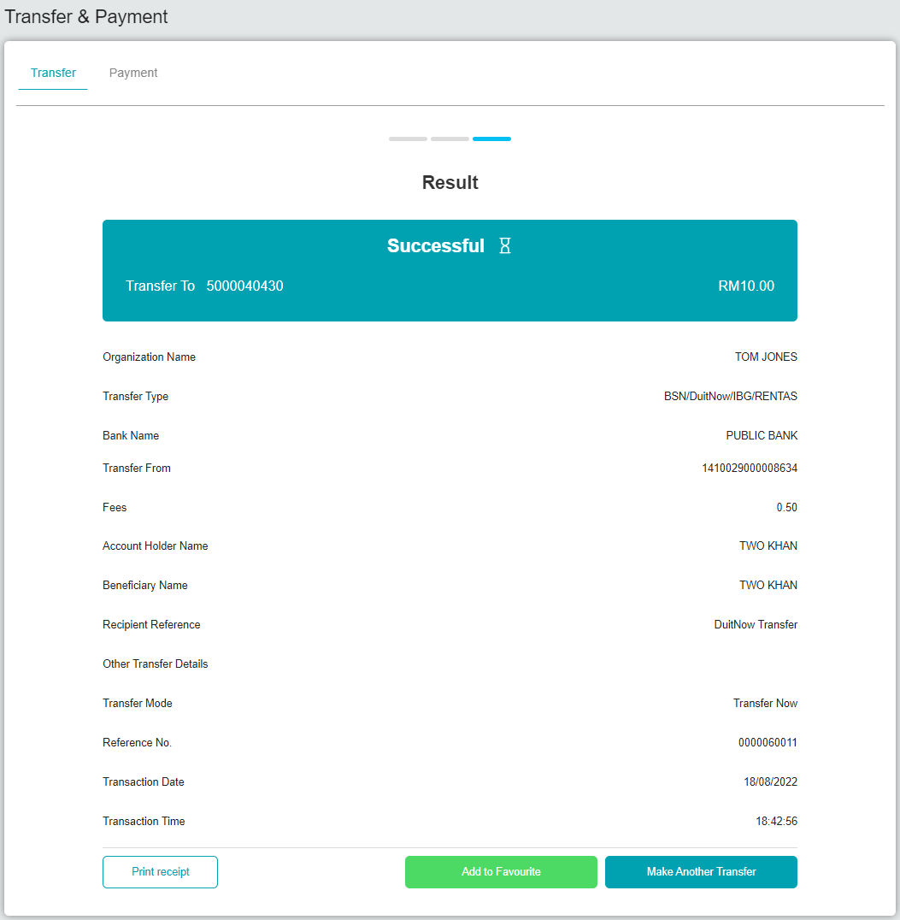  Figure 4: Transfer & Payment > Transfer (Result)  Initiator  - Login BSNeBiz as initiator with dot in the login user id.  Username: umai.initiator  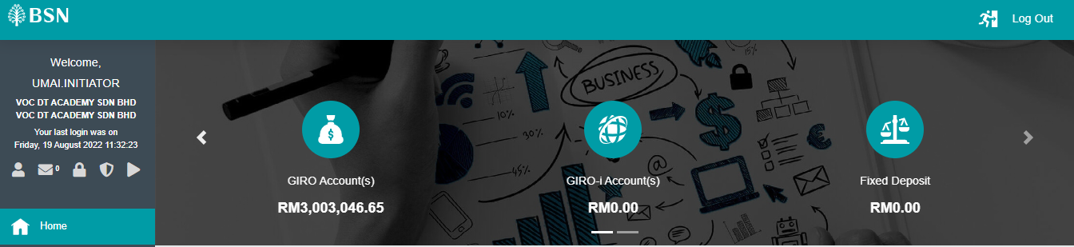  Figure 5: BSNeBiz > Home  - Make BSNeBiz > DuitNow transfer  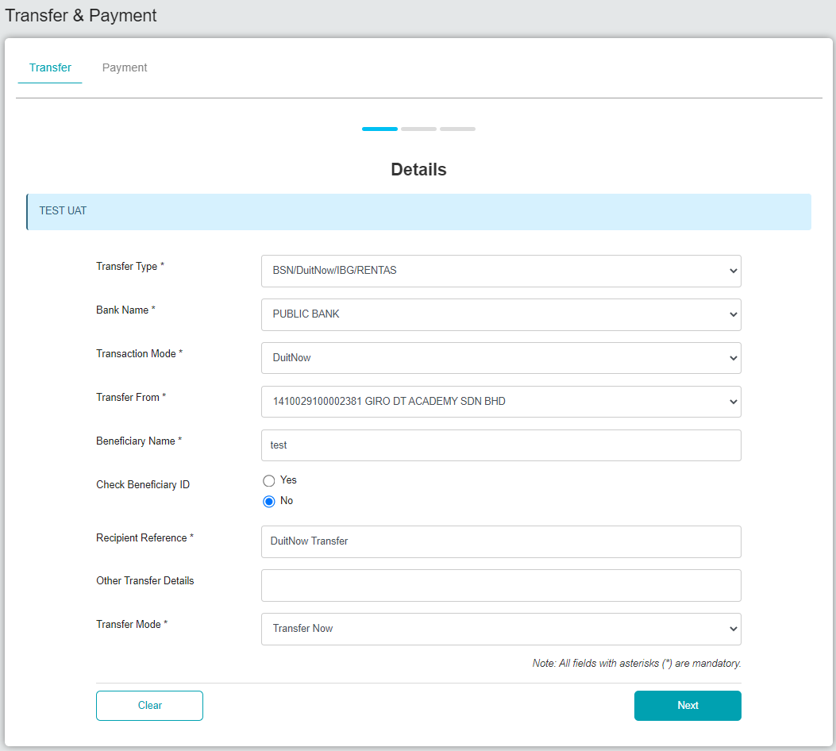  Figure 6: Transfer & Payment > Transfer (Details)  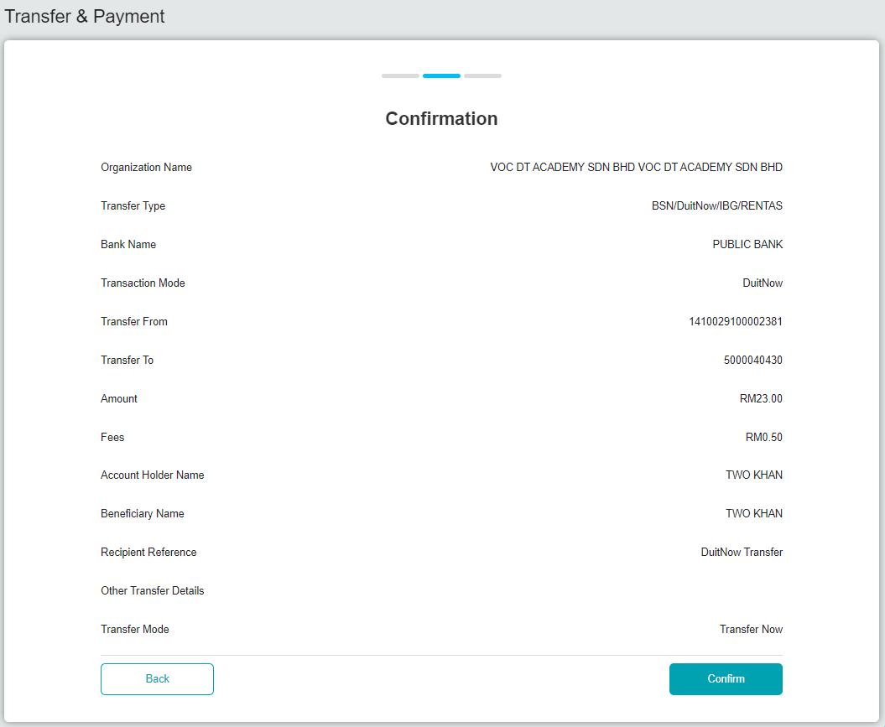  Figure 7: Transfer & Payment > Transfer (Confirmation)  - Result: DuitNow is pending for approval.  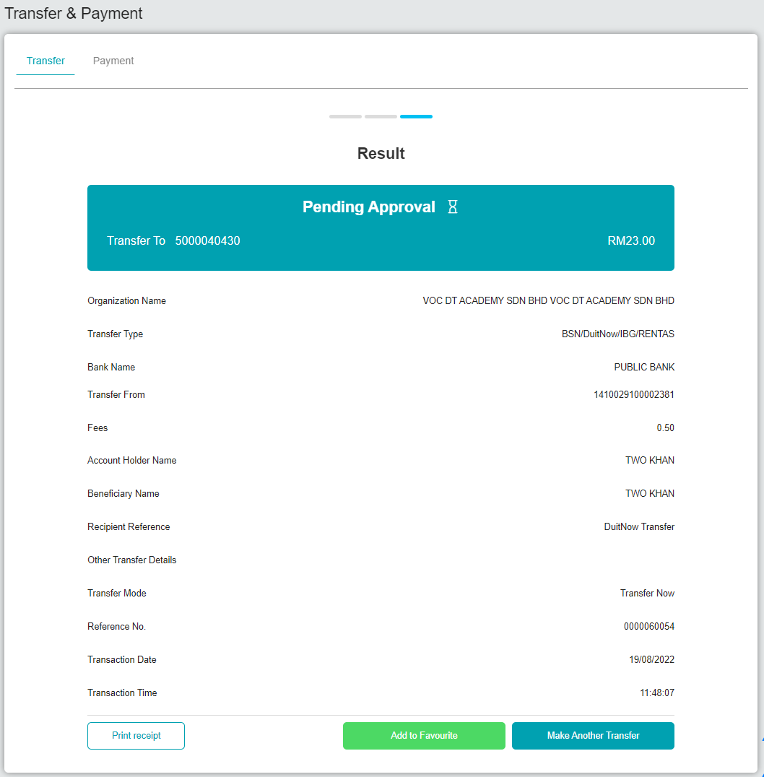  Figure 8: Transfer & Payment > Transfer (Result)  Approver  - Login BSNeBiz as approver with dot in the login user id.  Username: umai.approver  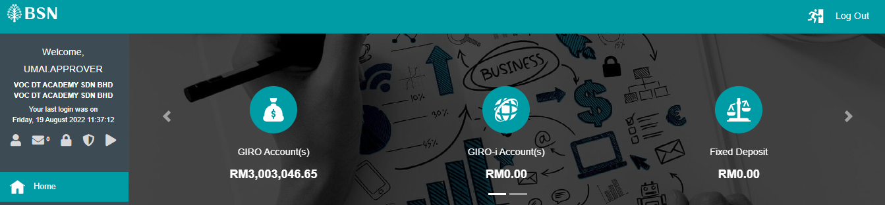  Figure 9: BSNeBiz > Home  - Approve DuitNow instant transfer.  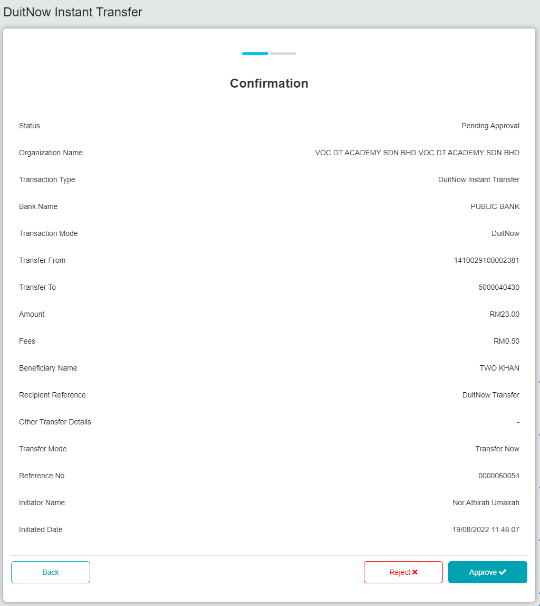  Figure 10: Authorization > DuitNow Instant Transfer (Confirmation)  - Result: DuitNow is successful.  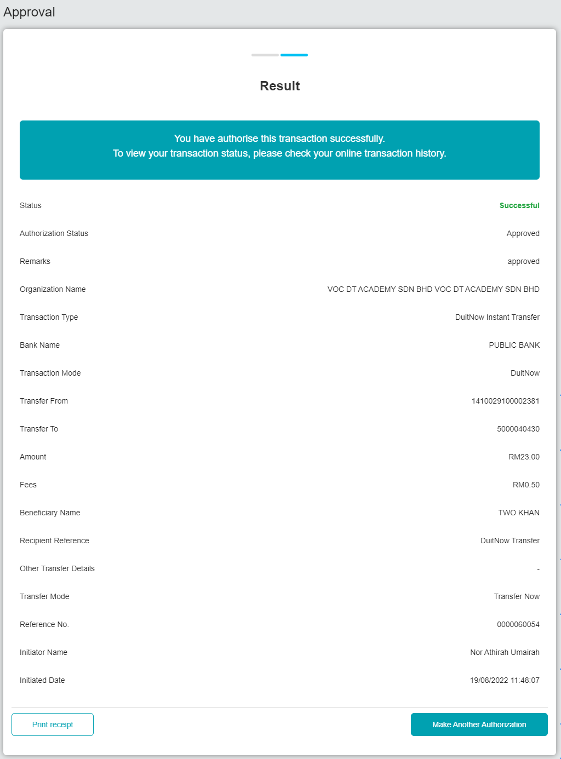  Figure 11: Authorization > DuitNow Instant Transfer (Result)

