SCPID#6380
Test Title: |  | Enable Loan Account and Batch Window
Test Description: |  | Issue:  En.Rahmat request to auto-enable Loan account and Batch Window setting  Solution:  - Auto-enable Loan account and Batch Window when submitting IBAM>CBE>BSNeBiz Submission  - Create program Auto-enable Loan account and Batch Window for existing companies
Test Functionality: |  | To test auto enabled batch window and loan account
Test Procedure: |  | Test steps:  - Request unregistered company from JTM or ICBS with loan account  - Create company application via IBAM>CBE>BSNeBiz Application>BSNeBiz Submission  - Access IBAM>CBE>Org Setup company setting and account management page  - Expected result, company setting batch window and loan account is auto enabled
Response Message:
Successfully created a new application. Batch Window and Loan Account auto enabled (Yes).
Test Result: | Pass: Fail: |  | Tested by: | Nor Athirah Umairah (29/08/2022)
Reason for Failure:
Remarks: |  | Logged in as Administrator.  - Access IBAM>CBE>BSNeBiz Application>Create. Fill in the required details and submit.  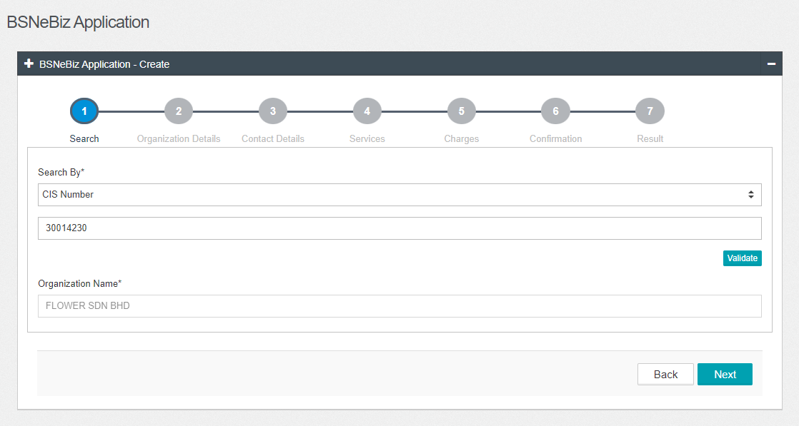  Figure 1: IBAM > CBE > BSNeBiz Application > Create (Search)  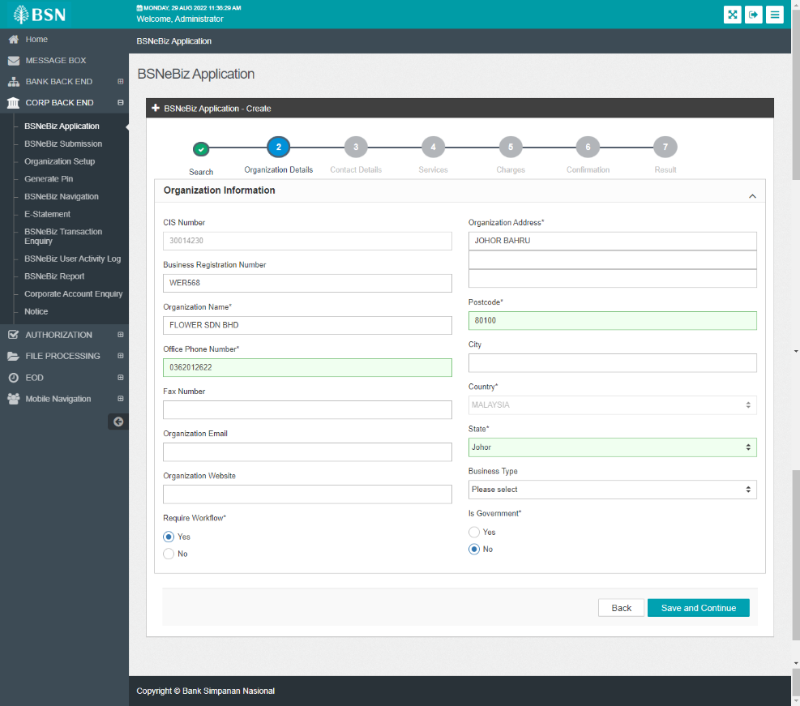  Figure 2: IBAM > CBE > BSNeBiz Application > Create (Organization Details)  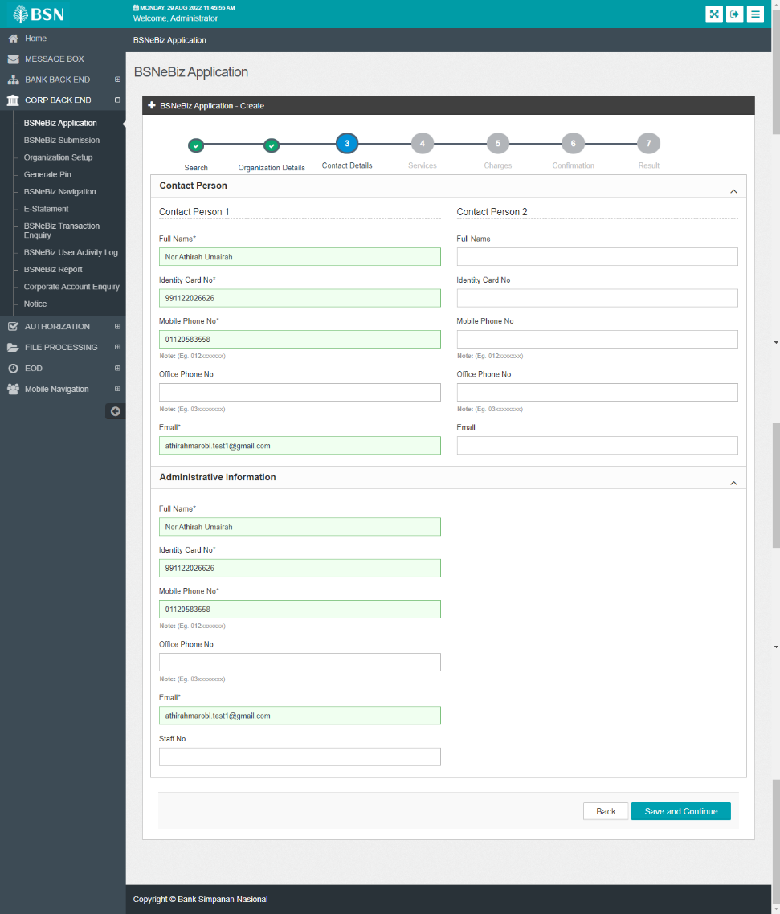  Figure 3: IBAM > CBE > BSNeBiz Application > Create (Contact Details)  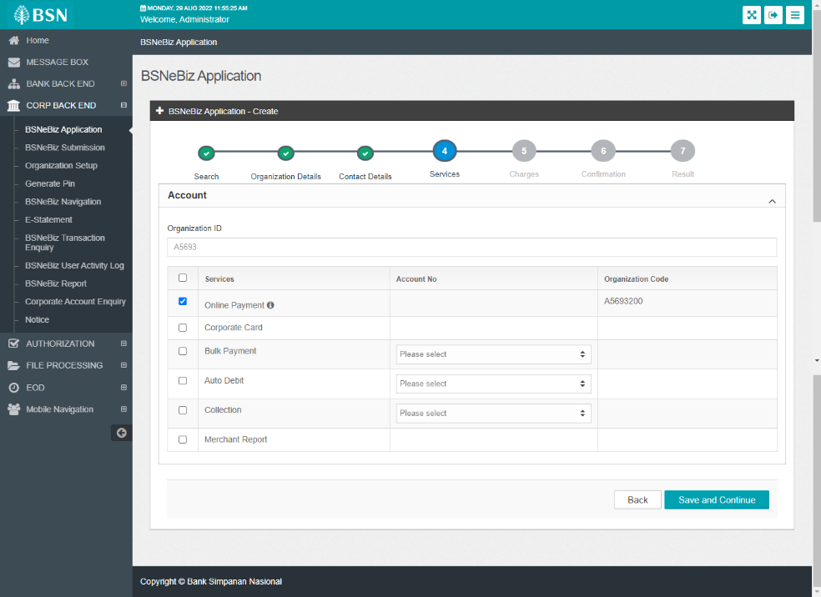  Figure 4: IBAM > CBE > BSNeBiz Application > Create (Services)  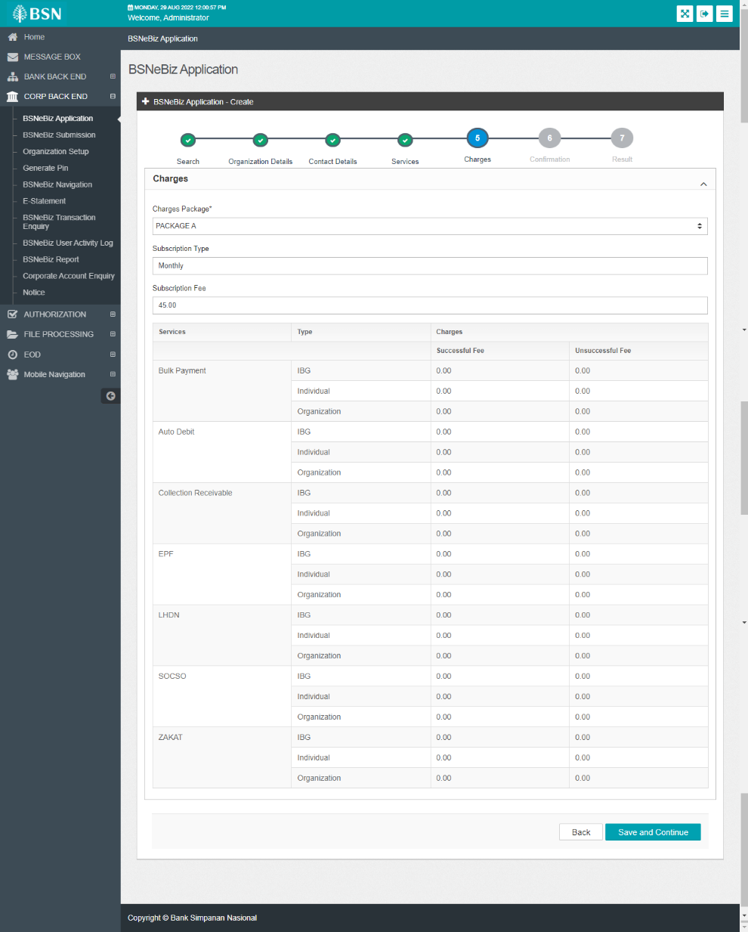  Figure 5: IBAM > CBE > BSNeBiz Application > Create (Charges)  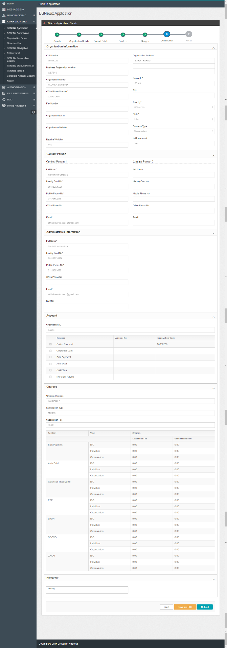  Figure 6: IBAM > CBE > BSNeBiz Application > Create (Confirmation)  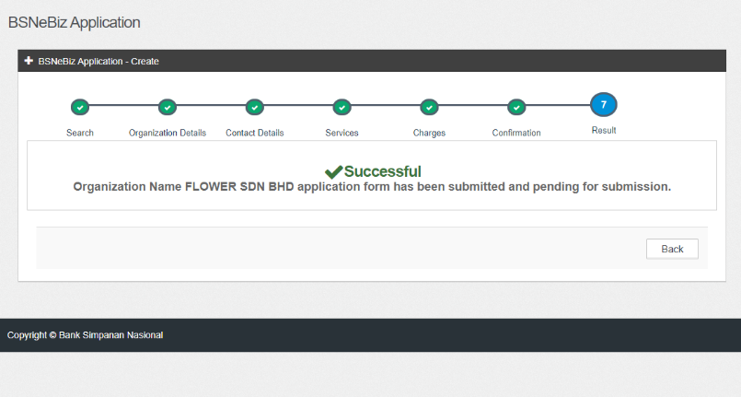  Figure 7: IBAM > CBE > BSNeBiz Application > Create (Result)  - Access IBAM>CBE>BSNeBiz Submission. Submit the submission.  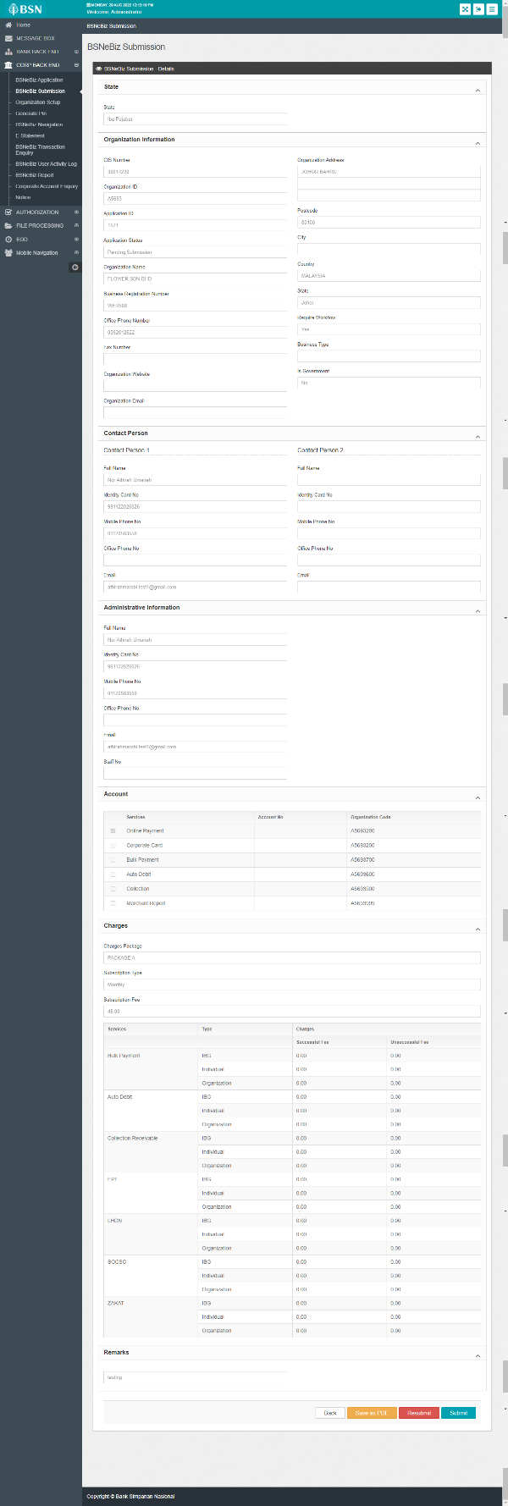  Figure 8: IBAM > CBE > BSNeBiz Submission > Details  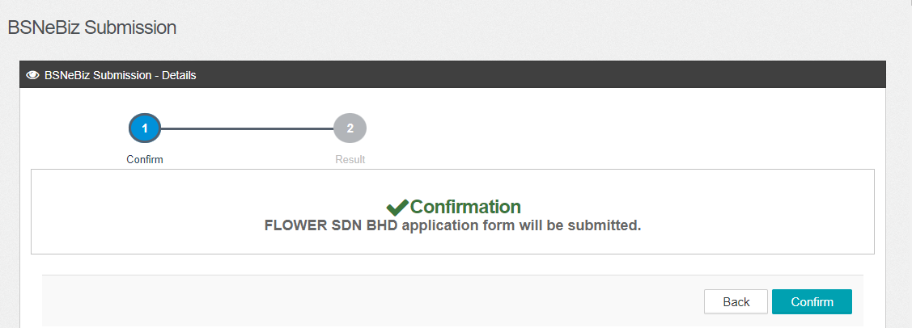  Figure 9: IBAM > CBE > BSNeBiz Submission > Details (Confirm)  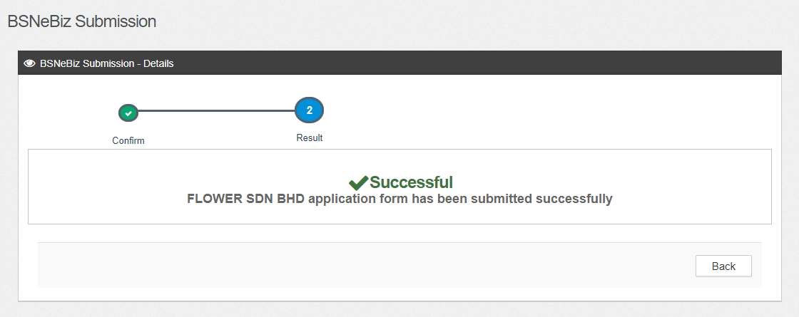  Figure 10: IBAM > CBE > BSNeBiz Submission > Details (Result)  Result:  - Batch Window = Yes  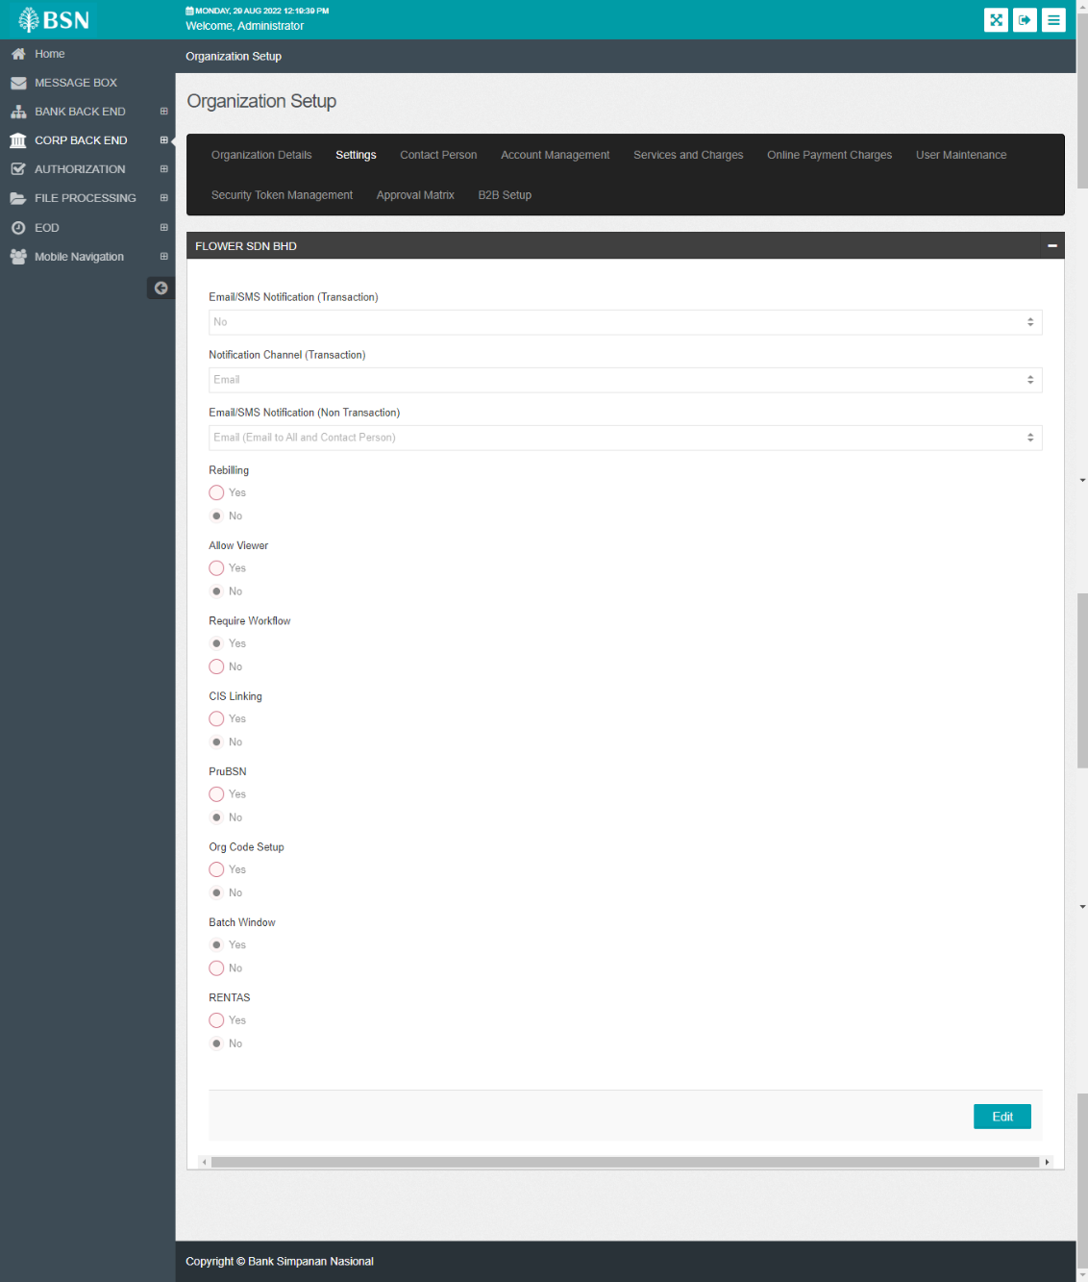  Figure 11: IBAM > CBE > Organization Setup > Settings  - Loan Account = Yes  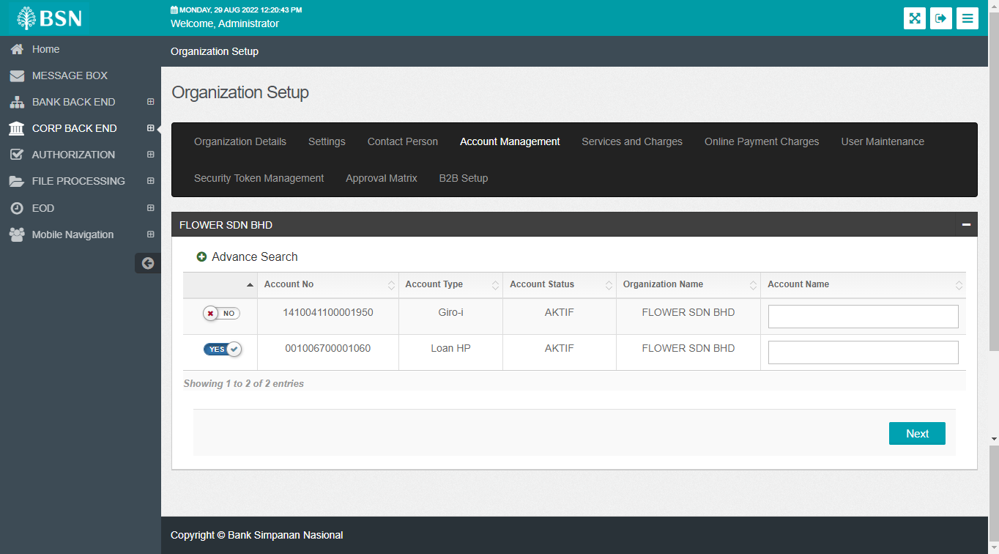  Figure 12: IBAM > CBE > Organization Setup > Account Management

