SCPID#6389
Test Title: |  | Application Form Expired notification
Test Description: |  | Add more information in email notification such as;  - Where & which state to submit the SLA  - Contact person  - Cc email to related state  - Etc.
Test Functionality: |  | To test notifications for expired application form.
Test Procedure: |  | Test steps:  Application form should be new,  creationDate should be after 00:00:00 minus 30 days start from today and before 00:00:00 minus 30 days start from today plus 1  eg:  today date = 23/8/2022  alert date from = 25/7/2022 00:00:00  alert date to = 26/7/2022 00:00:00  creation date should be = 25/7/2022 14:12:32
Response Message:
Successfully created a new application. Received expired application form notification emails.
Test Result: | Pass: Fail: |  | Tested by: | Nor Athirah Umairah (02/09/2022)
Reason for Failure:
Remarks: |  | BSNeBiz  - BSNeBiz Login Page>New Application. Submit the new application.  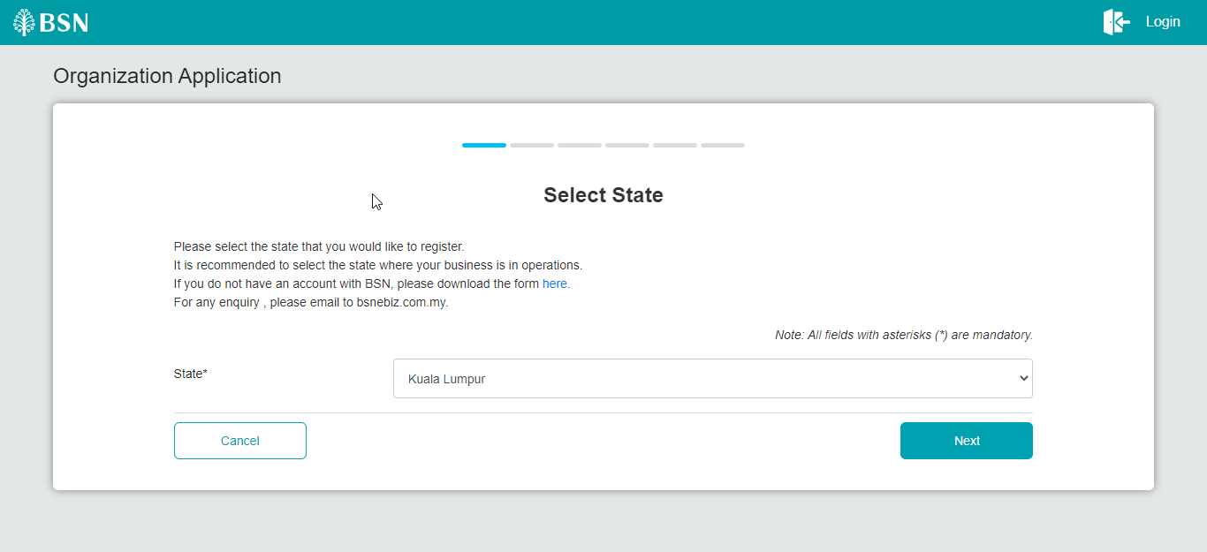  Figure 1: BSNeBiz > Organization Application (Select State)  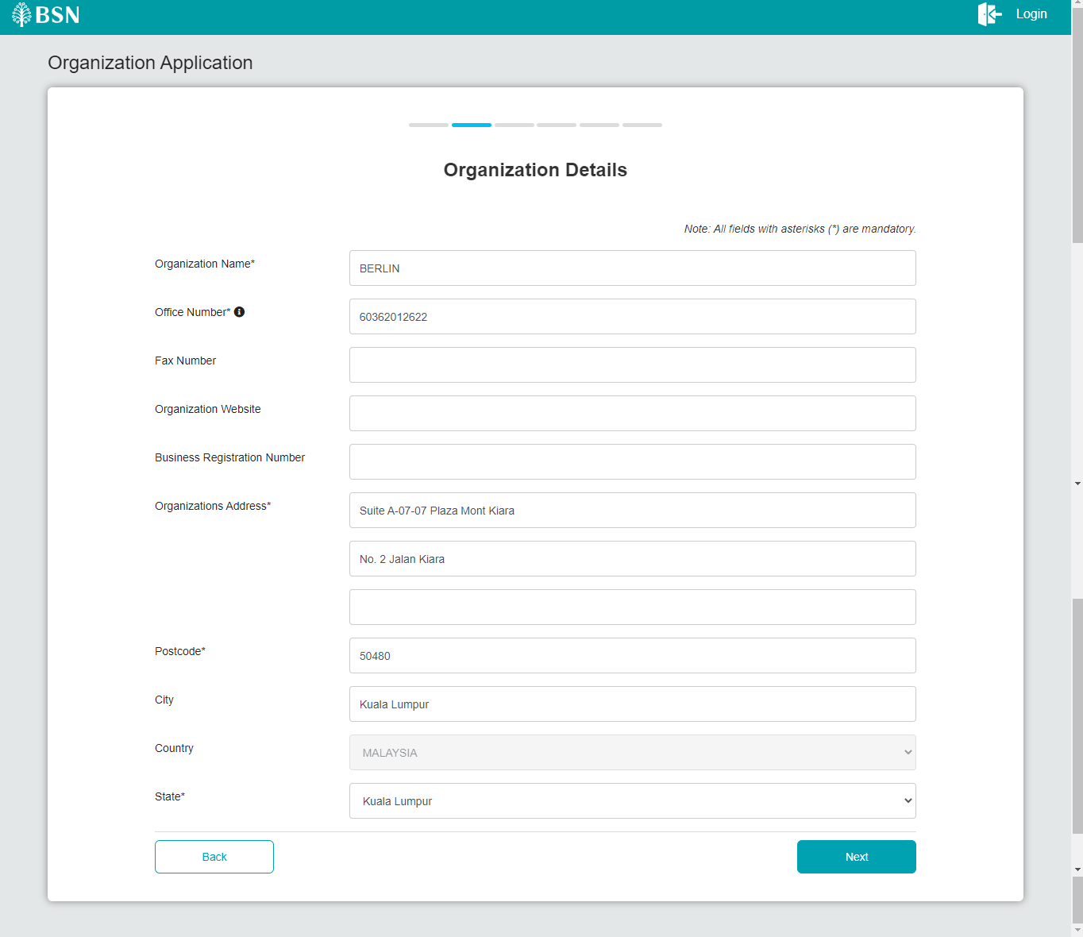  Figure 2: BSNeBiz > Organization Application (Organization Details)  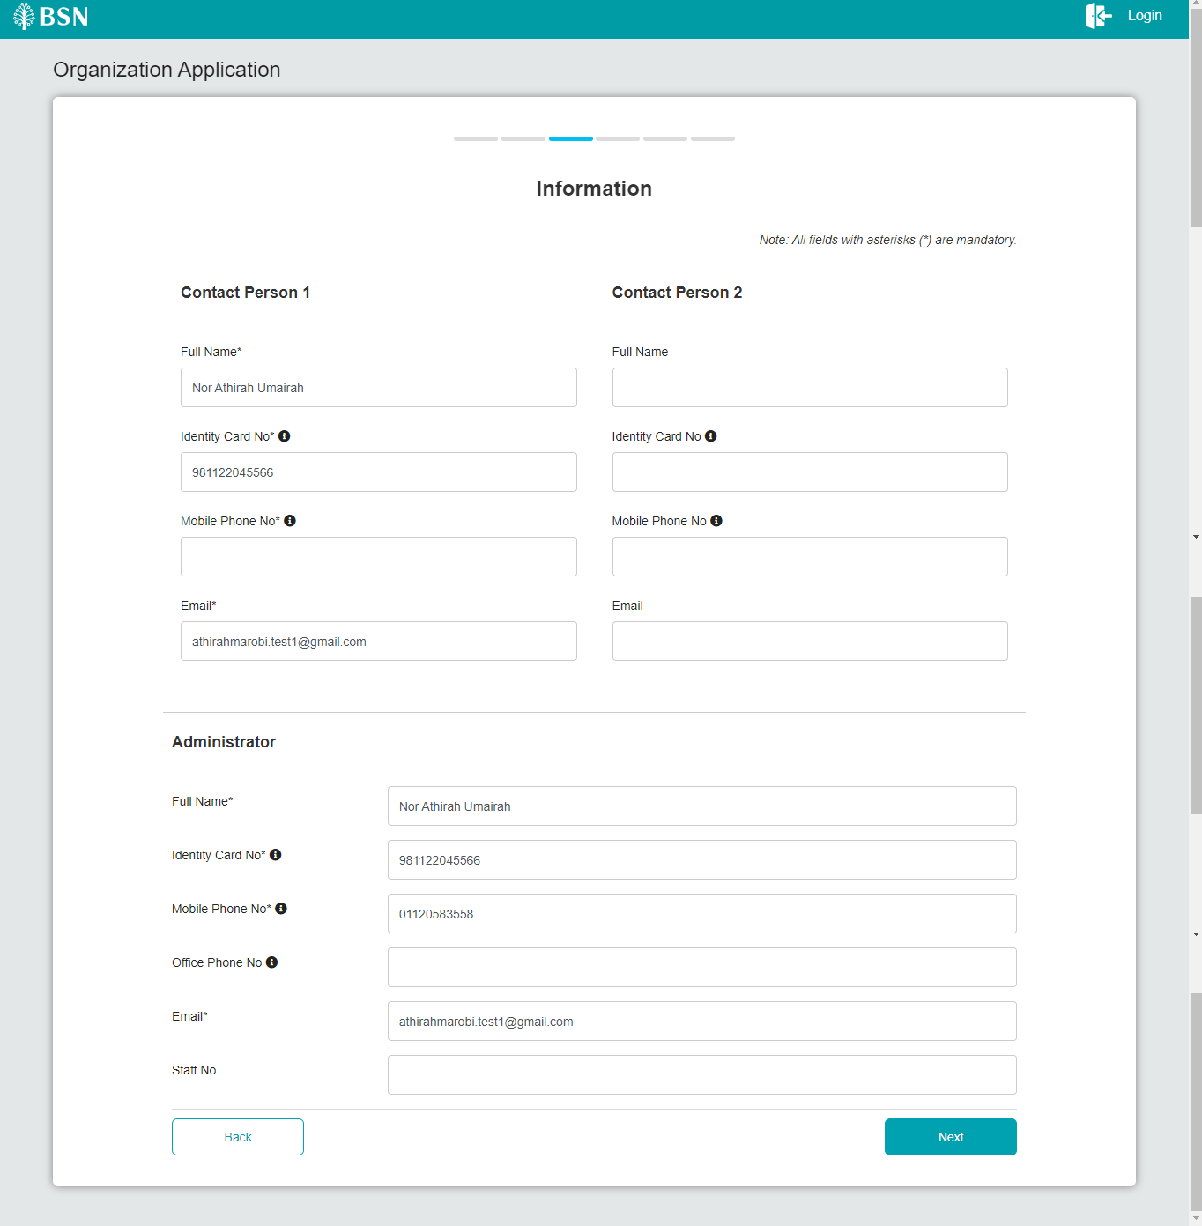  Figure 3: BSNeBiz > Organization Application (Information)  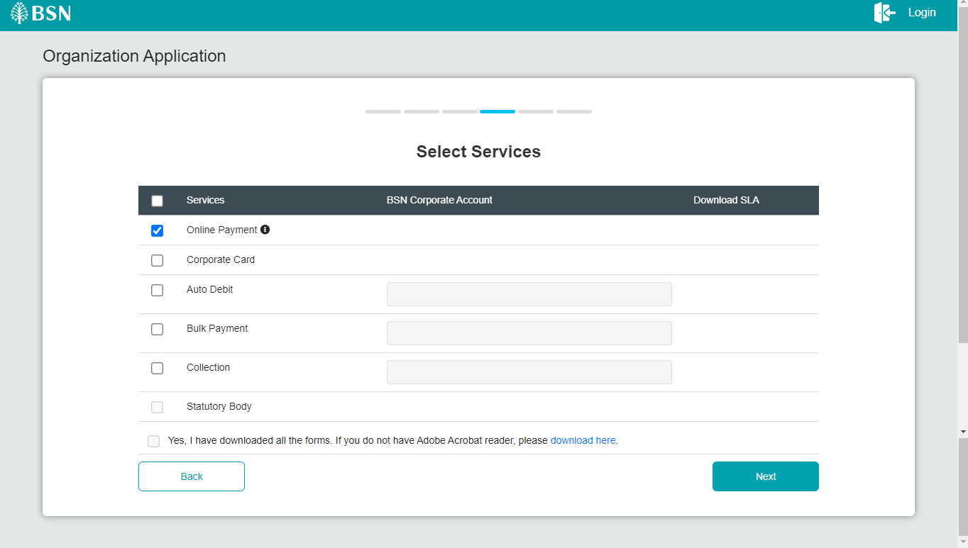  Figure 4: BSNeBiz > Organization Application (Select Services)  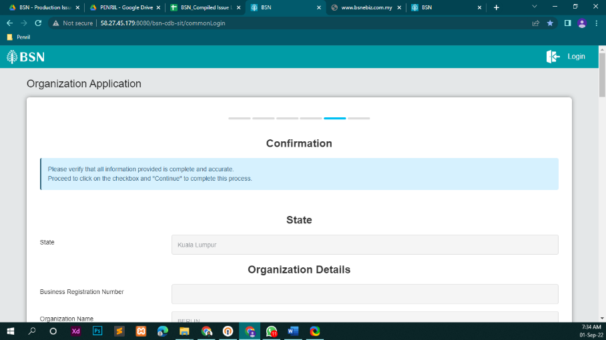  Figure 5: BSNeBiz > Organization Application (Confirmation)  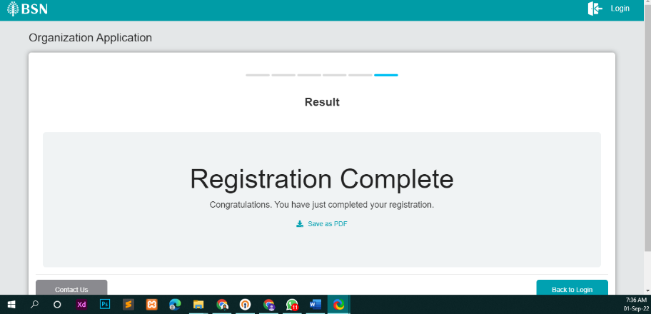  Figure 6: BSNeBiz > Organization Application (Result)  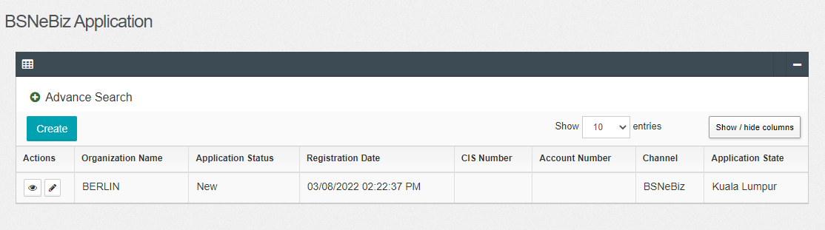  Figure 7: IBAM > CBE > BSNeBiz Application  Result:  Received expired email notification.  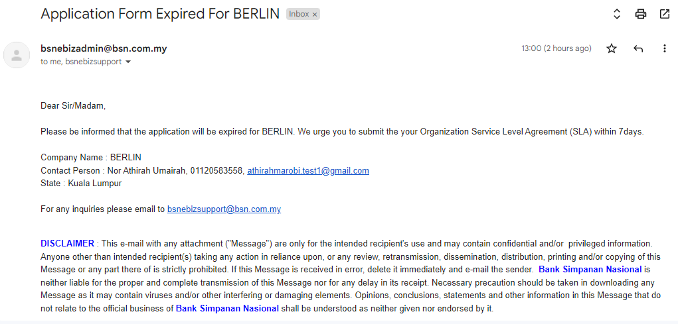  Figure 8: Email Notification  *Note: UKB user with same state and allowed new application permission will receive the email (cc email).  