SCPID#6398
Test Title: |  | Rentas transaction fail due to ValueDT
Test Description: |  | Issue:  Approver approver RENTAS the next day but recipient bank reject  Finding:  BSNeBiz set RENTAS request message, parameter ValueDT, to initiated date, not approval date  Solution:  Fix ValueDT set to approval date
Test Functionality: |  | To test on the successful of RENTAS transaction.
Test Procedure: |  | Test steps:  - Access BSNeBiz CDB as initiator and authorizer.  - Initiate a RENTAS transfer.  - The next day, approve the RENTAS transfer  - Expected result, RENTAS status successful should be Pending Processing and the Recent Activity status should be Accepted.
Response Message:
ValueDt in RENTAS log same with approval date.
Test Result: | Pass: Fail: |  | Tested by: | Nor Athirah Umairah (08/09/2022)
Reason for Failure:
Remarks: |  | Login as Initiator  - Make RENTAS transaction.  Initiate Date: 5/9/2022  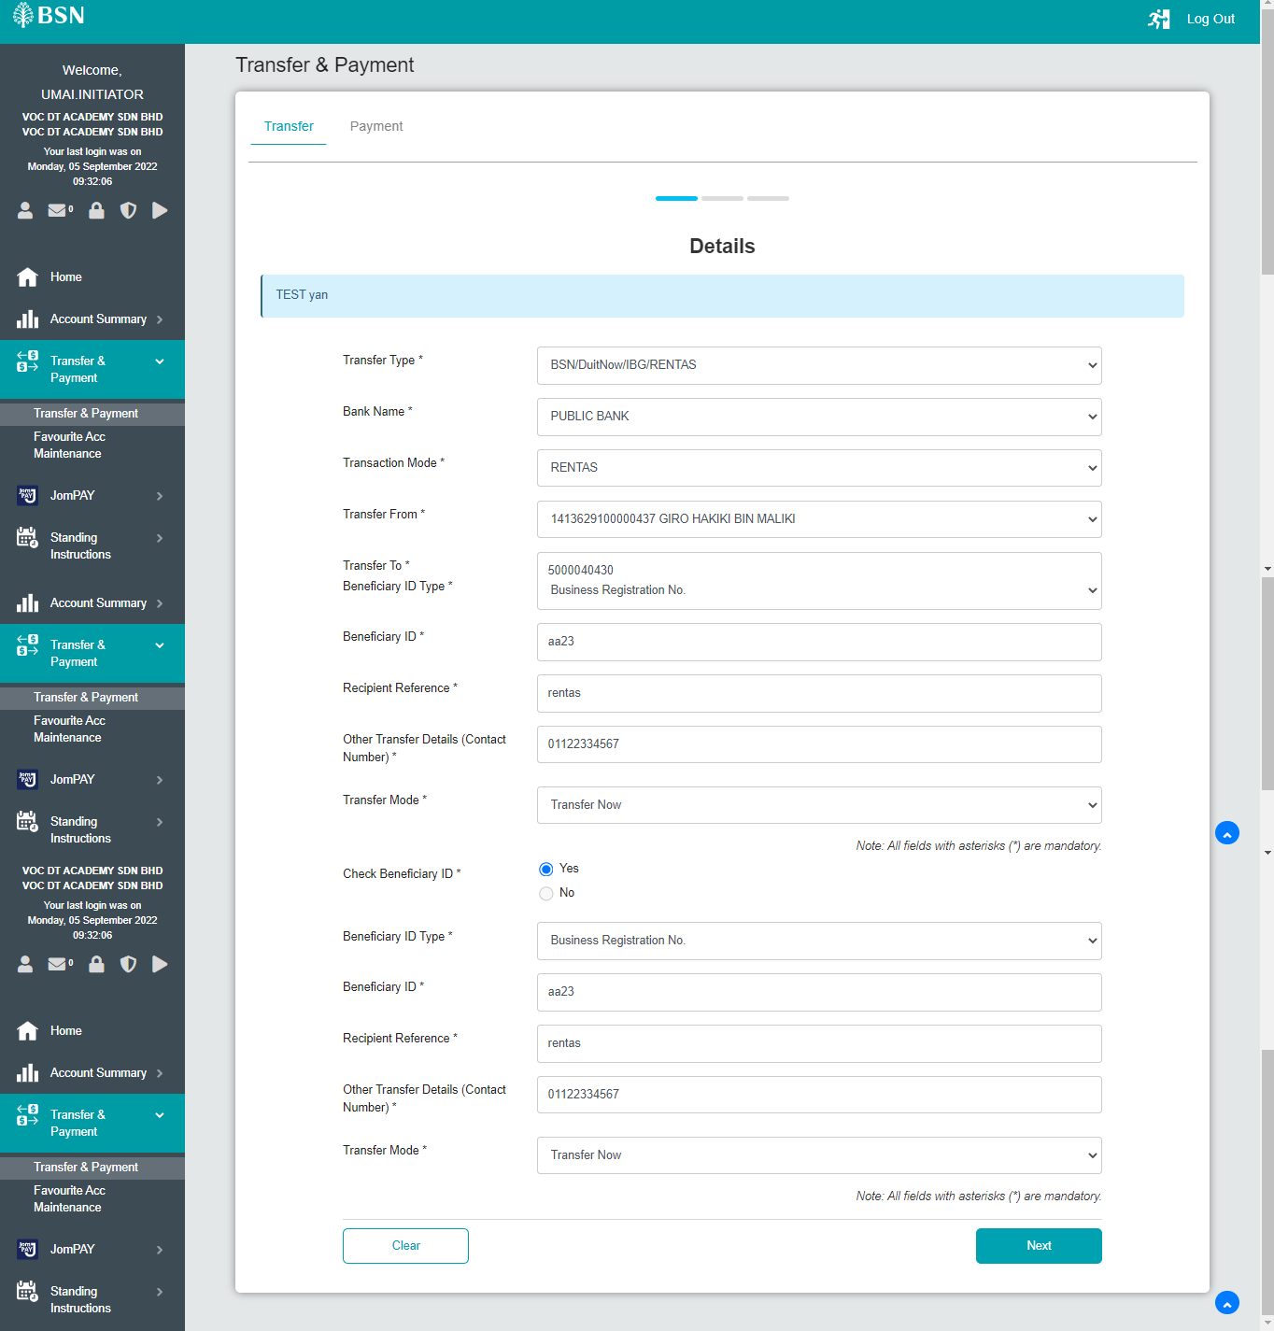  Figure 1: BSNeBiz > Transfer & Payment > Details  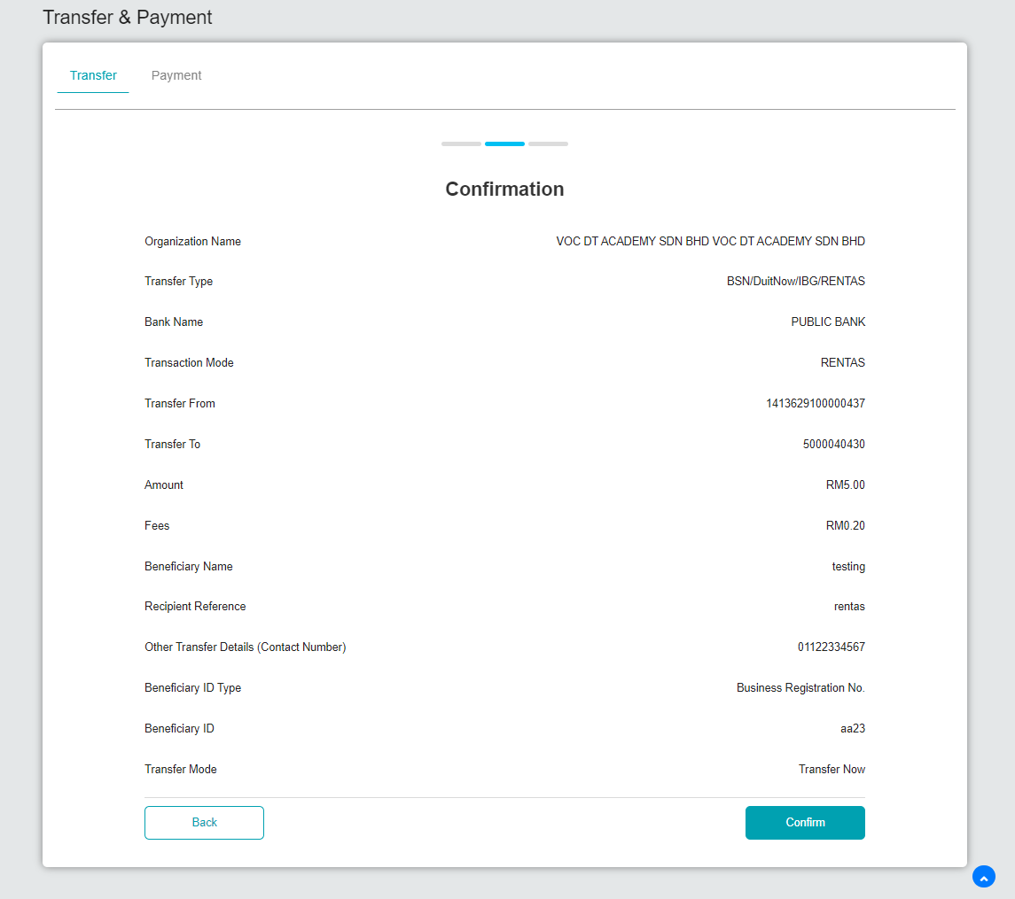  Figure 2: BSNeBiz > Transfer & Payment > Confirmation  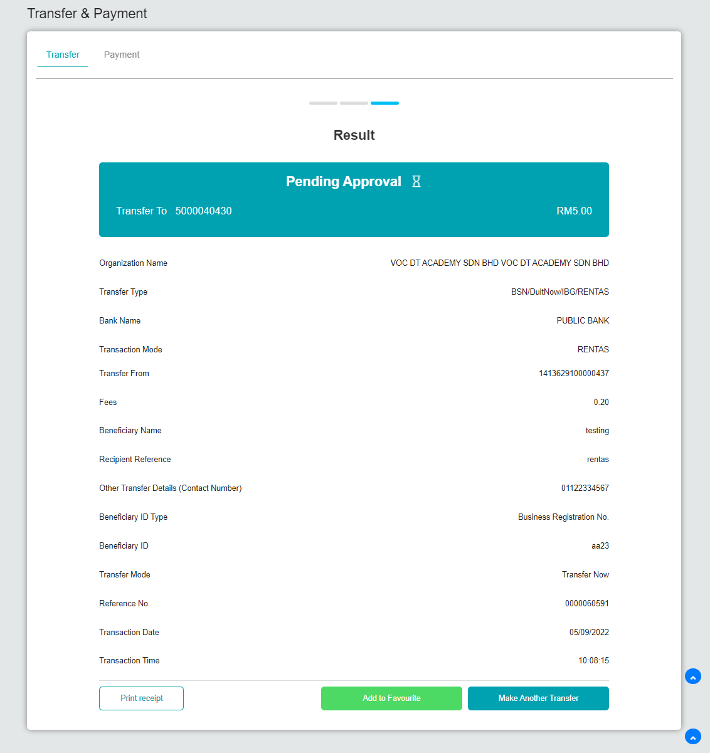  Figure 3: BSNeBiz > Transfer & Payment > Result  Login as Approver  - Approve the transaction on the next day.  Approval Date: 6/9/2022  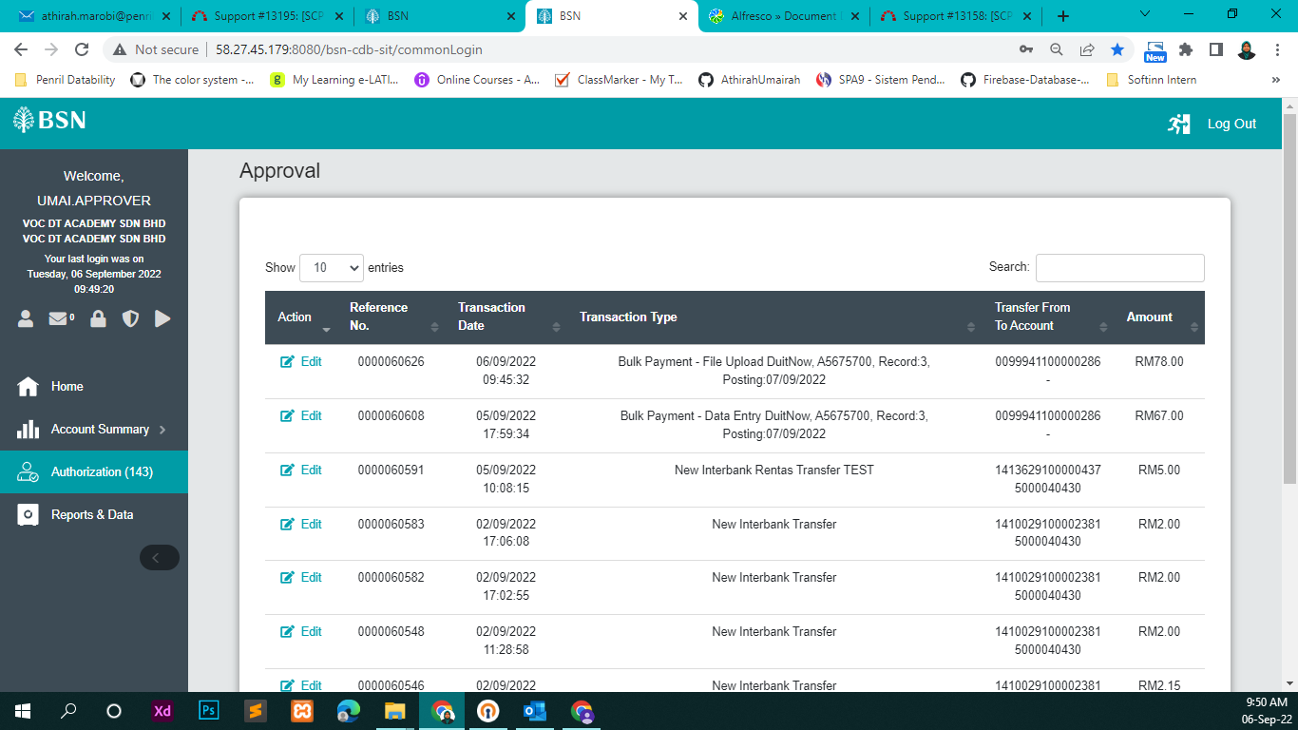  Figure 4: Authorization  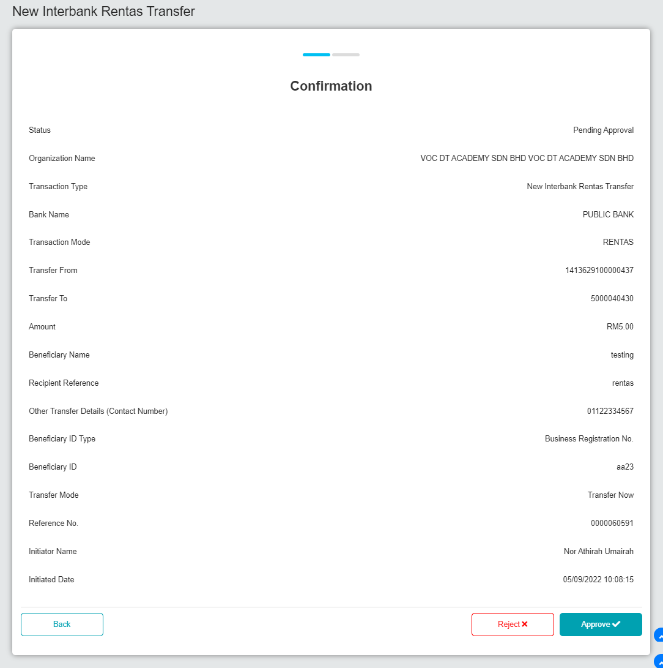  Figure 5: Approval (Confirmation)  Result:  RENTAS transaction status successful should be Pending Processing and the Recent Activity status should be Accepted.  *Note: Unsuccessful due to SIT host down.  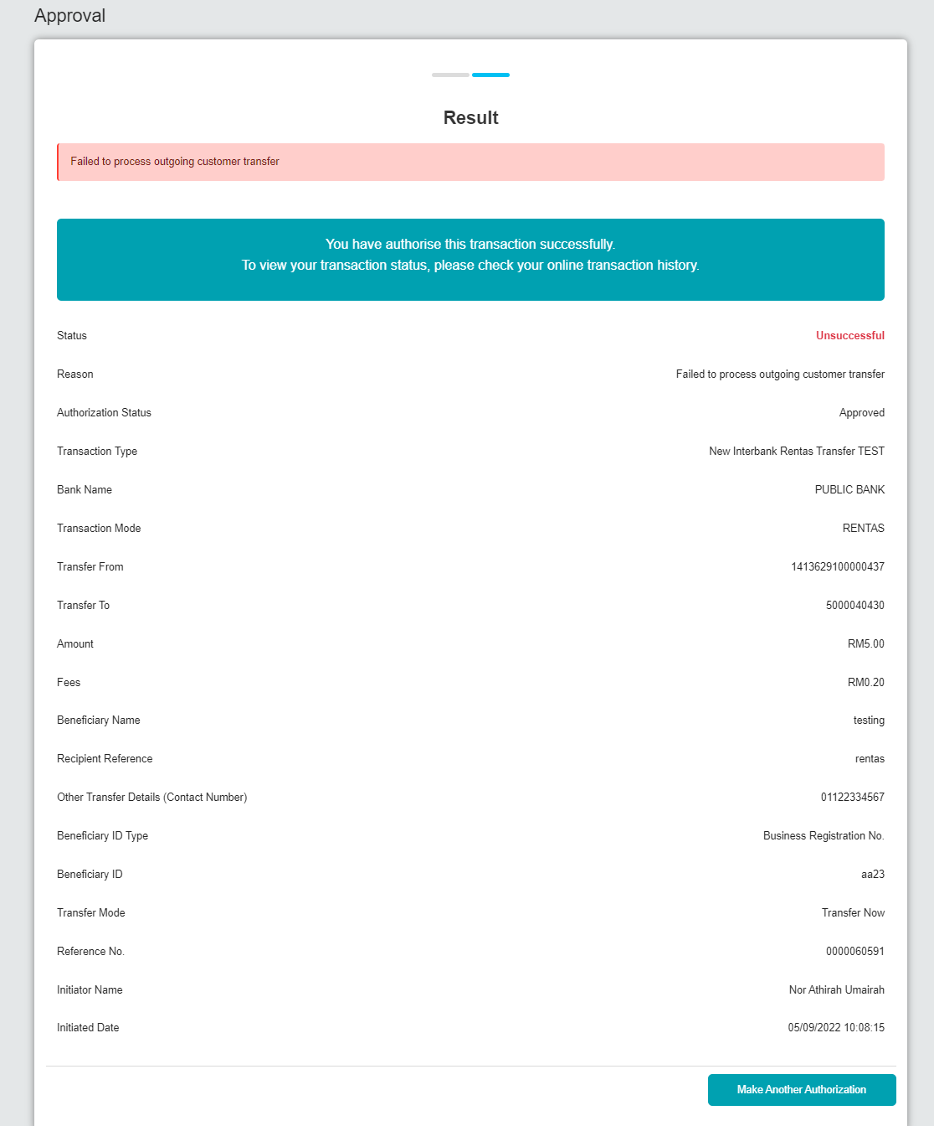  Figure 6: Approval (Result)  *ValueDt in RENTAS web service same with approval date.  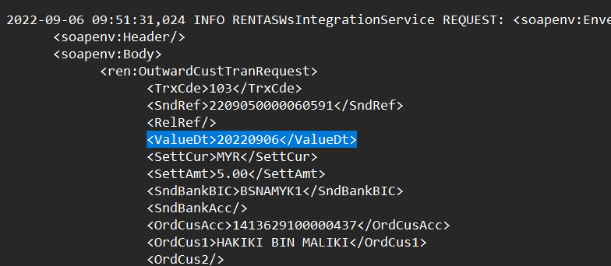  Figure 7: RENTAS Log

