SCPID#6426
Test Title: |  | Creation Date Bug
Test Description: |  | Issue:  BSNeBiz Application date is wrong in report  Finding:  IBAM>CBE>BSNeBiz Application has bug. At page 1, after click 'Save and Continue', the Registration Date is updated.  Solution:  Set Registration Date when creating application only.
Test Functionality: |  | To test on registration date for BSNeBiz Application.
Test Procedure: |  | Test steps:  - Access IBAM>CBE>BSNeBiz Application  - Edit an application. Take note of the Registration Date.  - Access page 1, Organization details  - Click 'Save and Continue'  - Once on page 2, go back to IBAM>CBE>BSNeBiz Application  - Expected result, the Registration Date at step 2 and 5 is the same
Response Message:
The Registration Date at step 2 and 5 is the same.
Test Result: | Pass: Fail: |  | Tested by: | Nor Athirah Umairah (29/09/2022)
Reason for Failure:
Remarks: |  | - Access IBAM>CBE>BSNeBiz Application.  - Edit an application. Take note of the Registration Date.  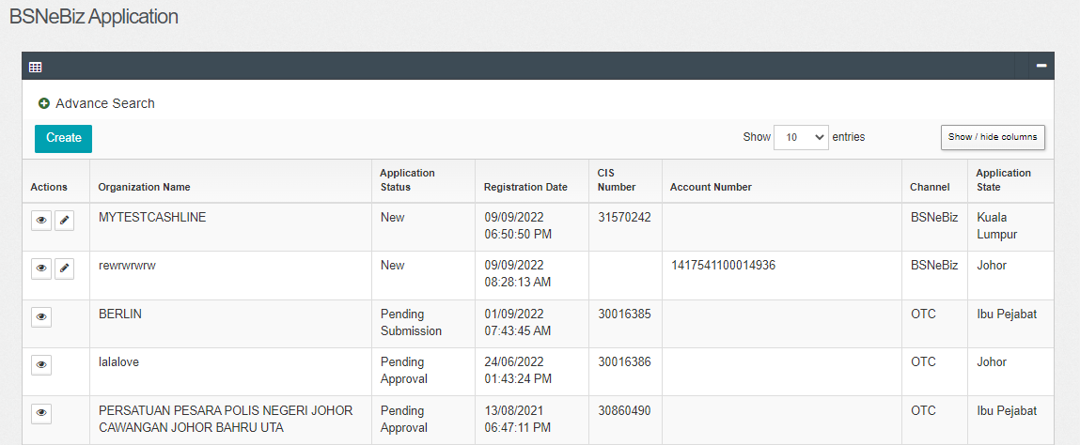  Figure 1: IBAM>CBE>BSNeBiz Application  - Access page 1, Organization details.  - Click 'Save and Continue'  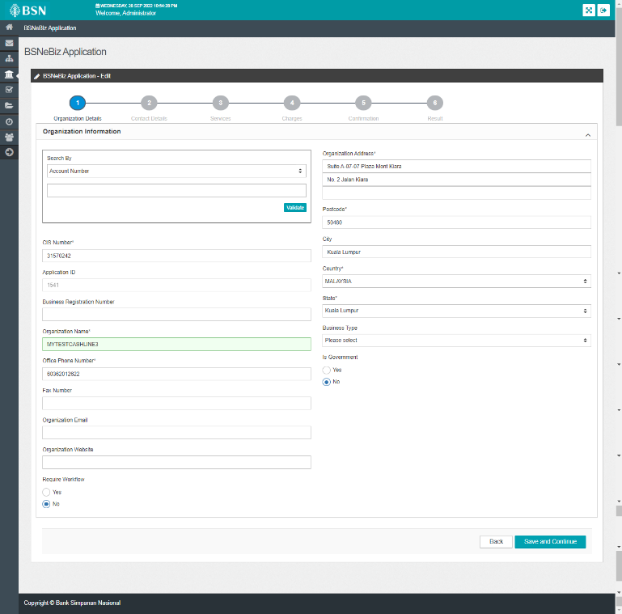  Figure 2: IBAM>CBE>BSNeBiz Application>Organization Details  - Once on page 2, go back to IBAM>CBE>BSNeBiz Application  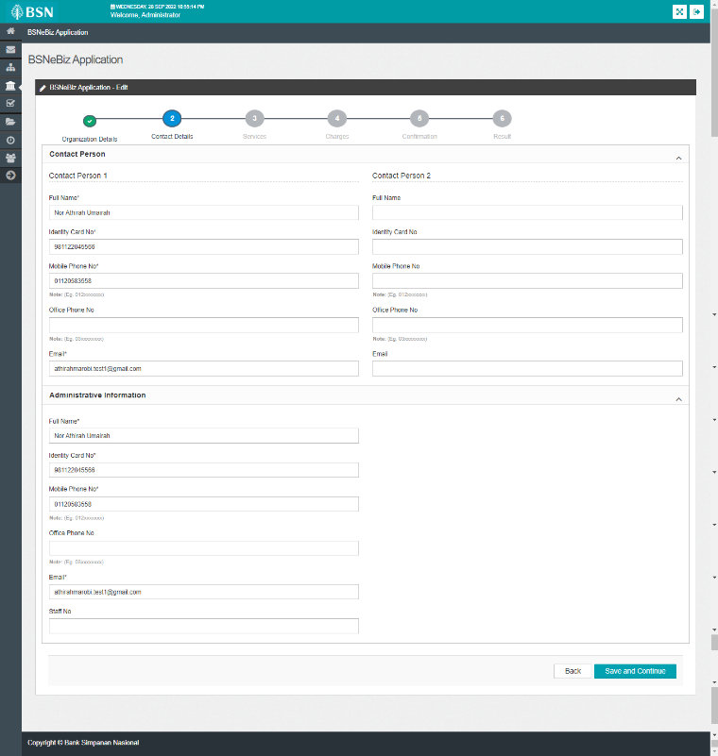  Figure 3: IBAM>CBE>BSNeBiz Application>Contact Details  Result:  The Registration Date at step 2 and 5 is the same.  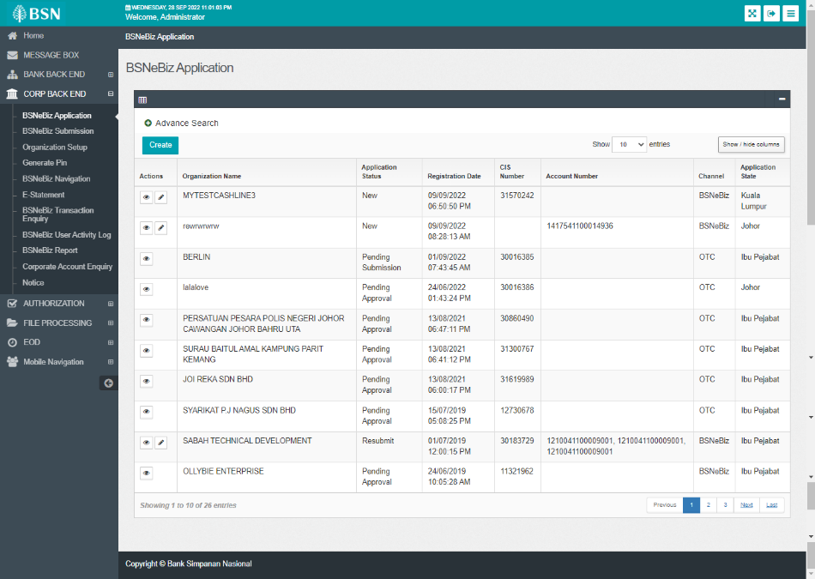  Figure 4: IBAM>CBE>BSNeBiz Application

