SCPID#6439
Test Title: |  | Paging Issue
Test Description: |  | Issue in paging where system display 20 entries per page by default.
Test Functionality: |  | To test on paging for SPP Report.
Test Procedure: |  | Test steps:  - Access IBAM>File Processing>SPP Report  - Select specific criteria and click on search button  - Select show entries (10,25,50,100)  - Expected result, data showed are based on selected number of entries
Response Message:
Data showed are based on selected number of entries.
Test Result: | Pass: Fail: |  | Tested by: | Nor Athirah Umairah (06/10/2022)
Reason for Failure:
Remarks: |  | - Access IBAM>File Processing>SPP Report  - Select specific criteria and click on search button  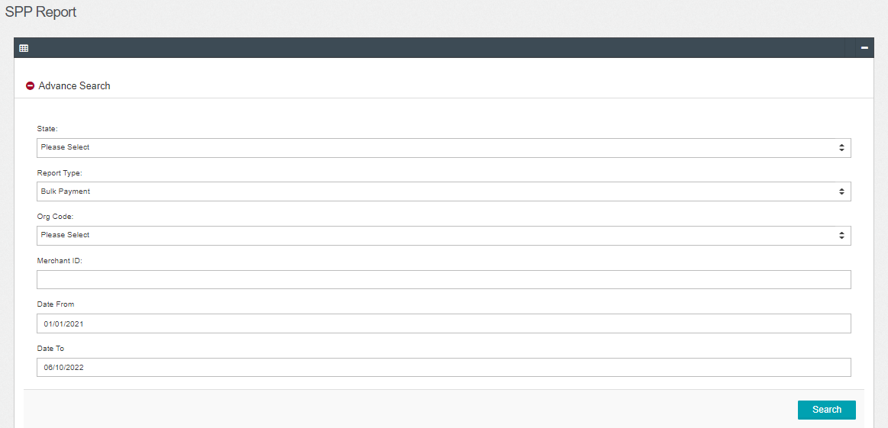  Figure 1: IBAM>File Processing>SPP Report  - Select show entries (10,25,50,100)  Result:  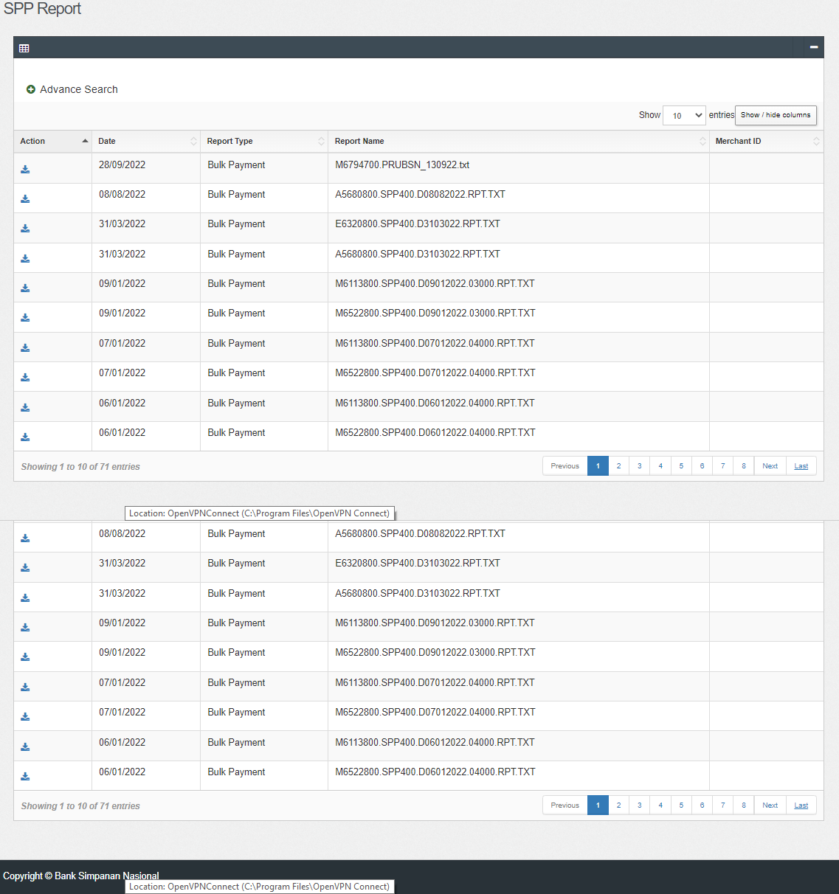  Figure 2: IBAM>File Processing>SPP Report (10 entries)  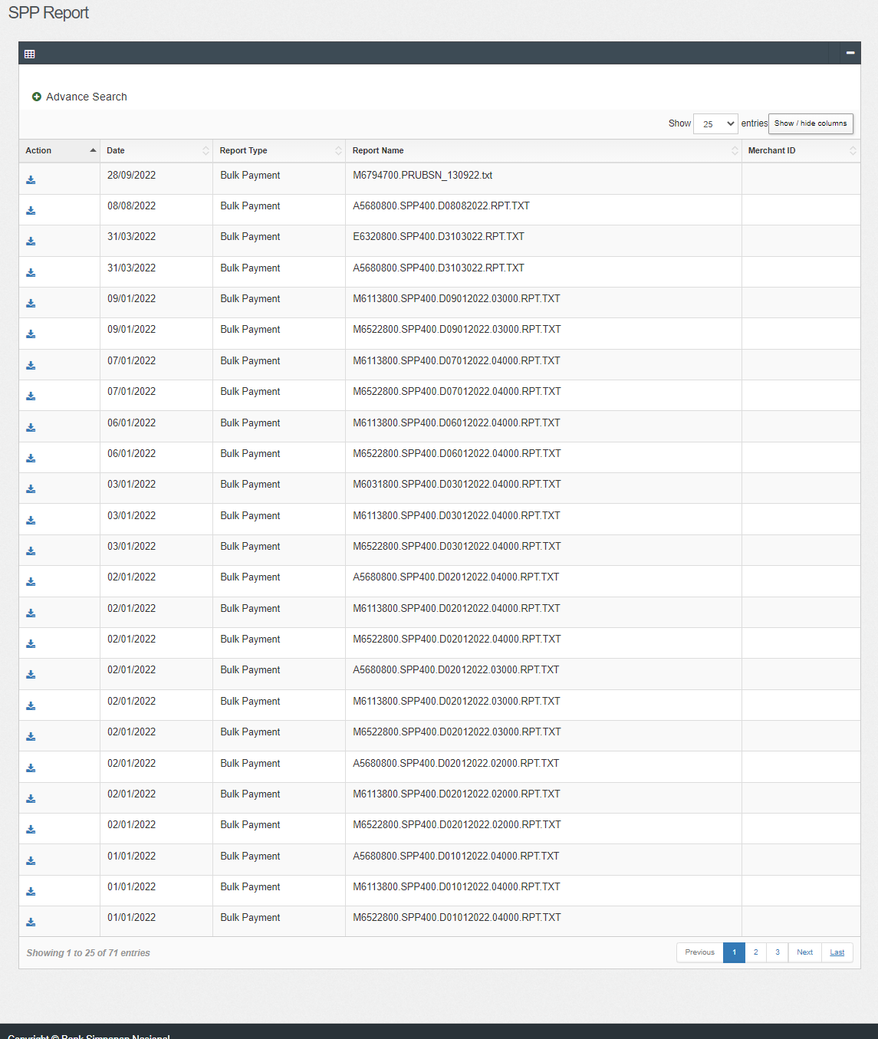  Figure 3: IBAM>File Processing>SPP Report (25 entries)  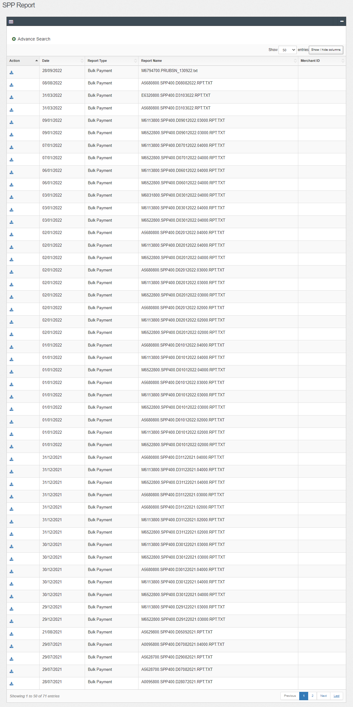  Figure 4: IBAM>File Processing>SPP Report (50 entries)  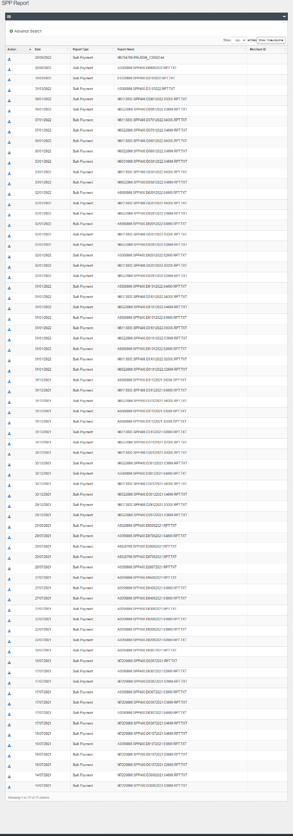  Figure 5: IBAM>File Processing>SPP Report (100 entries)

