SCPID#6450
Test Title: |  | Audit Finding Batch 3
Test Description: |  | Issue:  Inconsistent IB Session ID generated at BSNeBiz Transaction History Data  Finding:  BSNeBiz mistakenly set Websphere session ID as IB Session ID when approving transaction  Solution:  Fix BSNeBiz approval session ID
Test Functionality: |  | To test the session ID on approved transaction.
Test Procedure: |  | Test steps:  - Acesss BSNeBiz as initiator  - Make any transaction, ie own transfer  - Acesss BSNeBiz as approver and approve  - Ask developer to check session ID in database
Response Message:
Session ID displayed in correct format (yyyyMMdd).
Test Result: | Pass: Fail: |  | Tested by: | Nor Athirah Umairah (12/10/2022)
Reason for Failure:
Remarks: |  | - Access BSNeBiz as initiator  - Make own account transfer  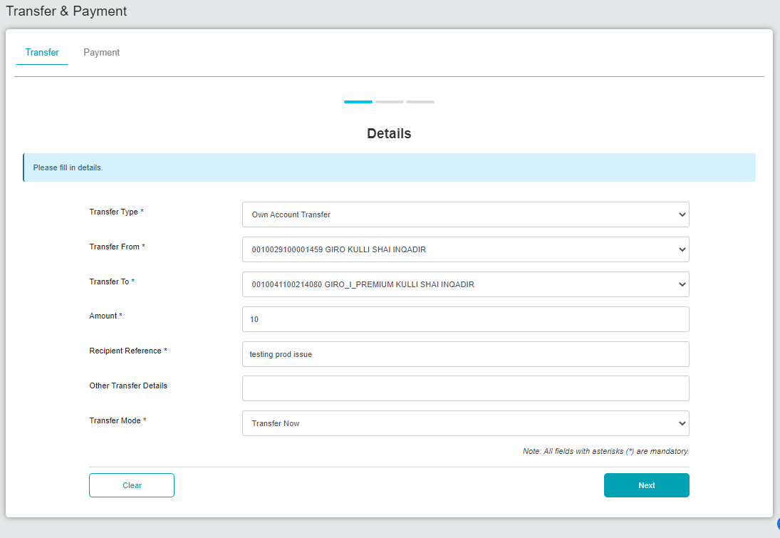  Figure 1: Transfer & Payment (Details)  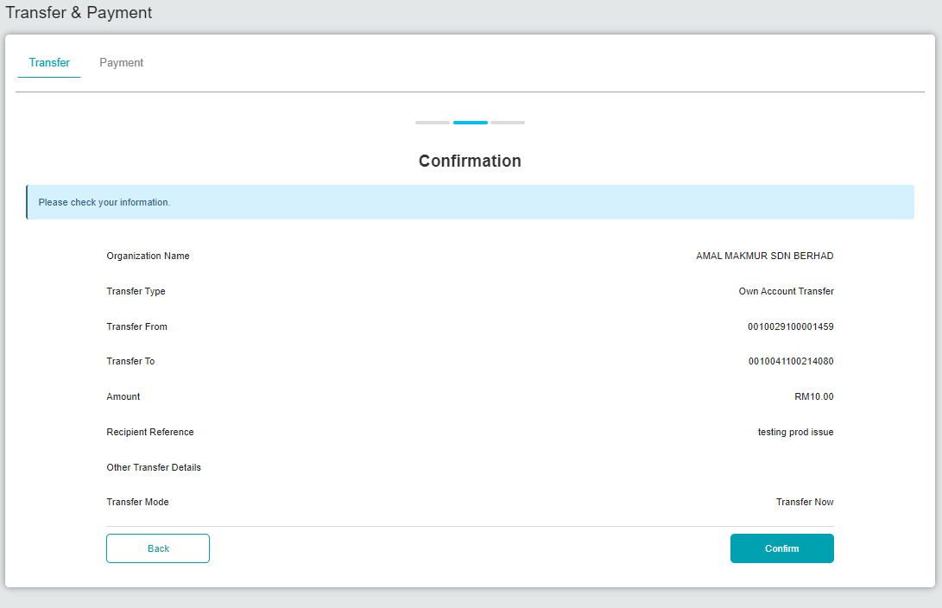  Figure 2: Transfer & Payment (Confirmation)  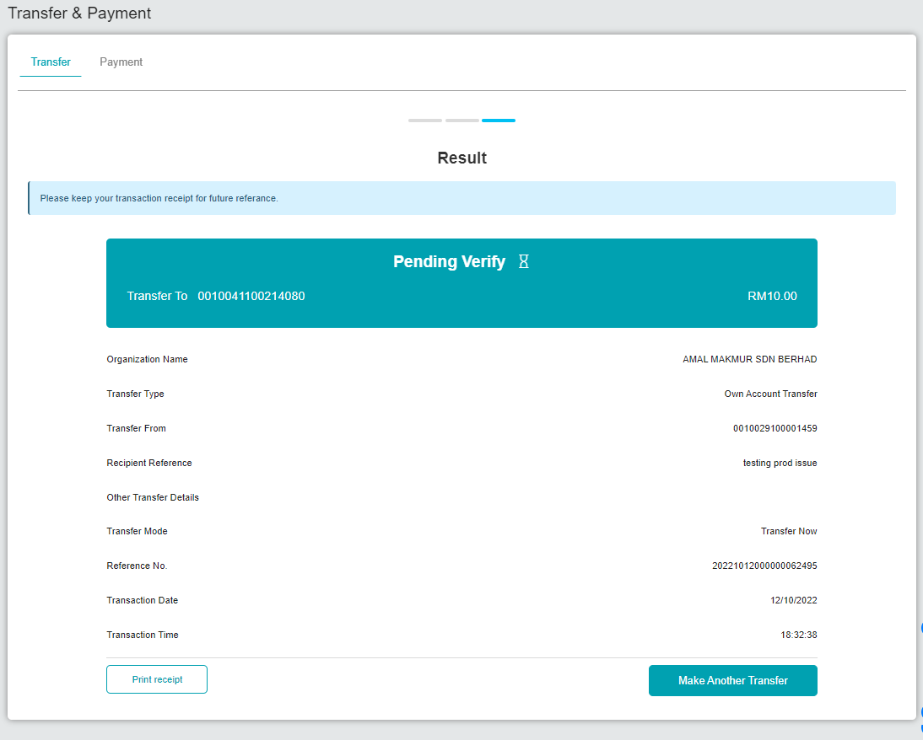  Figure 3: Transfer & Payment (Result)  - Access BSNeBiz as verifier and verify the transaction  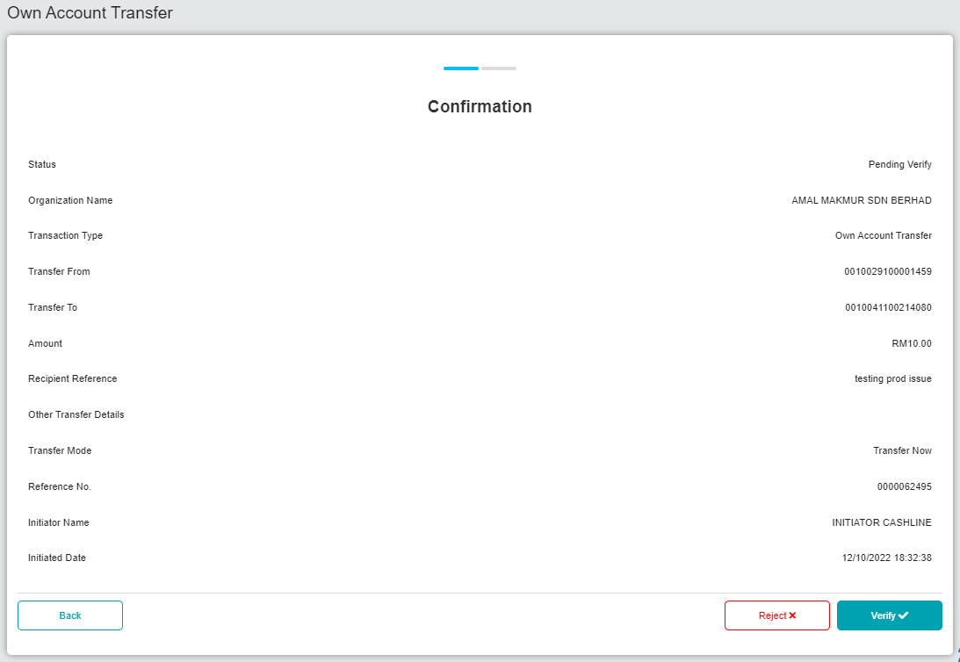  Figure 4: Own Account Transfer (Confirmation)  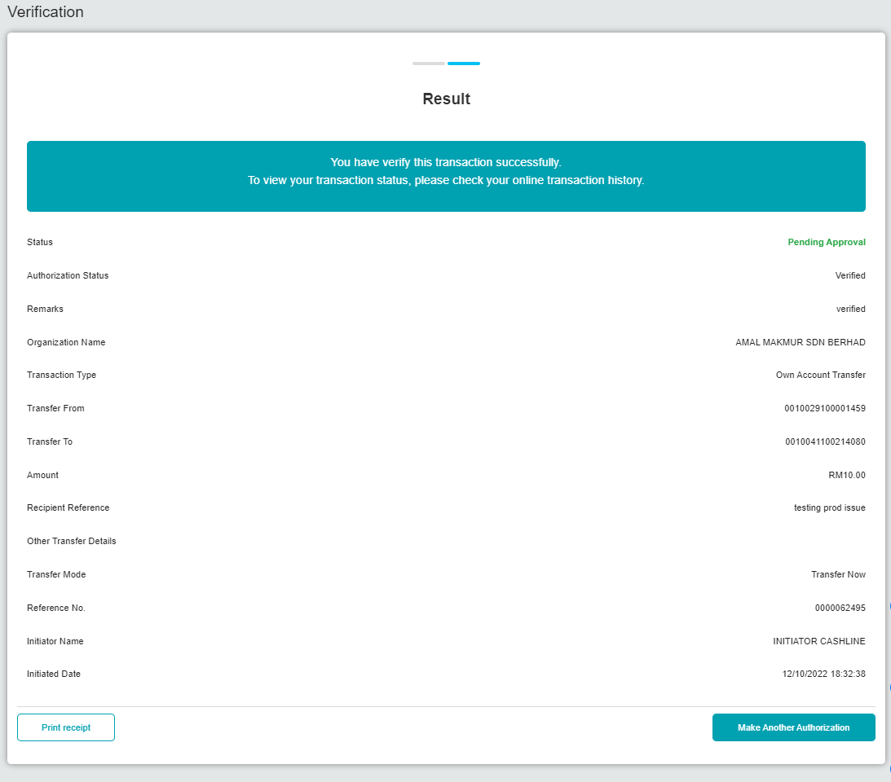  Figure 5: Own Account Transfer (Result)  - Acesss BSNeBiz as approver and approve the transaction  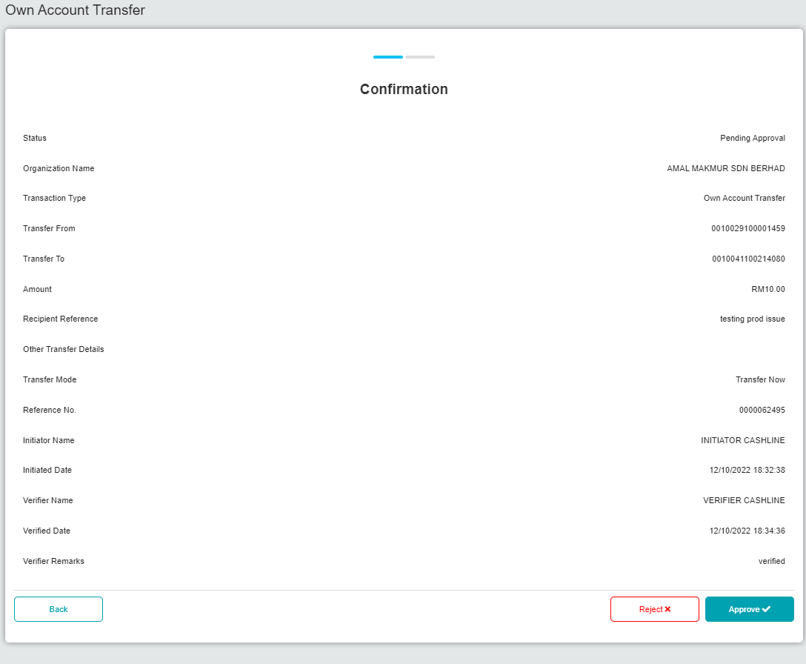  Figure 6: Approval - Own Account Transfer (Confirmation)  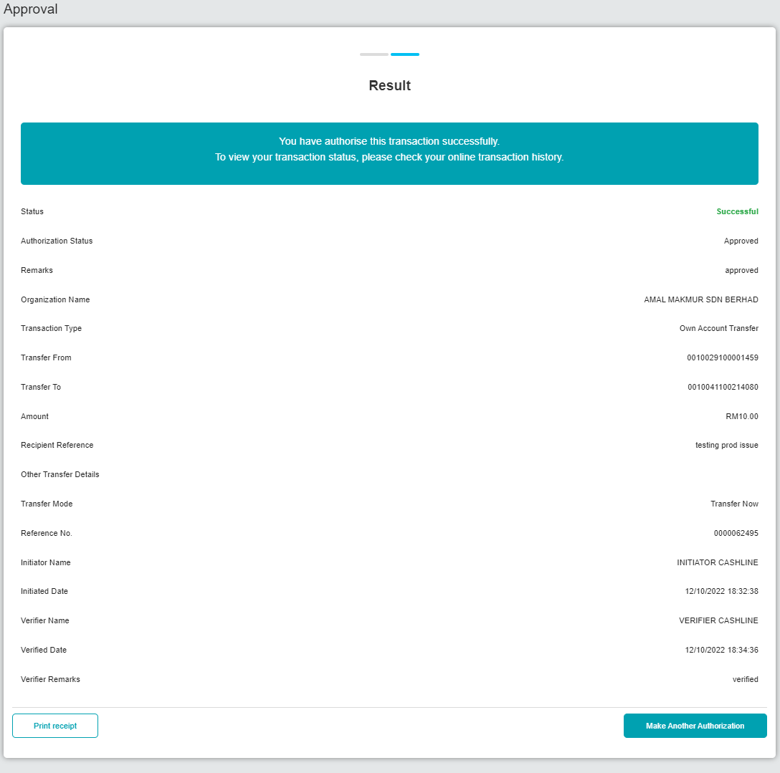  Figure 7: Approval - Own Account Transfer (Result)  - Ask developer to check session ID in database  Result:  