SCPID#6407
Test Title: |  | System to disable to send Temporary Password if the answer is wrong
Test Description: |  | New enhancement for incorrect security question answer.  If user insert more than 3 invalid security answer, user account will be locked. Have to call CA/email to BSNeBiz support to unlock user.
Test Functionality: |  | To test on new enhancement for incorrect security question answer.
Test Procedure: |  | Test steps:  Step I  - Click on user forgot password.  - Insert invalid security answer more than 3 times.  - System will display error message and user has been locked.  Step II  - Click on user forgot password.  - Insert invalid security answer less than 3 times.  - System will display error message.  - Insert valid security answer and able to go to the next page.  Step III  - Unlock user (CA/IBAM user).  - Insert temporary password and set new password and confirm password.  - Make sure user successfully can login to CDB.
Response Message:
Step I: System displayed error message and locked user.
Step II: System displayed error message and user directed to the next page.
Step III: User successfully logged in to CDB.
Test Result: | Pass: Fail: |  | Tested by: | Nor Athirah Umairah (17/10/2022)
Reason for Failure:
Remarks: |  | Step I  - Click on user forgot password.  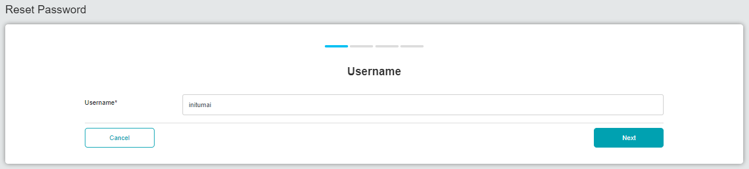  Figure 1: Reset Password (Username)  - Insert invalid security answer more than 3 times.  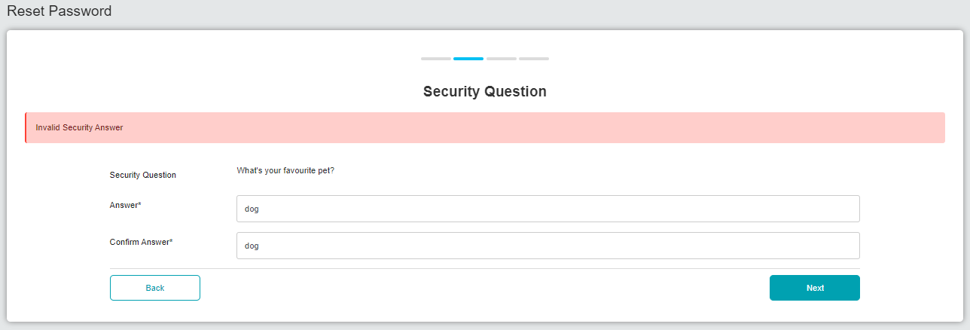  Figure 2: Reset Password (Security Question – First time)  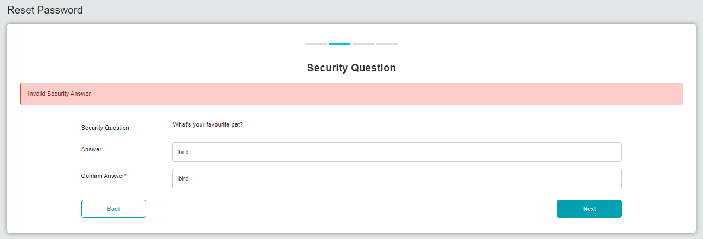  Figure 3: Reset Password (Security Question – Second time)  - System will display error message and user has been locked.  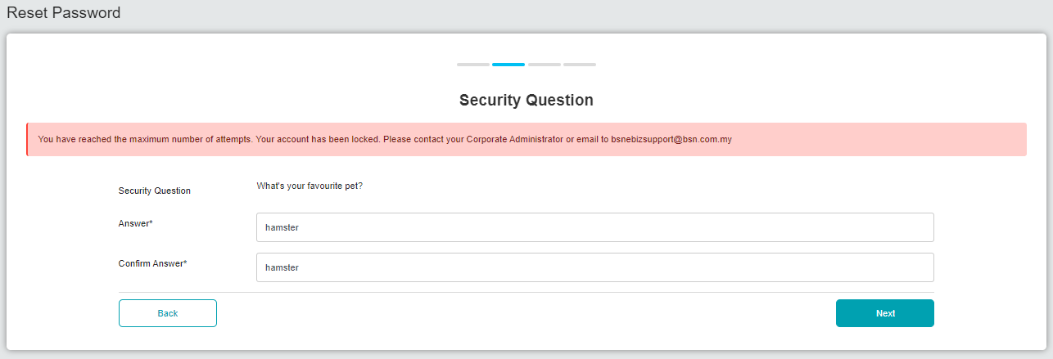  Figure 4: Reset Password (Security Question – Third time)  Figure 5: IBAM>Organization Setup>User Maintenance  Step II  - Click on user forgot password.  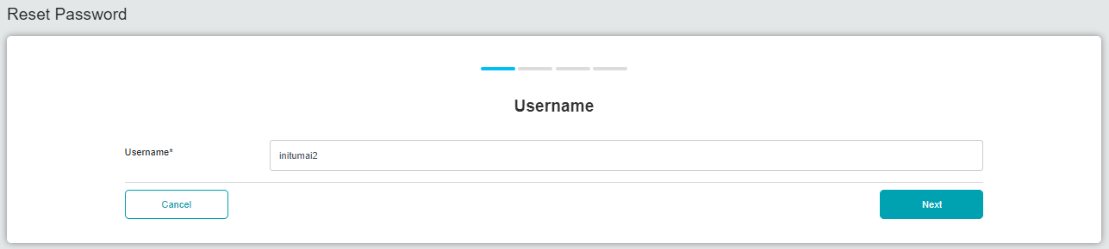  Figure 6: Reset Password (Username)  - Insert invalid security answer less than 3 times.  - System will display error message.  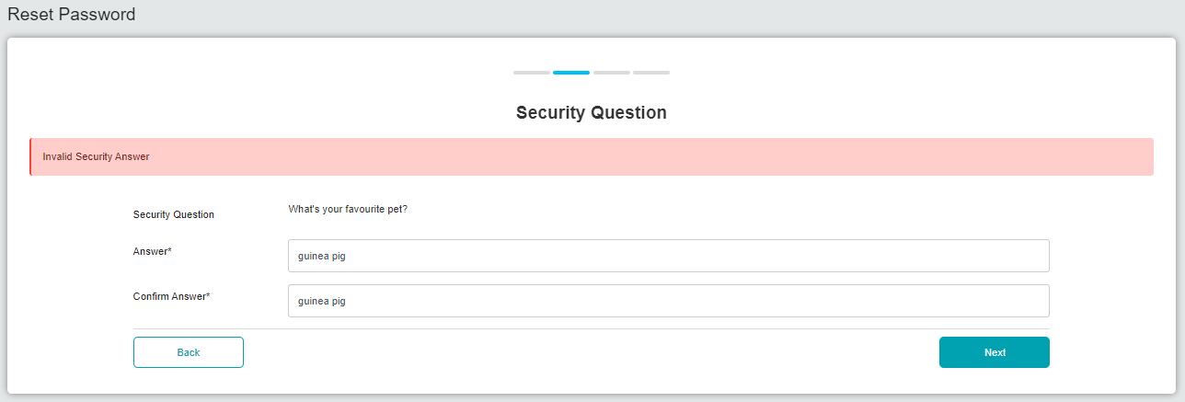  Figure 7: Reset Password (Security Question – First time)  - Insert valid security answer and able to go to the next page.  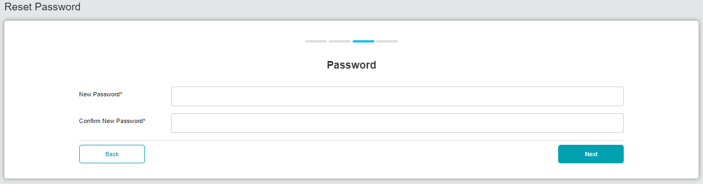  Figure 8: Reset Password (Password)  Step III  - Unlock user (CA/IBAM user).  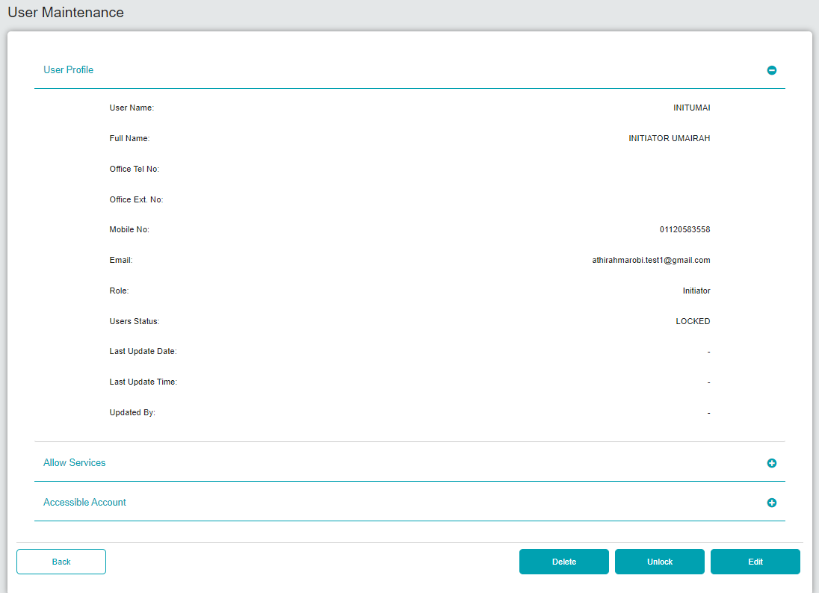  Figure 9: CA>User Maintenance  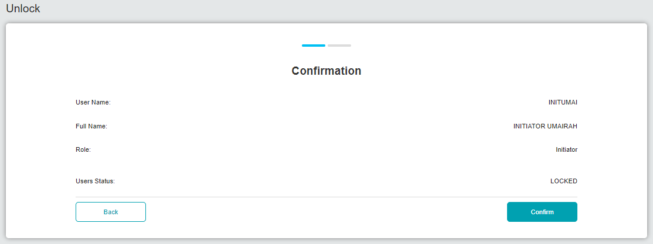  Figure 10: Unlock (Confirmation)  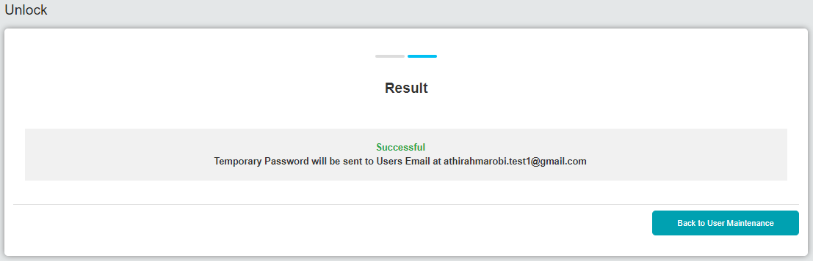  Figure 11: Unlock (Result)  - Insert temporary password and set new password and confirm password.  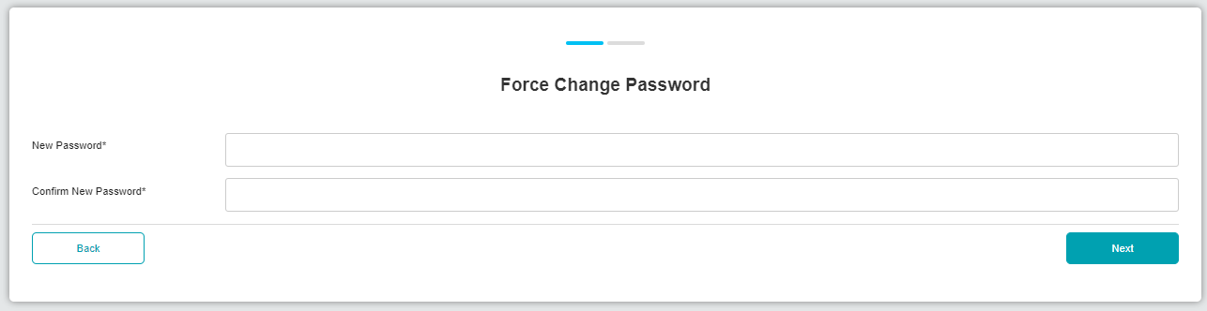  Figure 12: Force Change Password    Figure 13: Result  - Make sure user successfully can login to CDB.  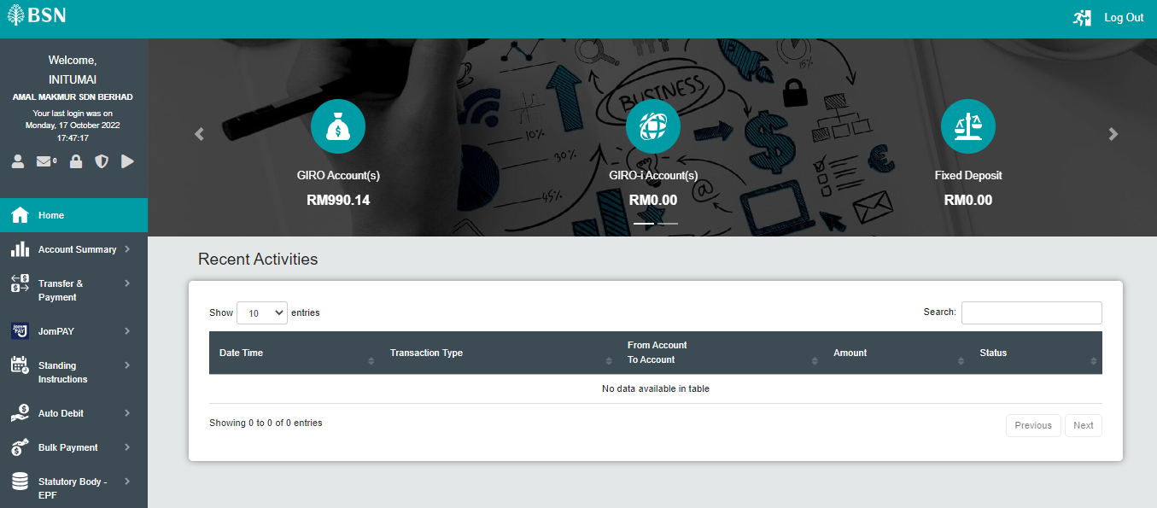  Figure 14: Homepage (Success Login)

