SCPID#6463
Test Title: |  | User able change own user access
Test Description: |  | Issue:  Request to not allow BKTM admin user to change their own role.  Only other BKTM admin user is allowed to change other BKTM admin user.  Solution:  Disable edit user role when user id same with login user id.
Test Functionality: |  | To test editing Role on Admin User Manager.
Test Procedure: |  | Test steps:  - Login IBAM using user maker/checker.  - Access IBAM > BBE > Admin User Manager.  - Select own “User Name” and click edit icon user.  - Expected result, user unable to edit their own Role. User able to edit Role for other usernames.
Response Message:
- User unable to edit their own Role. Radio button for Role has been disable.
- User able to edit Role for other usernames.
Test Result: | Pass: Fail: |  | Tested by: | Nor Athirah Umairah (27/10/2022)
Reason for Failure:
Remarks: |  | - Login IBAM using user maker/checker  Username: penrilmaker2  - Access IBAM > BBE > Admin User Manager  - Select own username and click edit icon user  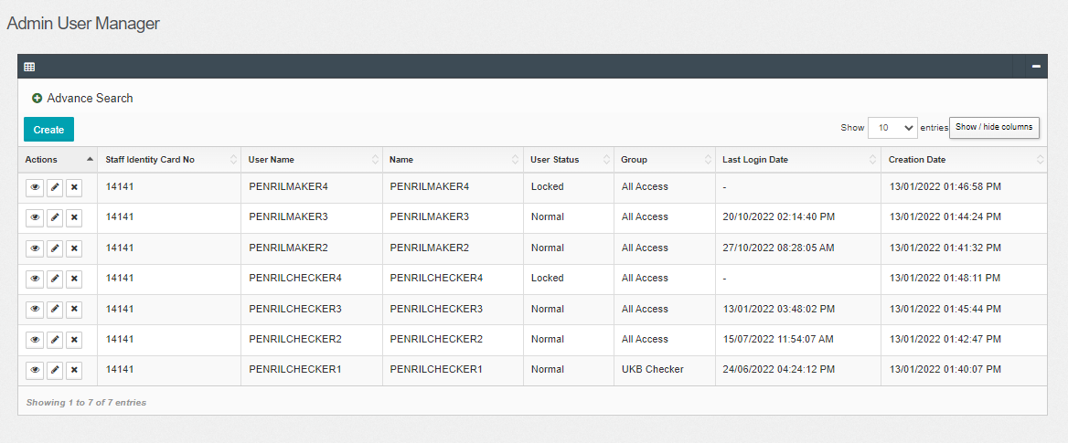  Figure 1: IBAM > BBE > Admin User Manager  - Expected result, user unable to edit their own Role. User able to edit Role for other usernames.  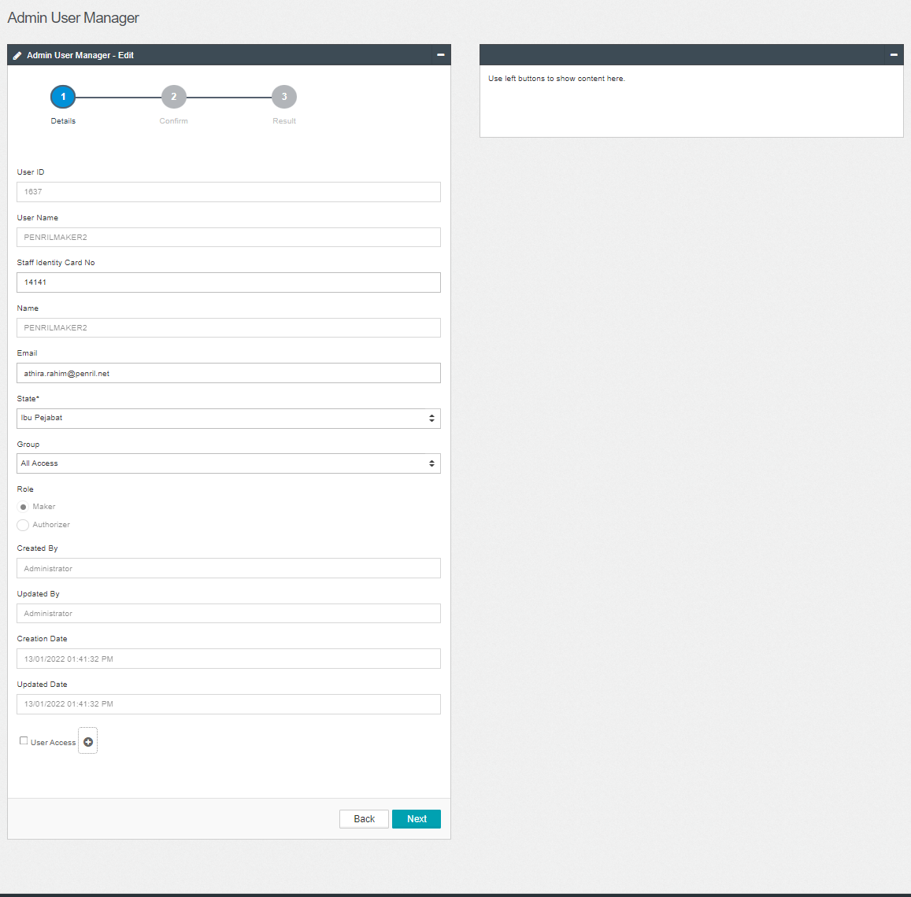  Figure 2: Admin User Manager – Edit (Own username)  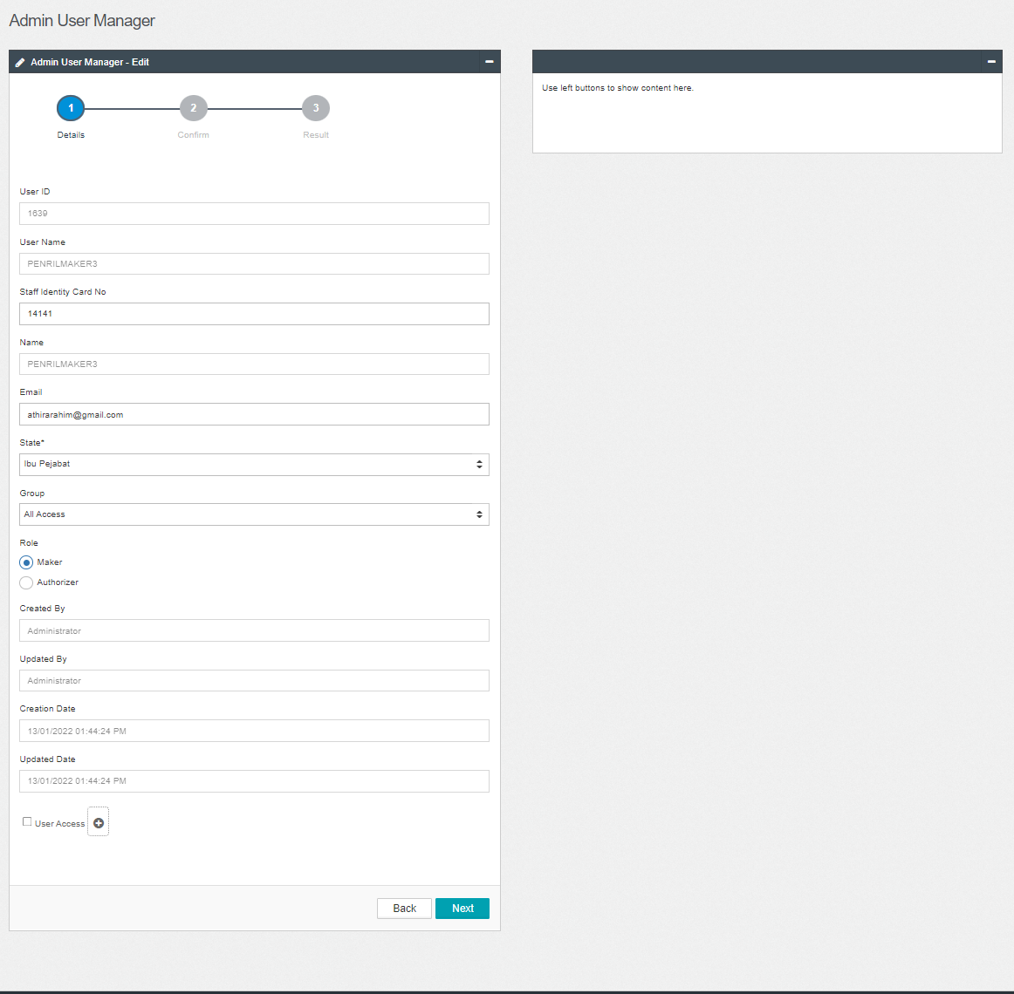  Figure 3: Admin User Manager – Edit (Other username)

