SCPID#6499
Test Title: |  | Enhance Configuration File
Test Description: |  | Task:  Move mockup configuration to database  Changes:  No front-end changes
Test Functionality: |  | To view account list from ICBS in Organization Setup, BSNeBiz Account Summary and Mobile BSNeBiz Quick Balance.
Test Procedure: |  | Test steps:  - Login and access IBAM>CBE>Org Setup>Company with account>Account Management. Last valid company is Nami Productions.  - Expected result, able to view account list from ICBS.  - Login and access BSNeBiz>Account Summary  - Expected result, able to view account list from ICBS.  - Login and access Mobile>Account Summary  - Expected result, able to view account list from ICBS.
Response Message:
Test Result: | Pass: Fail: |  | Tested by: | Nor Athirah Umairah (09/11/2022)
Reason for Failure:
Remarks: |  | - Login and access IBAM>CBE>Org Setup>Company with account>Account Management. Last valid company is Nami Productions.  - Expected result, able to view account list from ICBS.  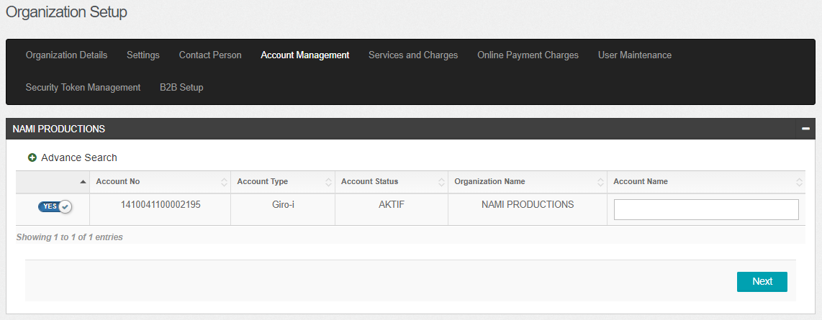  Figure 1: IBAM > CBE > Org Setup > Account Management  - Login and access BSNeBiz>Account Summary  - Expected result, able to view account list from ICBS.  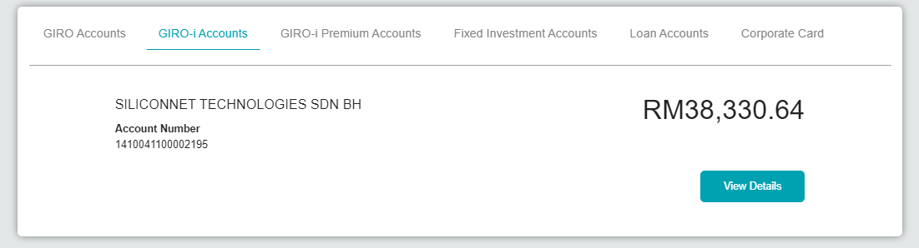  Figure 2: BSNeBiz > Account Summary  - Login and access Mobile>Quick Balance  - Expected result, able to view account list from ICBS.  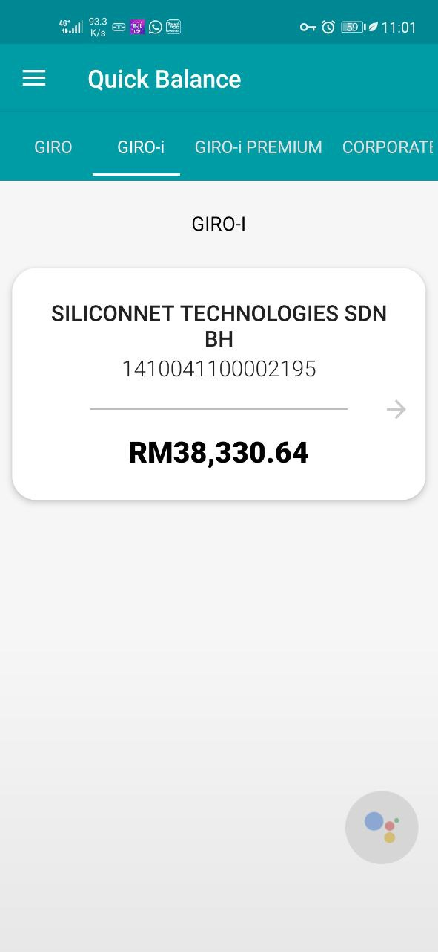  Figure 3: BSNeBiz > Quick Balance

