Summary:

Upon checking on 10/11/2022 8am the bank balance is stopped until 09112022 03:30am and the data BANK_BALANCE on 09112022 03:00 - 09112022 03:30 is not completed.

Then we try to delete the uncompleted data after that run Bank Calculation again. Upon calculating the balance we got an error db session time out on the new batch5 participant.

So I suggest work around to change manually the data on table BANK for participant (PDJMIDJ1, SYJMIDJ1, SYACIDJ1) status became 1 to exclude this participant from balance calculation and also temporary disable bank data offloading to hold the new participant batch5 data.

Successfully calculated bank balance until 10/11/2022 13:30 and enable back cronjob for bank balance calculation. So now bank balance and the report already run normally with the work around.

To resolve the work around still in progress under investigation.

Scenario:

Upon first check on BANK_BALANCE last data is on 09112022 03:30

After further checking BANK_BALANCE data on09112022 03:00 - 09112022 03:30 is not completed (counted 63 supposed 79) so we decided to remove those balance data first.

Select before delete BANK_BALANCE data on 09112022 03:00 - 09112022 03:30

Delete record BANK_BALANCE data on09112022 03:00 - 09112022 03:30

After we delete BANK_BALANCE data 09112022 03:00 - 09112022 03:30, starting to recalculate balance by using BankBalanceBatchMain.sh





BankBalanceBatchMain.sh is successful and can calculate balance for 09112022 03:00 data

Then we run BankBalanceManualBatchMain.sh to catch up bank balance calculation until current time but got error upon calculate for new batch5 participant (PDJMIDJ1, SYJMIDJ1, SYACIDJ1)

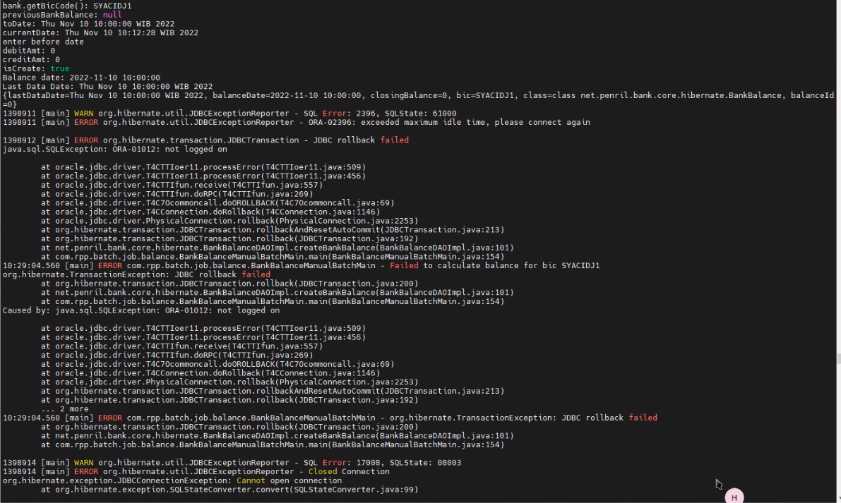

Then suggested to temporary manually update on table ci_portal.BANK for PDJMIDJ1, SYJMIDJ1, SYACIDJ1 status became 1, so this new bank did not included on balance calculation process temporarily.

Select before update status bank to 1

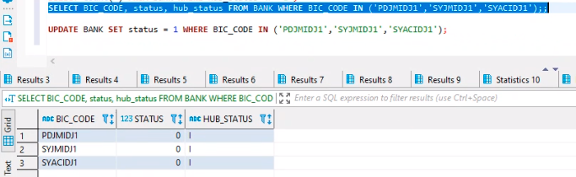

Update status bank to 1

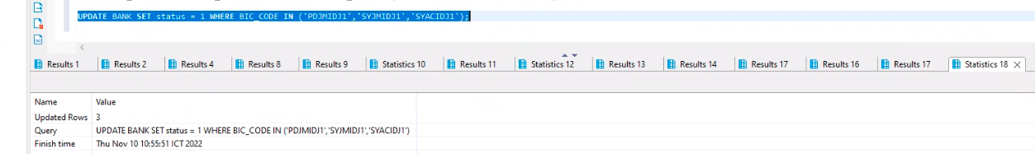

Delete bank balance data after failed before recalculate again.

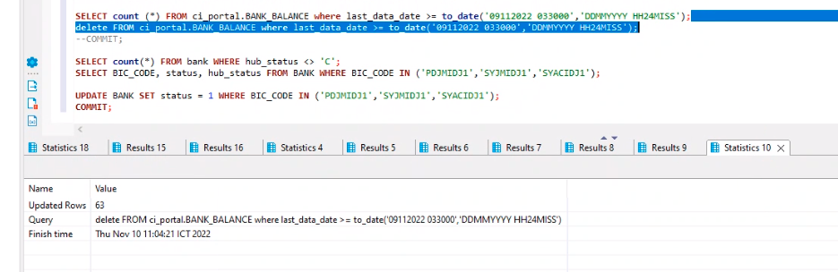

Disable Bank data offloading temporarily because the new participant batch5 causing db session timeout on calculating the balance

before Start calculate balance until current (10112022 13:30)

