SCPID#6504
Test Title: |  | NC failed ( No retry)
Test Description: |  | Issue:  Approved Jompay but got failed Notification Completion(NC). BSNeBiz batch program should retry the NC but it did not.  Finding:  BSNeBiz appoval did not update effective date, thus the BSNeBiz batch program did not retry the NC.  Issue only happens to Jompay with different initiated and approved date.  Solution:  Fix BSNeBiz appoval to update Jompay effective date
Test Functionality: |  | To test on Jompay transaction effective date same as approval date.
Test Procedure: |  | Test steps:  - Access BSNeBiz as Initiator  - Make a Jompay payment  - Access BSNeBiz as Approver  - Approve the Jompay payment  - Access IBAM>CBE>Transaction Enquiry  - Search for the Jompay transaction and access the details page  - Expected result, the effective date same as approval date.
Response Message:
Jompay effective date same as approval date.
Test Result: | Pass: Fail: |  | Tested by: | Nor Athirah Umairah (14/11/2022)
Reason for Failure:
Remarks: |  | - Access BSNeBiz as Initiator  - Make a Jompay payment  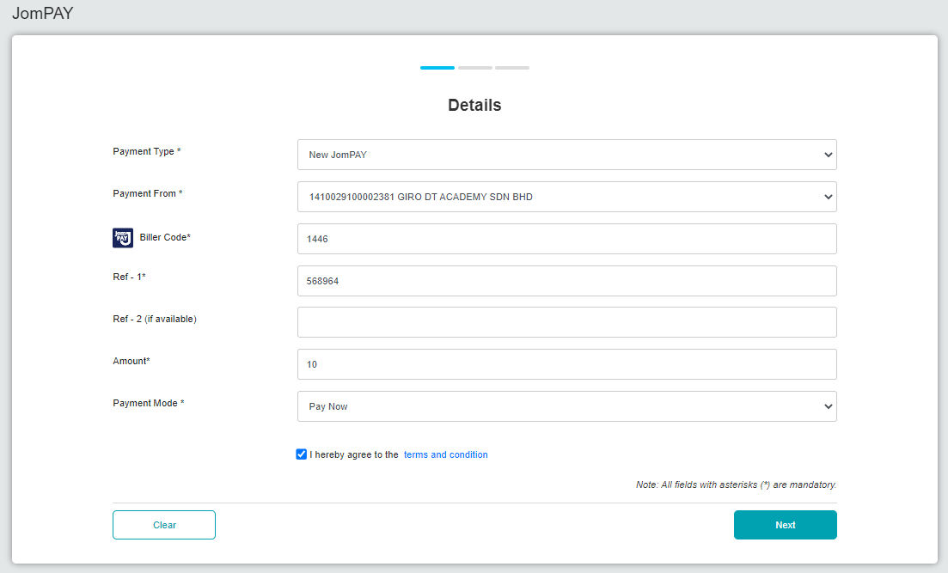  Figure 1: BSNeBiz > Jompay (Details)  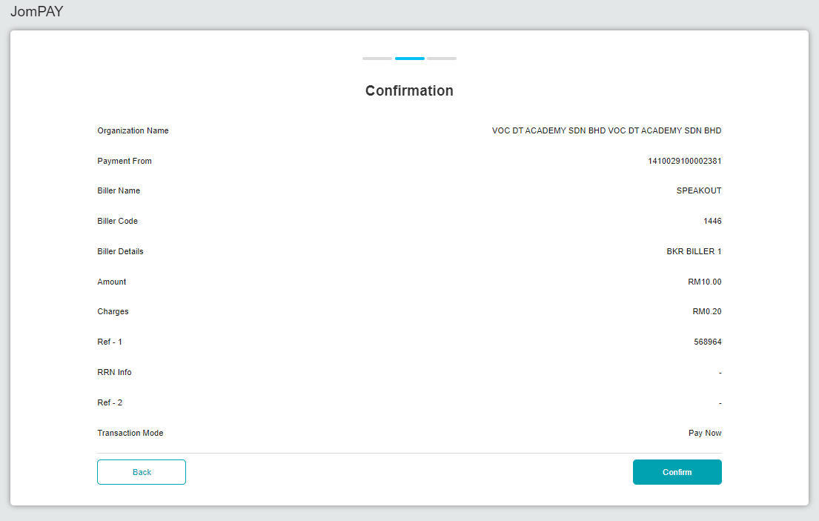  Figure 2: BSNeBiz > Jompay (Confirmation)  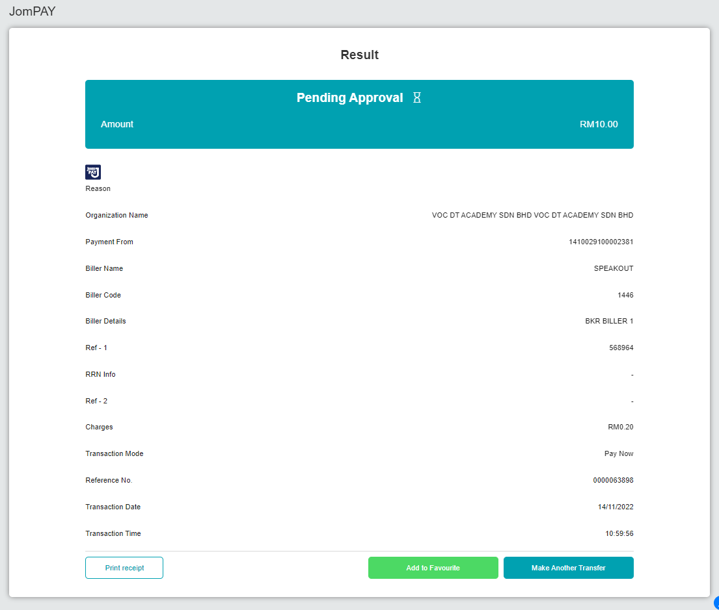  Figure 3: BSNeBiz > Jompay (Result)  - Access BSNeBiz as Approver  - Approve the Jompay payment  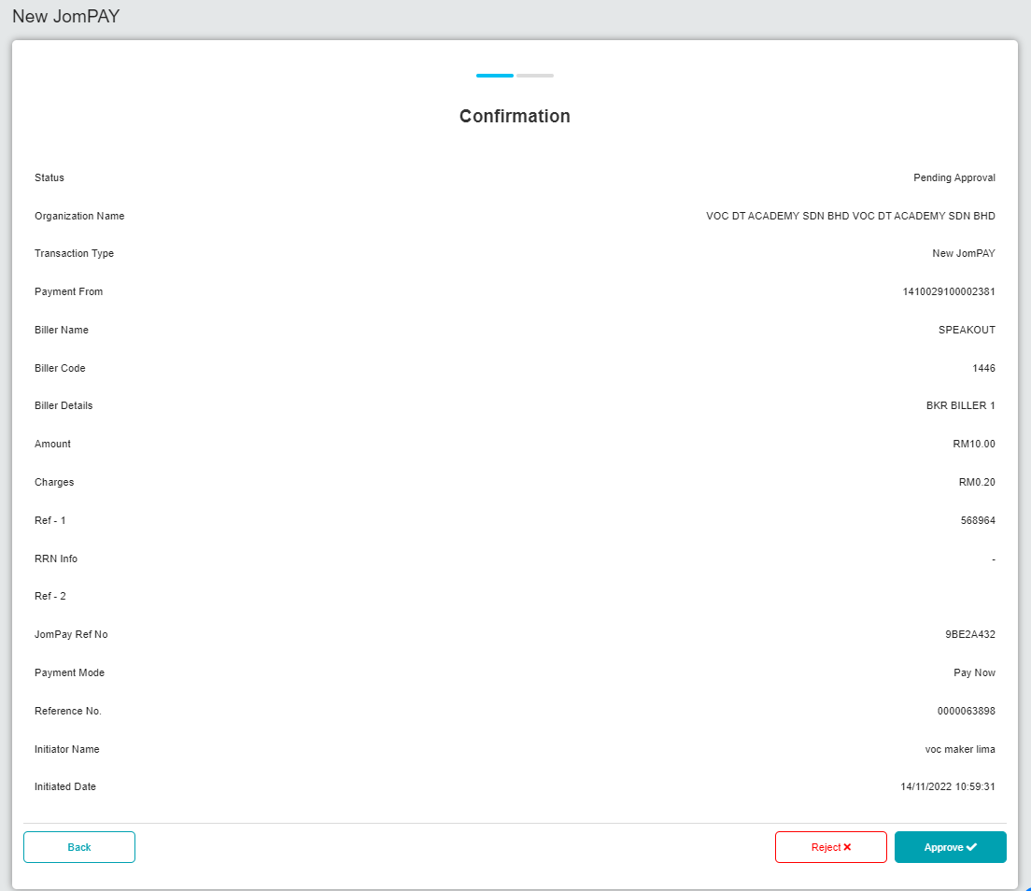  Figure 4: BSNeBiz > Authorization (Confirmation)  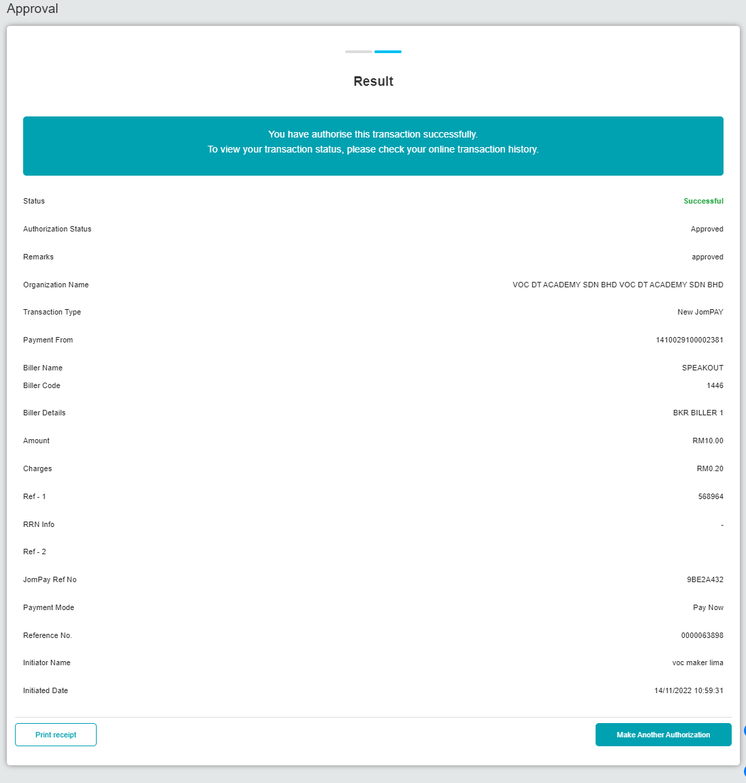  Figure 5: BSNeBiz > Authorization (Result)  - Access IBAM>CBE>Transaction Enquiry  - Search for the Jompay transaction and access the details page  - Expected result, the effective date same as approval date.  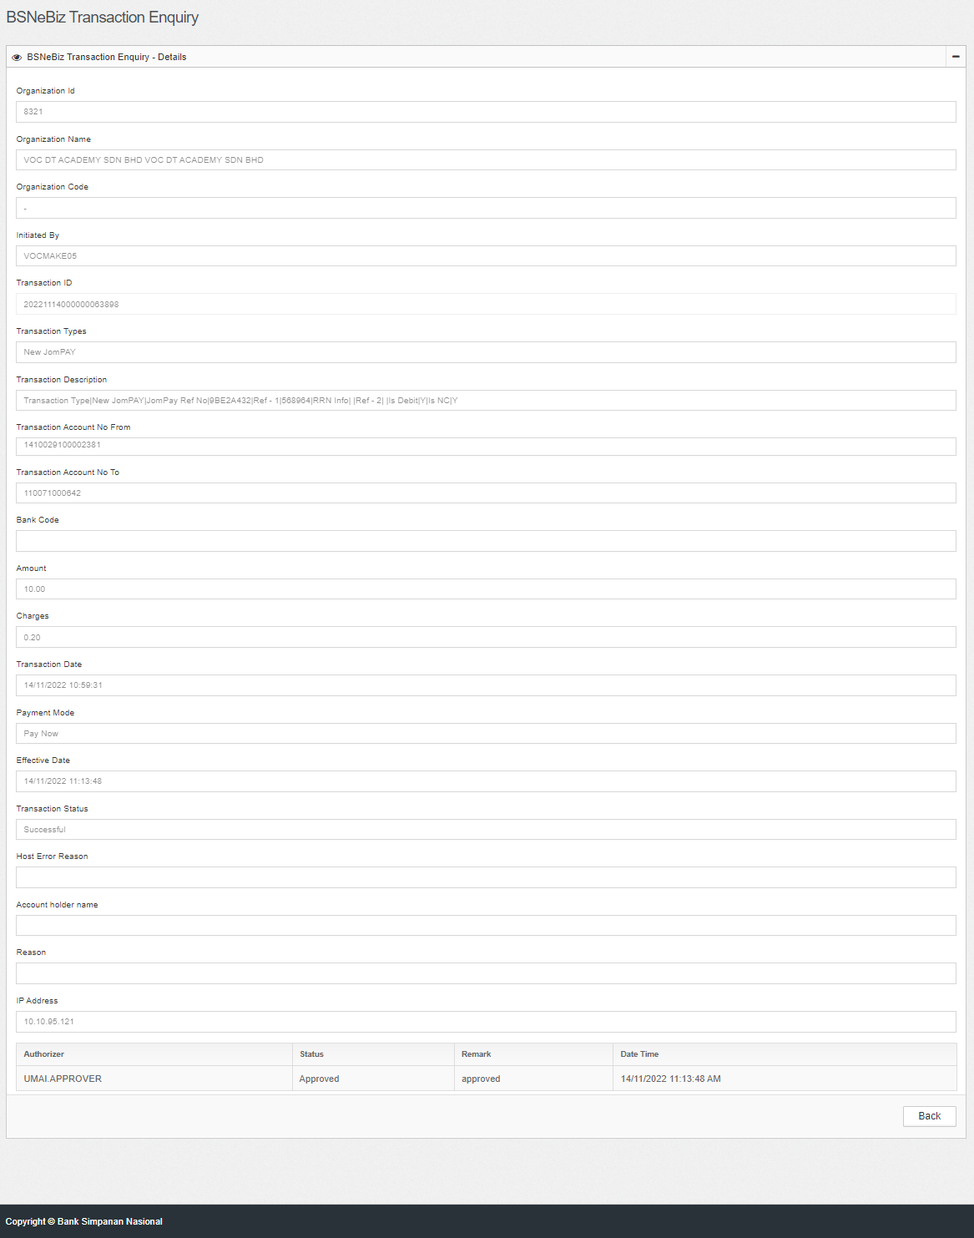  Figure 6: IBAM > CBE > BSNeBiz Transaction Enquiry - Details

