SCPID#6474
Test Title: |  | Rentas proceed although debiting Failed
Test Description: |  | Issue:  BSNeBiz ICBS debit failed but RENTAS notification sent to RENTAS web service  Finding:  For Giro-i account, the debit response code was mapped wrongly, causing the response code always success  Solution:  Fix the wrong response code mapping
Test Functionality: |  | To test on the account debited and refunded on successful and unsuccessful of RENTAS transaction.
Test Procedure: |  | Test steps:  - Prepare 2 accounts, Giro and Giro-i  - Access BSNeBiz  - Make RENTAS transfer from the 2 accounts  - Approve the transfer  - Expected result, if success, make sure the account is debited  - If failed due to RENTAS server offline, make sure the account is debited and refunded
Response Message:
Test Result: | Pass: Fail: |  | Tested by: | Nor Athirah Umairah (16/11/2022)
Reason for Failure:
Remarks: |  | Giro account  - Make RENTAS transaction.  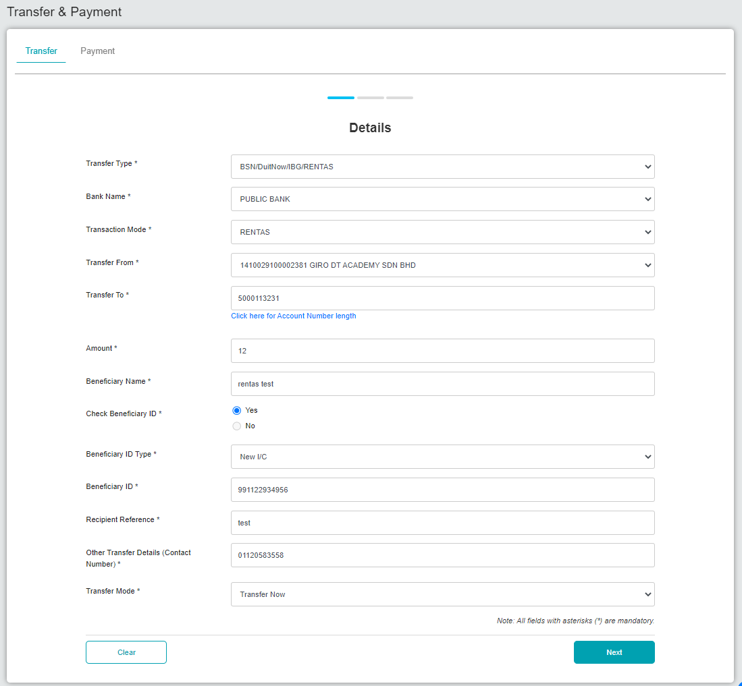  Figure 1: BSNeBiz > Transfer & Payment > Details  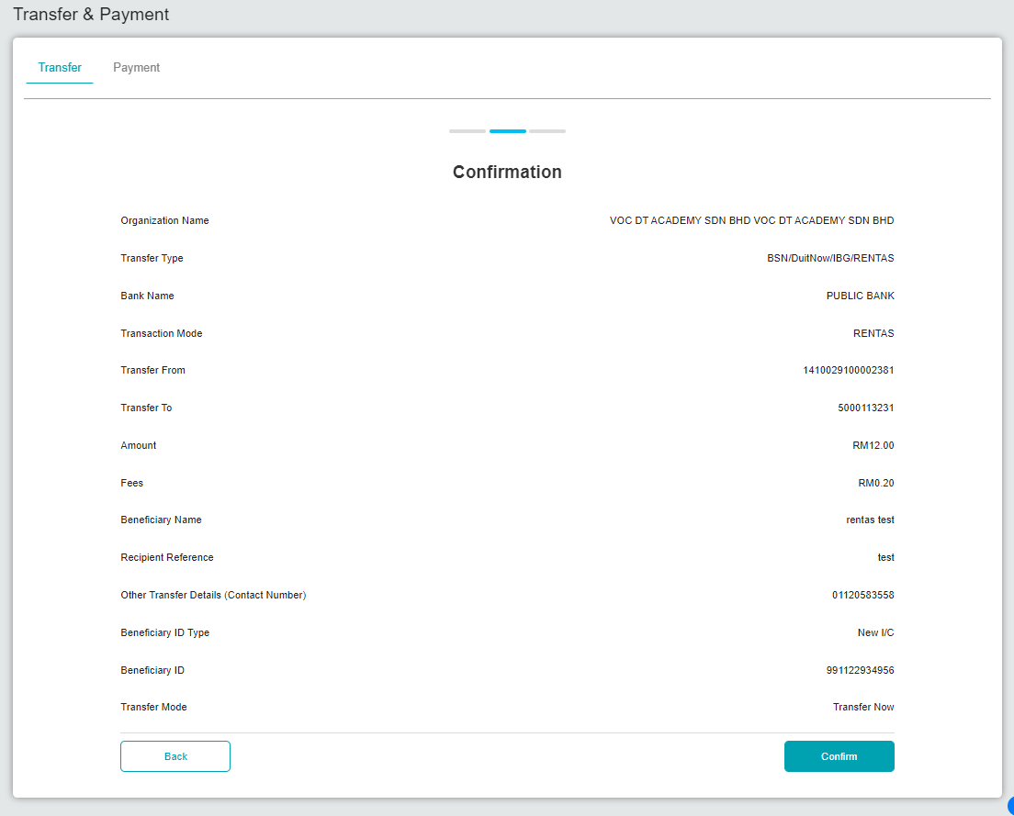  Figure 2: BSNeBiz > Transfer & Payment > Confirmation  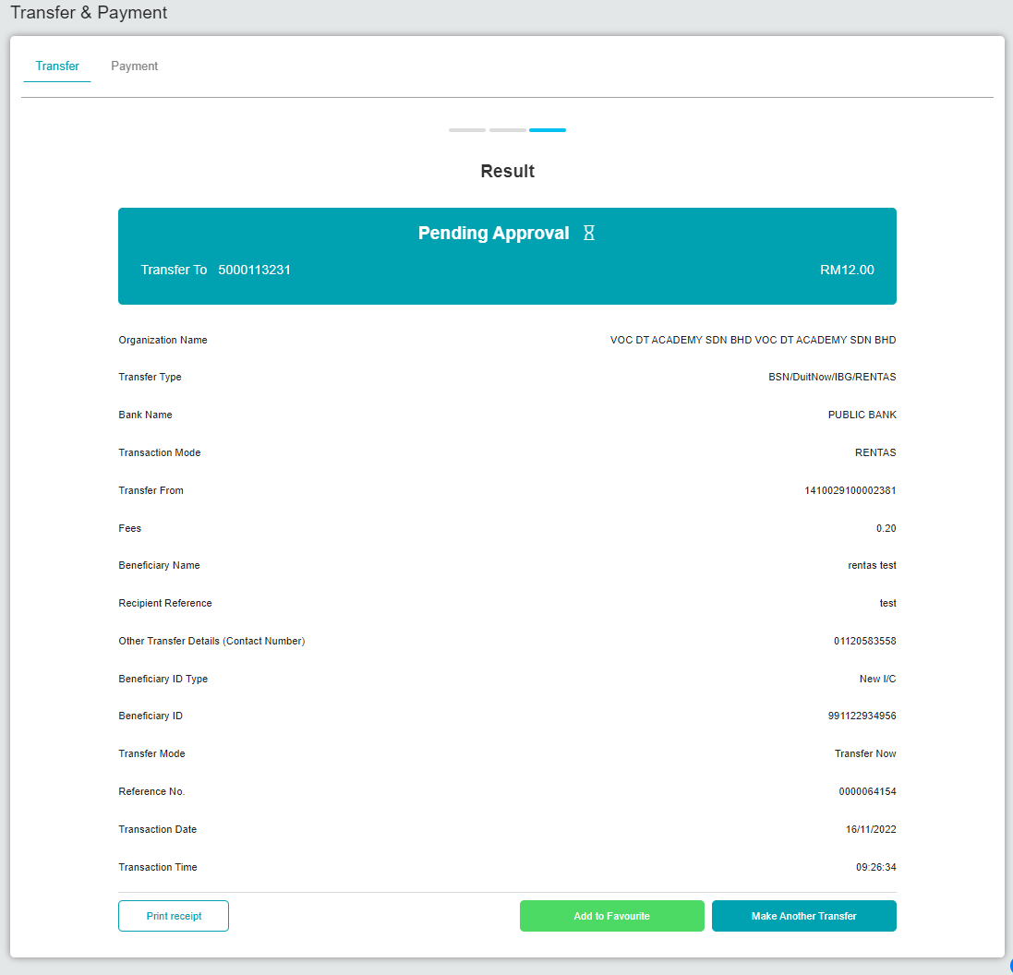  Figure 3: BSNeBiz > Transfer & Payment > Result  Giro-i account  - Make RENTAS transaction.  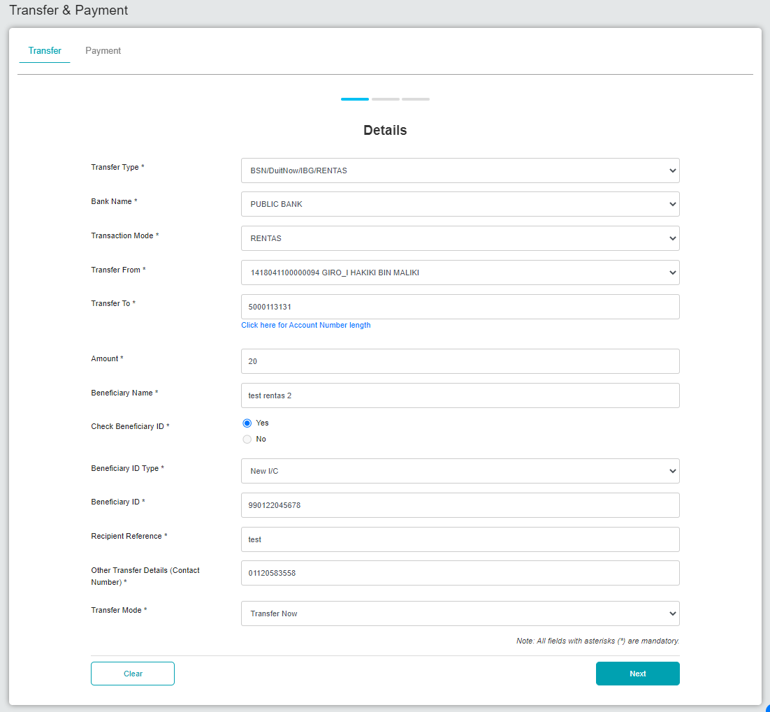  Figure 4: BSNeBiz > Transfer & Payment > Details  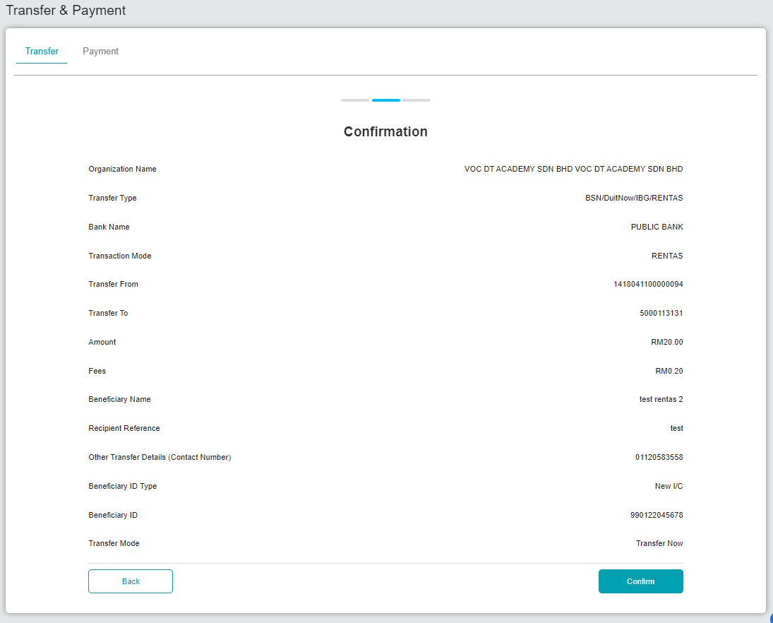  Figure 5: BSNeBiz > Transfer & Payment > Confirmation  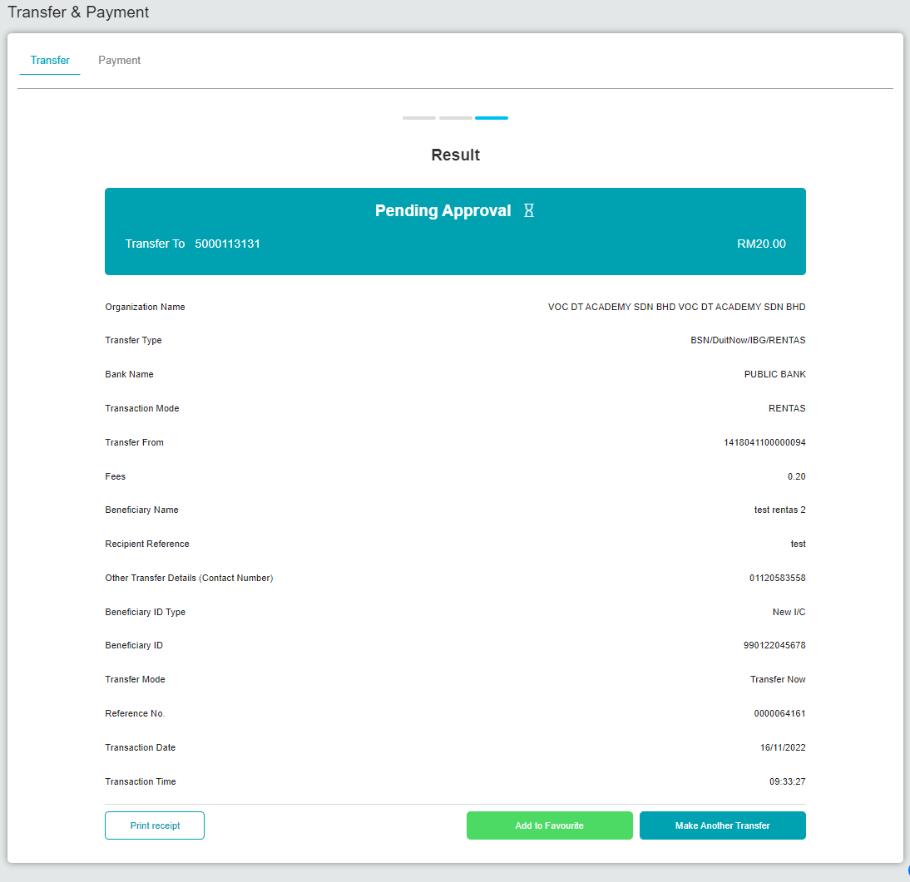  Figure 6: BSNeBiz > Transfer & Payment > Result  Approve the transfer  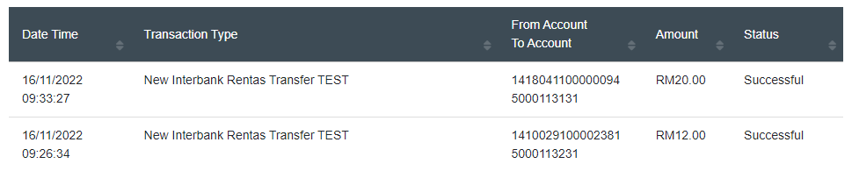  Figure 7: Transaction status  Account is debited  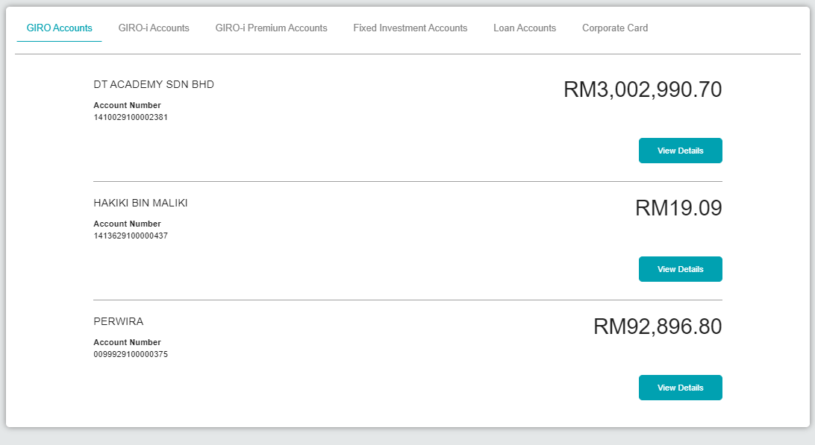  Figure 8: Account summary – Giro (Before)  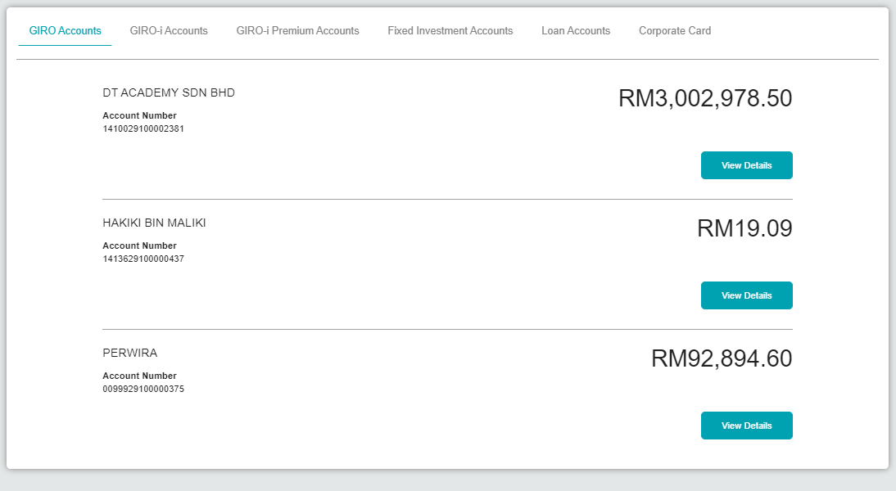  Figure 9: Account summary – Giro (After debited)  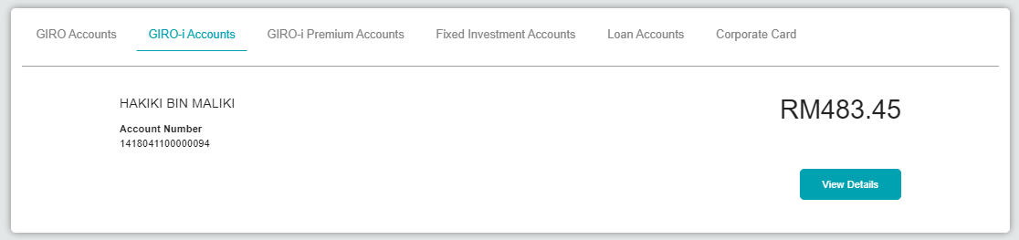  Figure 10: Account summary – Giro-i (Before)  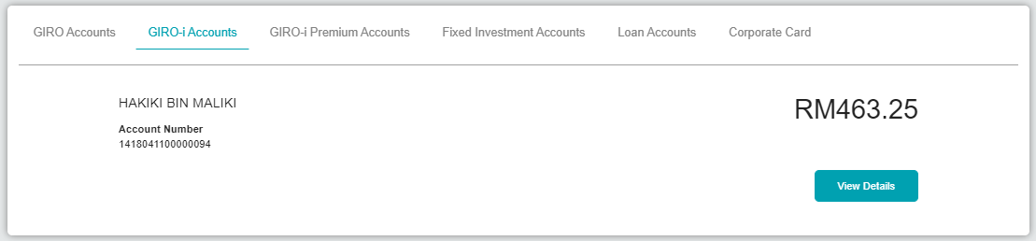  Figure 11: Account summary – Giro-i (After debited)  Unable to test for unsuccessful transaction due to server.  *Note: Unsuccessful result only applicable when server offline.  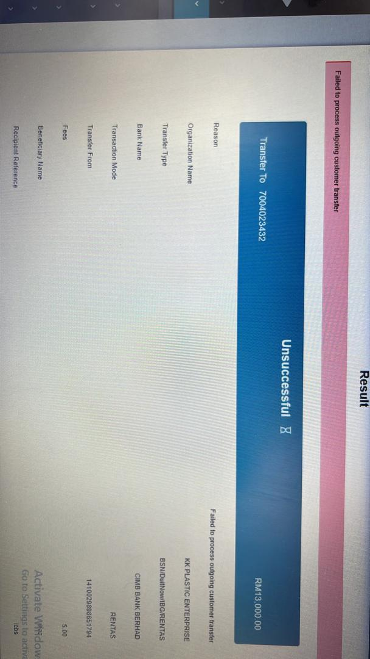  Example error of unsuccessful result

