SCPID#6461
Test Title: |  | Dormant IDs in BSNeBiz Internet Banking Admin Module (IBAM)
Test Description: |  | To check Dormant ID for IBAM user  - daily check based on last login date  - Create a cronjob program run daily to check the last login date with the dormant period and update the dormant status.  - Add field Last Login Date in user maintenance module in order to check the reason user in dormant status
Test Functionality: |  | To check status for CDB user and IBAM User.
Test Procedure: |  | - Already run the cronjob in SIT.  - User with last login date exceed dormant period, the status updated to DORMANT for CDB user and INACTIVE status for IBAM User.  - can check at  i. CBE > Organization Setup > User Maintenance  ii. BBE > User Manager  - for dormant period can check at BBE > Password Policy > User Inactive Period field
Response Message:
Test Result: | Pass: Fail: |  | Tested by: | Nor Athirah Umairah (25/11/2022)
Reason for Failure:
Remarks: |  | Dormant period  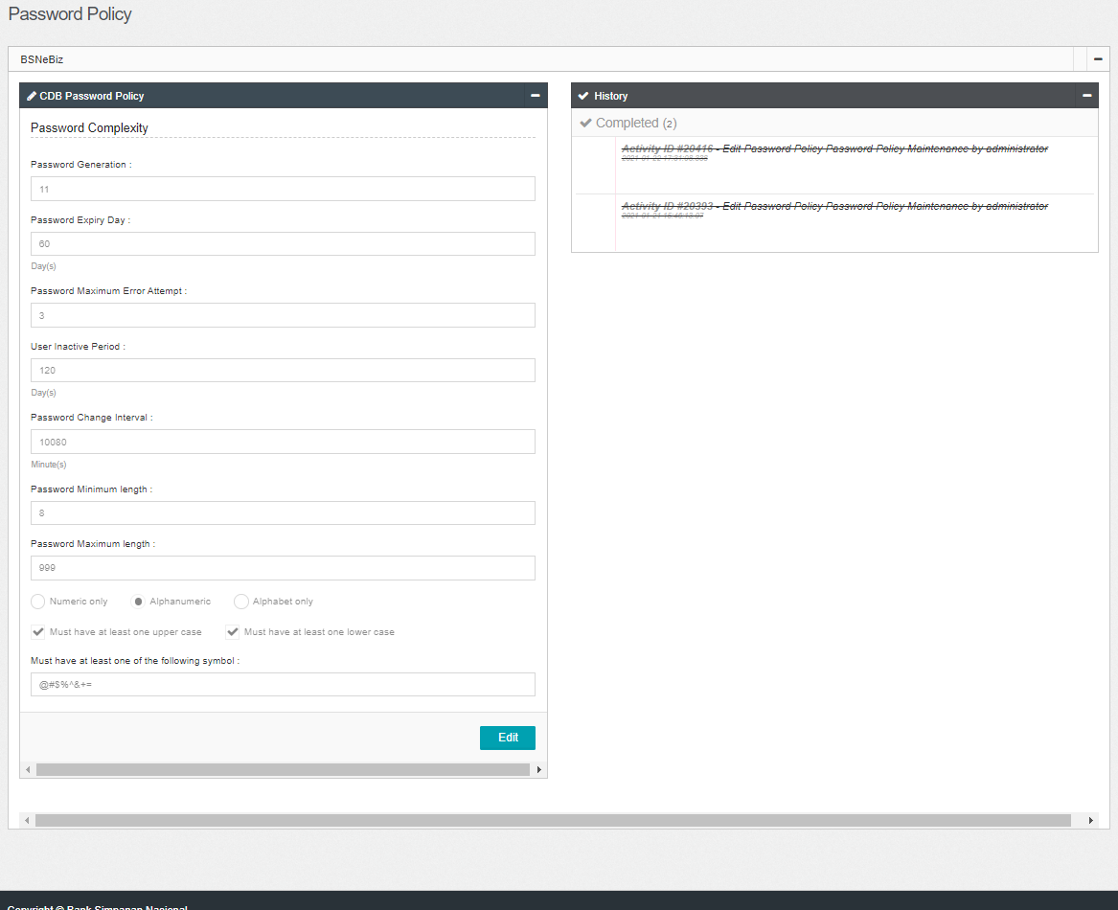  Figure 1: BBE > Password Policy > User Inactive Period  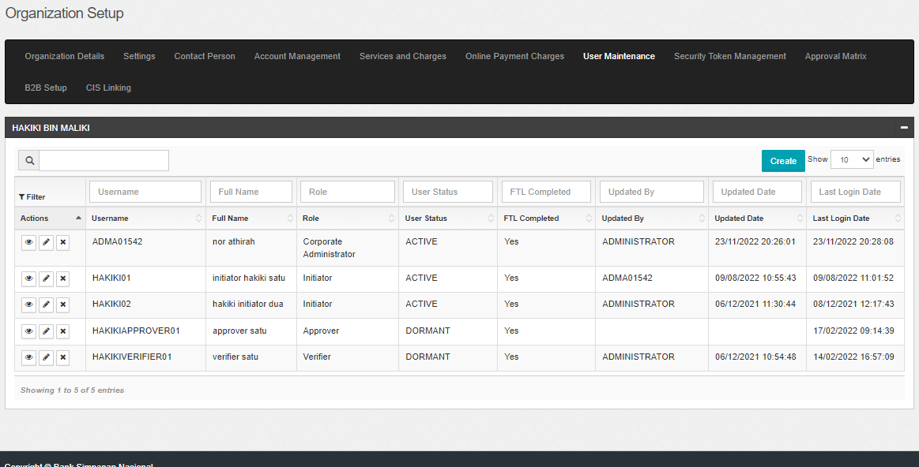  Figure 2: CBE > Organization Setup > User Maintenance  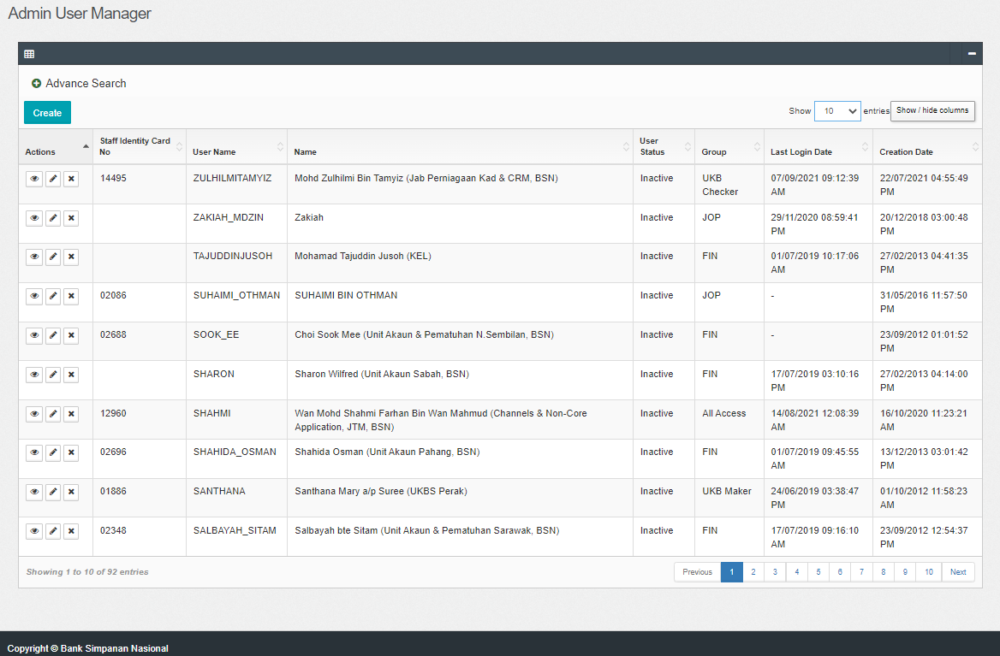  Figure 3: BBE > User Manager

