SCPID#6395
Test Title: |  | JomPay Off Us - PERKASA REALTY
Test Description: |  | Issue:  Request to chop data file and jompay report based on Biller Code
Test Functionality: |  | To test generate BSNeBiz Jompay Daily Report and BSNeBiz Jompay Exception Report.
Test Procedure: |  | Test steps:  Access IBAM > CBE > Report  - Make Jompay transaction  - Report will auto generate daily, data display +1 day  - Generated report will be verified by JTM and JPD
Response Message:
Test Result: | Pass: Fail: |  | Tested by: | Nor Athirah Umairah (25/11/2022)
Reason for Failure:
Remarks: |  | Login as Initiator  - Make Jompay transaction  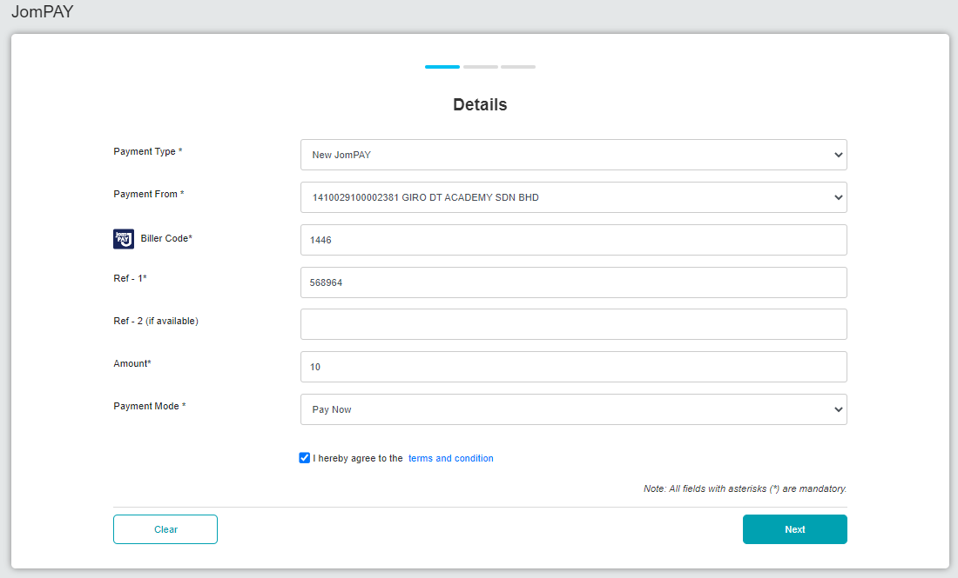  Figure 1: BSNeBiz > Jompay (Details)  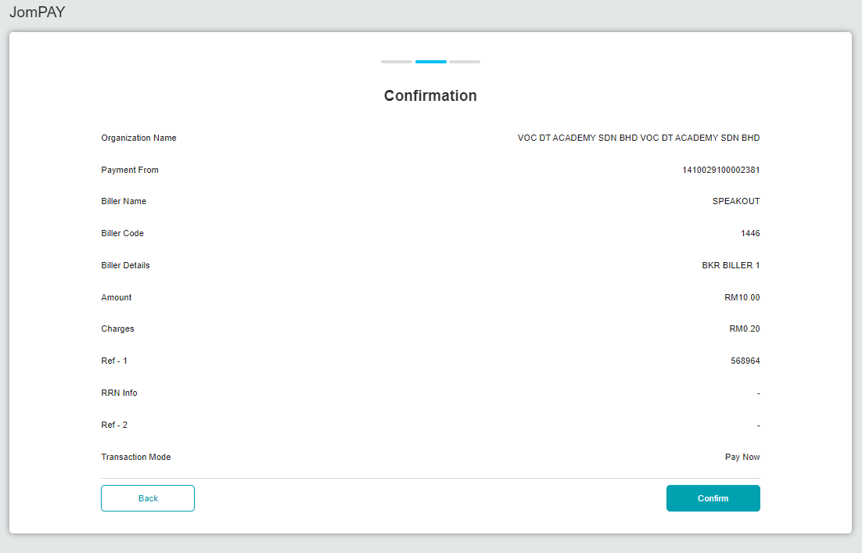  Figure 2: BSNeBiz > Jompay (Confirmation)  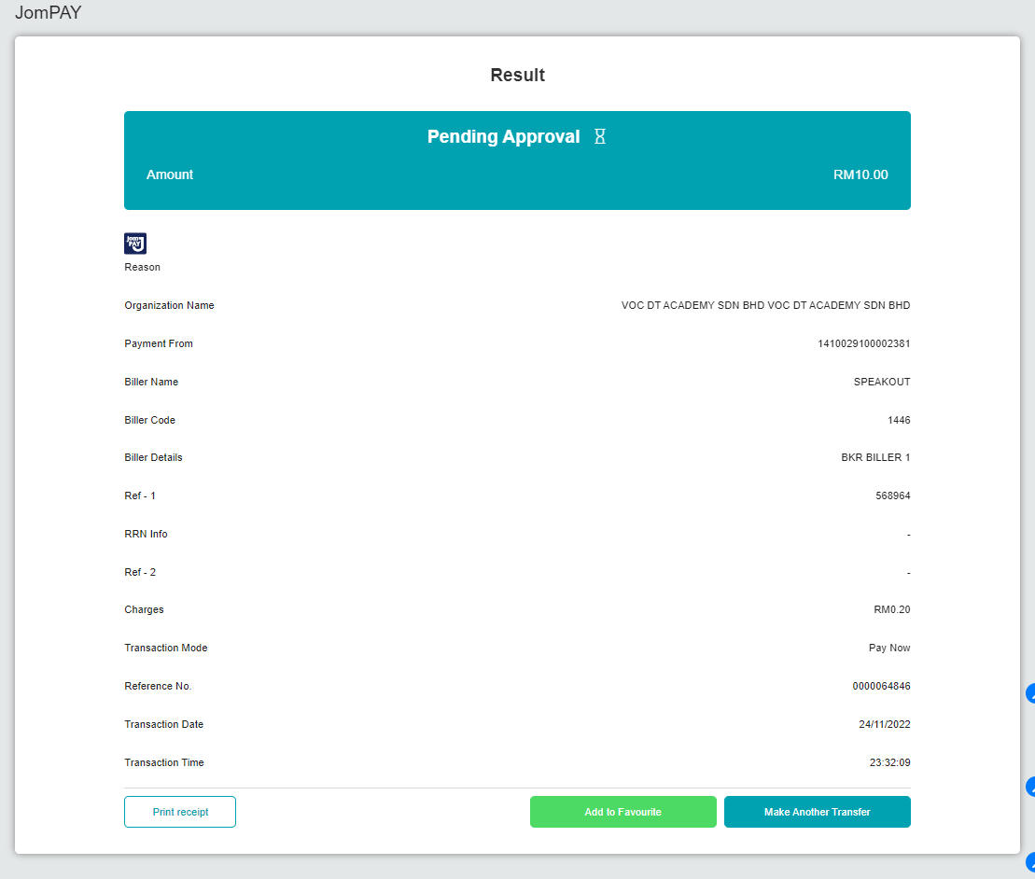  Figure 3: BSNeBiz > Jompay (Result)  Login as Approver  - Approve the transaction  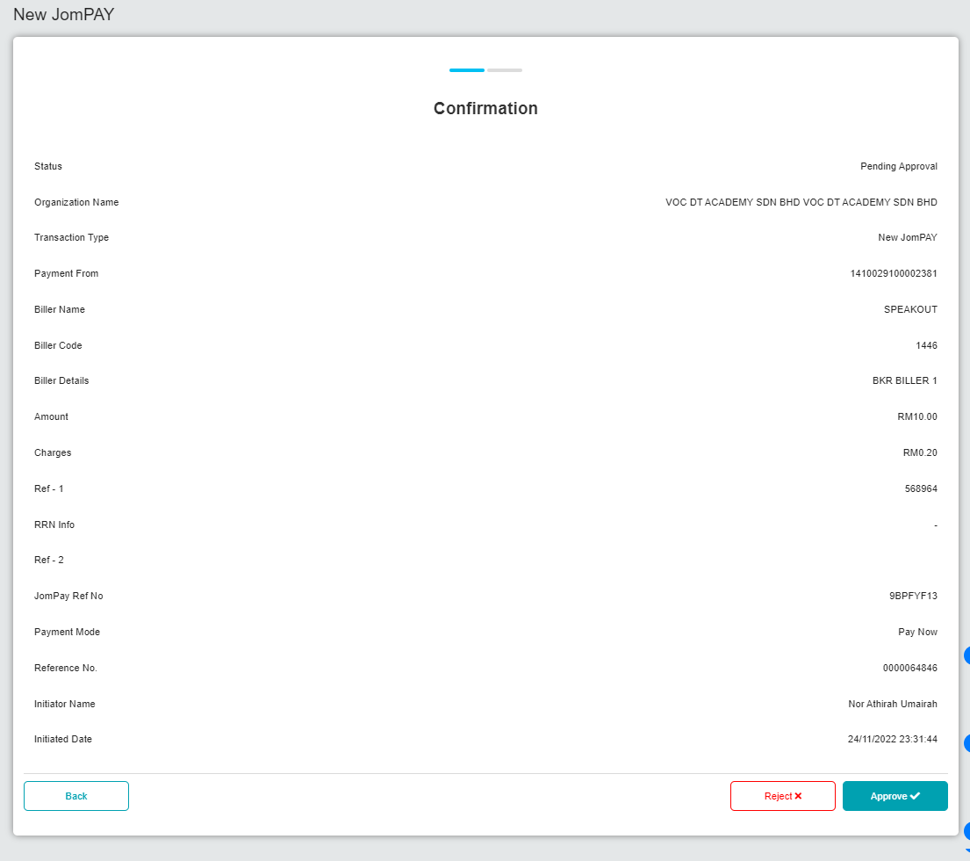  Figure 4: BSNeBiz > Approval (Confirmatiom)  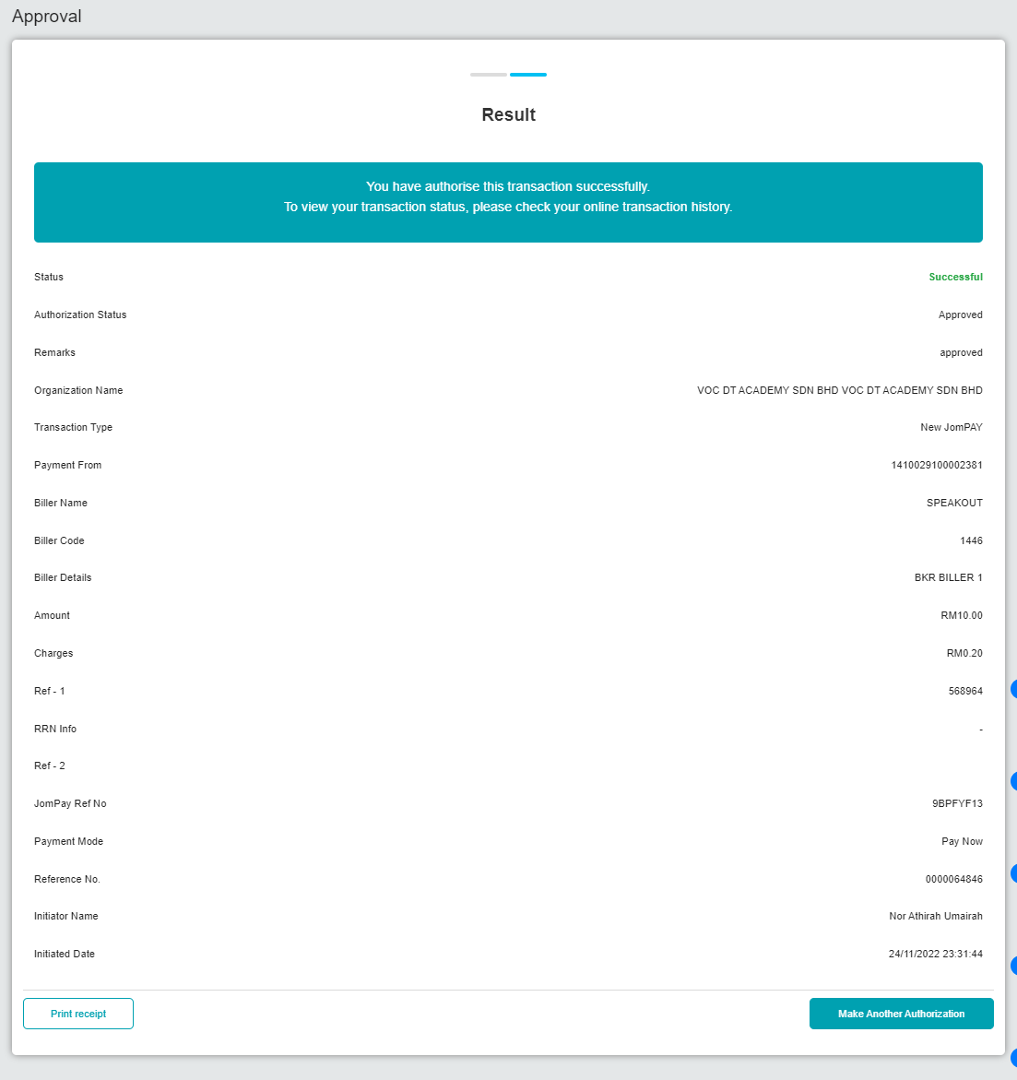  Figure 5: BSNeBiz > Approval (Result)  Access IBAM > CBE > Report  *manually run cronjob sit by developer during internal testing to generate report.  *Generated report will be verified by JTM and JPD.  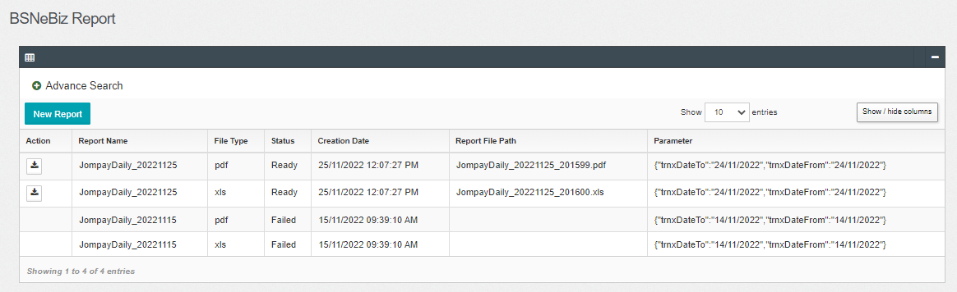  Figure 6: IBAM > CBE > BSNeBiz Report (BSNeBiz Jompay Daily Report)  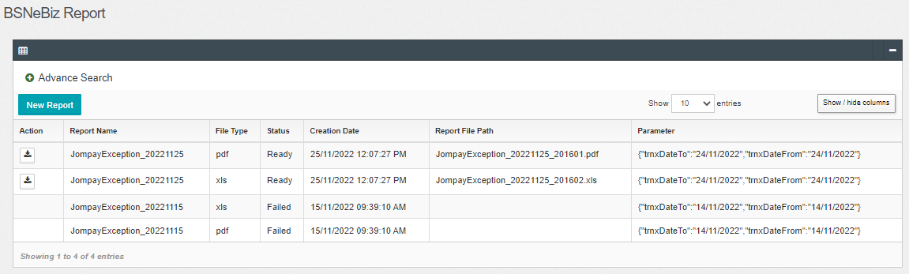  Figure 7: IBAM > CBE > BSNeBiz Report (BSNeBiz Jompay Exception Report)  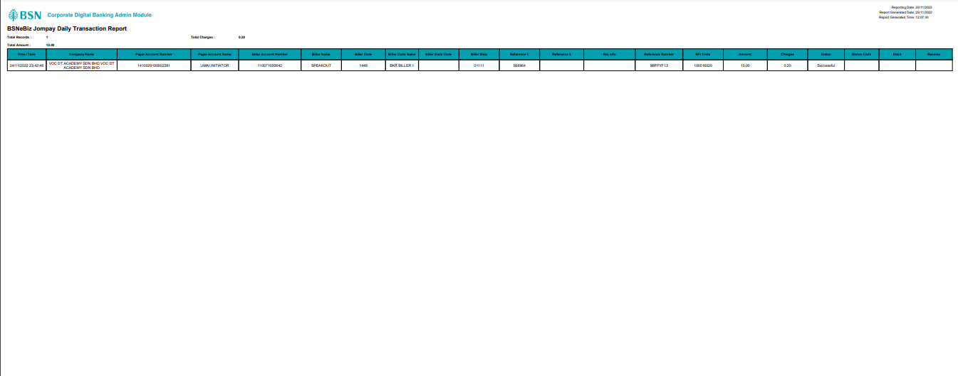  Figure 8: BSNeBiz Jompay Daily Report (pdf)  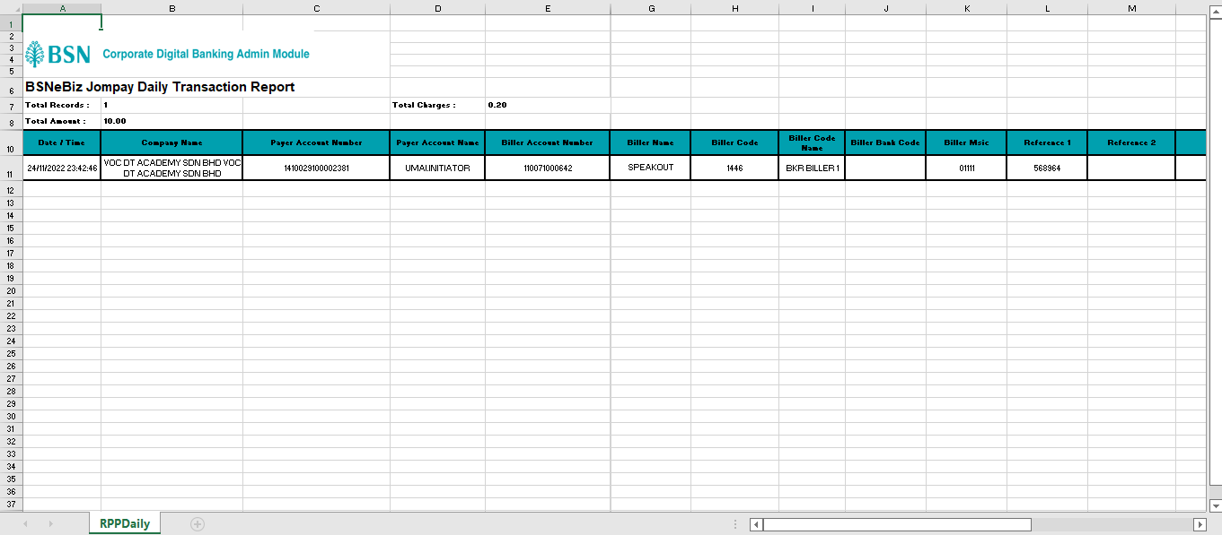  Figure 9: BSNeBiz Jompay Daily Report (xls)

