SCPID#6514
Test Title: |  | Email notification for all RENTAS Transaction
Test Description: |  | Issue:  All RENTAS transaction initiate by user (single user/initiator/approver) to trigger email notification to bank back-end user (Treasury Department).
Test Functionality: |  | To test on the successful of triggering email notification for RENTAS transaction.
Test Procedure: |  | Test steps:  - Perform RENTAS transaction (Initiator/Single user/Approver).  - Check user email received, make sure listing backend user also received email.  - hanifa@bsn.com.my  - noraisah@bsn.com.my  - hanafi_mokhtar@bsn.com.my  - aliarodzi@bsn.com.my  - sabariahsaid@bsn.com.my  - hamizah_jaafar@bsn.com.my  - norhalijah@bsn.com.my  - Can check in DB table DBO.BIB_EMAIL_LOG to make sure the listing emails are saved in DB.
Response Message:
Test Result: | Pass: Fail: |  | Tested by: | Nor Athirah Umairah (05/12/2022)
Reason for Failure:
Remarks: |  | Login as Initiator  - Make RENTAS transaction.  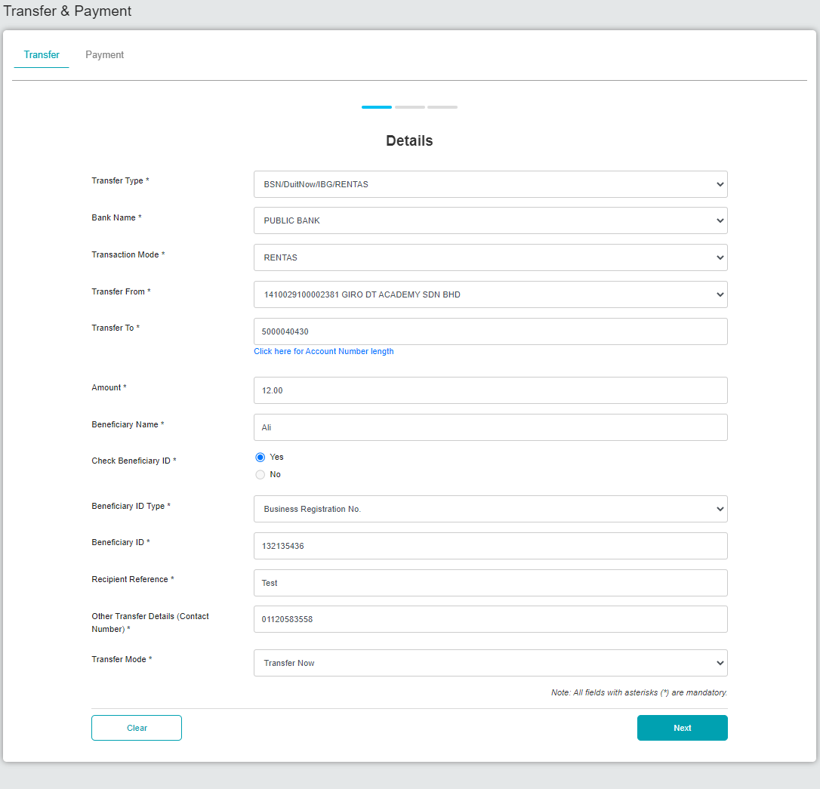  Figure 1: BSNeBiz > Transfer & Payment > Details  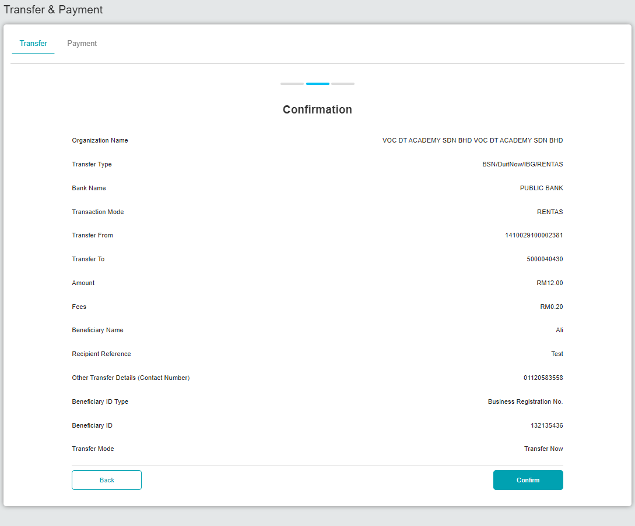  Figure 2: BSNeBiz > Transfer & Payment > Confirmation  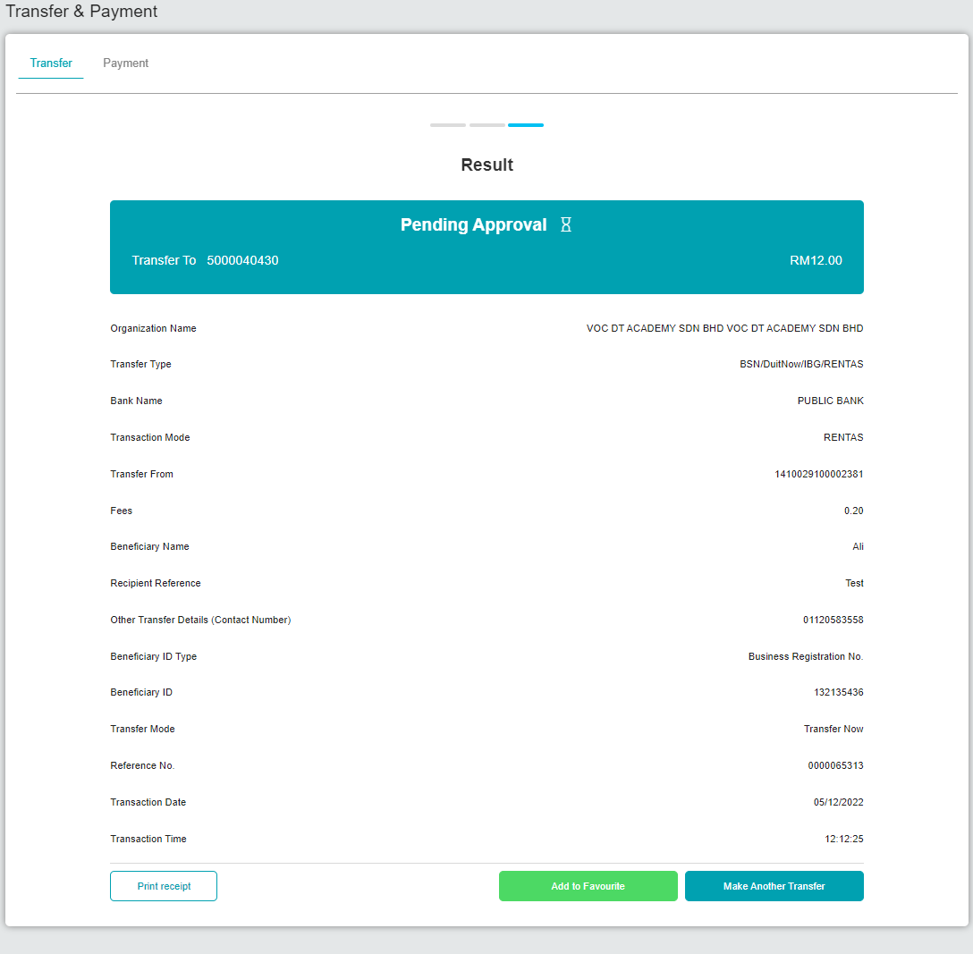  Figure 3: BSNeBiz > Transfer & Payment > Result  Login as Approver  - Approve the transaction.  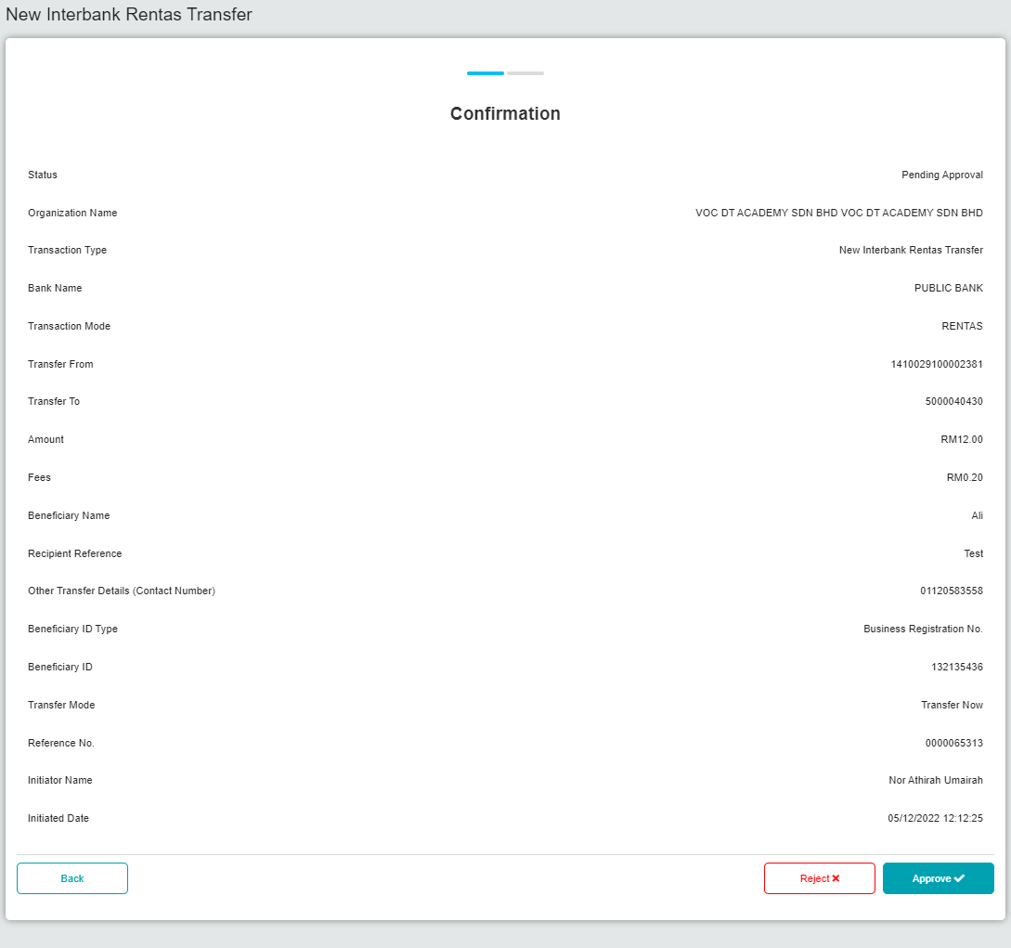  Figure 4: Approval (Confirmation)  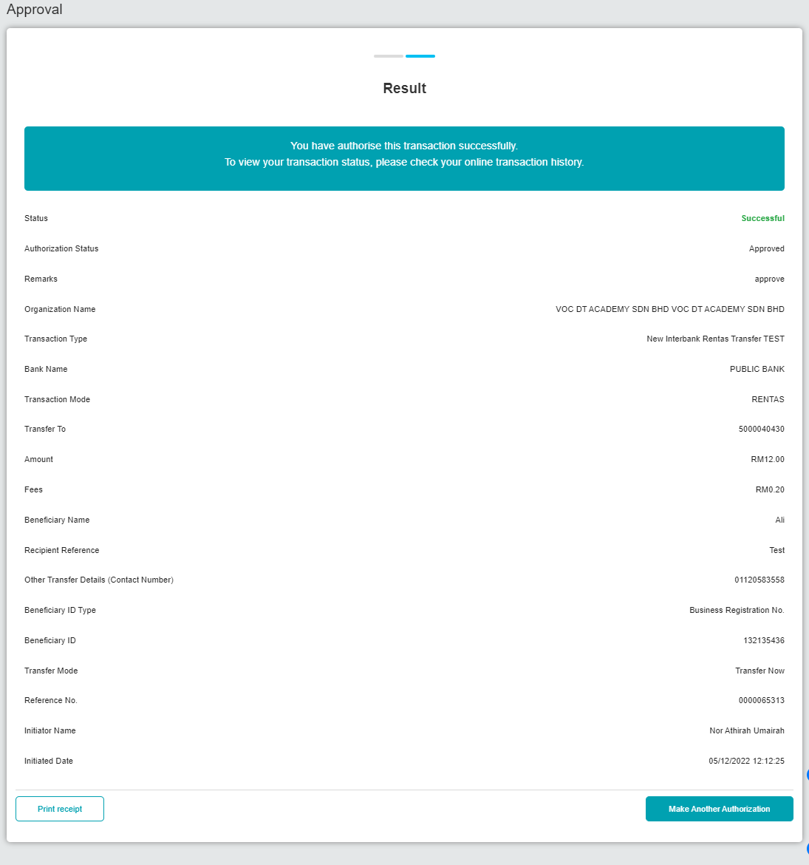  Figure 5: Approval (Result)  Result:  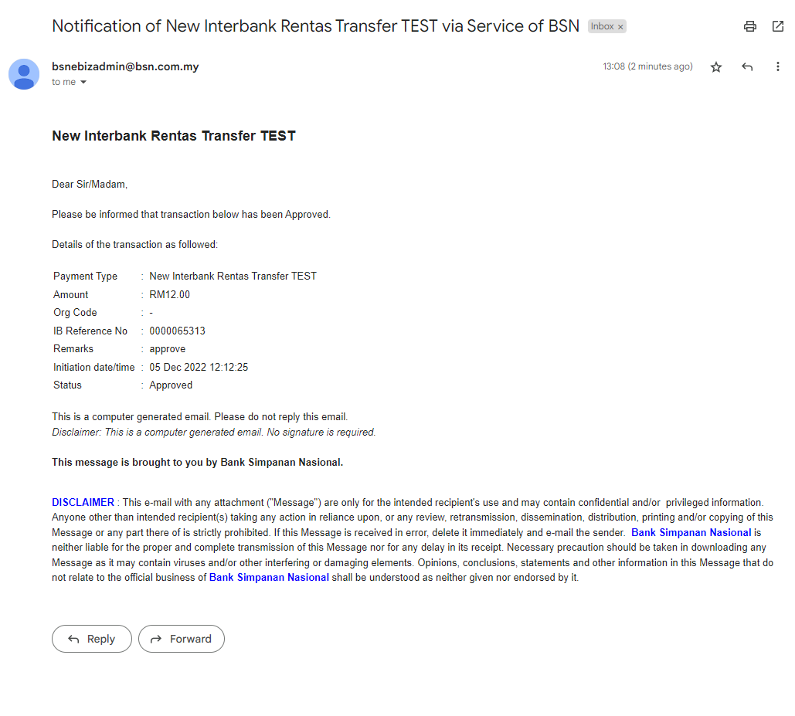  Figure 6: Email Notification

