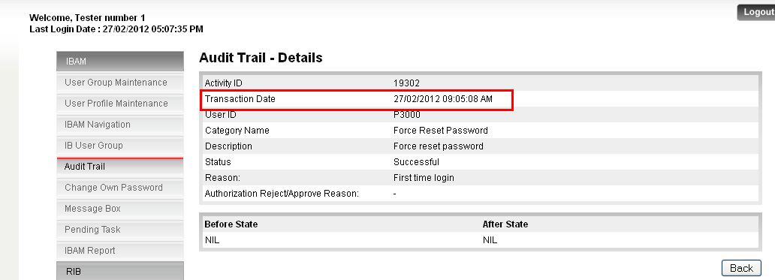

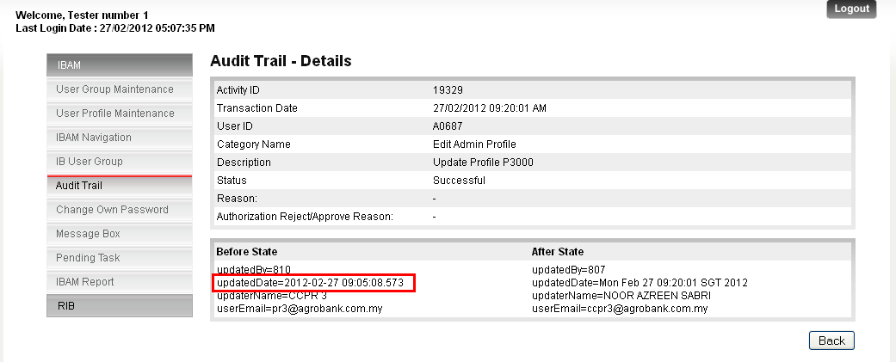

Check on the validity of Data:

* Before state shows that the update on the profile if done by CCPR3. When check on the record it shows that at transaction date CCPR3 has change his/her password due to first time login. Is this activity considered to be profile update? If yes, before state is correct.

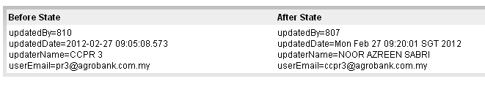

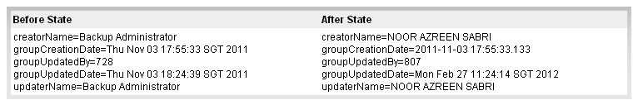

Standard Template of before and after information.

* Currently it shows that there are various information display based on before and after activity category. Can we have a standard template?

Example:

Last Updated by: <this should show User Name not User ID>

Last Updated date: <shall use standard format of date in IBAM>

Updated Description:

* + userEmail=
  + mobile number=