SCPID#6576
Test Title: |  | RENTAS Beneficiary ID
Test Description: |  | Issue:  Rentas transaction is not saved in DB.  Finding: The Beneficiary ID length insert by user is 16 but in DB the Beneficiary ID column length is set to 15.  Solution: Update Beneficiary ID column length in DB same as in BSNeBiz.
Test Functionality: |  | To test on the RENTAS transaction with Beneficiary ID length more than 15.
Test Procedure: |  | Test steps:  - Perform RENTAS transaction, set Beneficiary ID length more than 15 for Beneficiary Type Business Registration Number and Other ID.  - Check Transaction Inquiry list to make sure the transaction is saved in DB.
Response Message:
Test Result: | Pass: Fail: |  | Tested by: | Nor Athirah Umairah (19/01/2023)
Reason for Failure:
Remarks: |  | Beneficiary Type = Business Registration Number  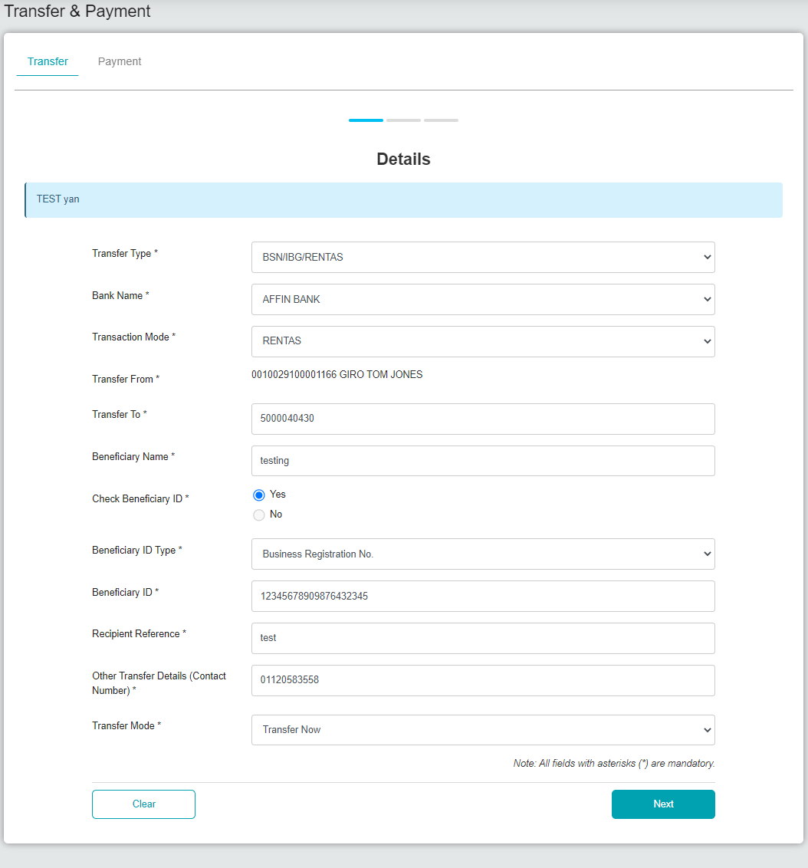  Figure 1: BSNeBiz > Transfer & Payment (Details)  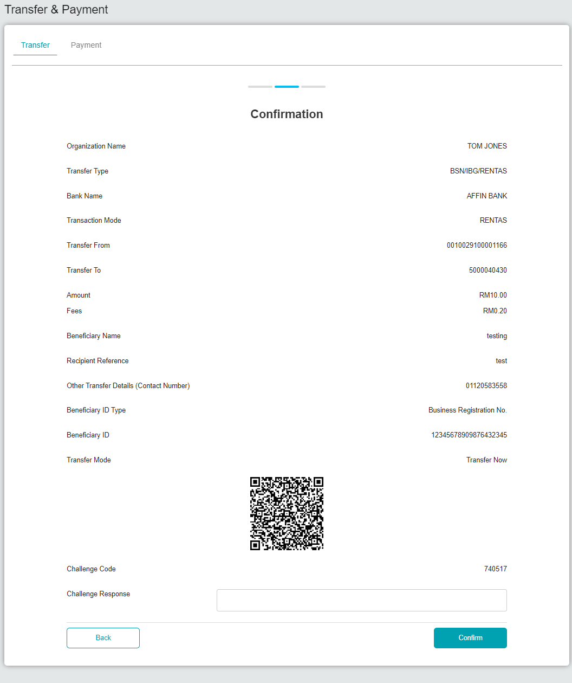  Figure 2: BSNeBiz > Transfer & Payment (Confirmation)  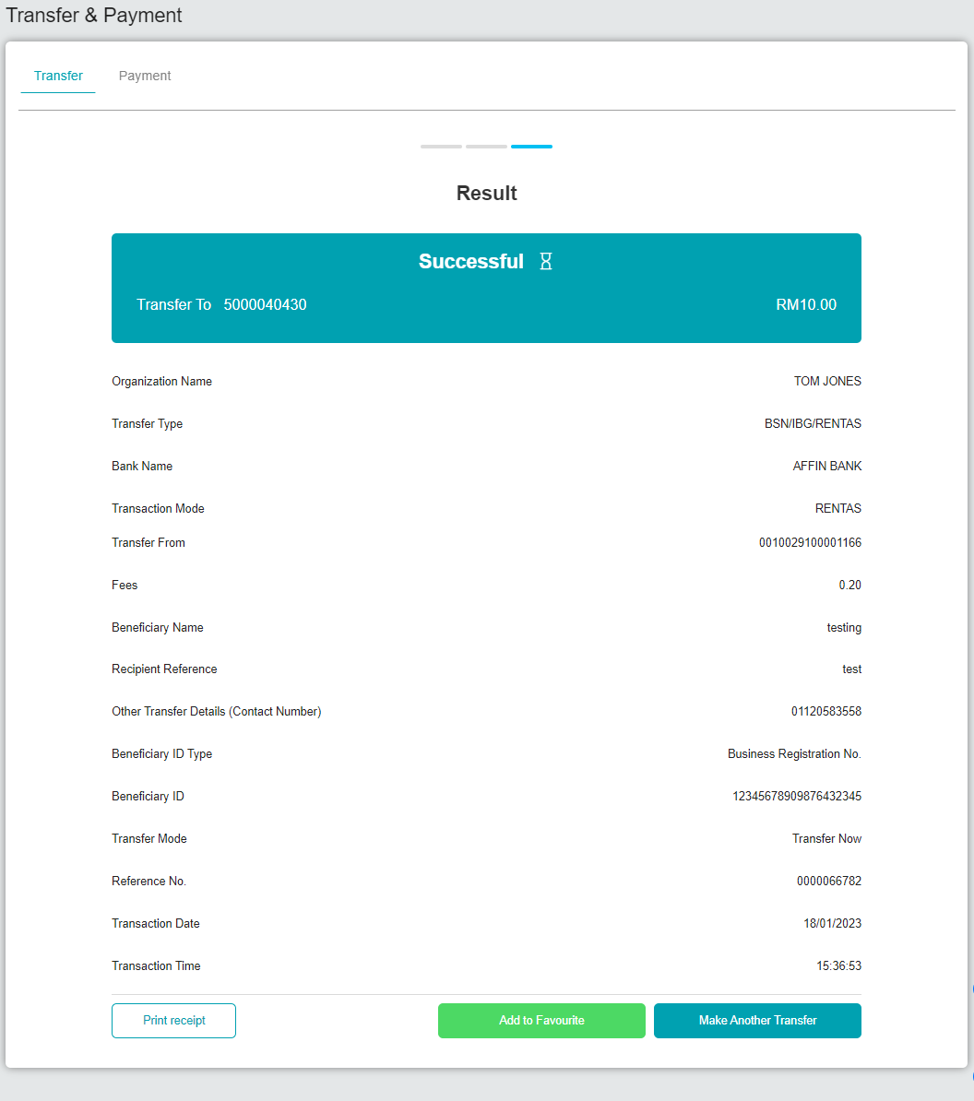  Figure 3: BSNeBiz > Transfer & Payment (Result)  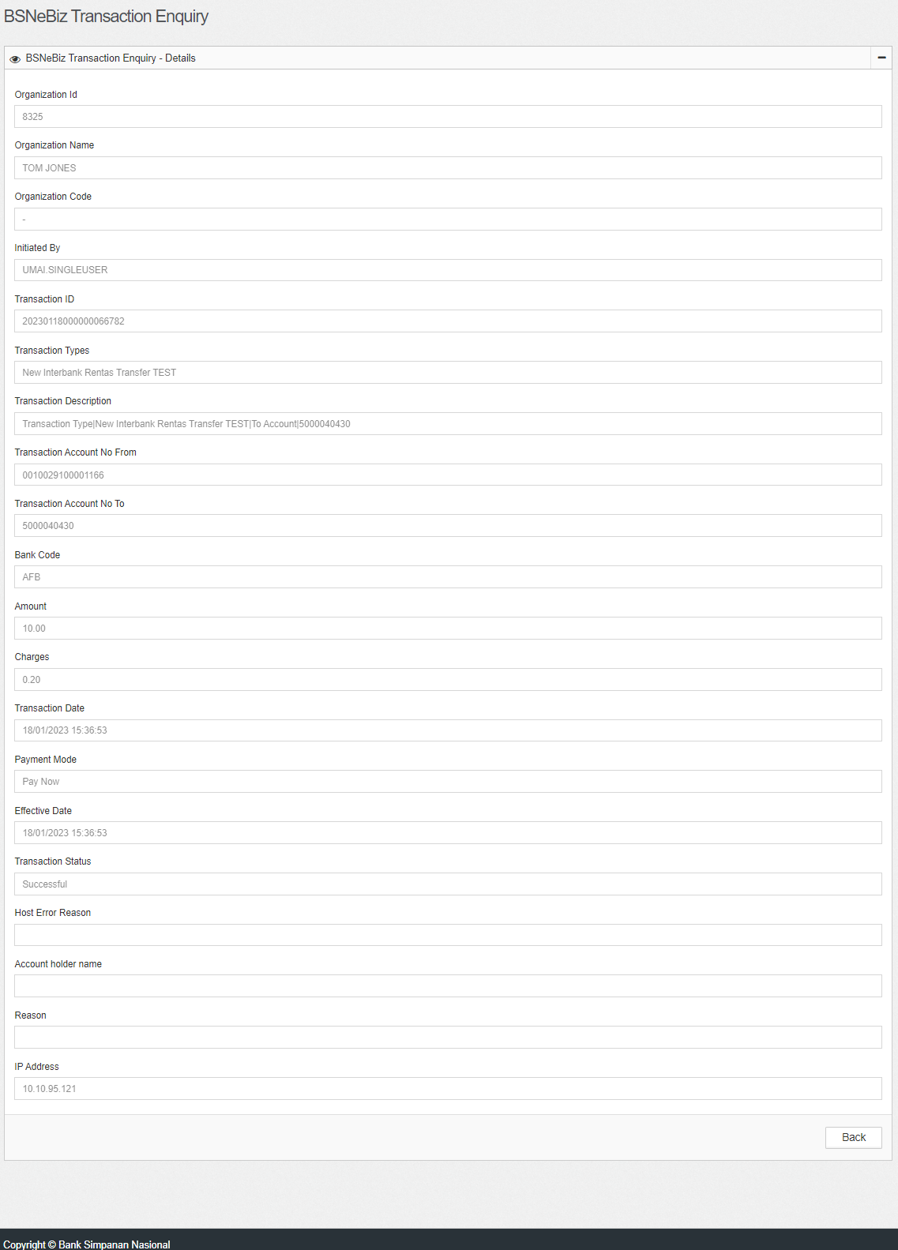  Figure 4: IBAM > Transaction Enquiry  Beneficiary Type = Other ID  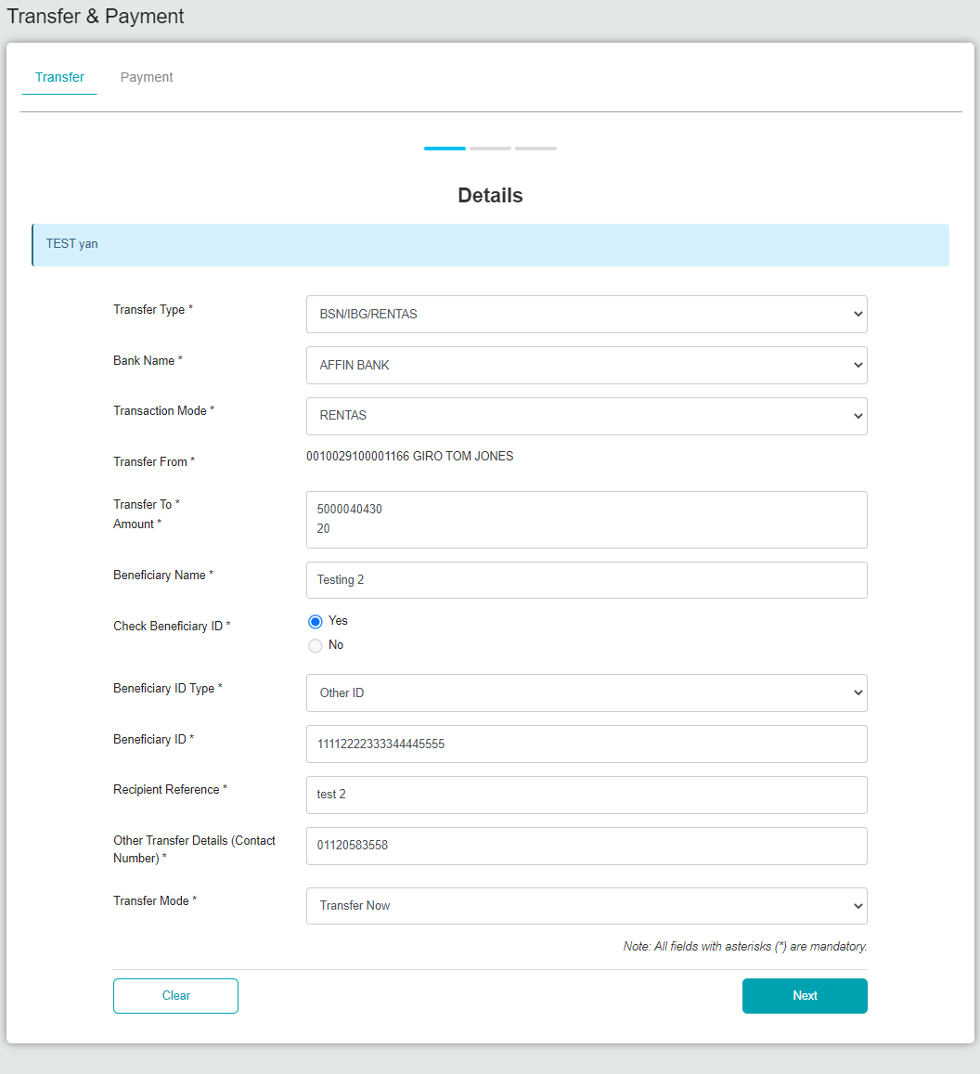  Figure 5: BSNeBiz > Transfer & Payment (Details)  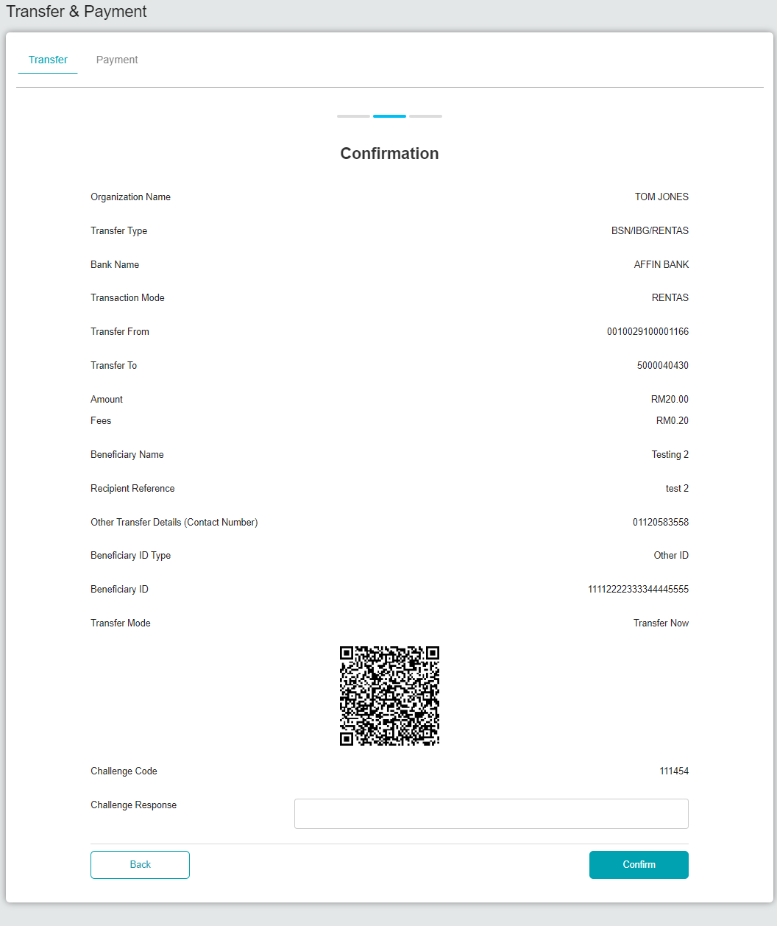  Figure 6: BSNeBiz > Transfer & Payment (Confirmation)  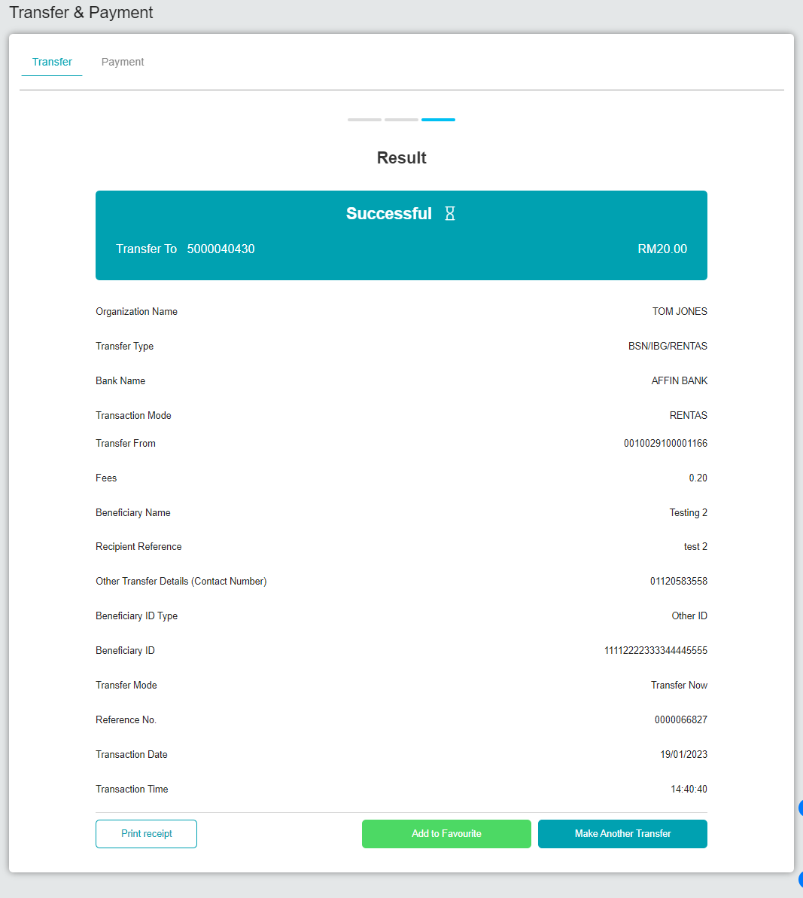  Figure 7: BSNeBiz > Transfer & Payment (Result)  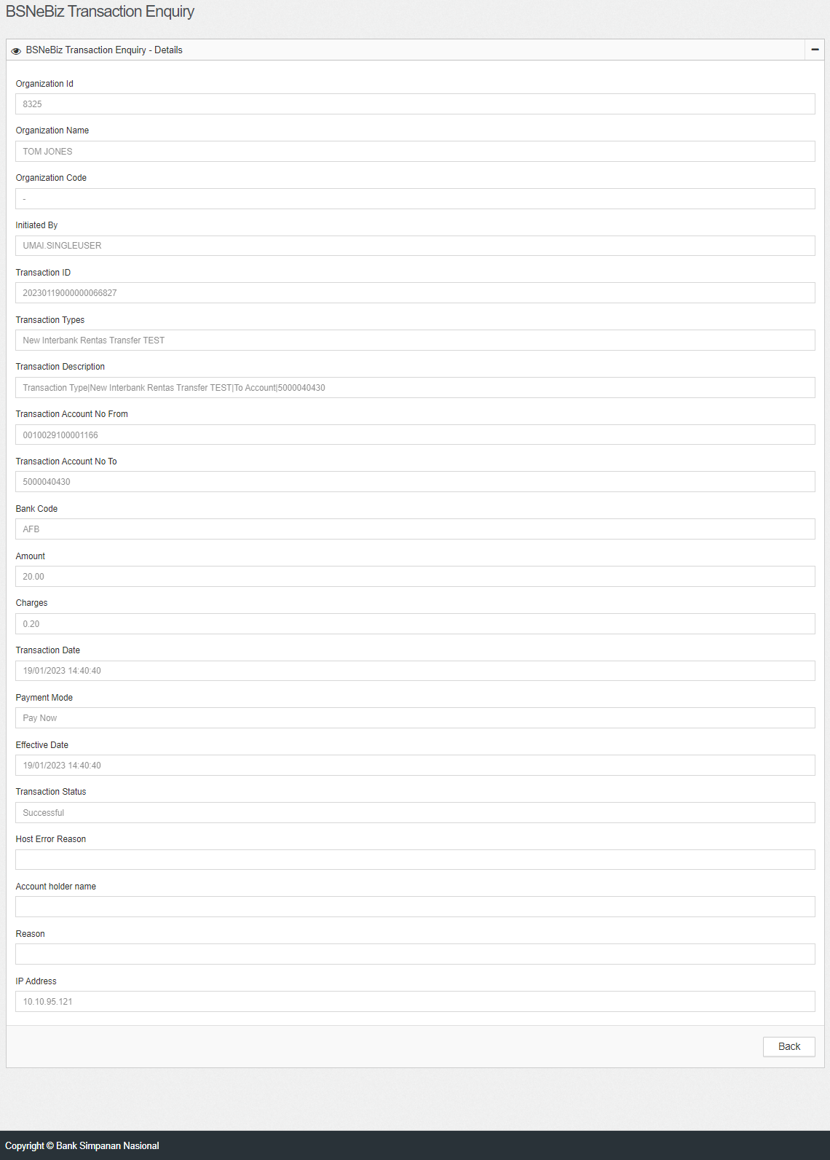  Figure 8: IBAM > Transaction Enquiry

