While do the testing on API Informational Module - env. Production, If we set the date range more than 30 minutes, for example 14 days (1 Desember 2022 – 14 Desember 2022) we will get response 500 internal server error. This happened if system response more than 60 s and request will set as timeout.

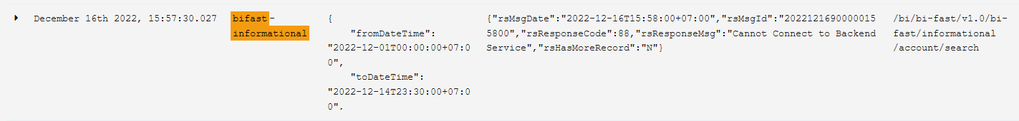

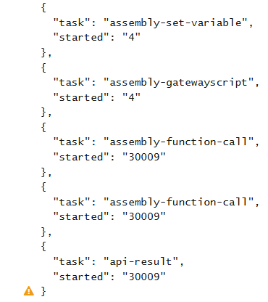

Target API CI-PORTAL = <https://bifastportalapi.corp.bi.go.id/ci-portal-api-data-query/APIServices>

|  |
| --- |
| Request:  { "fromDateTime": "2022-12-01T00:00:00+07:00", "toDateTime": "2022-12-14T23:30:00+07:00", "pageNumber": 1 } |