Count Total 1 month transaction data

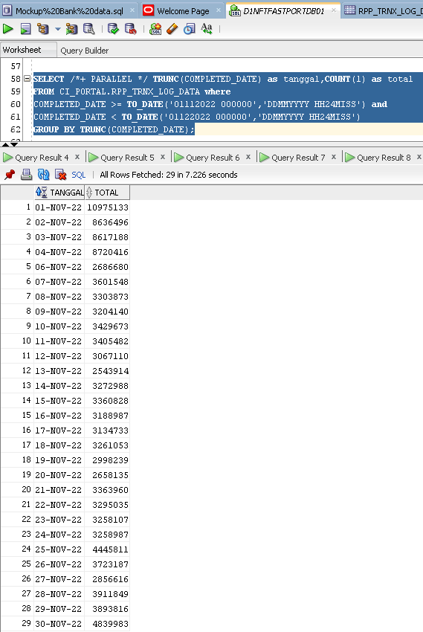

Total data 120,913,967

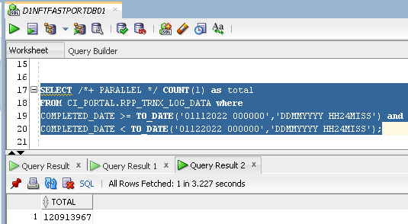

Count Total 1 month transaction data for CENAIDJA

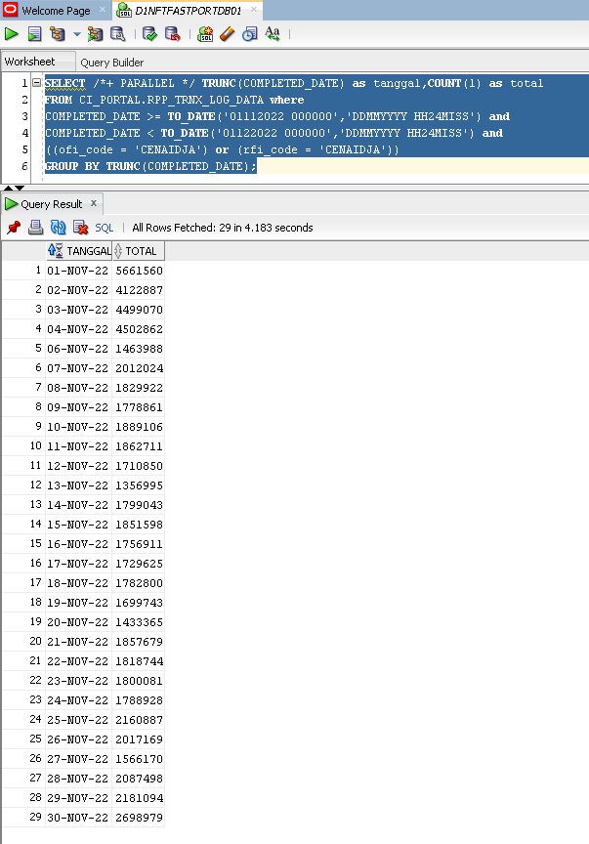

|  |  |  |  |  |
| --- | --- | --- | --- | --- |
| No | Service Name | Time Range | Response | Result |
| 1 | AccountSearch | 31 days data | Before  4m 26s  After  1m 34s | After |
| 15 days data | Before  2m 29s  After  53s | After |
| 7 days data | Before  1m 32s  After  27s | After |
| 1 days data | Before  19s  After  6s | After |
| 2 | TransactionSearch | 31 days data | Before  3m 12s  After  52s | After |
| 15 days data | Before  1m 46s  After  28s | After |
| 7 days data | Before  1m 1s  After  16s | After |
| 1 days data | Before  13s  After  4s | After |
| 3 | AggregateTransaction | 31 days data | Before  3m 25s  After  - |  |
| 15 days data | Before  2m  After  - |  |
| 7 days data | Before  1m 14s  After  - |  |
| 1 days data | Before  23s  After  - |  |
| 4 | ConsolidatedMember  Statement  (Still find for better way to enhancement) | 31 days data |  |  |
| 15 days data |  |  |
| 7 days data | Before  9m 31s  After  8m 1s | **After** |
| 1 days data | Before  1m 49s  After  1m 34s | After |
| 5 | MemberStatement  (on progress enhance) | 31 days data | Before  -  After  - |  |
| 15 days data | Before  -  After  - |  |
| 7 days data | Before  -  After  - |  |
| 1 days data | Before  10min ++ |  |
| 6 | CreditTransfer  Recapitulation | 31 days data | Before  40m 59s  After  54s | After |
| 15 days data | Before  17m 41s  After  32s | After |
| 7 days data | Before  9m 44s  After  20s | After |
| 1 days data | Before  1m 13m  After  9s | After |
| 7 | CreditTransferDetail | 31 days data | Before  7m 37s  After  - |  |
| 15 days data | Before  4m 22s  After  - |  |
| 7 days data | Before  2m 33s  After  - |  |
| 1 days data | Before  36s  After  - |  |
| 8 | CreditTransfer  Received | 31 days data | Before  5m 17s  After  - |  |
| 15 days data | Before  2m 32s  After  - |  |
| 7 days data | Before  1m 37s  After  - |  |
| 1 days data | Before  22s  After  - |  |
| 9 | CreditTransfer  Rejected | 31 days data | Before  1m 42s  After  - |  |
| 15 days data | Before  1m  After  - |  |
| 7 days data | Before  28s  After  - |  |
| 1 days data | Before  13s  After  - |  |
| 10 | CreditTransferSent | 31 days data | Before  1m 42s  After  - |  |
| 15 days data | Before  2m 53s  After  - |  |
| 7 days data | Before  1m 38s  After  - |  |
| 1 days data | Before  21s  After  - |  |