Please amend the following :

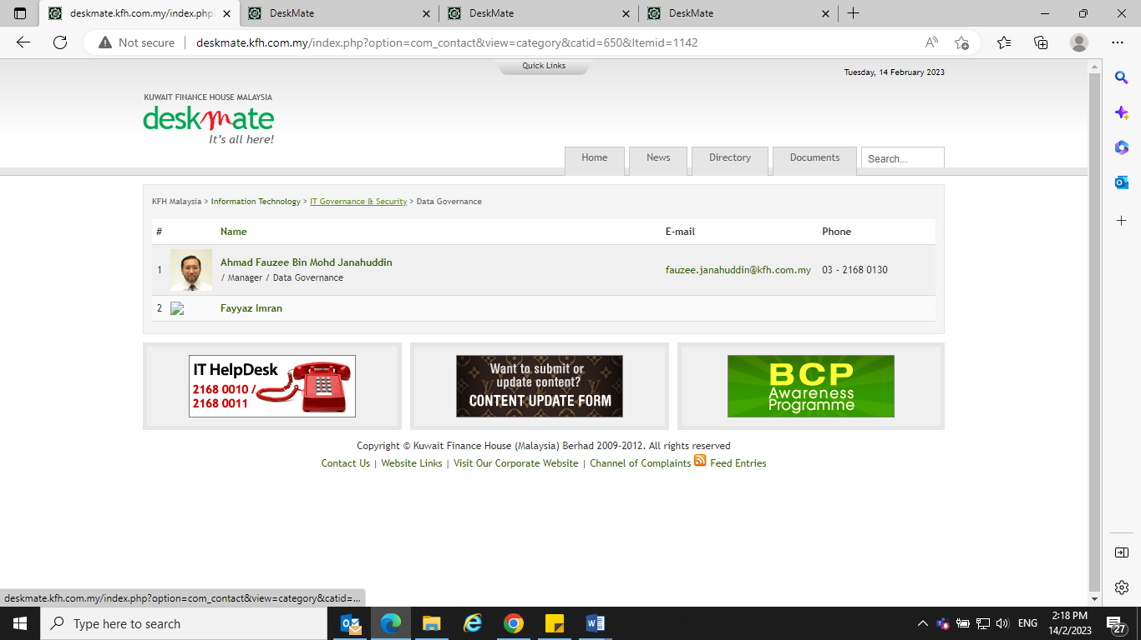

1. Title : Manager – Remove Data Governance
2. Org Chart changed – Data Governance is now under IT Planning &Architecture
3. Fayyaz Imran Mohd Setia Email : [fayyaz.setia@kfh.com.my](mailto:fayyaz.setia@kfh.com.my) Phone No. 03-2168 0137

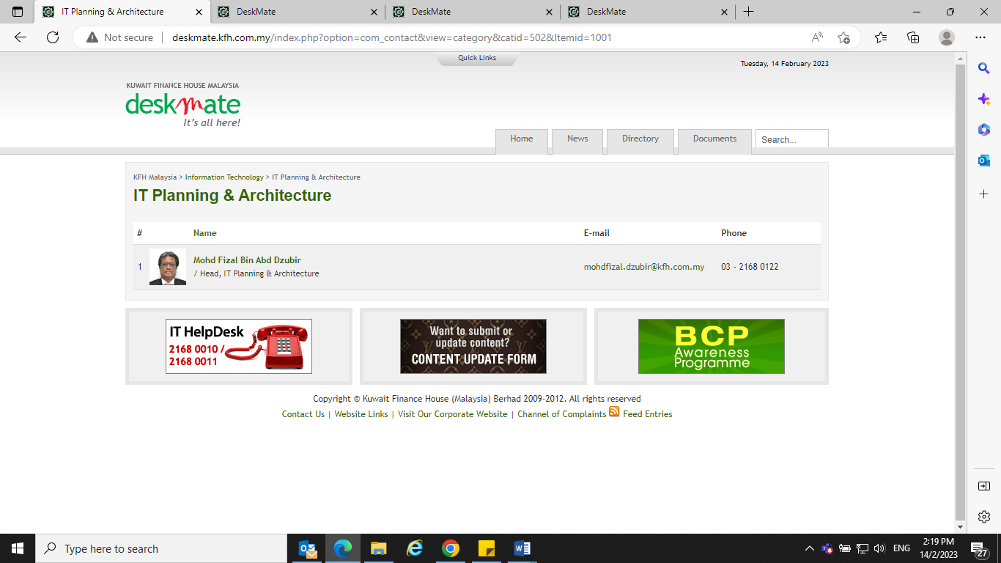

1. Title : Senior Manager – Remove Head, IT Planning & Architecture

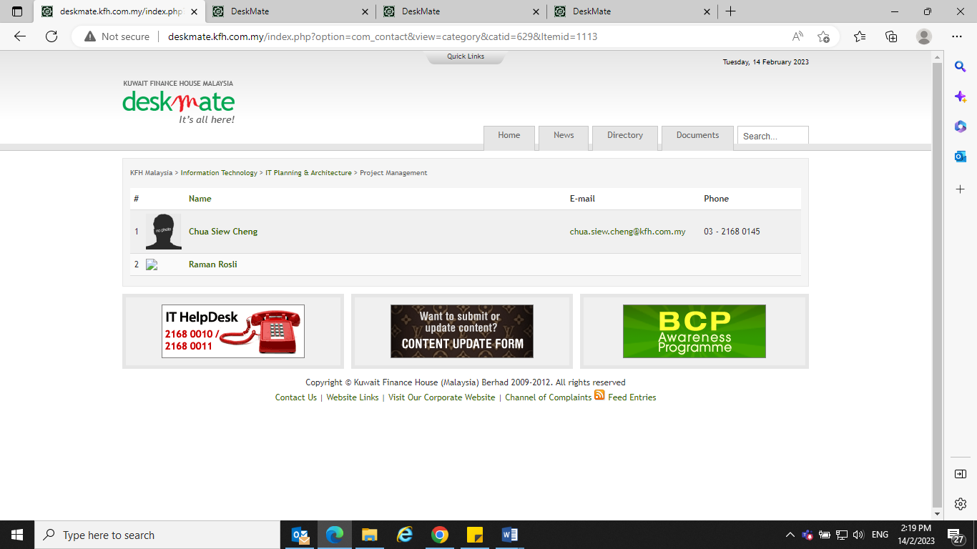

1. Correct name is Ramlan Rosli for No. 2 Email : ramlan.rosli@kfh.com.my

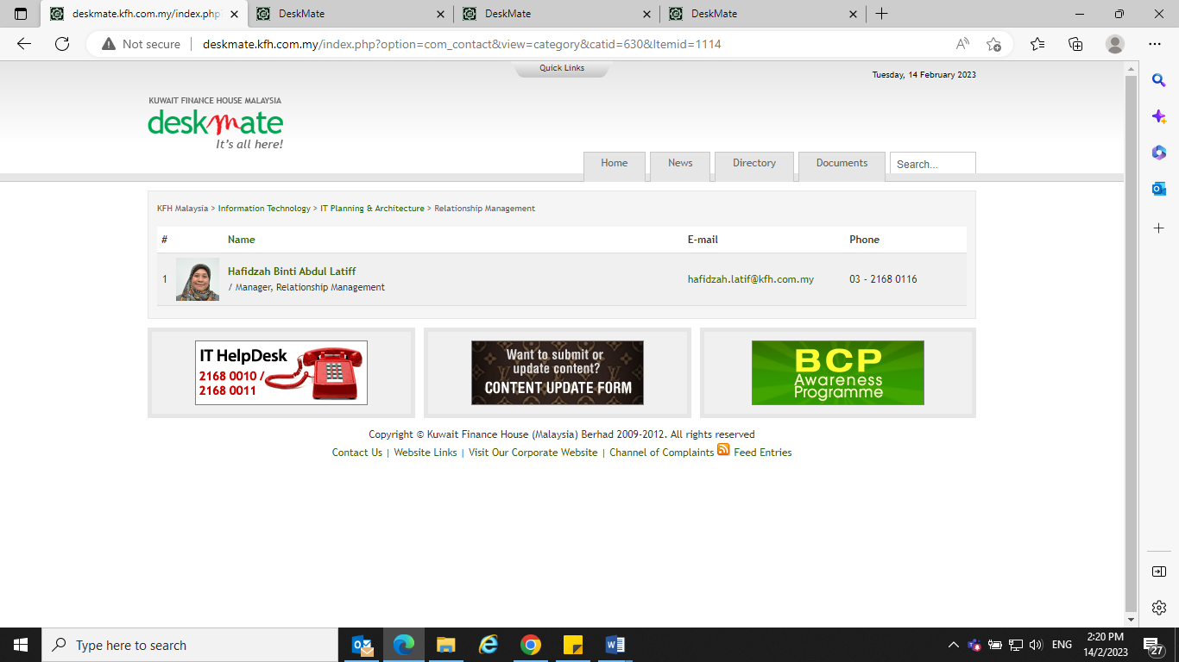

1. Title : Manager – Remove Relationship Management

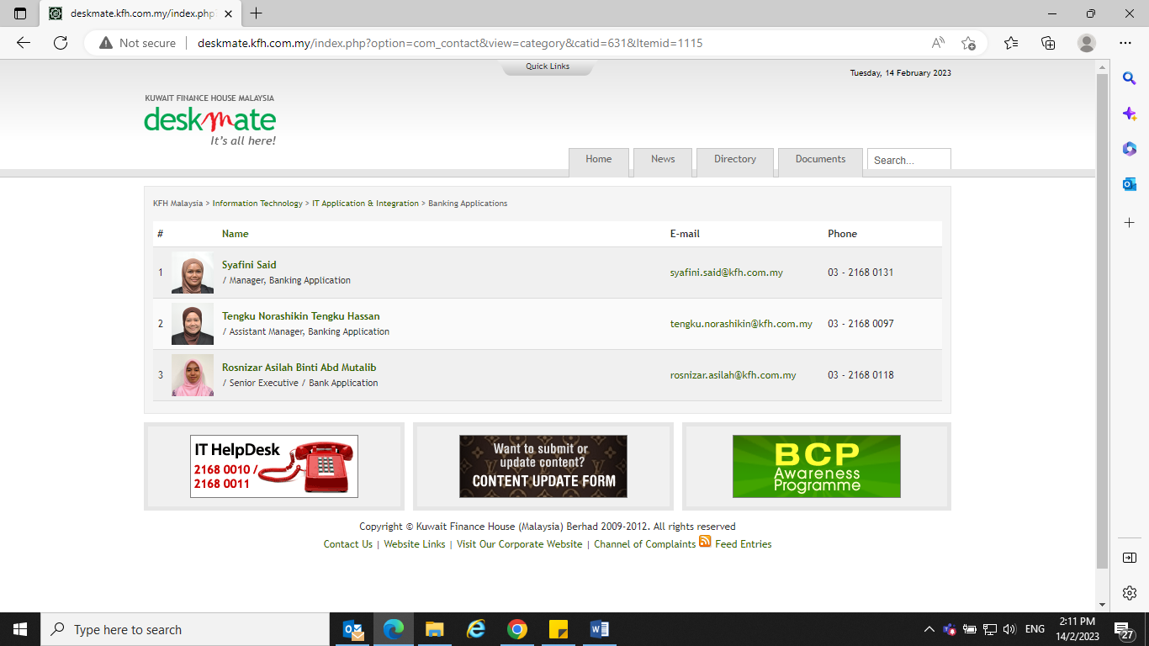

1. Title : Syafini Said : Manager – Remove Banking Application
2. Title : Tengku Norashikin Tengku Hassan : Assistant Manager – Remove Banking Application
3. Title : Rosnizar Asilah Abd Mutalib : Senior Executive – Remove Bank Application

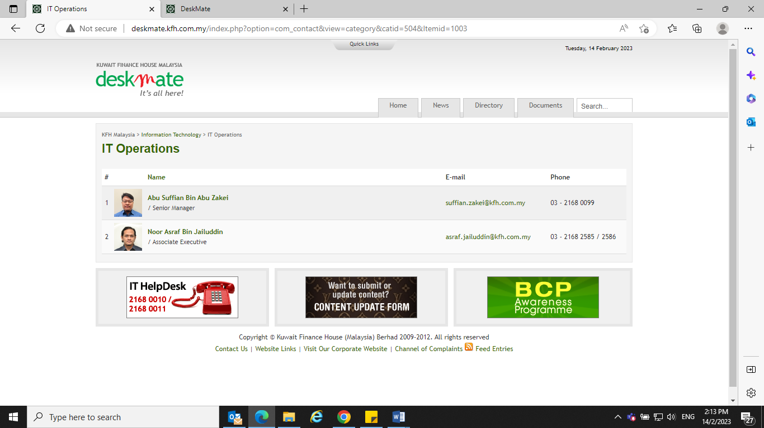

1. Name : Abu Suffian Abu Zakie – Not Zakei Email : suffian.zakie@kfh.com.my
2. Remove Noor Asraf Jailuddin & park under IT Application Support

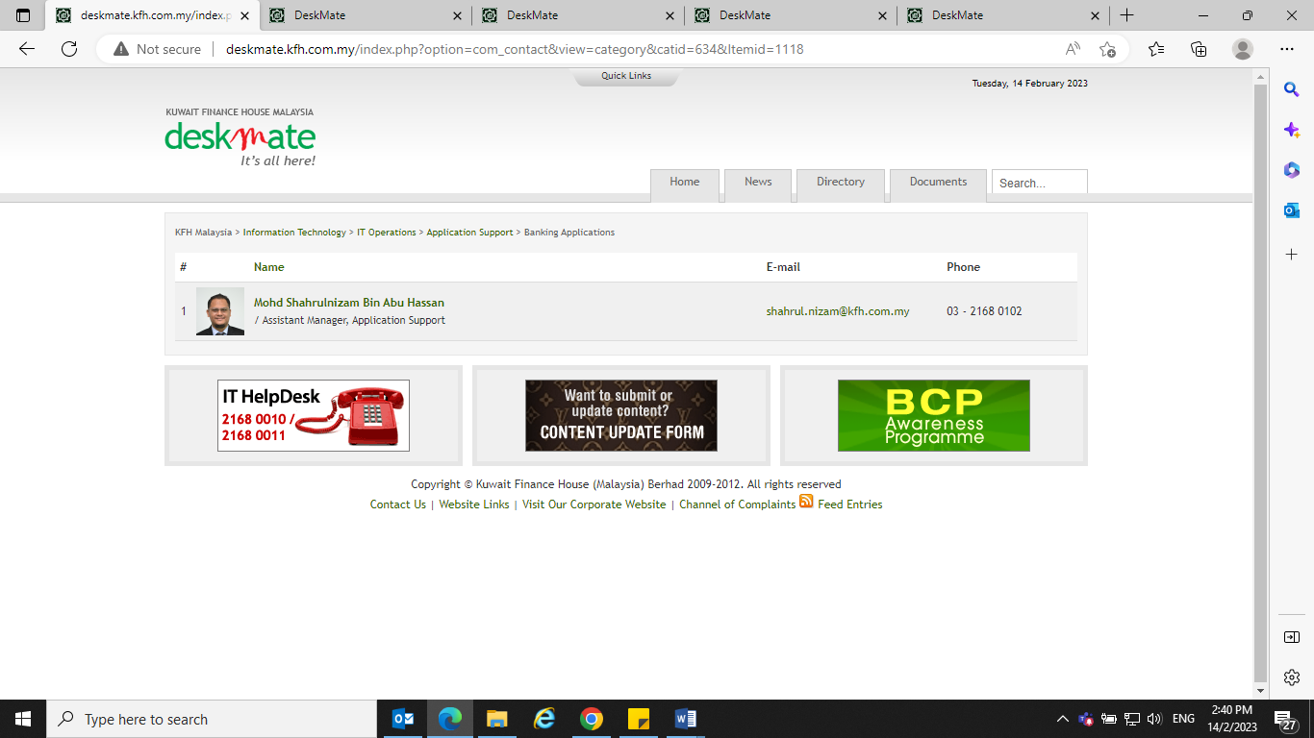

1. Title : Assistant Manager – Remove Application Support
2. Park Noor Asraf Jailuddin here with Mohd Sharulnizam Abu Hassan
3. Change Noor Asraf Jailuddin Phone No. to 03-2169 0106

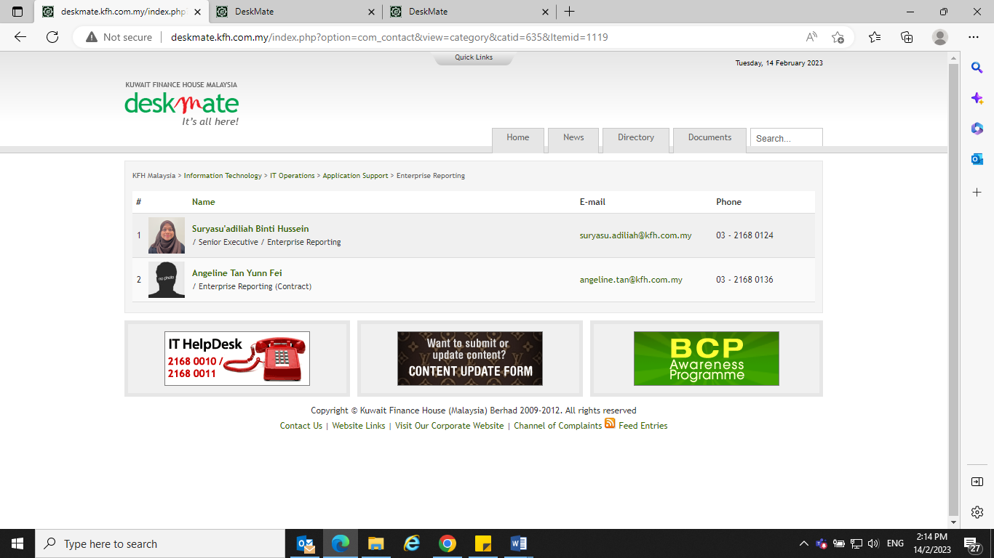

1. Title : Senior Executive – Remove Enterprise Reporting
2. Correct name is Suryasu'adliah Hussein Email : suryasu.adliah@kfh.com.my
3. Please leave blank for Angeline Tan Yunn Fei’s title (she is from contract agency)

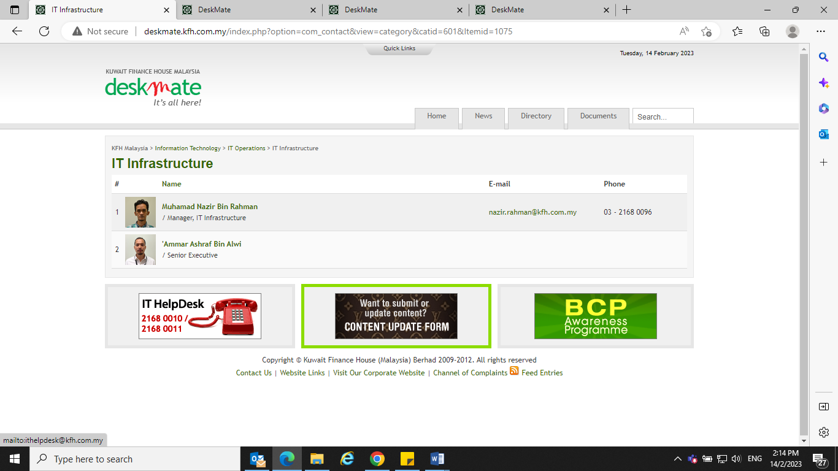

1. Title : Manager – Remove IT Infrastructure
2. Remove Ammar Ashraf Alwi & park under Database Admin

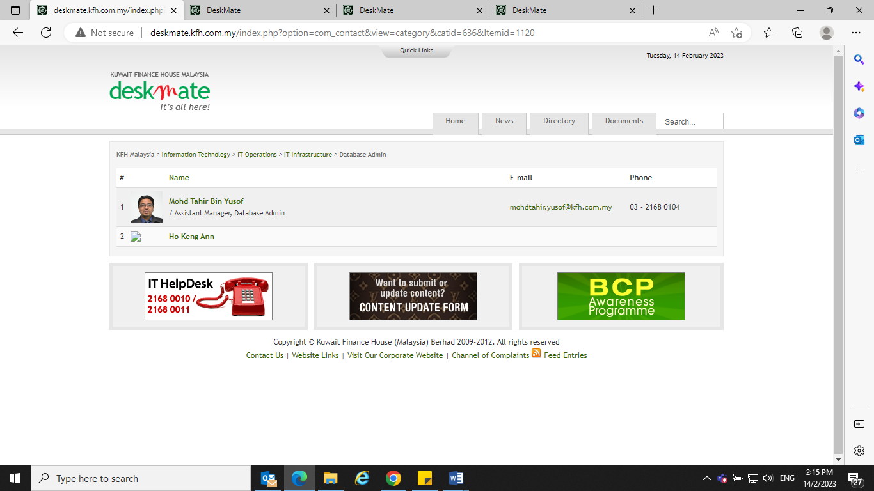

1. Title : Assistant Manager – Remove Database Admin
2. Park Ammar Ashraf Alwi here with Mohd Tahir Yusof
3. Add Email : [ammar.ashraf@kfh.com.my](mailto:ammar.ashraf@kfh.com.my) Phone No. : 03-2168 0105
4. Remove Ho Keng Ann (contract already terminated)

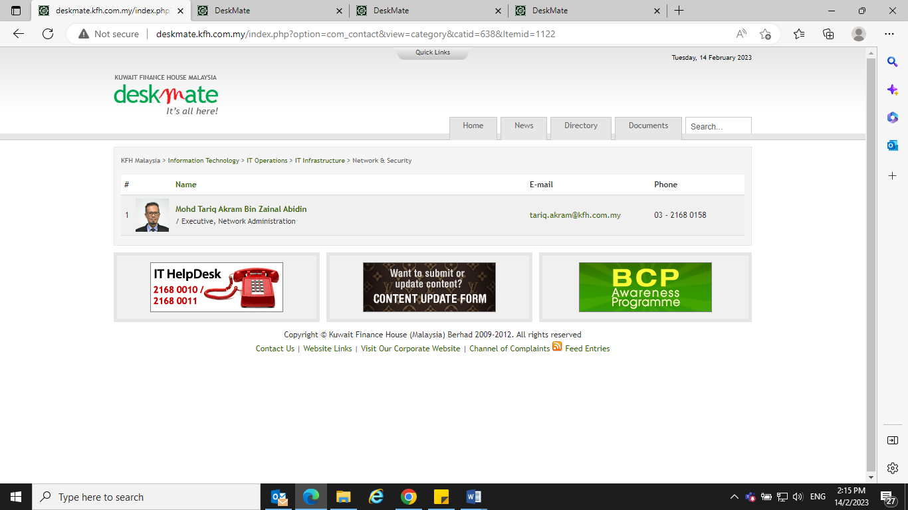

1. Title : Executive – Remove Network Administration

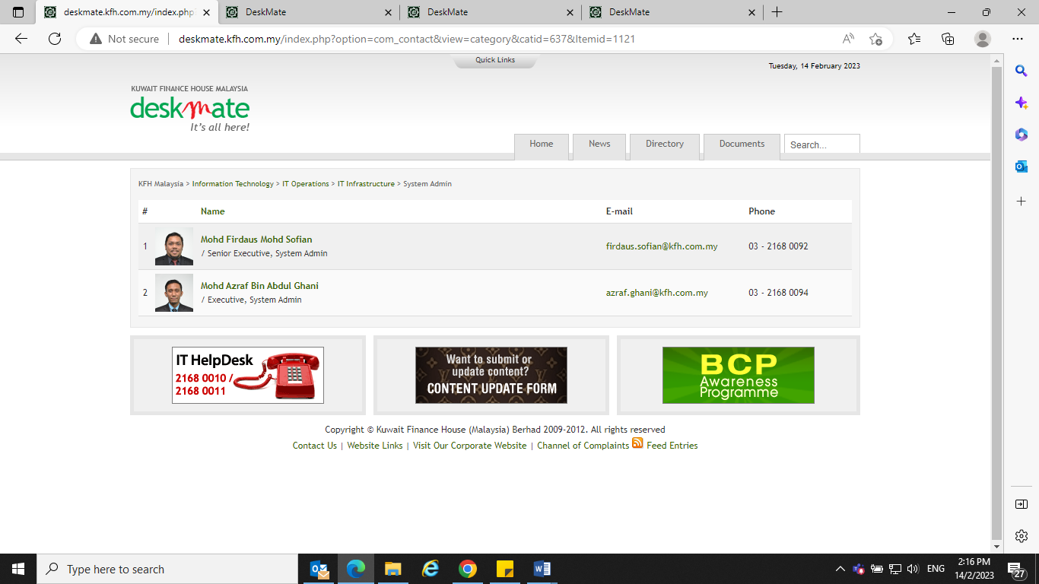

1. Title : Mohd Firdaus Mohd Sofian : Senior Executive – Remove System Admin
2. Title : Mohd Azraf Abdul Ghani : Executive – Remove System Admin

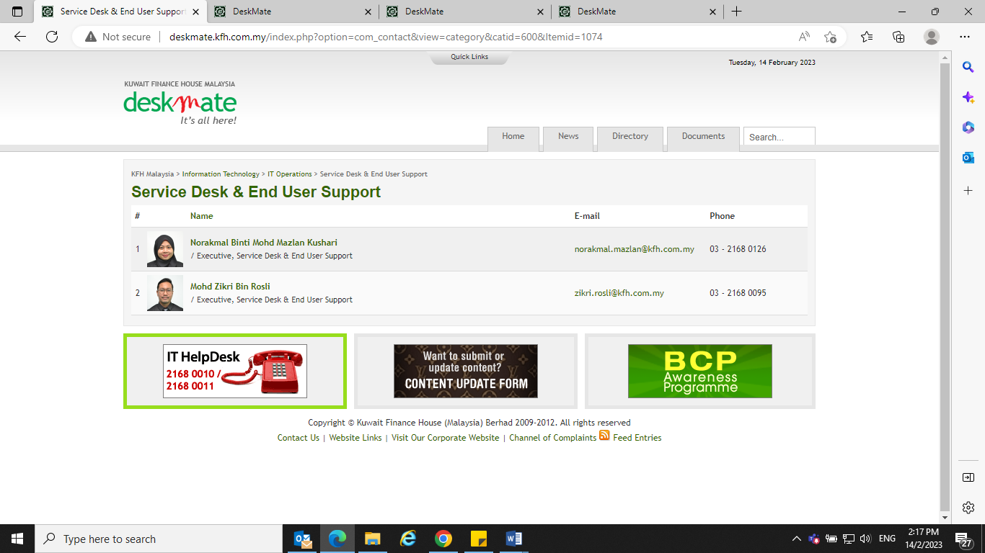

1. Title : Norakmal Mohd Mazlan Khushari : Executive – Remove Service Desk & End User Support
2. Title : Mohd Zikri Rosli : Executive - Remove Service Desk & End User Support
3. Park Ahmad Doni Basir here with Norakmal Mohd Mazlan Khushari and Mohd Zikri Rosli
4. Title : Executive Email : [ahmad.doni@kfh.com.my](mailto:ahmad.doni@kfh.com.my) Phone No.: 03-2168 0093

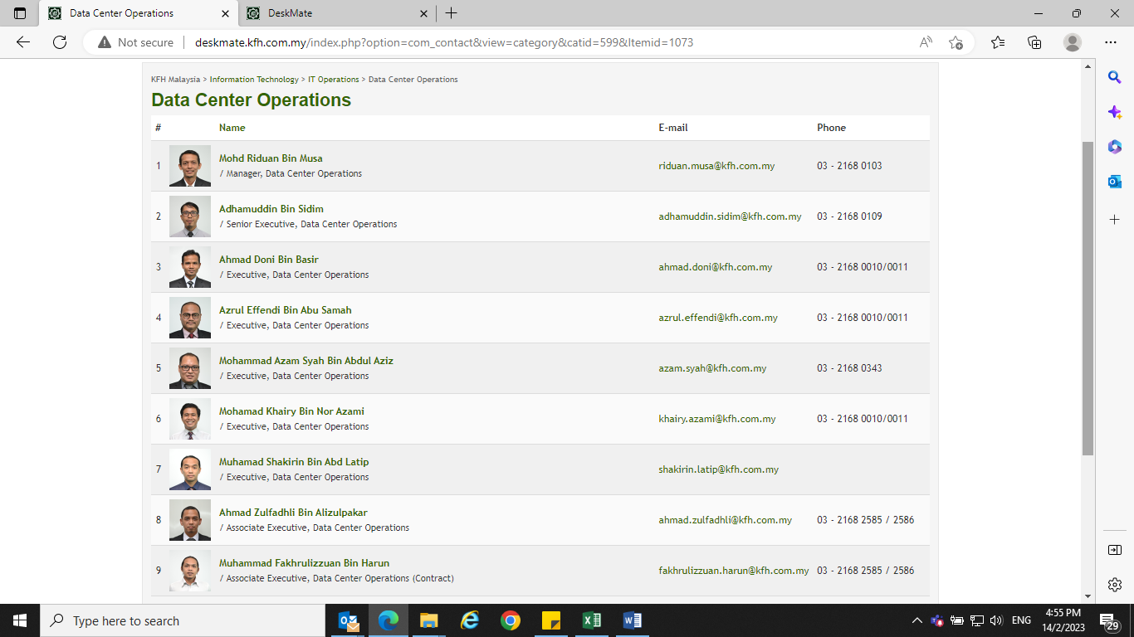

1. Title : Mohd Riduan Musa : Manager – Remove Data Center Operations
2. Title : Adhamuddin Sidim : Senior Executive - Remove Data Center Operations
3. Title : Azrul Effendi Abu Samah : Executive - Remove Data Center Operations
4. Title : Mohammad Azam Syah Abdul Aziz : Executive - Remove Data Center Operations
5. Change Mohammad Azam Syah Abdul Aziz Phone No. to 03-2168 0010/0011
6. Title : Mohamad Khairy Nor Azami : Executive - Remove Data Center Operations
7. Title : Muhammad Shakirin Abd Latip : Executive – Remove Data Center Operations
8. Add Muhammad Shakirin Abd Latip Phone No. 03-2168 2585/2586
9. Title : Ahmad Zulfadhli Alizulpakar : Associate Executive – Remove Data Center Operations
10. Title : Muhammad Fakhrulizzuan Harun : Associate Executive (Contract) - Remove Data Center Operations
11. Remove Ahmad Doni Basir & park under Service Desk & End User Support